IT Camp Study Guide
IoT (Internet of Things) Using Raspberry Pi and Scratch

1. Purpose of the Study Guide
This study guide is designed to support participants in acquiring foundational knowledge and hands-on skills in Internet of Things (IoT), block-based programming using Scratch, and basic computing with Raspberry Pi. It is intended for beginner-level learners participating in IT camp workshops.

2. Workshop Learning Objectives
Upon completion of the workshop, participants are expected to be able to:
- Define the concept of the Internet of Things (IoT).
- Describe the functions and uses of a Raspberry Pi computer.
- Develop simple programs using the Scratch programming environment.
- Explain fundamental programming concepts, including variables, control structures, and events.
- Interact with sensors and devices using the Sense HAT.
- Construct a basic IoT application integrating hardware and software components.

3. Workshop Topics Overview
Table Workshop Topics and Coverage
Topic | WS-1 | WS-2 | WS-3 (IoT)
Introduction to IoT, Raspberry Pi, and Scratch | ✓ | ✓ | ✓
Scratch Game Programming | ✓ | ✓ | ✓
Scratch Extensions | ✓ | ✓ | ✓
Raspberry Pi Basics | ✓ | ✓ | ✓
Virtual IT Field Trip | ✓ | ✓ | ✓
Guest Speaker Session | ✓ | ✓ | ✓
Raspberry Pi Setup | ✓ | ✓ | ✓
Sense HAT Hands-on | ✓ | ✓ | ✓
IoT Devices with Scratch |  | ✓ | ✓
Python Programming (Intro) |  |  | ✓
Future of IoT (Stargate Concept) | ✓ | ✓ | ✓

4. Core Concepts
4.1 Internet of Things (IoT)
The Internet of Things refers to physical objects embedded with sensors, processing capabilities, and communication technologies that enable them to collect and exchange data over networks.
4.2 Raspberry Pi
Raspberry Pi is a compact, affordable computer designed for educational purposes. It allows users to learn programming, interact with hardware, and develop real-world computing projects.
4.3 Scratch Programming
Scratch is a visual, block-based programming language that enables users to create interactive stories, games, and animations through a drag-and-drop interface.

5. Scratch Programming Fundamentals
Participants are introduced to essential programming concepts, including:
- Input and Output: Receiving and displaying information
- Variables: Storing and updating data
- Arithmetic Operations: Basic calculations (+, −, ×, ÷)
- Control Structures:
  - Sequence (step-by-step execution)
  - Repetition (loops)
  - Selection (conditional statements)
- Events: Trigger-based actions (e.g., key press, mouse click)
The Scratch interface consists of the Blocks Palette, Coding Area, Stage, and Sprite List, which together enable visual program development.

6. Game-Based Learning Activities
Game development is used as a primary instructional strategy to enhance engagement and reinforce programming concepts. Example activities include:
- Pong-style game development
- Catch-and-collect games
- Interactive animations
Participants are encouraged to design their own games as a creative extension activity.

7. Raspberry Pi Fundamentals
Participants learn to:
- Start and operate a Raspberry Pi system
- Navigate the operating system and pre-installed applications
- Use the device as a general-purpose computer and programming platform

8. Sensors and Sense HAT
8.1 Sensors
Sensors are devices that collect environmental data such as temperature, humidity, and motion.
8.2 Sense HAT Features
The Sense HAT includes:
- Environmental sensors (temperature, pressure, humidity)
- Motion sensors (accelerometer, gyroscope, magnetometer)
- LED matrix display (8×8 grid)
- Joystick for user input
These components allow participants to interact with real-world data and build physical computing applications.

9. Introduction to IoT Systems
Participants explore how IoT systems integrate multiple components:
- Sensors collect data
- Raspberry Pi processes the data
- Software (Scratch or Python) controls outputs
- Data may be transmitted to cloud platforms
Example demonstrations include simple IoT dashboards using platforms such as Cayenne.

10. Hands-On Learning Progression
Activities are structured to support incremental learning:
- Beginner Level: Basic Scratch programming and animations
- Intermediate Level: Game development and logic implementation
- Advanced Level: Sensor integration and IoT applications

11. Career Awareness and Real-World Connections
Participants engage in:
- Virtual or in-person IT field trips
- Guest speaker sessions featuring IT professionals
These activities provide insight into real-world applications of computing and potential career pathways.

12. Additional Learning Resources
Instructors or participants are encouraged to explore additional materials and representative instructional materials, and visual examples are provided in Illustrations (Figures 1–6).
The resources include:
- Scratch tutorials and project galleries (Figure 1)
- Raspberry Pi beginner guides (Figure 2)
- Scratch advanced projects (Figure 3)
- Tutorials for Raspberry Pi advanced projects, including Sense HAT (Figure 4)
- Game Options using Scratch and/or Raspberry Pi and Sense HAT (Figure 5)
- IoT dashboards using platforms such as Cayenne

Illustrations:
Figure 1 Scratch Project Galleries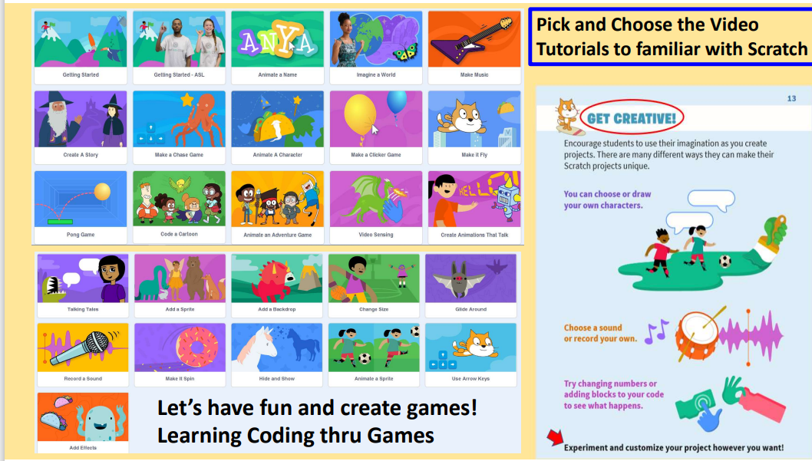 | Figure 2 Raspberry Pi Beginner Guide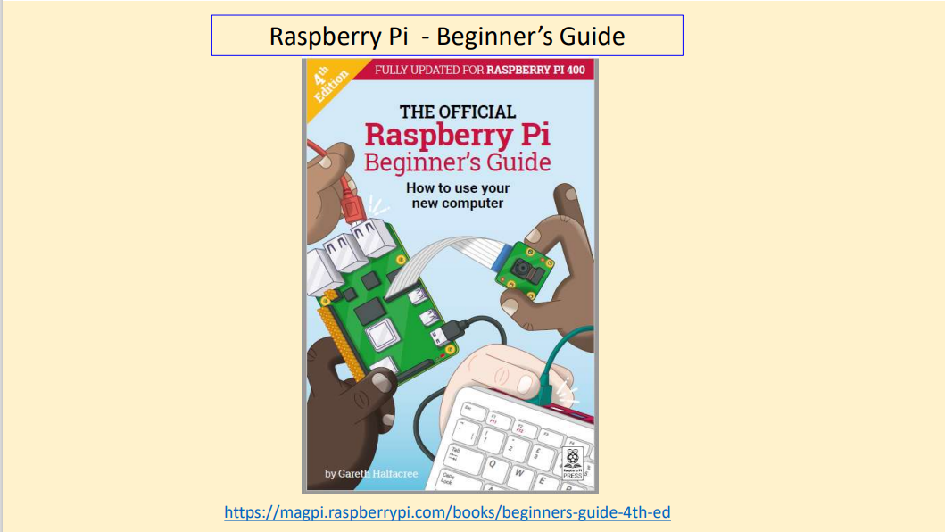
Figure 3 Scratch Advanced Projects  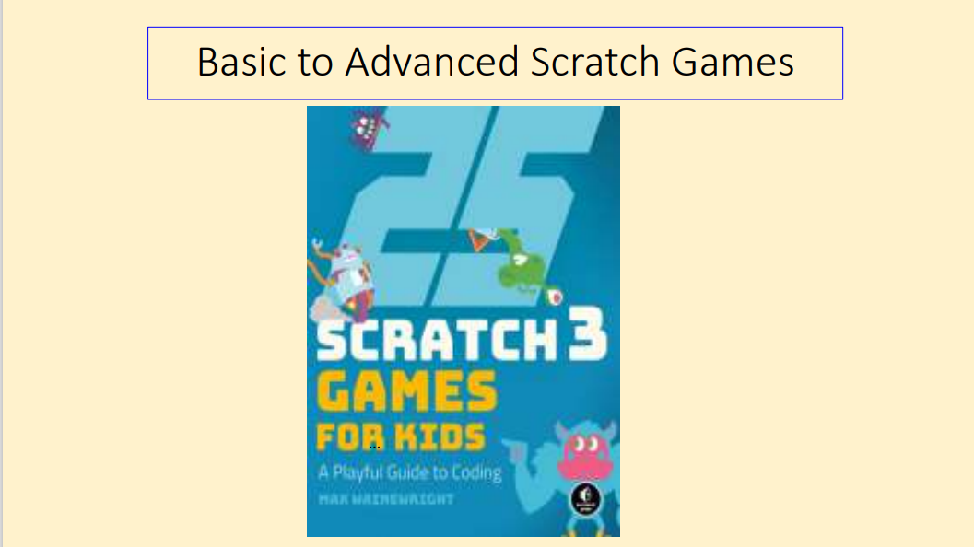 | Figure 4 Raspberry Pi and Sense HAT Cookbook  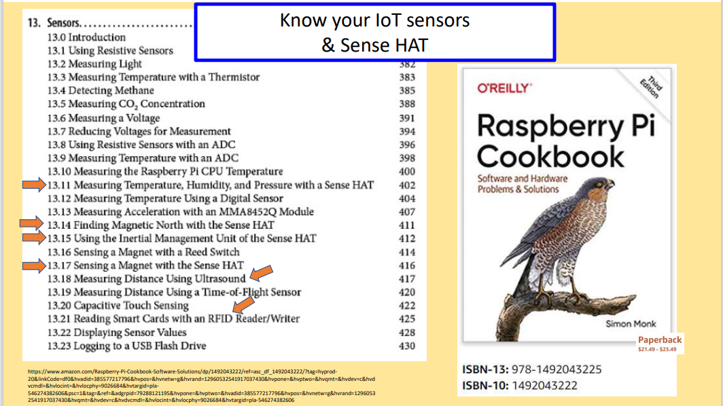
Figure 5 Game Options  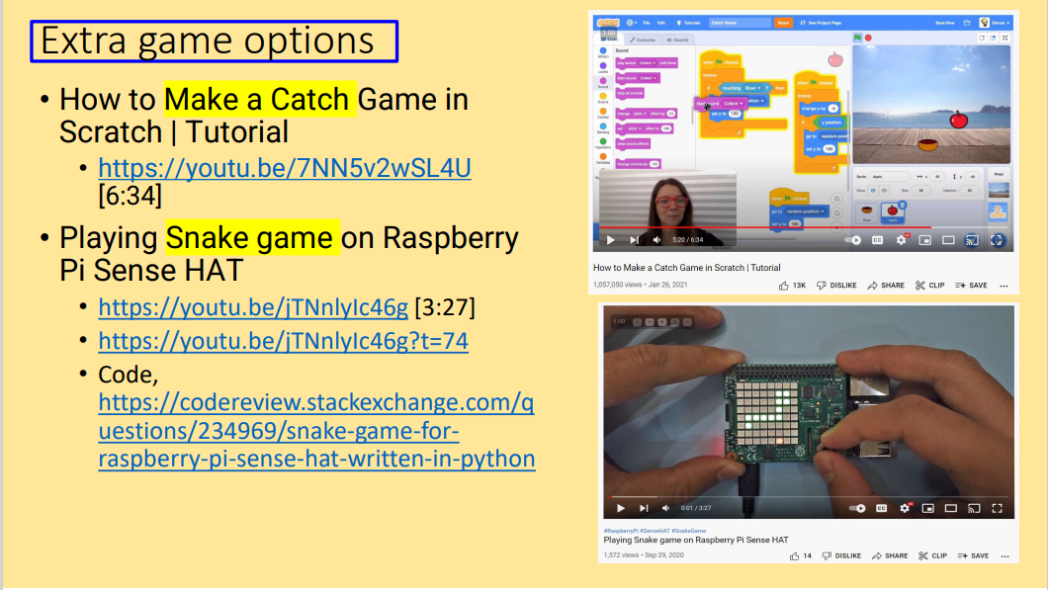 | Figure 6 IoT dashboards using platforms such as Cayenne  