CIS/CS 3223 NetCentric Computing– Fall 2024
Homework 01 – Develop a Loan Calculation Client-Server Internet Application

Name: ___________________
Prepared: 9/10, Due, 9/26 by 11:59 p.m.

Remarks:
- This is a not team/group project. However, I don’t mind you asking hints/help from other students but you are required to develop your own logic and write your own code.
- If I found out that your logic/code is similar to the logic/code from another student, both of you will received a grade of zero on this homework exercise.
- Feel free to watch How the Client and Server programs interact with each other. Here is the video link, https://youtu.be/w4Iqs18F-as [4:32]

Based on the Client-Server architecture and the knowledge learned in Socket Programming, develop a Client-Server loan calculator internet application [45 points].
Requirements:
- Write a Loan Calculator Server program to compute the monthly payment information according to the required loan data provided by a client such as loan years, loan amount, loan monthly interest rate.
  - Below is formula for calculating the loan monthly payment,
- monthly_payment = loan_amount (rate(1+rate)^months)/((1+rate)^months-1)
- or monthly_payment = loan_amount(rate (1+rate)^{months}) / ((1+rate)^{months} – 1)
  - Refer to the website below for the detailed information about the formula.
- https://www.rocketloans.com/learn/financial-smarts/how-to-calculate-monthly-payment-on-a-loan
- https://www.kasasa.com/blog/how-to-calculate-loan-payments-in-3-easy-steps
- Write a client program to connect to the Server and provides the required loan data (e.g., years, amount, monthly interest rate) and then display the monthly payment information received from the Server.
- You are free to use any programming language in the list (i.e., C++, Java, VB-net, and python) to write the programs.
  - If your language of choice is not in the list, you are required to check with me first. Otherwise, you will receive a grade of zero on this assignment.
  - I have sample server and client code written in Java, C++, Python only so feel free to modify the code to fit your needs.
  - You can Google the web for reference but you have to write the server and client programs based on the sample code provided by me.
- Both programs have to use the TCP service, not UDP service.
- Refer to my screenshots below or watch the video to see the interactions between the Server and Client programs.
  - Programs in action video link, https://youtu.be/w4Iqs18F-as [4:32]
  - You are not required to display the timestamps information.
    - I did that only to show you the timelines of the interactions between the server program and client program.
  - The Server program has to display all the loan prompt messages (e.g., years, amount, monthly interest rate) and the calculated monthly payment data send to the client.
  - The Client program has to display all the loan prompt messages and the calculated monthly payment data received from the server.
- To keep the programs simple, you are not required to provide the “Do you want to try again: (Y)es or (N)o? functions in your programs.
- Verify the correctness of your programs.
- Submit the source code of your server program and client program to Canvas.

Program sample run(s) between the Server and the Client:
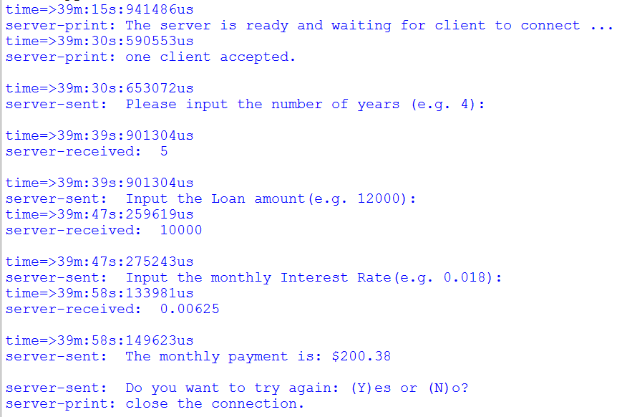 | 