Khaled Alsaqri & Ben Durao

Honors 490 Final Project

User-Interface Documentation

1. **Starting the Server:** 
   1. Compile and run program as one normally would through NetBeans.
   2. Upon running, this window will appear:

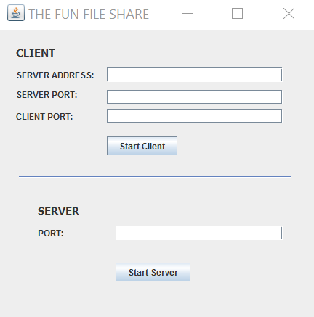

* 1. To start the server, enter port number in red circled text area above.
  2. After that, click the “Start Server” button and you should see the following window pop up:

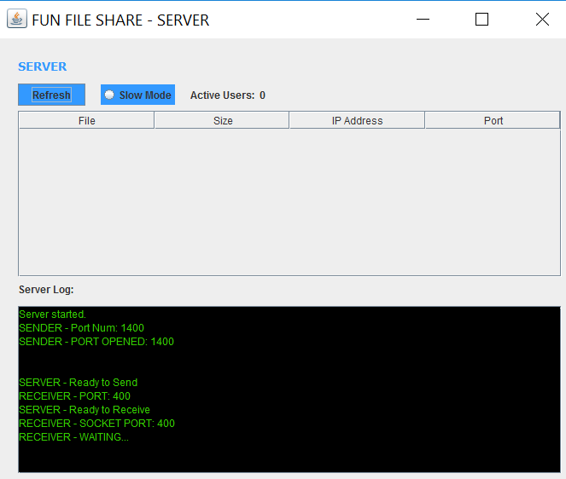

This is the Server window.

1. **Server Window** 
   1. If a client uploads a file to the server, it will show in the red circled table shown below:

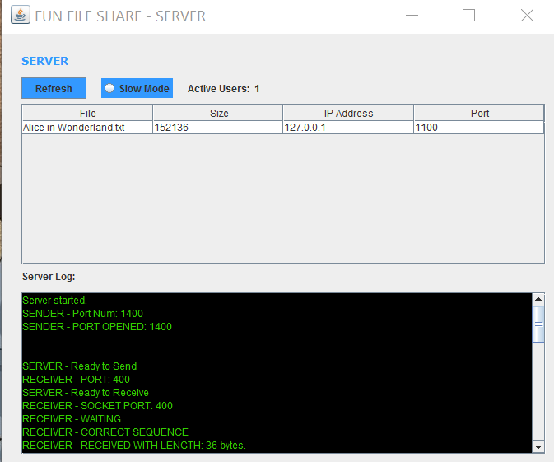

In this demonstration, we have uploaded a file already. Notice how over the table, “Active Users” is displayed as 1. This will increment as more users upload files to the server. Also notice how size (bytes), client IP, and port are all shown in the table. As more users upload the server, the larger the table will become.

* 1. Once a client exits the program, their files will be removed from the server.
  2. On the top of the table, we have a radio button labeled “Slow Mode” and a refresh button labeled “Refresh”. Hit these to perform desired actions
  3. On the bottom of the window we have a log that displays everything NetBeans would in its own log. One can easily scroll through this log with their mouse wheel. (Show in the image below, marked by the red circle).



1. **Starting the Client** 
   1. To start the client, go back to the main window, which, again is loaded by compiling and running the program as one normally would through NetBeans:

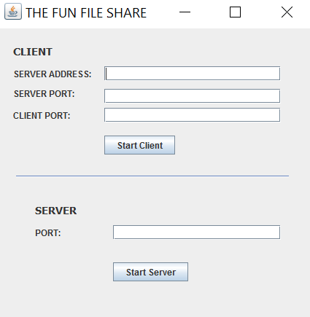

* 1. Enter the server’s information in the circled fields above. The Server’s IP address would go in the “Server Address:” text field, the server’s port would go in the “Server Port:” text field, and the newly created client port would be inputted in the “Client Port:” text field.
  2. After this information is filled out, hit the button marked “Start Client” to start the client.
  3. A new window will appear, shown below:

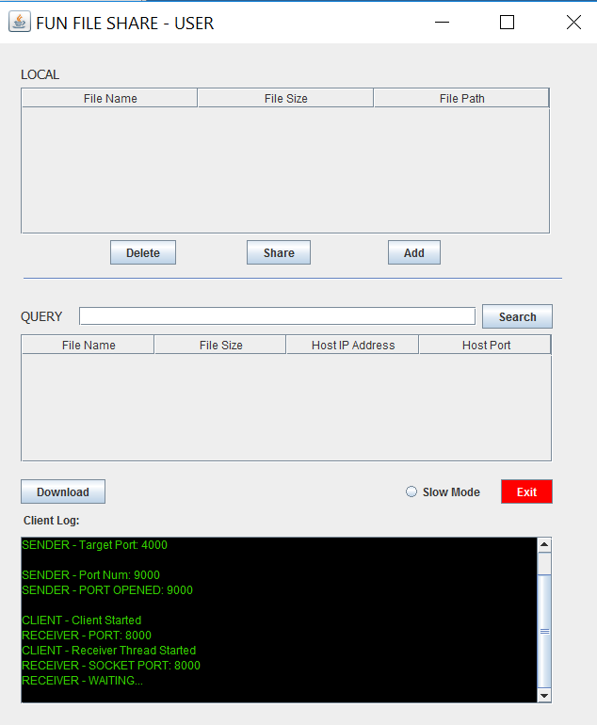

1. **Client Window:** 
   1. In the table marked with the red circle below, a client will see files that they would like to send to the server:



* 1. To add a file, simply click the Add button right underneath the table that is marked above.
  2. After doing so, a file directory of your computer will appear:

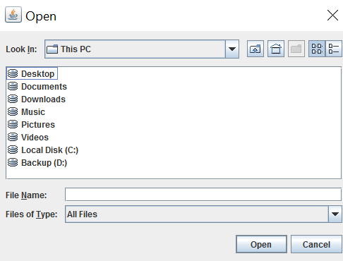

* 1. Select the file that you would like to upload to the server from here. After doing so the table mentioned in part (a) will look like so:

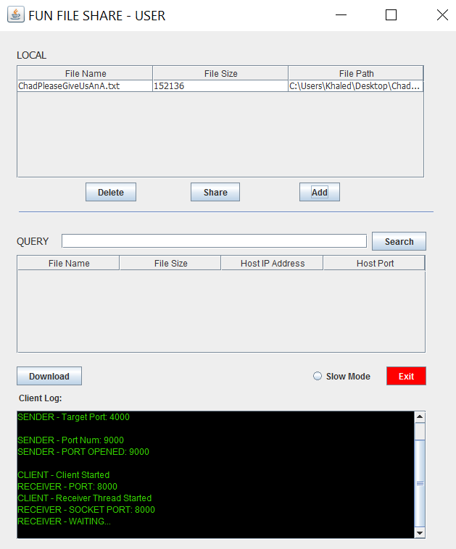

* 1. To upload to server, simply press the “Share” Button
  2. To delete a file from this table, simply press the “Delete” Button.
  3. To Query for a file on the server, use the search bar circled below and press the “Search”. The file will appear in the table below the search bar:



* 1. Press the “Download” button to download the file to your project folder (i.e. the NetBeans folder that contains the project files)
  2. Press the “Slow Mode” radio button to enter slow mode
  3. Press the Exit Button to Exit/ end connection with the server
  4. The log on the bottom of the window performs the same functions as the one mentioned above.

**\*\*\*\* LAST MINUTE ADDITIONS\*\*\*\***

1. When clicking Exit on client end, a popup menu will appear asking user if they are SURE they want to exit (YES OR NO option)
2. When clicking Download and download completed, a message will appear informing the user that the download is in fact completed.
3. Every log on the interface has the option to clear the log by clicking a button that says “Clear Log”