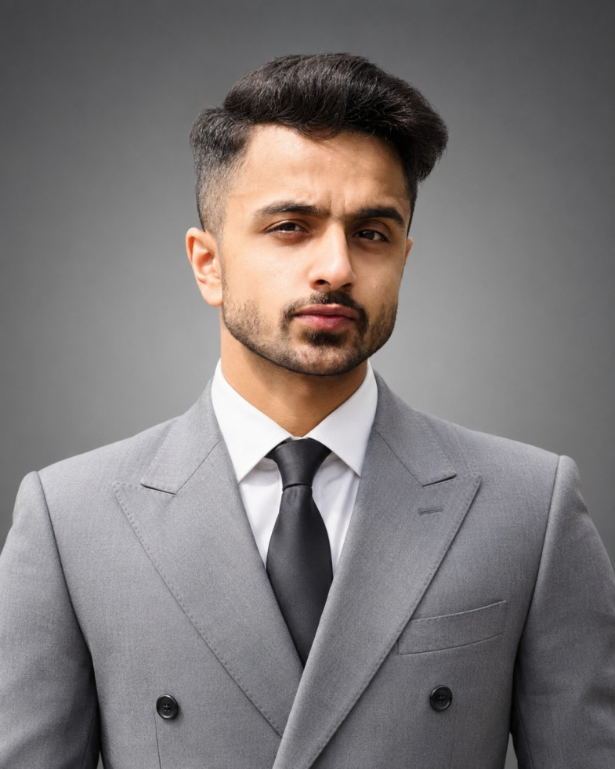
Usairam Saeed

M.Sc. Computer Science
RPTU University Kaiserslautern-Landau
Kaiserslautern, Germany
Location: Mansehra, Pakistan
Phone: +92 301 8165385
Email: saeed.usairam@gmail.com LinkedIn: linkedin.com/in/usairam-saeed GitHub: github.com/saymi313

Profile

Software Engineering graduate from FAST-NUCES with professional experience in AI engineering, full-stack development, and technical team leadership. Interested in intelligent systems, machine learning, and reliable software architecture. Seeking to strengthen theoretical knowledge and research skills through the M.Sc. Computer Science programme at RPTU, particularly in Intelligent Systems and Software Engineering.

Education

Bachelor of Science in Software Engineering Aug 2022 – Jun 2026
FAST-NUCES, Islamabad, Pakistan
- Graduated in June 2026.
- Dean’s List: Recognised for academic performance in the final semester, GPA 3.53/4.00.
- Final Year Project: CasaBelle, an AI- and blockchain-enabled real-estate system.
- Relevant coursework: Linear Algebra, Probability and Statistics, Data Structures and Algorithms, Operating Systems, Database Management Systems, Artificial Intelligence and Machine Learning, Natural Language Processing, Human-Computer Interaction, DevOps, and Cloud Computing.

Work Experience

AI Software Engineer Aug 2023 – Present
Avancod, Islamabad, Pakistan
- Built a financial assistant for US-based properties to automate financial analysis.
- Developed NeuroMark, a computer-vision attendance management system, improving face-detection accuracy by 25% and reducing false positives by 30%.
- Developed natural language processing and machine-learning models for financial-market and cryptocurrency prediction.
- Improved a company portfolio website’s user experience and redesigned an e-commerce website for a Spanish client.
Frontend Team Lead and AI Team Lead 2026 – Present
BangoPure Limited, United Kingdom, Remote
- Led frontend development and coordinated the integration of AI features into web applications within a remote product team.
- Guided frontend developers, reviewed code, and promoted consistent coding practices and code quality.
- Worked across application components and services, helping maintain integration, reliability, and maintainability as product features evolved.
- Collaborated with cross-functional team members to translate product requirements into practical software solutions.
Full Stack Developer Sep 2025 – Jan 2026
Scholars Avenue, Germany / Islamabad, Pakistan
- Built Scholarslee, a mentorship platform with 500+ monthly active users for browsing, booking, and paying mentors.
- Reduced booking friction by 70% through real-time chat and calendar integration.
- Recorded a 4.9/5 average mentor rating and a 100% payment success rate.

Selected Projects

CasaBelle – AI and Blockchain Real-Estate System (Final Year Project) Sep 2025 – Jun 2026
- Developed React.js frontend modules for property management, investment tracking, and role-based dashboards.
- Implemented NLP-based sentiment analysis of property reviews to support recommendation reliability.
- Integrated Google Authentication, JWT-based authorisation, and automated email verification.
- Collaborated on a multi-tier architecture combining blockchain, AI services, and cloud storage for property tokenisation and document verification.
NeuroMark – Computer Vision Attendance System May 2025 – Present
- Compared face-detection and face-recognition architectures under real-world constraints.
- Curated and preprocessed data to account for lighting variation and partial occlusion.
- Analysed false positives and false negatives through threshold tuning and model selection based on precision-recall trade-offs.
Nuvoletro – AI-Based Video Repurposer Dec 2025 – Jan 2026
- Built an AI SaaS platform that transforms long-form YouTube videos into social content using generative AI and NLP.
- Developed a Retrieval-Augmented Generation (RAG) pipeline using LangChain and ChromaDB to improve consistency with a brand’s voice.
- Integrated OpenAI Whisper for audio-to-text processing within a Dockerised microservices architecture.
AlgoDinero – Financial AI Market Prediction Aug 2025 – Dec 2025
- Developed a full-stack market-forecasting dashboard using ensemble approaches, including Transformers, LSTMs, and NLP-based sentiment analysis.
- Combined deep-learning architectures with statistical methods such as ARIMA for volatility prediction.
- Built a FastAPI and MongoDB backend to process market data and display trends through interactive Plotly dashboards.

Technical Skills

Programming languages Python, JavaScript, C, C++, HTML, CSS
Frameworks and libraries React.js, Next.js, Node.js, Tailwind CSS, OpenCV, NumPy, Pandas, PyTorch, Matplotlib
Databases MongoDB, MS SQL, PostgreSQL, DynamoDB, ChromaDB

Cloud, DevOps and design

Language Skills
AWS, Docker, Kubernetes, Jenkins, Figma, Sketch, Adobe XD

Urdu: Native German: A1, basic user
English: IELTS Academic overall 6.5 (Listening 6.0, Reading 7.0, Writing 6.5, Speaking 6.0).

Certifications

Front-End Apps with React, IBM, Jun 2026 Agile Development and Scrum, IBM, Jun 2025
AWS Academy Cloud Foundations, AWS, Jan 2026 Introduction to UX/UI Design, IBM, Jun 2025
Complete Machine Learning, Stanford Online, Jun 2025 Essential UI/UX Design with Figma, Udemy, Jan 2025

Honours and Awards

- Gold Medalist, ETEA (Aug 2022): 13th overall in Khyber Pakhtunkhwa, score 81/100.
- 1st Place, UI/UX Design, DeenFest 2024 (Oct 2024): among 25 competing groups.
- 1st Place, Web Design, Soventure (Nov 2025): first place for the third consecutive time.

