An Analysis of difference in the mean Cholesterol level in Cleveland between Male and Female population

*A_group 129*

*Pratyush Garg, Mohamad Aves Cutleriwala, Chandra Shekar Ballankala, Venkata Naga Durga Akhila Tavva, Mudassir Mohammad*

Tuesday, 28 Dec, 2021

**Abstract:** *Cholesterol level is growing concern as a health issue in human health as it is considered as one of the causes in heart diseases. Variation in cholesterol level in females is higher than males. Females are more at risk for high cholesterol than males, which can be seen in races. Question, Is there a difference in the mean Cholesterol level in Cleveland between Male and Female population? Method, Dataset is analysed using Wilcoxon also known as Mann Whitney U Test method after determining not normal distribution by a histogram. In all, the results suggest that we reject null hypothesis.*

# Introduction

*Cholesterol level show how much cholesterol is circulating in your blood. Drastic change in cholesterol level leads to heart diseases. The level of cholesterol should not be too high or too low based on human age. Cigarette smoking, high blood pressure, and high blood cholesterol are the most clearly established risk factors that have been identified as being strongly associated with coronary heart disease. Serum cholesterol level is heavily dependent on two factors: 1. It is influenced by food intake 2.It varies by race. We are currently analysing how the cholesterol level is different for male and female.*

*This study attempts to evaluate whether cholesterol level is different for male and female. We ask the following research question:*

*Is there a difference in the mean Cholesterol level in Cleveland between Male and Female population?*

*The null hypothesis is:*

*H0: There is no difference in the mean of cholesterol level in Cleveland between male and female population.*

*The alternative hypothesis is:*

*H1: There is a difference in the mean of cholesterol level in Cleveland between male and female population.*

# Visualization

*Our dataset has 303 observations (rows) and 17 variables (columns).*

*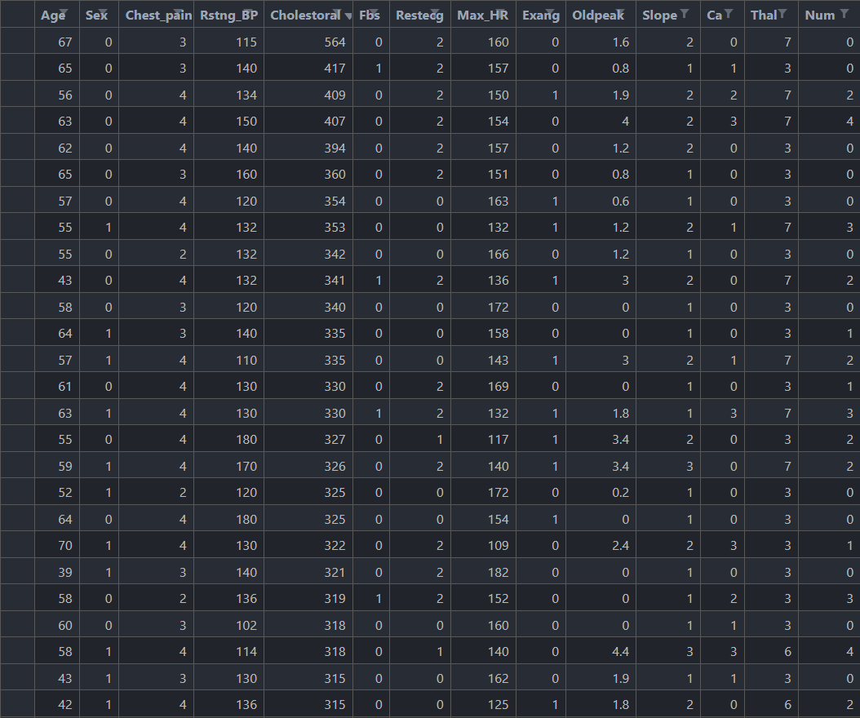Table 1: Dataset of sex(male/female) and cholesterol level.*

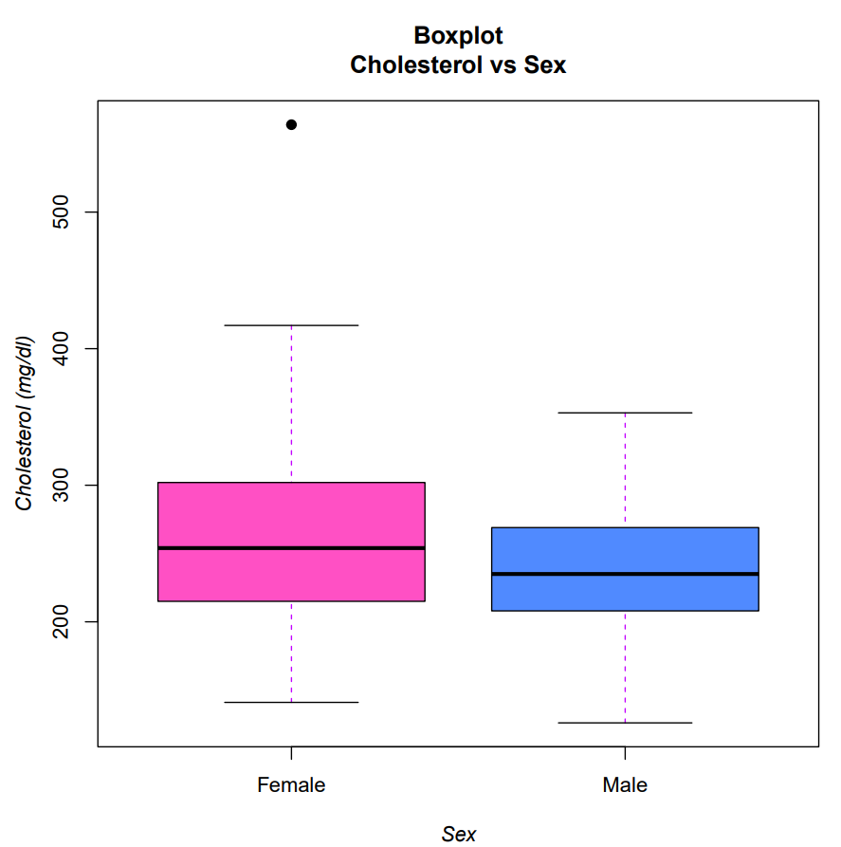*Figure 1: Box plot of independent variables(male/female) and cholesterol level.*

*Figure 1 shows a boxplot with a box plot model. Most of the data points are occurring around the mean. Our data had one outlier; the value of the outlier is very high that it occurs at the top of the plot box.*

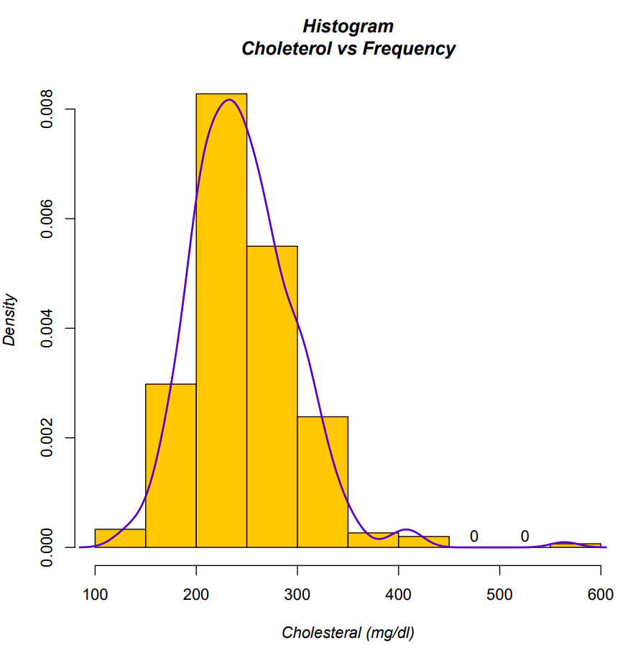

*Figure 2: Distribution of frequency*

*Figure 2 shows a histogram showing the frequency distribution of our dependent variable and include the normal curve overlay.*

*Summary of descriptive statistics variables used for analysis:*



*Table 2: Descriptive Statistics of cholesterol level of male and female Variables.*

# Analysis

# *W = 11836*

# *p-value = 0.007549*

# *The result is significant (strong evidence against null hypothesis)*

# *Therefore, the null hypothesis is rejected*

# Conclusions

*We can conclude that the mean cholesterol level for male and female is different. Female tend to have high cholesterol level compare to male.*

# References

1. Prasad, B. T. & Tsokos, C. P., 2017. *A Statistical Study of Serum Cholesterol Level by Gender and Race.* [Online]   
   Available at: https://www.ncbi.nlm.nih.gov/pmc/articles/PMC7189954/  
   [Accessed 20 11 2022].