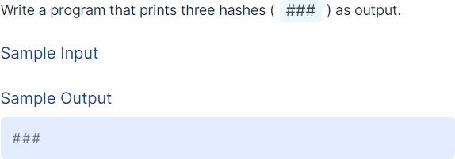

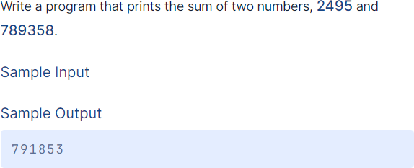

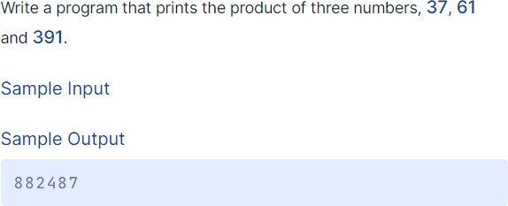

Escape Sequences
An escape sequence is a sequence of characters that, when used inside a character or string, does not represent itself but is converted into another character or series of characters

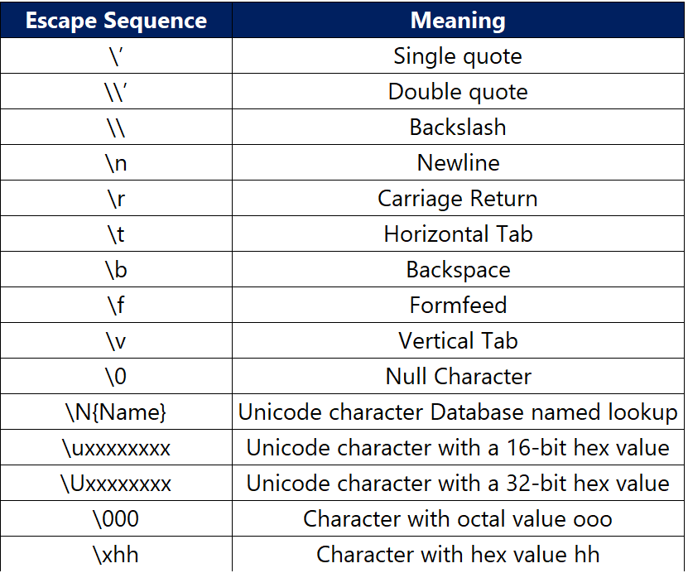
Examples
print('Who's this?')
print('Who\'s this?')
print('Interview\nBit')
print('Interview\\Bit')
print('Interview\tBit')
print('Interview \bBit')
print("\x48\x45\x4C\x4C\x4F\x20\x57\x4F\x52\x4C\x44")
print("\110\105\114\114\117\040\127\117\122\114\104")
print(r"Hello\nWorld")

Inputs and Outputs Basics

Input() function
- To get some data from the user.
- input() functionality is used to accept the data from the user
- By default, data received using input() is of string data type. It can be converted into the required data type by typecasting.
- To convey the purpose of this data input to the user, we can pass string to the input()
- Ex: a = input(‘Enter a number’)

Output()Function
- To display data to the user.
- print() functionality is used.
- We can pass any type of data to the print() function.
- We can even pass multiple data elements at once.
Ex: print(a,b)
- Parameter ‘end’ can be used to specify how the output should end.
Ex: print(‘Hello’,end=’ ’)
- Parameter ‘sep’ can be used to specify how the multiple data elements passed have to be separated with using attributes.
Ex: print(a,b,sep=’\n’)
- And we can use \n at any place in the string to break the line and start at new line
Ex: print(“Welcome to \n Python Programming Language”)

Examples for print() Function

Print("Hello Welcome")
print("Hello", "how are you?")
print("Hello", "how are you?", sep="---")
print ("This is so Important", end= "**")
print("20","05","2023",sep="-")
print("Python", end=' @ ')
print("enter your name")

Take Input From User:

input() allows flexibility to take the input from the user. Reads a line of input as a string. Code:

username = input() print(username)

Input:
Ajay

Output:
Ajay

Working with Strings

String Concatenation
Joining strings together is called string concatenation.

Code:

a = "Hello" + " " + "World" print(a)

Output:

Hello World

Concatenation Errors
String Concatenation is possible only with strings.

Code:

a = "*" + 10
print(a)

Output:
File "main.py", line 1 a = "*" + 10
^
TypeError: can only concatenate str (not "int") to str

String Repetition

* operator is used for repeating strings any number of times as required. Code:

a = "*" * 10 print(a)

Output:

**********

Code:

s = "Python"
s = ("* " * 3) + s + (" *" * 3) print(s)

Output:

* * * Python * * *

Length of String

len() returns the number of characters in a given string. Code:

username = input() length = len(username) print(length)

Input:
Ravi

Output:
4

String Indexing
We can access an individual character in a string using their positions (which start from 0) . These positions are also called as index.

Code:

username = "Ravi" first_letter = username[0] print(first_letter)

Output:
R

IndexError
Attempting to use an index that is too large will result in an error:

Code:

username = "Ravi" print(username[4])

Output:

IndexError: string index out of range

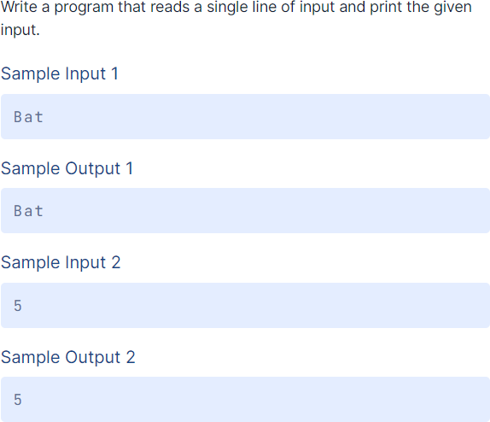

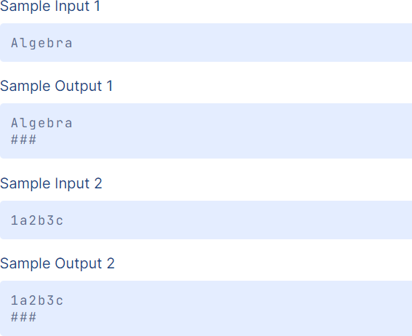

Write a program to swap two numbers:

a = 10
b = 20

temp = a
a = b
b = temp

print("After swapping:")
print("a =", a)
print("b =", b)

