SIMATS ENGINEERING
Assignment
COURSE NAME: OBJECT ORIENTED ANALYSIS AND DESIGN
COURSE CODE: CSA11
COURSE OUTCOME COVERED
CO1: Analyse the fundamentals of Object-Oriented Systems Development, including object basics, Object-Oriented Systems Development Life Cycle, Object-Oriented Methodologies, Model-Driven Development (MDD), and Agile practices.
CO2: Apply UML techniques including Use Case, Class, Interaction, State Transition, Activity, Package, Component, and Deployment Diagrams to model a software system.
CO3: Analyse objects, classes, attributes, methods, and relationships through Use Case Modelling, Object Analysis, Classification, and identification of object relationships.
Assignment Weightage: 100%
QUESTIONS: 1 Total Marks:100
Annexure A
Assignment
Code of Conduct:
I Kari Durga Mani Sankar certify that this submission is my original work and that I have adhered to the guidelines specified for this assessment.
I understand that any violation of academic integrity rules will result in disciplinary action.
Signature of the student: Kari Durga Mani Sankar

Course Code & Name

CSA11 – Object Oriented Analysis and Design

Assignment Title | Object-Oriented Analysis and UML-Based Design of an Autonomous Drone-Based Disaster Response and Rescue System (ADDRRS)
Course Outcome(s) – CO | CO1: Analyse Object-Oriented Systems Development concepts, methodologies, life cycle models, MDD, and Agile practices for developing a real-world software solution.  CO2: Apply UML modelling techniques to represent system structure, interactions, workflows, behaviour, components, and deployment architecture.  CO3: Analyse objects, classes, attributes, methods, and relationships using Use Case Modelling, Object Analysis, Classification, and relationship identification techniques.
Bloom’s Taxonomy Level | BL3 – Apply, BL4 – Analyse, BL5 – Evaluate, BL6 – Create
SDG Mapping (SDG 1–17) | SDG 3 – Good Health and Well-being  SDG 9 – Industry, Innovation and Infrastructure SDG 11 – Sustainable Cities and Communities SDG 13 – Climate Action

Problem Statement
Analyse and develop an Object-Oriented Analysis and Design model for an Autonomous Drone-Based Disaster Response and Rescue System (ADDRRS) that supports emergency teams in locating affected people, assessing disaster zones, coordinating rescue operations, and monitoring emergency situations.

The system shall allow authorized emergency personnel to register disaster incidents, define affected zones, assign drones, monitor drone status, and manage rescue missions. Autonomous drones equipped with cameras and sensors shall collect information about disaster locations and transmit images, videos, environmental readings, and location information to the central command system.

The system shall maintain information about drones, operators, rescue missions, disaster zones, victims, emergency teams, sensor data, alerts, and resources. The system shall support route planning, mission assignment, real-time drone monitoring, emergency notifications, and mission completion reporting.

Working from this scenario, students shall identify the major actors and use cases and develop Use Case, Class, Sequence, Activity, State Transition, Package, Component, and Deployment Diagrams. Students shall identify object responsibilities and evaluate suitable

design principles and patterns for achieving low coupling, high cohesion, flexibility, and maintainability.

Constraints
The design shall clearly identify the system boundary, emergency actors, autonomous components, objects, classes, attributes, methods, and relationships. All UML diagrams shall maintain consistency with the identified use cases and system behaviour.

The model shall explicitly consider real-time communication, autonomous operations, failure handling, security, reliability, scalability, and responsibility assignment. Design axioms and suitable design patterns shall be applied wherever appropriate.

The final submission shall include assumptions, constraints, traceability between use cases and classes, and justification for major design decisions.

Tools Can Be Used

- StarUML
- Visual Paradigm
- Draw.io
- PlantUML
- Papyrus Tools
- ArgoUML
- Enterprise Architect
- Lucidchart

Assessment Rubrics
Criteria (CO Mapping) | Max Marks | Excellent | Good | Satisfactory | Needs Improvement
Problem Understanding, Object Identification & Requirements Analysis (CO1) | 10 | Clearly analyses the problem domain and accurately identifies all major actors, objects, system responsibilities, and requirements from the given scenario. | Identifies most actors, objects, and requirements with minor gaps or inaccuracies. | Identifies basic actors and objects but analysis is incomplete or contains some inconsistencies. | Poor understanding of the problem; major actors, objects, and requirements are missing or incorrectly identified.
Use Case Modelling & Actor Identification (CO2) | 10 | Correctly identifies all relevant actors and use cases; Use Case Diagram clearly represents system boundary, relationships, and interactions. | Most actors and use cases are correctly identified with minor modelling errors. | Basic actors and use cases are identified, but relationships or system boundary need improvement. | Actors and use cases are poorly identified; diagram is incomplete or inconsistent.
Class Identification, | 15 | Classes, attributes, methods, associations, | Class structure is mostly | Basic classes and | Classes, attributes,

Attributes, Methods & Relationships (CO2/CO3) |  | aggregation/composition, inheritance, and dependencies are accurately identified and logically justified. | correct with minor errors in attributes, methods, or relationships. | relationships are identified but lack detail or contain  several modelling issues. | methods, or relationships are missing, inappropriate, or poorly structured.
UML  Behavioural & Interaction Modelling (CO2) | 15 | Sequence, Activity, and State Transition Diagrams accurately represent system behaviour and are fully consistent with the identified use cases and classes. | Behavioural diagrams are mostly correct with minor inconsistencies. | Basic  behavioural diagrams are provided but some interactions, activities, or states are incomplete. | Behavioural diagrams are missing, unclear, or inconsistent with the proposed system.
UML  Architectural Modelling & Design Evaluation (CO3) | 15 | Package, Component, and Deployment Diagrams clearly represent modular structure, system components, dependencies, and deployment environment with strong justification. | Architectural diagrams are mostly correct with minor omissions or modelling errors. | Basic  architectural representation is provided but lacks clarity or sufficient justification. | Architectural diagrams are incomplete, inappropriate, or inconsistent with the system design.
Object Responsibilities, Design Principles, Axioms & Patterns (CO3) | 15 | Responsibilities are appropriately assigned; design axioms, cohesion, coupling, encapsulation, abstraction, and suitable design patterns are clearly justified and effectively applied. | Design principles and patterns are appropriately applied with minor limitations in justification. | Some design principles are identified, but application or justification is limited. | Design principles, axioms, responsibilities, or patterns are absent or incorrectly applied.
Consistency, Traceability & Overall Design Quality (CO3) | 10 | All UML models are mutually consistent, requirements are traceable to use cases/classes, and the overall design is complete, feasible, scalable, and maintainable. | Design is largely consistent and traceable with minor gaps. | Some consistency and traceability are demonstrated, but important links are missing. | Major inconsistencies exist between requirements, use cases, classes, and UML diagrams.
Reflection, SDG Relevance & Learning Outcomes | 10 | Provides insightful reflection on design decisions, challenges,  OOAD concepts learned, | Provides good reflection with reasonable connection to | Reflection is present but generic with limited | Reflection is missing, superficial, or unrelated to the

 |  | and clearly establishes the relevance of the selected SDGs. | design decisions and SDGs. | discussion of learning and SDG relevance. | assignment and SDGs.
Total | 100

Table of Contents
Table of Contents 1
1. Problem Analysis and Requirement Summary 1
1.1 Functional Requirements (derived from the scenario) 1
1.2 Non-Functional Requirements 1
1.3 Requirement Analysis Summary 1
2. Actor Identification 1
3. Use Case Descriptions 1
3.1 Fully-Dressed Use Case: Register Disaster Incident 1
3.2 Fully-Dressed Use Case: Assign Drone to Mission 1
3.3 Fully-Dressed Use Case: Detect Victim / Generate Alert 1
3.4 Fully-Dressed Use Case: Handle Drone Failure / Fallback 1
3.5 Remaining Use Cases (Brief Descriptions) 1
4. Use Case Diagram 1
5. Object and Class Identification 1
6. Class Diagram 1
6.1 Core Domain: Users, Incidents, Missions, Drones 1
6.2 Sensing, Detection and Alerting Subsystem 1
7. Sequence / Interaction Diagram 1
8. Activity Diagram 1
9. State Transition Diagram 1
10. Package Diagram 1
11. Component Diagram 1
12. Deployment Diagram 1
13. Object Responsibility Analysis 1
14. Design Axioms, Principles and Design Pattern Justification 1
14.1 Design Axioms Applied 1
14.2 Design Principles 1
14.3 Design Patterns Justified 1
15. Assumptions and Constraints 1
15.1 Assumptions 1
15.2 Constraints 1
16. Requirement-to-Use Case/Class Traceability 1
17. Implementation / Prototype and Results 1
18. Reflection on Design Decisions and Learning Outcomes 1
18.1 SDG Relevance 1
19. GitHub Upload 1

1. Problem Analysis and Requirement Summary
The Autonomous Drone-Based Disaster Response and Rescue System (ADDRRS) is a software-controlled, real-time coordination platform that lets authorised emergency personnel manage the full lifecycle of a disaster response: reporting an incident, defining the affected geographic zone, dispatching autonomous drones equipped with cameras and environmental sensors, monitoring those drones in real time, detecting victims and hazards, coordinating rescue teams, and producing a final mission report.
The problem domain combines four concerns that any OOAD solution must reconcile: (a) human coordination — administrators, operators and rescue teams working from a shared operational picture; (b) autonomous hardware — drones that must fly, sense, self-diagnose and fail safely without a human in the loop at every step; (c) real-time data — continuous telemetry and sensor streams that must be processed and acted upon quickly; and (d) mission-critical reliability — the system must keep functioning (or fail gracefully) even when a drone loses connectivity or a sensor malfunctions, because lives may depend on it.

1.1 Functional Requirements (derived from the scenario)
- FR1: Authorised personnel shall be able to register a disaster incident with type, severity and location.
- FR2: The system shall allow an affected zone/geofence to be defined for an incident.
- FR3: Operators shall be able to assign one or more drones to a rescue mission and plan a route.
- FR4: Drones shall autonomously navigate, capture images/video/environmental readings, and transmit them to the command centre.
- FR5: The system shall monitor drone status (battery, location, health) in real time.
- FR6: The system shall detect victims/hazards from transmitted data and generate alerts.
- FR7: Alerts shall be routed to the relevant rescue team for coordination and acknowledgement.
- FR8: The system shall track and allocate resources (personnel, vehicles, medical kits) to missions.
- FR9: The system shall handle drone failure through fail-safe behaviour (return-to-home / backup drone reassignment).
- FR10: The system shall generate a mission-completion report once a mission ends.

1.2 Non-Functional Requirements
- Real-time responsiveness for telemetry, alerts and video/sensor streaming.
- High availability and fault tolerance for autonomous operation and communication loss.
- Security: authenticated, role-based access; encrypted drone-to-ground communication.
- Scalability to support many concurrent drones, missions and zones.
- Maintainability and extensibility (new sensor types, new drone models, new alert rules).

1.3 Requirement Analysis Summary
Read as an object model, the scenario is naturally decomposed into: people who use the system (Emergency Admin, Drone Operator, Rescue Team Member), the emergency domain (DisasterIncident, DisasterZone, Victim, Alert), the mission domain (RescueMission, Route, Resource), and the autonomous-hardware domain (Drone, Sensor, SensorData, CommandControlCenter). This grouping directly informs the actor list, use cases and class model developed in the following sections.

2. Actor Identification
Actors were identified by asking, for each sentence of the problem statement, "who or what initiates or receives a system interaction?". This produced three human actors, two system/hardware actors, and one external service actor.
Actor | Type | Description / Role in the System
Emergency Admin | Primary (Human) | Registers incidents, defines disaster zones, manages resources and oversees overall response.
Drone Operator | Primary (Human) | Assigns drones to missions, plans routes, monitors live drone status, handles fail-safe actions.
Rescue Team Member | Primary (Human) | Receives alerts, coordinates ground rescue, updates mission status, views mission reports.
Autonomous Drone | Primary (System/Hardware) | Captures sensor data, navigates autonomously, transmits data, reports its own failures.
Command & Control Centre | Supporting (System) | Aggregates drone telemetry, runs detection logic, dispatches alerts, archives missions.
Weather / GIS Service | Supporting (External System) | Supplies terrain, weather and geospatial data used during route planning.
Emergency Admin, Drone Operator and Rescue Team Member all specialise a common User actor archetype (they authenticate the same way and share basic profile behaviour), which is reflected later as class inheritance from an abstract User class.

3. Use Case Descriptions
Fourteen use cases were identified. The four most critical are documented in full below; the remainder are summarised in the accompanying table.
3.1 Fully-Dressed Use Case: Register Disaster Incident
Field | Description
Use Case ID / Name | UC-01 / Register Disaster Incident
Primary Actor | Emergency Admin
Preconditions | Admin is authenticated and authorised.
Trigger | Admin receives a report of a disaster event.
Main Flow | 1. Admin logs in. 2. Admin selects "New Incident". 3. Admin enters type, severity, location and description. 4. System validates and stores the incident. 5. System prompts Admin to define the affected zone (UC-02).
Alternate Flow | 3a. Incomplete data → system flags missing fields and asks Admin to correct them.
Postconditions | A new DisasterIncident record exists with status = "Open".

3.2 Fully-Dressed Use Case: Assign Drone to Mission
Field | Description
Use Case ID / Name | UC-03 / Assign Drone to Mission
Primary Actor | Drone Operator
Preconditions | An open incident and defined zone exist; at least one drone is available.
Trigger | Operator decides to dispatch a drone to a zone.
Main Flow | 1. Operator selects zone and mission. 2. System lists available drones (battery, range, sensor fit). 3. Operator selects a drone. 4. System (via <<include>> Plan Route) calculates an optimal route considering zone geometry and weather. 5. Operator confirms; drone is launched.
Alternate Flow | 2a. No drone available → system notifies Operator and suggests queuing the mission. 4a. Route blocked by no-fly zone/weather → system recalculates or flags manual override.
Postconditions | RescueMission is created with status "In Progress" and an assigned Drone and Route.

3.3 Fully-Dressed Use Case: Detect Victim / Generate Alert
Field | Description
Use Case ID / Name | UC-07 / Detect Victim / Generate Alert
Primary Actor | Autonomous Drone (system actor); Command & Control Centre
Preconditions | Drone is airborne and actively scanning a zone.
Trigger | Sensor captures data that is transmitted to the command centre.
Main Flow | 1. Drone captures image/video/environmental reading. 2. Drone transmits SensorData. 3. Command Centre analyses the data. 4. If a victim/hazard is detected, an Alert is generated (<<include>> Send Emergency Notification). 5. Alert is routed to the nearest available Rescue Team.
Alternate Flow | 3a. No detection → drone continues scanning (<<extend>> Coordinate Rescue Team is skipped).
Postconditions | A Victim record and an Alert exist; the Rescue Team has been notified.

3.4 Fully-Dressed Use Case: Handle Drone Failure / Fallback
Field | Description
Use Case ID / Name | UC-12 / Handle Drone Failure / Fallback
Primary Actor | Autonomous Drone; Drone Operator
Preconditions | Drone is airborne and part of an active mission.
Trigger | Onboard diagnostics detect a fault (battery, sensor, communication) or connection is lost.
Main Flow | 1. Drone detects fault and reports it (if link available). 2. System triggers fail-safe: return-to-home or reassignment of a backup drone. 3. Operator is alerted and may override. 4. Mission continues with backup drone or is marked incomplete.
Alternate Flow | 1a. Total loss of communication → system assumes failure after timeout and auto-triggers return-to-home / backup dispatch.
Postconditions | Drone status = "Failed"/"Returning"; mission continuity is preserved where possible.

3.5 Remaining Use Cases (Brief Descriptions)
ID | Use Case | Brief Description
UC-02 | Define Affected Zone | Admin draws/enters a geofenced disaster zone linked to an incident.
UC-04 | Plan Route | System calculates an optimised flight path for a mission (included by UC-03).
UC-05 | Monitor Drone Status | Operator/Command Centre view real-time telemetry of active drones.
UC-06 | Capture & Transmit Sensor Data | Drone captures and streams camera/sensor data to the centre.
UC-08 | Coordinate Rescue Team | Rescue members plan and log ground response actions (extends UC-07).
UC-09 | Send Emergency Notification | Push notification/alert delivered to relevant personnel.
UC-10 | Manage Resources | Admin allocates/releases personnel, vehicles and supplies.
UC-11 | Generate Mission Completion Report | Rescue Team/Operator closes a mission and system compiles a report.
UC-13 | Authenticate User | Common login/role-check used by all human actors.
UC-14 | View Live Feed | Operator/Rescue Team view a drone's live video/telemetry feed.

4. Use Case Diagram
The diagram below shows the system boundary, the three human actors, the two system actors (Autonomous Drone and Command & Control Centre), the supporting external Weather/GIS service, and the fourteen use cases with their include/extend relationships.
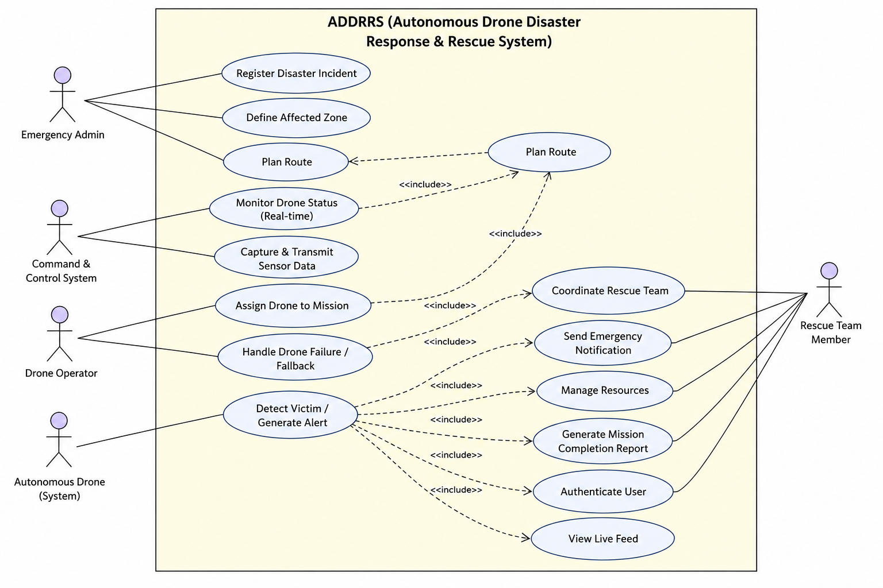
Figure 1: Use Case Diagram — ADDRRS

5. Object and Class Identification
Candidate classes were identified using noun-phrase analysis of the problem statement combined with CRC (Class-Responsibility-Collaborator) reasoning, then filtered to remove duplicates, attributes-in-disguise, and out-of-scope nouns (e.g. "team" alone was rejected in favour of the more precise RescueTeamMember).
Class | Category | Justification
User (abstract) | Actor/Entity | Common authentication & profile behaviour shared by all human roles.
EmergencyAdmin | Entity | Specialised user who registers incidents and manages resources.
DroneOperator | Entity | Specialised user who assigns drones and plans routes.
RescueTeamMember | Entity | Specialised user who receives alerts and coordinates ground rescue.
DisasterIncident | Entity | Core record of a reported disaster event.
DisasterZone | Entity | Geofenced area associated with an incident.
RescueMission | Entity/Control | Coordinates the assignment of a drone and route to respond to an incident.
Drone | Entity | Autonomous hardware asset central to the domain.
Route | Entity | Planned flight path for a mission.
Sensor (abstract), Camera, EnvironmentalSensor | Entity | Represents onboard sensing hardware and its specialisations.
SensorData | Entity | Captured reading/media transmitted from a drone.
Victim | Entity | Person identified from sensor data requiring rescue.
Alert | Entity/Control | Notification artefact raised on detection.
Resource | Entity | Personnel/vehicles/supplies consumed by a mission.
CommandControlCenter | Control/Boundary | Coordinates monitoring, detection dispatch and archiving.
Rejected candidates included "Report" (modelled as a method/behaviour of RescueMission rather than a separate persistent class, since it is a derived view), "Location" (modelled as the GeoPoint/GeoPolygon value types used as attributes, not as independent classes), and "Team" (too vague; refined to RescueTeamMember).

6. Class Diagram
For clarity the class model is presented as two linked diagrams: the core mission/incident model, and the sensor/detection/alert subsystem. Both diagrams share the Drone class, which is the connecting point between mission assignment and autonomous sensing.

6.1 Core Domain: Users, Incidents, Missions, Drones
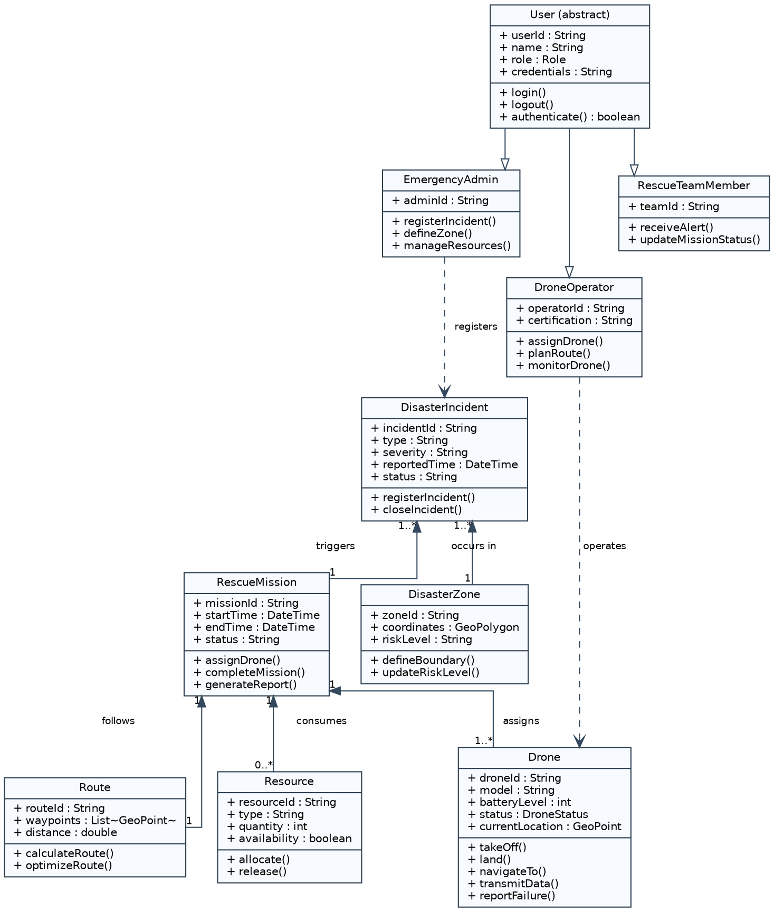
Figure 2a: Class Diagram — Core Mission and Incident Domain

6.2 Sensing, Detection and Alerting Subsystem
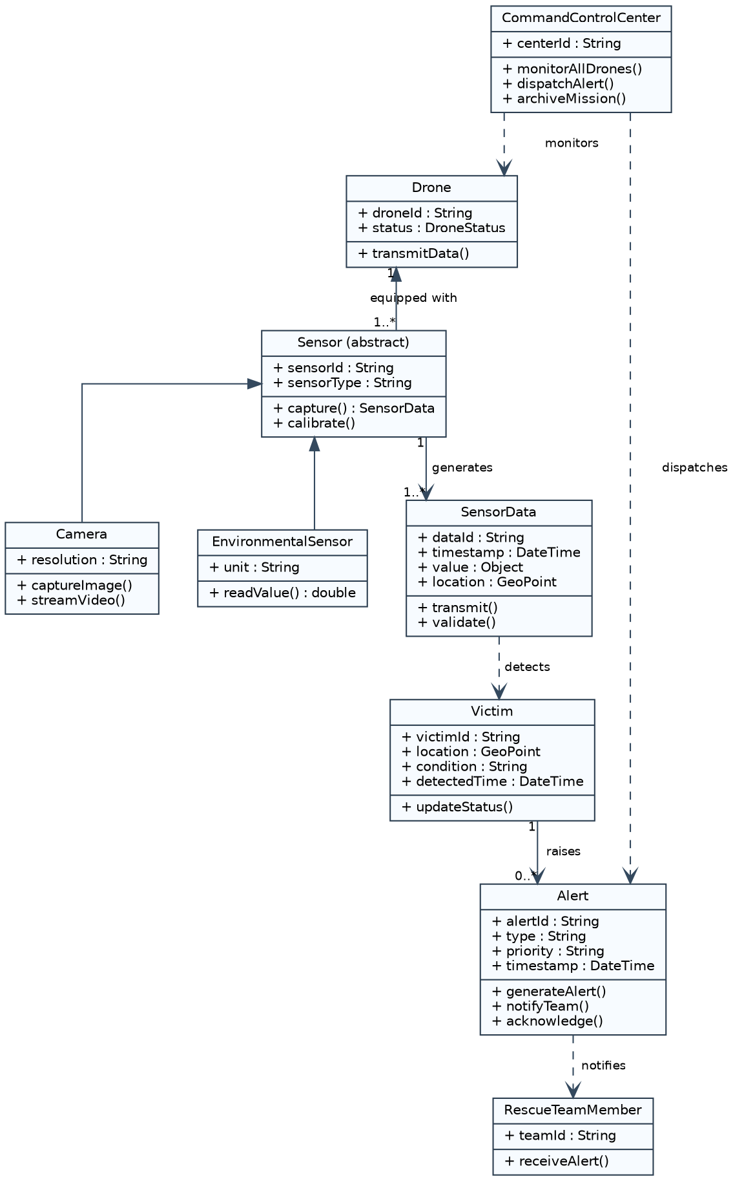
Figure 2b: Class Diagram — Sensor, Victim Detection and Alert Subsystem
Key relationships: User is generalised by EmergencyAdmin, DroneOperator and RescueTeamMember (inheritance). DisasterIncident aggregates one-or-more DisasterZone and triggers one-or-more RescueMission (aggregation, since a zone can outlive a specific mission). RescueMission is composed of a Route and consumes zero-or-more Resource records (composition, since a mission's own route has no meaning outside that mission). A Drone is composed of one-or-more Sensor instances, each of which generates SensorData; SensorData that indicates a person is used to create a Victim, which raises an Alert that notifies a RescueTeamMember.

7. Sequence / Interaction Diagram
The sequence diagram below traces the "Detect Victim / Generate Alert" scenario (UC-07), which is the most behaviourally complex and safety-relevant flow in the system, spanning the Drone, Sensor, Command & Control Centre, RescueMission, Alert and RescueTeamMember objects.
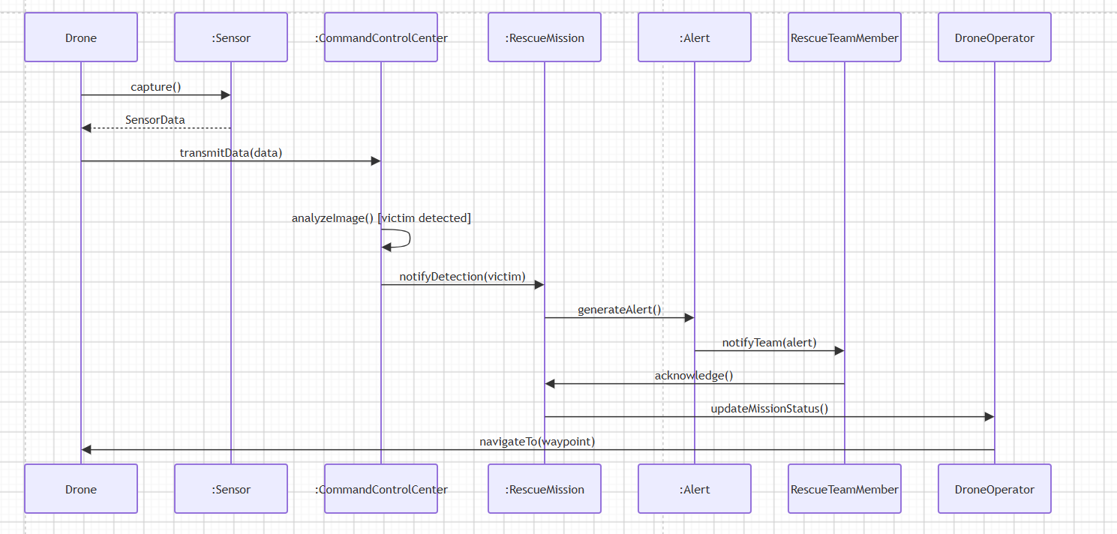
Figure 3: Sequence Diagram — Victim Detection and Alert Notification
A second, shorter interaction (Assign Drone to Mission, UC-03) follows the pattern: DroneOperator → RescueMission: assignDrone(droneId) → RescueMission → Route: calculateRoute() → Route → Drone: navigateTo(route) → Drone → CommandControlCenter: reportStatus("EnRoute"). This is omitted as a full diagram for brevity but follows directly from the class collaborations shown in Figure 2a.

8. Activity Diagram
The activity diagram models the end-to-end operational workflow of a single drone mission, from incident registration through autonomous scanning, victim detection, failure handling, and mission completion reporting.
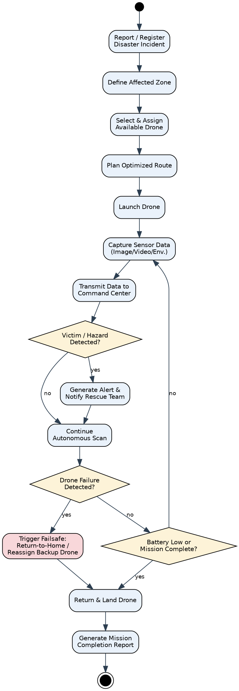
Figure 4: Activity Diagram — End-to-End Drone Mission Workflow

9. State Transition Diagram
The Drone class exhibits the richest lifecycle in the system and is therefore chosen as the subject of the state machine: it must correctly move between idle, active, scanning, transmitting, failure and recovery states.
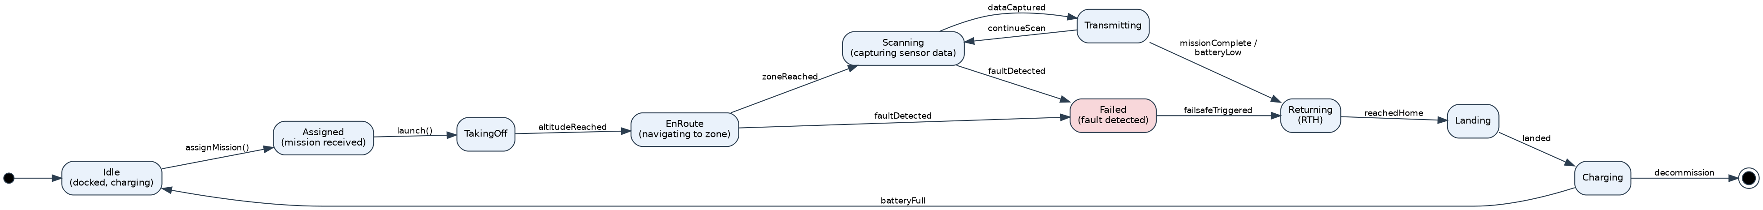
Figure 5: State Transition Diagram — Drone Object Lifecycle

10. Package Diagram
The system is decomposed into ten packages reflecting a layered, feature-oriented architecture. The Presentation layer depends downward on feature packages, which in turn depend on a shared Data Persistence package, keeping dependencies acyclic.
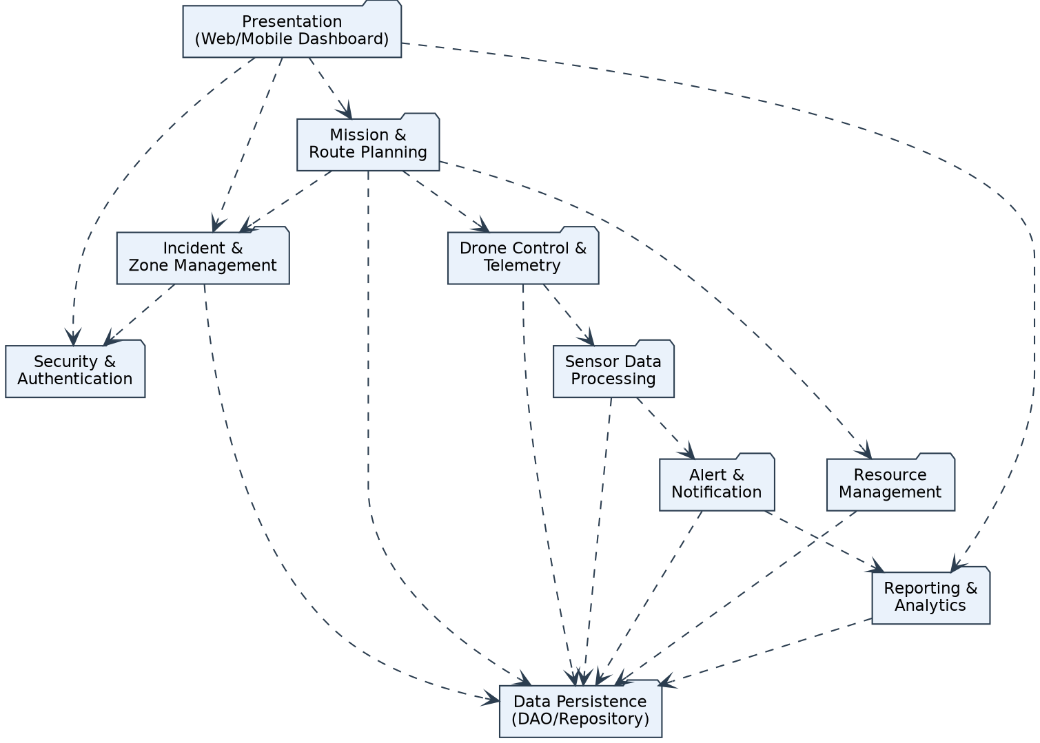
Figure 6: Package Diagram — ADDRRS Module Structure

11. Component Diagram
At the component level, the packages of Figure 6 are realised as independently deployable services communicating over REST, gRPC/MQTT and a publish/subscribe message broker, so that the high-volume drone telemetry path is decoupled from the interactive dashboard path.
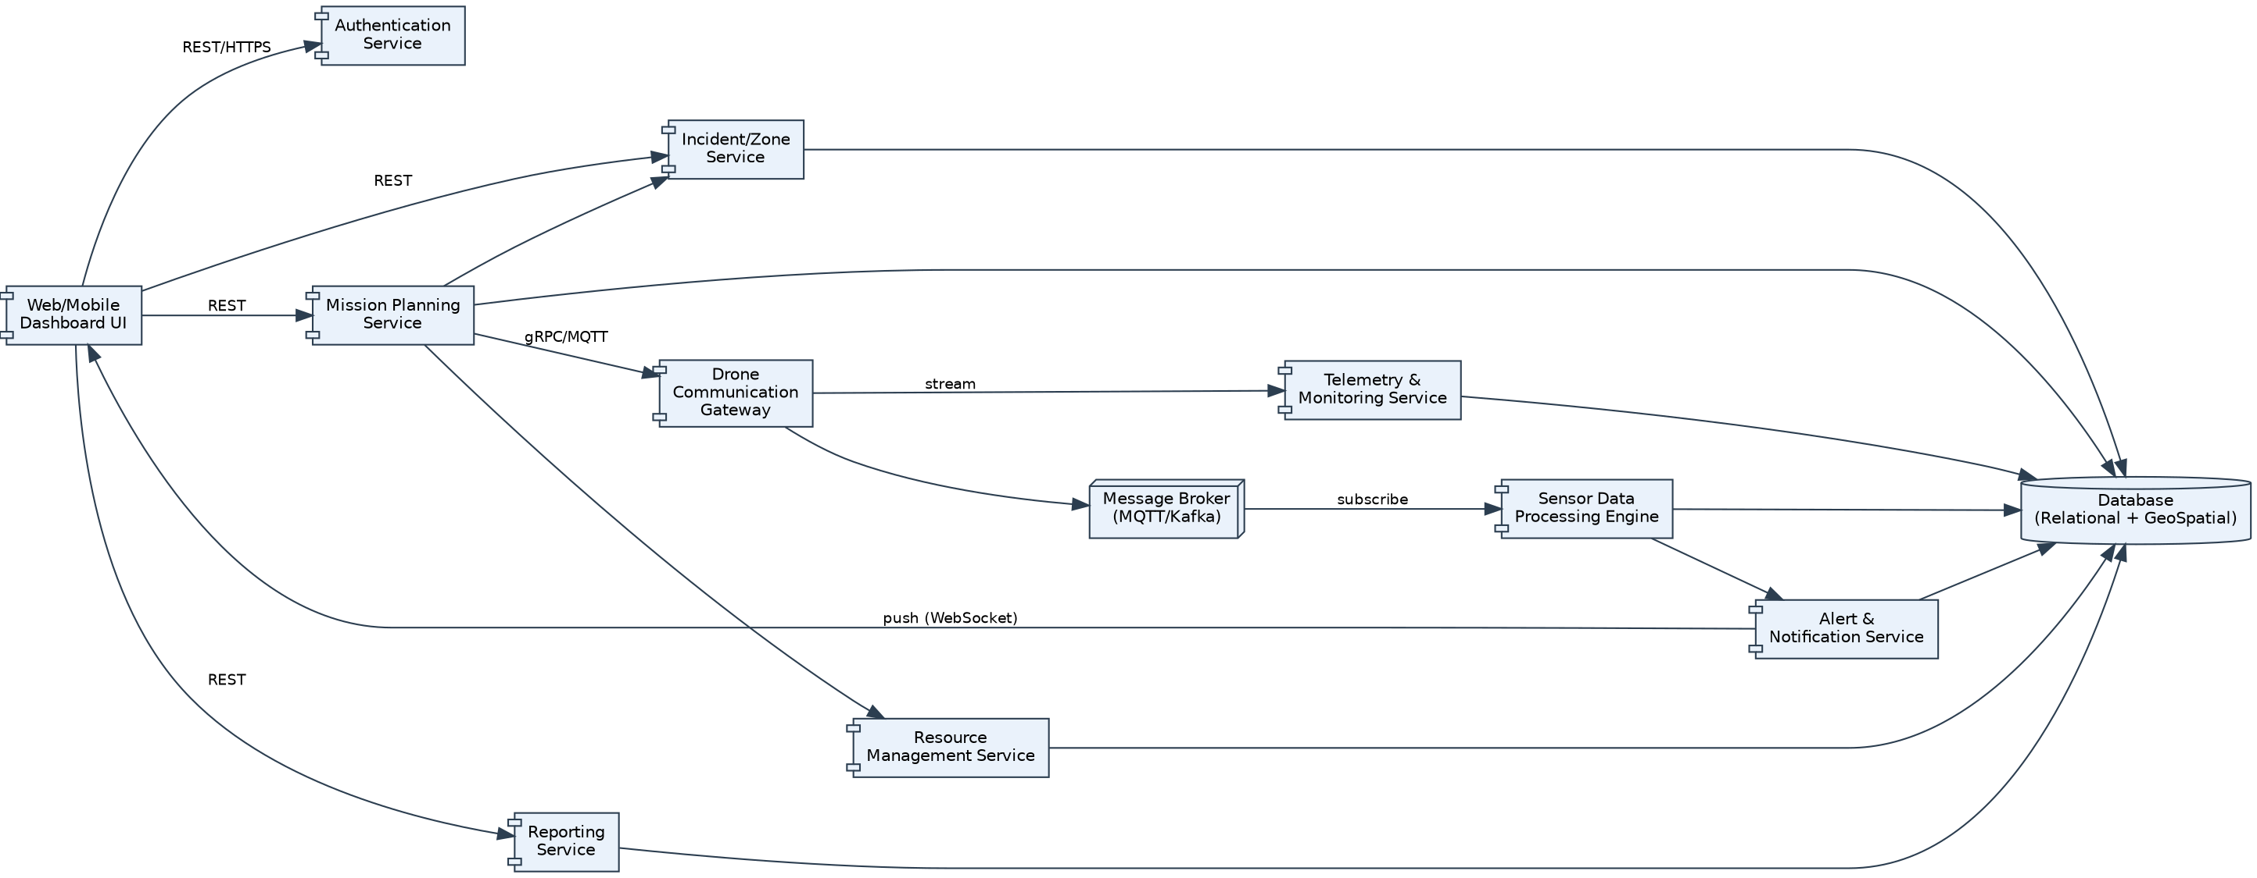
Figure 7: Component Diagram — Service-Level Architecture

12. Deployment Diagram
The deployment view separates four physical/logical nodes: the Drone Unit (embedded flight controller and sensor module), Ground Control (field operator device with an RF telemetry link to the drone), the Cloud/Data-Centre execution environment (API gateway, microservice cluster, message broker and database), and Client Devices (admin browser and rescue team mobile app).
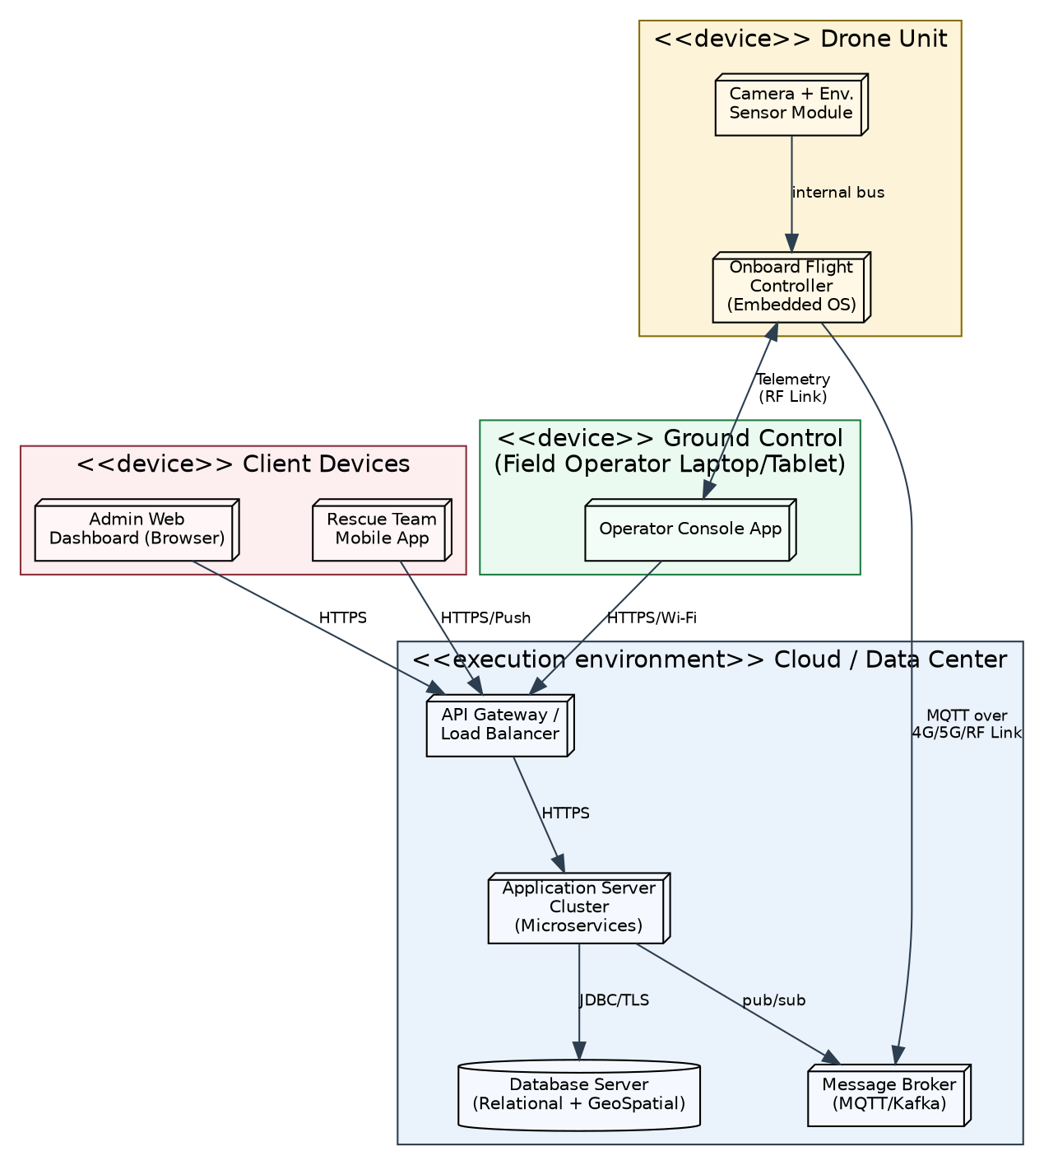
Figure 8: Deployment Diagram — Physical Architecture

13. Object Responsibility Analysis
Responsibilities were assigned using CRC-style reasoning so that each class has a single, cohesive purpose and collaborates with, rather than duplicates, the behaviour of others.
Class | Key Responsibilities | Collaborators
RescueMission | Owns mission lifecycle: assigning a drone, tracking status, completing the mission, requesting a report. | Drone, Route, Resource, DisasterIncident
Drone | Knows and reports its own state (location, battery, health); executes navigation and data transmission commands. | Sensor, Route, CommandControlCenter
Sensor / SensorData | Captures raw readings and packages them with timestamp/location for transmission; validates data integrity. | Drone, CommandControlCenter
CommandControlCenter | Aggregates telemetry from many drones; runs/coordinates detection analytics; dispatches alerts; archives completed missions. | Drone, Alert, RescueMission
Alert | Encapsulates notification content, priority and acknowledgement state; knows how to notify its recipients. | Victim, RescueTeamMember
Resource | Tracks its own availability and allocation state. | RescueMission
This distribution follows the Single Responsibility Principle: RescueMission coordinates but does not itself fly a drone or generate sensor data; Drone knows about flight and its own sensors but not about business rules for victim detection, which are the responsibility of the CommandControlCenter's analytics collaboration.

14. Design Axioms, Principles and Design Pattern Justification

14.1 Design Axioms Applied
- Axiom 1 — Independence of Functional Requirements: each package in Figure 6 addresses one functional concern (incident management, mission planning, drone control, sensing, alerting) so that a change to alerting rules does not ripple into route planning.
- Axiom 2 — Minimisation of Information Content: classes expose the minimum interface needed for collaboration (e.g. Drone exposes navigateTo()/transmitData() rather than exposing its internal flight-control state to other objects).

14.2 Design Principles
- High Cohesion: RescueMission, Drone and Alert each group tightly related data and behaviour.
- Low Coupling: DroneOperator interacts with Drone only through RescueMission/Route abstractions, not directly with low-level flight controls.
- Encapsulation: internal telemetry buffers and sensor calibration state are private to Drone/Sensor and accessed only via public operations.
- Abstraction: the abstract User and Sensor classes let new roles (e.g. a future "Medical Coordinator") or sensor types (e.g. thermal imaging) be added without touching existing collaborators.

14.3 Design Patterns Justified
Pattern | Applied To | Justification
Observer | CommandControlCenter notifying dashboards and RescueTeamMembers of new Alerts | Multiple, dynamically-changing subscribers (dashboard, mobile app) need to react to alert events without the Alert class knowing their concrete types — supports low coupling.
Strategy | Route.calculateRoute() choosing between shortest-path, weather-avoidance or no-fly-zone-avoidance algorithms | Route-planning logic can vary independently of the RescueMission/Drone classes that use it.
State | Drone lifecycle (Idle, EnRoute, Scanning, Failed, Returning …) | Encapsulates state-dependent behaviour cleanly, matching the State Transition Diagram in Figure 5 and avoiding large conditional blocks.
Factory Method | Creating the correct Sensor subtype (Camera vs EnvironmentalSensor) when a Drone is provisioned | Decouples Drone from concrete sensor classes, supporting future sensor types (Open/Closed Principle).
Facade | CommandControlCenter as a simplified interface over telemetry, detection and archiving subsystems | Presentation layer and mobile clients interact with one coherent interface instead of many fine-grained services.

15. Assumptions and Constraints

15.1 Assumptions
- Drones have onboard autonomy sufficient for navigation and basic obstacle avoidance; the system issues waypoints rather than manual flight control.
- A reliable (if intermittent) communication link (cellular/RF) exists between drones and the ground segment; total blackout is treated as an exception (UC-12).
- Victim detection uses either onboard/edge inference or server-side image analytics; the specific ML model is out of scope for this OOAD exercise.
- All human actors are pre-registered and issued credentials by a system administrator; self-registration is out of scope.
- One drone is assigned to at most one active mission at a time; multi-drone swarming for a single mission is a future extension.

15.2 Constraints
- The design must clearly separate system boundary, actors and autonomous components (addressed by the Use Case and Deployment Diagrams).
- All diagrams must remain mutually consistent with the identified use cases (addressed by the traceability matrix in Section 16).
- Real-time communication, failure handling, security and scalability must be explicitly modelled (addressed respectively by the Sequence Diagram, State Diagram/UC-12, the Security & Authentication package, and the layered Component/Deployment views).
- Only the specified UML toolchain concepts (Use Case, Class, Interaction, State, Activity, Package, Component, Deployment) are used; no implementation-specific detail beyond what is needed to justify the design is included.

16. Requirement-to-Use Case/Class Traceability
The matrix below demonstrates that every functional requirement identified in Section 1 is realised by at least one use case and grounded in at least one concrete class, ensuring the models are consistent rather than independently invented.
Req. | Use Case(s) | Primary Class(es)
FR1 | UC-01 Register Disaster Incident | DisasterIncident, EmergencyAdmin
FR2 | UC-02 Define Affected Zone | DisasterZone
FR3 | UC-03 Assign Drone to Mission, UC-04 Plan Route | RescueMission, Drone, Route, DroneOperator
FR4 | UC-06 Capture & Transmit Sensor Data | Sensor, Camera, EnvironmentalSensor, SensorData, Drone
FR5 | UC-05 Monitor Drone Status, UC-14 View Live Feed | Drone, CommandControlCenter
FR6 | UC-07 Detect Victim / Generate Alert | SensorData, Victim, Alert, CommandControlCenter
FR7 | UC-08 Coordinate Rescue Team, UC-09 Send Emergency Notification | Alert, RescueTeamMember
FR8 | UC-10 Manage Resources | Resource, EmergencyAdmin
FR9 | UC-12 Handle Drone Failure / Fallback | Drone (State Diagram), RescueMission
FR10 | UC-11 Generate Mission Completion Report | RescueMission

17. Implementation / Prototype and Results
A full working implementation is outside the scope of this design exercise; however, the design is directly implementable. A minimal prototype would realise the model as follows:
- Backend: microservices per package (Section 10) implemented in a language such as Java/Spring Boot or Node.js/Express, one service per bounded context (Incident, Mission, Drone Gateway, Sensor Processing, Alert).
- Persistence: a relational database (e.g. PostgreSQL with PostGIS) for incidents, zones, missions and resources; a time-series or document store for high-volume SensorData/telemetry.
- Messaging: MQTT or Kafka topics for drone telemetry and sensor-data ingestion, matching the publish/subscribe link shown in the Component Diagram.
- Frontend: a role-based web dashboard (Admin/Operator) and a lightweight mobile app (Rescue Team) consuming the REST/WebSocket APIs shown in Figure 7.
- Expected results: given the class and interaction design, a proof-of-concept can demonstrate incident → mission → simulated telemetry → detected "victim" → alert → acknowledgement end-to-end using mocked drone hardware, validating that the object collaborations in Figures 2a/2b and 3 are sufficient to satisfy FR1–FR10.
Students completing an implementable prototype should place source code, a README describing how to run it, and any test evidence in the project repository referenced in Section 19.

18. Reflection on Design Decisions and Learning Outcomes
Modelling ADDRRS clarified why Object-Oriented Analysis and Design separates concerns before any code is written: the hardest part of this system is not any single algorithm but the coordination between autonomous, intermittently-connected hardware and time-critical human decision-making. Working through CRC-style responsibility assignment made it clear that RescueMission had to be a first-class coordinating object rather than just a foreign key linking a Drone to an Incident — without it, failure handling and reporting responsibilities would have leaked into the Drone class and violated cohesion.
The State Transition Diagram was the most valuable artefact for this domain: because a drone's correct behaviour depends entirely on "what state am I in", modelling the lifecycle explicitly (rather than inferring it from scattered boolean flags) directly justified adopting the State design pattern. Similarly, drawing the Deployment Diagram surfaced a constraint that was only implicit in the problem statement — that drone-to-ground communication is a separate, lossy channel from ground-to-cloud communication — which in turn justified the fail-safe use case (UC-12) and the State Diagram's Failed/Returning states.
On design axioms: keeping functional independence between packages (Axiom 1) initially seemed like over-engineering for a class assignment, but it directly simplified the traceability matrix in Section 16, since each requirement could be pointed at a small, clearly bounded set of classes rather than scattered responsibilities.

18.1 SDG Relevance
- SDG 3 (Good Health and Well-being): faster victim detection and rescue coordination directly reduces casualty and response-time risk in disasters.
- SDG 9 (Industry, Innovation and Infrastructure): the system demonstrates applied autonomous-systems and real-time-data infrastructure for public safety.
- SDG 11 (Sustainable Cities and Communities): supports resilient emergency-response infrastructure for urban and regional disaster management.
- SDG 13 (Climate Action): climate-linked disasters (floods, wildfires, storms) are exactly the incident types ADDRRS is designed to respond to, supporting adaptive disaster-response capacity.

19. GitHub Upload
https://github.com/durga1610/CSA1109-OOAD

