**Taxation**

Modern economics defines tax as a mode of income redistribution. The usual meaning of tax people think is that a tax is imposed by the government to fulfil its important obligations on the expenditure front.

***Impact of Tax***

The term impact is used to express the immediate result of or original imposition of the tax. The impact of a tax is on the person on whom it is imposed first.

***Incidence of Tax***

The term incidence refers to the location of the ultimate or the direct money burden of the tax as such. It signifies the settlement of the tax burden on the ultimate tax payer.

***Direct Tax***

The tax which has incidence and impact both at the same point is the direct tax—the person who is hit, the same person bleeds. As for example income tax, interest tax, etc.

***Indirect Tax***

The tax which has incidence and impact at the different points is the indirect tax—the person who is hit does not bleed, someone else bleeds. As, for example, excise, sales tax, etc which are imposed on either producers or the traders, but it is the general consumers who bear the burden of tax.

***Tax Base***

Tax base is the legal description of the object with reference to which the tax is payable. E.g. base of excise duty is production of commodities. Base of income tax is the income of the individuals.

***Tax Buoyancy***

* Tax buoyancy is one of the key indicators to assess the efficiency of a government’s tax system.
* Generally, as the economy achieves faster growth, the tax revenue of the government also goes up.
* Tax buoyancy explains this relationship between the changes in government’s tax revenue growth and the changes in GDP.
* In other words, it measures the responsiveness of tax mobilisation to economic growth.

Here the change in the tax revenue can be for two reasons. One is due to automatic increase and another one is due to discretionary changes in the tax rate or coverage or both.

**METHODS OF TAXATION**

There are three methods of taxation prevalent in economies with their individual merits and demerits

* 1. ***Progressive Taxation***
  2. This method has increasing rates of tax for increasing value or volume on which the tax is being imposed.
  3. Indian income tax is a typical example of it. The idea here is less tax on the people who earn less and higher tax on the people who earn more—classifying income earners into different slabs.
  4. This method is believed to discourage more earnings by the individual to support low growth and development unintentionally. Being poor is rewarded while richness is punished. Tax payers also start evading tax by showing lower unreal income.
  5. But from different angles this tax is pro-poor and taxes people according to their affordability/ sustainability. This is the most popular taxation method in the world and a populist one, too.

* 1. ***Regressive Taxation***
  + This is just opposite to the progressive method having decreasing rates of tax for increasing value or volume on which the tax is being imposed.
  + There are not any permanent or specific sectors for such taxes. As a provision of promotion, some sectors might be imposed with regressive taxes. As for example, to promote the growth and development of the small scale industries, India at one time had regressive excise duty on their productions.
  + This method while appreciated for rewarding the higher producers or income-earners, is criticised for being more taxing on the poor and low-producers. This is not a popular mode of taxation and not as per the spirit of the modern democracies.

* 1. ***Proportional Taxation***
* In such taxation method, there is neither progression nor regression from the rate of taxes point of view. Such taxes have fixed rates for every level of income or production, they are neutral from the poor or rich point view or from the levels of production point of view.
* Usually, this is not used by the economies as an independent method of taxation. Generally, this mode is used as a complementary method with either progressive or regressive taxation.
* If not converted into proportional taxes, every progressive tax will go on increasing and similarly every regressive tax will decrease to zero, becoming completely a futile tax methods. That is why every tax, be it progressive or regressive in nature, must be converted into proportional taxes after a certain level.

***Direct taxes:***

1. On income: Income tax, Corporation tax and MAT(zero profit companies, book profits), Dividend distribution tax (by the company on shares purchased, source), capital gains tax (at buyer, destination~~), interest tax (on banks)~~
2. on expenditure: ~~hotel receipt tax (now service tax), FBT (service tax), Gift tax~~
3. on assets, property, capital transactions: STT, CTT, ~~Wealth tax, Banking cash transaction tax, Estate duty~~

***Income Tax***

Income tax in India is a tax paid by individuals or entities depending on the level of earnings or gains during a financial year. The earnings may be both actual and notional. The Government of India decides the rate of income tax as well as income tax slabs on which individuals are taxed.

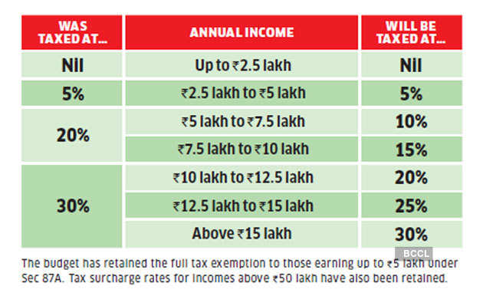

***Corporate tax***

Corporate tax is a tax imposed on the net income of the company.

The central government slashed corporate tax rates for domestic firms from 30% to 22% and for new manufacturing companies from 25% to 15% to boost economic growth.

***Minimum Alternate Tax***

At times it may happen that a taxpayer, being a company, may have generated income during the year, but by taking the advantage of various provisions of Income-tax Law (like exemptions, deductions, depreciation, etc.), it may have reduced its tax liability or may not have paid any tax at all.

Due to an increase in the number of zero tax paying companies, Minimum Alternate Tax (MAT) was introduced by the Finance Act, 1987 with effect from assessment year 1988-89. Later on, it was withdrawn by the Finance Act, 1990 and then reintroduced by Finance Act, 1996.

MAT is calculated at 18.5% on the book profit (the profit shown in the profit and loss account) or at the usual corporate rates, and whichever is higher is payable as tax.

It is applicable on all companies except those engaged in infrastructure and power sectors, free trade zones, charitable activities, venture and angel funds. Foreign companies with income sources in India also come under it.

***Dividend Distribution tax***

The Dividend Distribution Tax is a tax levied on dividends that a company pays to its shareholders out of its profits. The Dividend Distribution Tax, or DDT, is taxable at source, and is deducted at the time of the company distributing dividends.

The Union Budget 2020-21, presented by Finance Minister has brought in some major changes for investors, including the treatment of Dividend Distribution Tax (DDT). The FM in her budget speech proposed to remove DDT and adopt the classical system wherein the dividend shall be taxed in the hands of the recipients at their applicable slab rates and companies will no longer be required to pay DDT. The dividend distribution tax (DDT) has been abolished at both the company and mutual fund levels.

It will make a revenue loss to the Government as the tax will not apply now with a flat rate of 15 per cent, rather get paid as per the income slabs of the recipients. The change is estimated to entail a revenue loss of ₹25,000 crores annually.

**COMMODITIES TRANSACTION TAX (CTT)**

Only for non-agricultural commodity futures.

Commodities Transaction Tax (CTT) is a tax similar to Securities Transaction Tax (STT), levied in India, on transactions done on the domestic commodity derivatives exchanges. Globally, commodity derivatives are also considered as financial contracts. Hence CTT can also be considered as a type of ‘financial transaction tax’.

**SECURITIES TRANSACTION TAX (STT)**

The STT is a type of ‘financial transaction tax’ levied in India on transactions done on the domestic stock exchanges.

The rates of STT are prescribed by the Central government through its Budget from time to time. In tax parlance, this is categorised as a direct tax.

**CAPITAL GAINS TAX**

This is a direct tax and applies on the sales of all ‘assets’ if a profit (gain) has been made by the owner of the asset – a tax on the ‘gains’ one gets by selling assets. The tax has been classified into two –

* + Short Term Capital Gain (STCG): It applies ‘if the Asset has been sold within 36 months of owning it’. In this case the ‘rate’ of this tax is similar to the normal income tax slab. But the period becomes’ 12 months’ in cases of shares, mutual funds, units of the UTI and ‘zero coupon bond’ – in this case the ‘rate’ of this tax is 15 per cent.
  + Long Term Capital Gain (LTCG): It applies ‘if the asset has been sold after 36 months of owning it’. In this case the ‘rate’ of this tax is 20 per cent. In cases of shares, mutual funds, units of the UTI and ‘zero coupon bond’ there is ‘exemption’ (zero tax) from this tax (provided that such transaction is subject to ‘Securities Transaction Tax’).Though,recently, a LTCG of 10 per cent (above ₹1 lakh of capital gains) was introduced on them by the Government.

Merits of direct taxes

1. Progressive and hence distributory function
2. Encourages savings and investment: NPS and PPF
3. Certainty
4. Elasticity: quick results when raised or lowered

Demerits of direct taxes

1. Collection expensive, narrow base
2. Externality not counted.
3. Hardships not counted
4. High levels lead to laziness, low foreign investment
5. Litigations and avoidance, black money

Those related to state

1. On income: Agriculture income tax, professional tax (max 2500, 14th FC says 12k)
2. On property: Land revenue, Stamp/registration duty, property tax in urban areas

***Indirect taxes***

1. Custom: only CVD and SAD under GST
2. Excise: only petroleum outside till GST council takes a call. On Tobacco, both GST+ excise
3. Service
4. CST

All state taxes under GST except liquor, petroleum and electricity

Specific unit tax

If a tax is levied at a flat rate per unit of goods produced/sold/imported regardless of the value then it is called specific duty

e.g.: cigarette length, 2rs per kg of iron.

Ad-valorem tax (on value in percentage terms)

If a tax is levied as % of the value of the goods regardless of number of units produced/ sold/imported then it is called ad valorem tax. E.g.: 10% on the value of the car.

**Custom duty**

Customs Duty is levied when goods are transported across borders between countries. It is the tax that governments impose on export and import of goods.

**Types of custom duty**

Basic Customs Duty (BCD); Countervailing Duty (CVD); Special CVD; Protective Duty,

Anti-dumping Duty

Countervailing duty- to encourage export, countries give subsidy to exporters. So, the cost of production for exporters comes down. Hence, exporters can export to other countries at cheaper rate. It largely affects producers of the importing country. To counterbalance this, importing countries impose duty on imported goods to raise the price of the subsidized product to offset its lower price. This called countervailing duty.

Special additional duty of customs- Special additional duty is levied on imports to ensure that local sellers do not lose out on competition. I.e., SAD is levied due to the reason that imports are cheap compared to price charged by local manufacturer. Thus to ensure both the imports and local prices are equal. Special additional duty is levied to counter balance the sales tax or value added tax payable by local manufacturers.

Protective duty- Protective tariffs are taxes, duties, or other roadblocks (generally in the form of monetary fees) placed on foreign goods by a national or state government in order to protect domestic products and markets. The increased fees levied on foreign goods are generally passed on to the consumer, making the foreign goods considerably more expensive than similar goods produced within the country. This system is designed to encourage consumers to purchase more domestic products and in the process, prop up domestic industries that would otherwise go bankrupt because of the availability of cheaper foreign products.

Anti-dumping duty- An anti-dumping duty is a protectionist tariff that a domestic government imposes on foreign imports that it believes are priced below fair market value. Dumping is a process wherein a company exports a product at a price that is significantly lower than the price it normally charges in its home (or it’s domestic) market.

**EXCISE DUTY**

Excise duty is a form of tax imposed on goods for their production, licensing and sale. An indirect tax paid to the Government of India by producers of goods, excise duty is the opposite of Customs duty in that it applies to goods manufactured domestically in the country, while Customs is levied on those coming from outside of the country.

**Duty inversion**

Inverted duty structure is a situation where import duty on finished goods is low compared to the import duty on raw materials that are used in the production of such finished goods

**SERVICE TAX**

The share of the services sector in the GDP of India has been going upward for the last decade. The introduction of service tax in 1994–95 by the Government of India has started paying the government on its tax revenue front. Introduced to redress the asymmetric and distortionary treatment of goods and services in the tax regime, the service tax has seen gradual expansion in the country. As against the usual practice of expanding the list of services, the Budget for 2012-13 introduced a ‘negative list’ approach.

Service tax and service charge

As of now, service tax is compulsory but service charge is not

**Central sales tax-**

Central Sales Tax (CST) is a tax on sales of goods levied by the Central Government of India. CST is applicable only in the case of inter-state sales and not on sales made within the state or import/export of sales.The tax collected is retained by the state in which the tax is collected. CST is administered by Sales Tax authorities of each state.

**Merits of Indirect taxes**

1. Convenient: no extra paper work
2. Wider base
3. Less evasion, especially under VAT/GST(input credit)
4. Elasticity: small change, large revenue
5. Checks on sin goods

Demerits

1. Regressive. Both rich and poor taxed equally
2. Single point tax= high level of corruption, evasion.
3. Multiple taxes without taking into account value addition- cascading effect

**SURCHARGE AND CESS**

**CESS**

A cess is levied on the tax payable and not on the taxable income. A cess can be levied on both direct and indirect taxes. The revenue obtained from income tax, corporation tax, and indirect taxes can be allocated for various purposes. Unlike a tax, a cess is levied to meet a specific purpose; its proceeds cannot be spent on any kind of government expenditure.

In the 2019 Union Budget, a 4% health and education cess was announced which incorporates the previous 3% education cess as well as an additional 1% to provide for the health of rural families.

Infrastructure cess depending on engine capacity on vehicles excise

Clean environment cess on coal excise— Rs. 400/tonne

Swachbharat and KrishiKalyan cess on services.

**Surcharge**

It is also like cess. A tax additionally levied as a percentage of existing tax amount, but without any specific purpose. It is levied if the size of the tax base exceeds a certain threshold limit.

Both cess and surcharge doesn’t form part of divisible pool of taxes that centre shares with sates.

**Criteria used by finance commission**

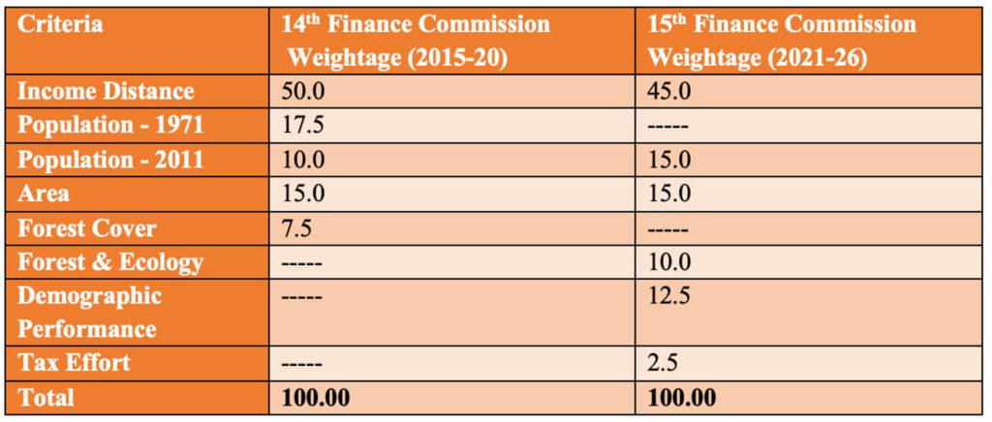

**Devolution of taxes to states:** The share of states in the centre’s taxes is recommended to be decreased from 42% during the 2015-20 period to 41% for 2020-21. The 1% decrease is to provide for the newly formed union territories of Jammu and Kashmir, and Ladakh from the resources of the central government.

**Net tax revenue**

**= Gross tax revenue – (National climate calamity fund under Public account +States share**

**Gross tax revenue= DT + IT + UT w/o legislature**

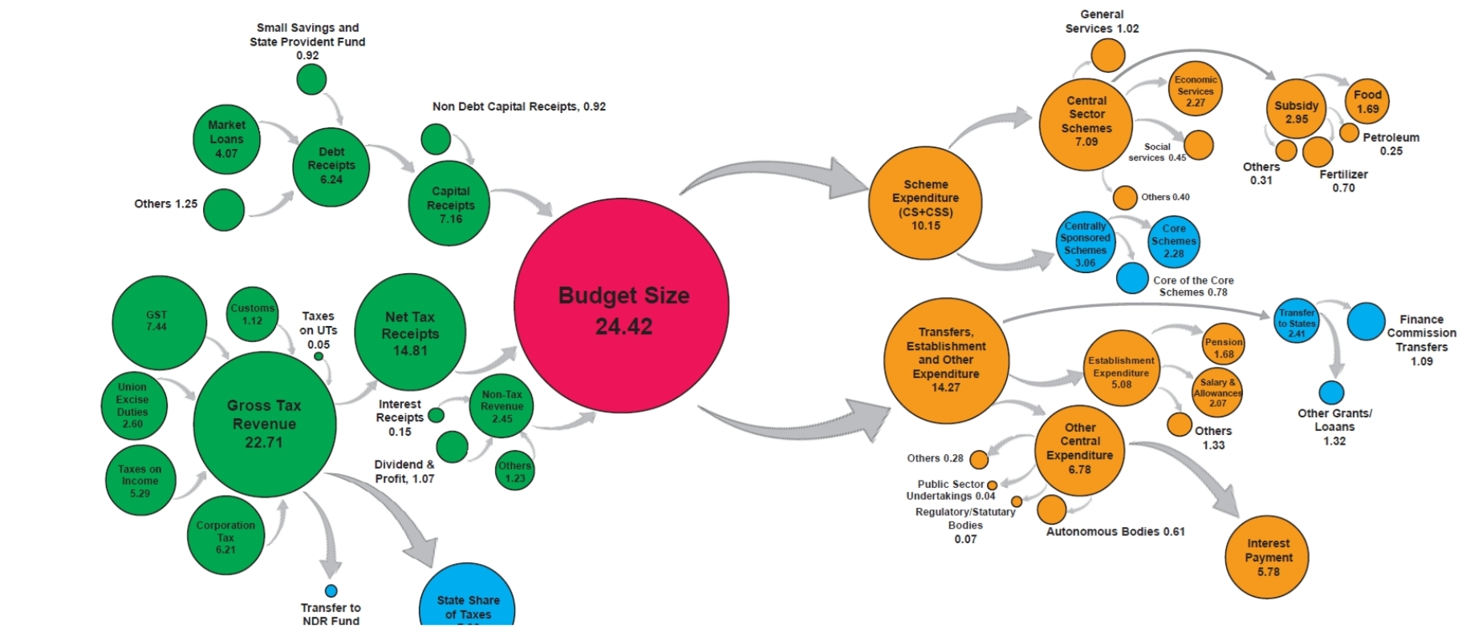

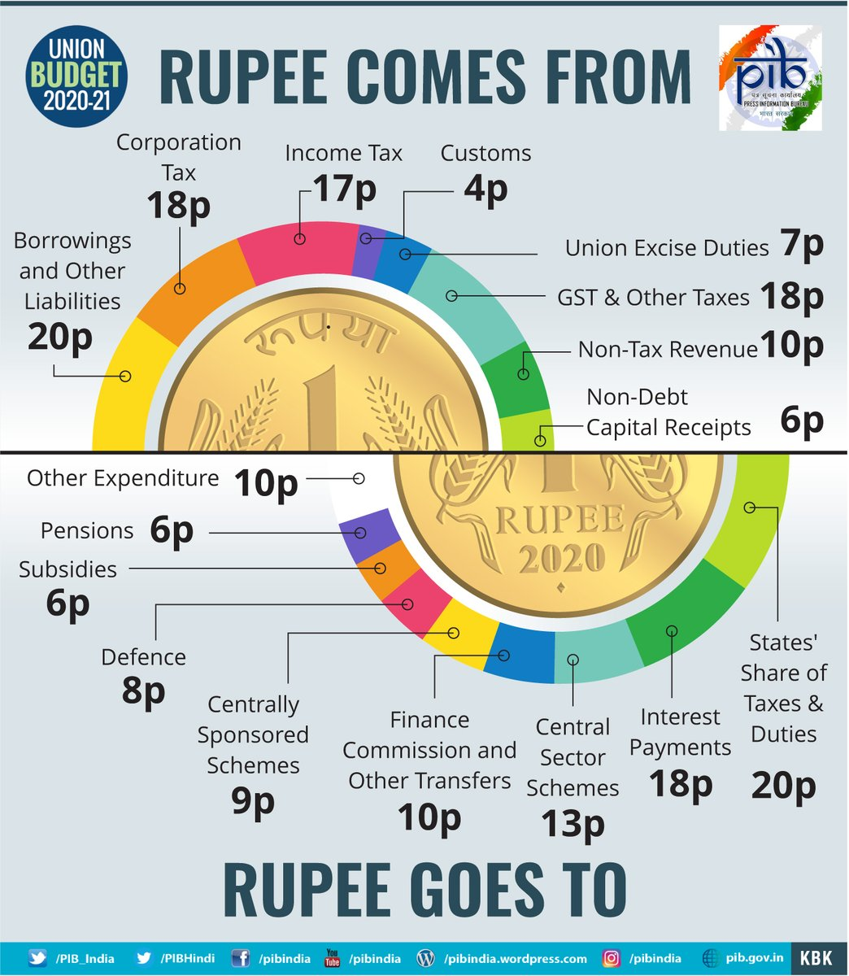

**VALUE ADDED TAX**

The value added tax (VAT) is a method of tax collection as well as name of a state level tax (at present) in India. A tax collected at every stage of value addition, i.e., either by production or distribution is known as value added tax.

* + From production to the level of sale, there are many points where value is added in all goods.
  + VAT method of tax collection is different from the non-VAT method in the sense that it is imposed and collected at different points of value addition chain, i.e., multi-point tax collection.
  + That is why there is no chance of imposing tax upon tax which takes place in the non-VAT method. This is why VAT does not have a ‘cascading effect’ on the prices of goods -it does not increase inflation—and is therefore highly suitable for an economy like India where due to high level of poverty large number of people lack the market level purchasing capacity. It is a pro-poor tax system without being anti-rich because rich people do not suffer either.

*Need of VAT In India*

1. Reduce the cascading effect and improve the purchasing capacity and living standard of the poor people.
2. At the central level, there has been uniformity of taxes for the economy. But there is no ‘uniformity’ at the state level taxes (i.e., state excise, sales tax, entertainment tax, etc.). This is detrimental to the development of a single market for Indian economy as a whole. India basically had many markets but no Indian market as such. To bring in uniformity at the state-level taxes, VAT was a necessary step in India.
3. It becomes almost impossible to go for large scale tax evasion. To prove one’s level of value addition, the purchase invoice/receipt is a must which ultimately makes it cross-check the level of production and sale in the economy.

Keeping all these in mind, India started tax reforms (Chelliah Committee and Kelkar Committee) and a certain level of success has been achieved in this area. In the year 1996, the central government started collecting its excise duty on the VAT method and the tax was given a new name—the CENVAT.

The next proposal was to merge the states excise duty (imposed on intoxicants only) and their sales taxes into one tax—the state VAT or VAT. This could not take place due to states’ lack of political will. Ultimately only sales taxes of the states were changed to be named VAT and was started to be collected on the basis of the VAT method.

**Goods and Services Tax**

Goods and Service Tax (“GST”), India’s most significant tax reform, comes to effect on **1st July 2017**. After a decade of consideration, GST will finally be implemented to replace many of the prevailing Indian indirect taxes levied by Central and State Government like:

* Excise duty (tax levied at the factory-level sale of manufactured goods),
* VAT (tax levied on goods from whole sellers to retailers/customers),
* CST (tax for transfer of goods between states),
* Service tax (tax levied on sale of services), etc.

Export/import duties (except CVD and Special additional duty of customs) continue to prevail on as is basis.

**What this unified tax means?**

Goods and Service Tax (GST) is a consumption based tax levied on manufacture, sale and consumption of goods and services. The underlying principle of GST is to tax goods at the point of consumption rather than production and simplifying the current system, wherein a good is taxed multiple times at different rates.

The primary reason to implement GST is to avoid the double taxation and enable credit of input tax against the output tax. Presently, a manufactured good is first subjected to Excise Duty (levied by Central government) on release from factory followed by a VAT (levied by state government) when sold to consumer. There is no provision of taking credit of the excise duty paid against the output VAT, thus resulting in cascading effect on taxes.

GST is a single tax from manufacturer to the consumer. Under GST, credit of input tax paid at each stage will be available on the next stage, thus leading to tax on value addition only.

The list of taxes (Currently levied by Central and State) being subsumed by GST are as follows:

|  |  |
| --- | --- |
| **Central** | **State** |
| § Service Tax  § Central Excise Duty  § Additional Excise Duty  § Additional Custom Duty or as Countervailing Duty (CVD)  § Special additional Duty of Customs  § Central Surcharge and Cess | § State Value Added Tax (VAT)/ Sales tax  § Central Sales Tax  § Entertainment Tax (other than the tax levied by local bodies)  § Octroi and entry Tax  § Purchase Tax  § Luxury tax  § Taxes on lottery, betting and gambling |

***Cascading effect***

Manufacturer to wholesaler-----10000+1000(tax)

Wholesaler to retailer-------wholesaler adds value of 500----- 11000+500+1150(tax) = 12650

Tax component on consumer is 1000(tax on product) +100(tax on tax) +50(tax on value addition)

* Cascading effect causes wholesaler to sell without bill, thus increasing black money
* The retailer bribes the inspector
* The final consumer gets the product at a cheaper price but no warranty

***Input tax credit***

Final consumer pays only for the values added. The retailer will have paid to the wholesaler before value addition but this will be returned from the consumer payment as input tax credit

Tax received on output-tax received on input= ITC deposited into GSTIN

Tax collection increased, inspector raj decreases and self-policing is better

***Evolution of GST***

MODVAT🡪CENVAT🡪VAT🡪GST

CENVAT:

* Excise on every raw material and spare. So, companies go for in-house manufacturing rather than ancillaries and MSMEs. It is cascading as well
* ITC was provided for raw materials and components under MODVAT

**Benefits**

* Less inspector raj--GSTN portal, less human interface, low compliance cost, ease of doing business
* Less cascading effect.
* Demand increases---make in India
* Rate arbitrage(difference in tax rates between states) will be low which helps in balanced regional growth
* Ancillarisation increases thanks to ITC
* Same base computation
* Import will be considered interstate trade but has custom as well. But for exports, it will only be custom. Exports will be zero rated

**Short term challenges**

1. Destination based tax
2. Revenue neutral rate
3. Max revenue for states come from VAT----122nd Amendment—compensation for 5 years--14th FC----GST compensation fund with tapering effect
   1. Cess on pan masala
   2. Cess Coal
   3. Cess Tobacco
   4. Cess on all other goods and services
4. If you apply cess on the above, it leads to inflation. But cess only on demerit and expensive

**GST slabs and Classification**

0%----- essential goods and services, exempt and negative list of services---grandfathered

5%------high quality food, coal(plus cess), kerosene, transport

12%------ayurvedic, cellphones, higher quality food, luxury, fertilisers, 5 star

18%-----pasta, ice-cream, steel, cameras, monitor, telecom, liquor restaurants

28%------demerit, betting, cinema

**CGST, SGST and IGST**

GST will have two components, concurrently levied by central and state governments, forming “Dual GST”:

* Central Goods and Service Tax (CGST) to be levied by Central
* State Goods and Service Tax (SGST) to be levied by State

CGST and SGST will be applicable on all transactions except the exempted goods and services.

On inter-state supply of goods and services, Integrated Goods and Service Tax (IGST) will be levied by Central government based on destination principle.

The input tax credit of CGST cannot be taken against SGST and vice versa. However, input tax credit of CGST and SGST can be taken against IGST and vice versa. Input tax credit of IGST would be first used against payment of CGST and then SGST.

Refer illustration for clarity. The below illustration presents the intra and inter-state transaction model of GST:

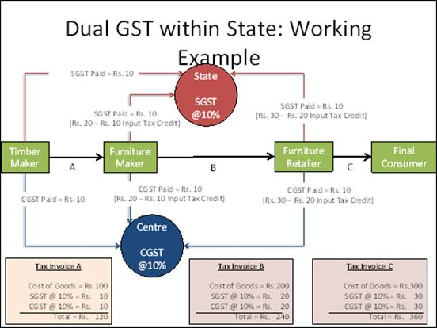

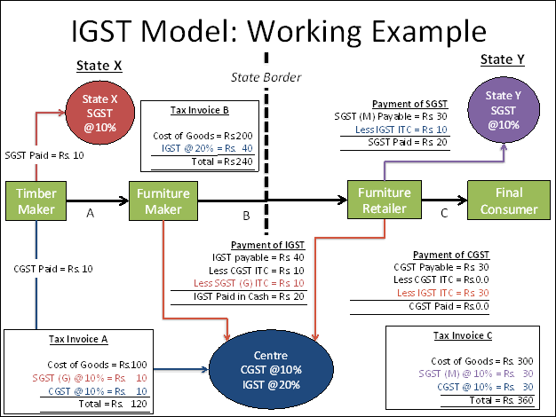

**What are the Benefits of GST?**

**Government:**

* Ease of administration: A single tax system will be simpler and easy to administer than multiple taxes. Further, robust end-to-end IT infrastructure can be built for a simpler and single tax regime.
* Increase in tax compliance: Due to the seamless transfer of input credit from one stage to the other there is an in-built mechanism in the GST framework to incentivize traders to comply with tax.
* Reduction in cost: GST is expected to reduce cost of collection of tax revenues on account of its simplicity and improve efficiencies.

**Businesses:**

* Ease of compliance with robust infrastructure: A robust IT infrastructure will be the back-bone of GST enabling Businesses to register, make payments, file returns, etc. This will result in better compliance and transparency.
* Simplified accounting: Although, initially Businesses will have to incur cost to upgrade their accounting systems with the new GST regime but in the long run GST is expected to reduce the procedural costs due to uniform accounting. The Businesses will be required to maintain only three accounts – CGST, SGST and IGST against the excise/VAT/Service tax input and output records maintained currently.
* Uniformity of tax rate: Doing business in the country will become tax neutral, irrespective of the place of operation, as GST proposes common rates across the country.
* Increase in manufacturing activities: Subsuming of central sales tax and availability of set-off of input credit on goods will reduce the cost of goods and services manufactured. This will improve the competitiveness of Indian goods in export markets thus boosting the manufacturing activities in the country.

**Consumers:**

* Price reduction: Because of levying tax only on the value addition the overall tax burden on goods is expected to come down, thus reducing overall prices.

**GST SLABS AND GST COUNCIL**

The government has categorised items in five major slabs for different goods and services - 0%, 5%, 12%, 18% and 28%. Cesses may be imposed on the items under the highest slab of 28%.

GST Council: The President must constitute a Goods and Services Tax Council within sixty days of this Act coming into force. GST council examines issues relating to goods, services tax and make recommendations to the Union, and the States on parameters like rates, exemption list and threshold limits. The Council shall function under the Chairmanship of the Union Finance Minister and will have the Union Minister of State in charge of Revenue or Finance as member, along with the Minister in-charge of Finance or Taxation or any other Minister nominated by each State Government.

**GST (Compensation to States) Act, 2017-**As per the GST (Compensation to States) Act, 2017, loss of revenue to the States on account of  
implementation of Goods and Services Tax is payable during the transition period of 5 years.  
The same Act says that financial year 2015-16 is to be taken as the base year for calculating  
compensation amount- The projected nominal growth rate of revenue subsumed for a state duringthe transition period shall be 14% per annum.  
Government needs extra revenue to compensate the states, and so the GST Council allowedcentre to impose additional cess for five years on certain goods over and above the highest taxbracket of 28%. These goods on which cess will be levied include tobacco products, coal, motorvehicles, which include all types of personal aircraft and yachts. These additional cesses,however, will be removed after five years and the states incurring losses would have to findalternative sources of revenue.  
The percentage of the additional cess changes from good to good. Both intra-state and inter- state supplies of goods or services would attract GST cess over and above the applicable CGST, SGST, and IGST rates. Clean environment cess- RS. 400 a tonne on domestic coal and imported coal will go into GST compensation fund.

**Anti-profiteering clause of GST**

GST Act provides that it is mandatory to pass on the benefit due to reduction in rate of tax or from input tax credit to the consumer by way of commensurate reduction in prices. If the firms do not pass it on, they are liable for penal action. GST rules prevent entities from making excessive profits by not passing on such reliefs.

Since the GST. , along with the input tax credit, is eventually expected to bring down prices, a National Anti-profiteering Authority (NAA) is to be set up to ensure that the benefits that accrue to entities due to reduction in costs is passed on to the consumers. Also, entities that hike rates. Inordinately, citing GST as the reason will be checked by this body.

**GST & Understanding of Economy**: The information (big data) gathered in the process of GST filling is altering the understanding of experts and policy makers alike about the economy. Some exciting findings from the information have been summarised below—

■A large increase in the number of indirect taxpayers has been noticed; many have voluntarily chosen to be part of the GST, especially small enterprises that buy from large enterprises and want to avail themselves of input tax credits.

■The distribution of the GST base among the states is closely linked to their Gross State Domestic Product (GSDP), allaying fears of major producing states that the shift to the new system would undermine their tax collections.

■New data on the international exports of states suggests a strong co-relation between export performance and states’ standard of living.

■ India’s exports are unusual in that the largest firms account for a much smaller share than in other comparable countries.

■Internal trade is about 60 per cent of GDP (even greater than estimated by the Economic Survey 2016–17) and compares very favourably with other large countries.

■The need of GST has commenced a vigorous process of formalisation in country (as increasing number of ‘non-formal’ firms and registering for GST). This will not only enhance the level of tax compliance in the country but have multiplier effect in the medium to long run—in the form of increased income levels, higher tax collections, increased social security of the employees, etc. (Economic Survey 2019-20).

Though, the Government was focussed on removing the technical glitches related to the GST Network even by mid-2020, the GSTN portal had already emerged a major source of data available in the public domain. This data repository, once mined as per the developmental needs, will necessarily give the country a better and diversified understanding of the economy.

**TAX EXPENDITURE**

Tax Expenditure corresponds to relaxations given when tax burden becomes difficult for the sustainability of a particular sector. Tax exemptions or incentives are given in the form of lower rates of tax relative to normal rates. Tax expenditures are revenue losses attributable to tax provisions that often result from the use of the tax system to promote social goals without incurring direct expenditures.

**CORPORATE TAX REFORM**

The existing rates used to be 30 per cent for the domestic and 35 per cent for the foreign companies, operating in the country. Following the ongoing process of corporate tax reforms the Government, in September 2019, affected a major change in the corporate income tax (CIT). The change which was enforced from fiscal 2019–20 is being briefly summarised below:

The central government slashed corporate tax rates for domestic firms from 30% to 22% and for new manufacturing companies from 25% to 15% to boost economic growth.

Corporate tax is a tax imposed on the net income of the company.

The new effective tax rate inclusive of surcharge and cess for domestic companies would be 25.17% and for new domestic manufacturing companies would be 17.01%.

These rates would be applicable to those companies who forego the current exemptions and incentives.

Also, the Minimum Alternate Tax (MAT) will not apply to such companies.

MAT has been reduced to 15 percent from 18.5 percent for companies who continue to avail exemptions and incentives.

The reduction in the corporate tax rate for domestic companies would be effective from 1st April 2019.

The change for new domestic companies would apply for those which get incorporated on or after 1st October 2019 and start producing on or before 31st March 2023.

This drastic move was aimed at three major objectives—firstly, boosting the production volume of the manufacturing sector which involves a large number of MSMEs (including the newly launched start-ups); secondly, attracting higher investments in manufacturing industries; and thirdly, creating more job opportunities.

■The rate structure was left unchanged for the foreign companies.

**IMPACT**

* Lower corporate income tax rates and the resultant change in profitability will likely prompt companies to invest more, raising their capital expenditure (capex).
* Additional capacities will, eventually, through a secondary round effect, prompt these companies to hire more employees.
* The present cut in taxes can make India more competitive on the global stage by making Indian corporate tax rates comparable to that of rates in East Asia.
* The tax cut is expected to cause a yearly revenue loss of ₹1.45 lakh crore to the government which is struggling to meet its fiscal deficit target.
* If it manages to sufficiently revive the economy, the present tax cut can help boost tax collections and compensate for the loss of revenue.

**DIRECT TAX AND INDIRECT TAX CONTRIBUTION**

Total tax revenue of the Government of India includes both direct & indirect taxes.

Direct taxes are progressive. It has equity built into it. Direct taxes like income tax are also automatic Stabilisers- when the economy grows, there is inflation, wages rice, people move into higher tax brackets and pay more taxes which reduces their spending thus stabilizing prices. They help in stabilising economic cycles without explicit government action.

Indirect taxes on the other hand largely do not differentiate between the rich and the poor though there is a progressive element, the luxury goods attract a higher GST and basic import duty. But on many essential goods, there is tax and the poor pay it. Indirect taxes also contribute to inflation and may dent savings and demand. Thus, they are relatively anti-growth and anti-equity.

In 1985-86, the indirect tax revenue was more than 4 times that of the direct tax revenue. The share of indirect taxes in the total tax revenue was 83% compared to the 17% share of direct taxes in 1985-86. The reason was that rich were very few in the country and indirect taxes were easy to collect

In 2000-01, direct taxes contributed only 36.31 per cent to the total taxes and the remaining revenue came from indirect taxes. However, by 2018-19, the share of direct taxes had risen to 54.78 per cent.

Direct taxes have been growing at a slower pace than indirect taxes.

**SIMPLIFICATION OF DIRECT TAX SYSTEM**

■ Taxpayers’ Charter: With the objective of enhancing the efficiency of the delivery system of the income tax department, a taxpayers’ charter is to be adopted. For a tax system to function smoothly and achieve the objective of compliance, an element of trust is required between taxpayers and the tax administration.

■ Concessional Corporate Tax: The concessional corporate tax rate of 15 per cent (plus surcharge and cess) announced for the newly incorporated domestic companies

■ Sovereign Wealth Fund: Government announced 100 per cent exemption on interest, dividend and capital gains income made by sovereign wealth funds of foreign governments on their investments made in priority sectors (notified before March 2024 with a minimum lock-in period of 3 years).

■ Faceless Appeals: Taking further step towards use of electronic mode (e-mode) and minimising human interface in tax administration, the Government has started ‘faceless appeals’ in case of income tax returns (‘faceless assessment’ is already in practice). Aimed to impart greater efficiency, transparency and accountability to the assessment process, few years back, a new faceless assessment scheme was introduced by the Government.

It is a randomized and anonymized assessment, aims to eliminate physical interface between taxpayer and tax assesse.

In this system, one need not appear before a tax officer and there is no physical movement of papers or person.

It will reduce a lot of pressure and address issues faced by tax administration during an assessment.

The need is to make the faceless or e-assessment widespread and mandatory.

■ ‘Vivad se Vishwas’ Scheme: On the line of ‘SabkaVishwas Scheme’ launched to reduce litigation in indirect taxes in 2019–20 (which settled a total of 1.89 lakh cases in less than one year), the Government launched a new scheme Vivad se Vishwas in 2020–21 to reduce the litigation in direct taxes. By late January 2020, there were 4.83 lakh direct tax cases pending in various appellate forums (Commissioner, High Court and Supreme Court).

Under the scheme, which will remain open till June 2020, a taxpayer would be required to pay only the amount of the disputed taxes and will get complete waiver of interest and penalty (provided payment is made by March 2020). Those who avail this scheme after March 2020 will have to pay some additional amount. The cases under appeal are also eligible under the scheme.

**TAX HAVENS**

A tax haven is generally an offshore country that offers foreign individuals and businesses little or no tax liability in a politically and economically static environment.

Tax havens also share limited or no financial information with foreign tax authorities.

Tax havens do not typically require residency or business presence for individuals and businesses to benefit from their tax policies.

**BASE EROSION AND PROFIT SHIFTING**

Base Erosion and Profit Shifting (BEPS) is a tax avoidance strategy used by multinational companies by exploiting gaps and mismatches in tax rules to artificially shift profits to low or no-tax locations.

Indian government has ratified the international agreement to curb base erosion and profits shifting (BEPS) – Multilateral Convention to Implement Tax Treaty Related Measures.

The Convention is an outcome of the OECD / G20 BEPS Project to tackle base erosion and profit shifting.

The Multilateral Convention will enable the application of BEPS outcomes through modification of existing tax treaties of India in a swift manner.

It is also in India’s interest to ensure that all its treaty partners adopt the BEPS anti-abuse outcomes.

The Convention will enable curbing of revenue loss through treaty abuse and base erosion and profit shifting strategies by ensuring that profits are taxed where substantive economic activities generating the profits are carried out and where value is created.

**DOUBLE TAXATION AVOIDANCE AGREEMENT**

Double Taxation Avoidance Agreements is a treaty signed between two countries, which, through the elimination of international double taxation, promotes the exchange of goods, services, and investment of capital between the two countries.

India has signed the Double Taxation Avoidance Agreements or DTAA with 88 countries. Foreign companies that are resident in the countries that India has a DTAA with, can claim more beneficial provisions and rates between the IT Act and the DTAA.

Some of the major benefits of Double Taxation Avoidance Agreements (DTAA) are mentioned below:

* The countries under the DTAA are provided relief from double taxation. Relief on double taxation is provided by the exemption of incomes earned abroad from tax in the resident country or by providing credit to the extent taxes that have been already been paid abroad.
* In some cases, the DTAA also provide concessional rates of tax.
* DTAA can become an incentive for even legitimate investors to route investments through low-tax regimes to sidestep taxation. This leads to a loss of tax revenue for the country.
* DTAA also provides tax certainty to the various investors and businesses of both the countries through the clear allocation of taxing rights between the contracting states by Agreement.

**GENERAL ANTI AVOIDANCE RULES**

General Anti-Avoidance Rule is a set of rules or framework which helps the revenue authorities decide about whether a particular transaction has commercial substance or not. If not, then it is not a genuine transaction and then the tax liability associated with it is decided.

It is framed by the Department of Revenue under the Ministry of Finance.

Tax evasion is when a person or entity does not pay the taxes that is due to the government. This is illegal and liable to prosecution.

Tax avoidance is where entities try to avoid tax by taking recourse to legal actions. Tax avoidance is not illegal.

GAAR is specifically against transactions where the sole intention is to avoid tax. GAAR will address the cases which are technically not illegal but not ethical as they avoid the payment of taxes. Thereby the transaction has not been promoted by a person to be commercially viable but only for purpose of taking tax advantages.

In case of foreign investors, GAAR is applicable only to those who have not taken benefits under Double Taxation Avoidance Agreements (DTAA).

**ADVANTAGES**

GAAR would enhance the tax revenues of government by seeking or finding out non-genuine transactions and avoiding taxes. It helps in improving the tax revenues of government which will add in lessening the fiscal deficits of government.

GAAR will bring out competitive advantages to several businesses who have been doing genuine transactions. This creates a better economic and business environment for people to recognise that the state exists to bring about genuine investments and transactions having pro-commercial viabilities.

In ease of doing business rank, it will add to the advantage of India being recognised as a more serious country in accepting what is free and fair trade practices rather than only giving free tax advantages to people.

**TRANSFER PRICING AND APA**

Transfer pricing has become an important part in the BEPS issue.

If a subsidiary company sells goods to a parent company or vice versa, the price of those goods paid by the parent to the subsidiary for the opposite 'within the county or internationally, is the transfer price.

Transfer pricing is generally done in a way as to show high profit in countries where the corporate tax rate is low and low profits/losses where the rates high. Therefore, transfer pricing norms need to be rationalised so that the tax revenues that are due to the government are not eroded. Tax evasion and money laundering has to be choked by tightening the transfer pricing regime. The solution is advance pricing agreements (APA).

An APA is an agreement between a taxpayer and the tax authority determining the Transfer Pricing methodology for pricing the tax payer’s international transactions for future years. An APA provides certainty with respect to the tax outcome of the tax payer’s international transactions.

**Benefits of APAs**

It gives certainty to taxpayers

It would help in reducing disputes and enhance revenues

Make the country an attractive destination for foreign investments

May lower the complaints and litigation costs

**TOBIN TAX**

Tobin tax is a tax on international flow of short term capital. The tax is known after economist James Tobin who proposed it in1972 in the form a currency transaction tax.

Basically, Tobin tax aims to discourage volatile short term capital flows or hot money which are very speculative. Tobin has advocated the imposition of tax on cross border flow of short term capital as these are the sources of volatility and risks in the host economies.

The burden of a Tobin tax is inversely proportional to the length of the transaction, i.e., the shorter the holding period, the heavier the burden of tax. Variants of Tobin tax are imposed by many countries to discourage short term capital flows or hot money.

**PIGOUVIAN TAX**

Pigouvian Tax is the tax levied on the negative externalities caused due to the given market activity concerned. This tax is intended to correct the negative outcomes of the market activity and discourage its continuity by levying tax.

An example of this would be carbon emission by industries which has negative impact on the environment, in that sense Carbon-tax would be an example of the Pigouvian tax.

**WITHHOLDING TAX**

A withholding tax is an amount that an employer withholds from employees’ wages and pays directly to the government. It is same as tax deduction at source.

**LAFFER CURVE**

Laffer curve explains the relationship between tax rate and tax revenue. It says that at lower as well as higher tax rates, the tax revenue is low but the tax revenue is high at optimal tax rates.

