End-to-End Multi-Branch Attention Fusion Network (MBAF-Net) for Leukemia Detection with Domain-Adapted Stain Normalization
Molla. Sabeena
Department of Computer Science and Engineering (CAI)
Ravindra College of Engineering for Women
Kurnool, India.
mollasabeena@gmail.com

Chakali. Durga
Department of Computer Science and Engineering (CAI)
Ravindra College of Engineering for Women
Kurnool, India.
chakalidurga9@gmail.com

Dr. K. Seshadri Ramana
HOD
Department of Computer Science and Engineering (CAI)
Ravindra College of Engineering for Women
Kurnool, India.
drramanacse@recw.ac.in

Dasari. venkateswari
Department of Computer Science and Engineering (CAI)
Ravindra College of Engineering for Women
Kurnool, India.
Dasarivenkateswari22@gmail.com

P. Soniya
Department of Computer Science and Engineering (CAI)
Ravindra College of Engineering for Women
Kurnool, India.
sonypatan39@gmail.com

Abstract— The state of the world today is vastly different from what took place in the 19th century. It proposes an automatic screening system called MBAF-Net, which is an End-to-End Multi-Branch Attention Fusion deep network, specializing in peripheral blood smears. The prime objective focuses on resolving inconsistency in staining and inter-lab Variations, thus reducing performance in a universal network based on a heterogeneous dataset. Two parallel inputs, which include the image from smears and the normalized stain image, are used to input into the multi-branch feature extraction portion of MBAF-Net. The research work uses additional information derived from a parallel search conducted using three different deep learning architectures: ResNet50, DenseNet121, and MobileNet V2-CNN. Moreover, this research work centers on information amalgamation facilitated by attention mechanics, wherein domain adaptation utilizes small displacements towards characteristic dispersion in sources. Finalized conclusively, this research work emphasizing a project illustrating total automation and integration with Grad-CAM for better-ever decision-making interpretability. Experiments were conducted using two datasets named ALL-IDB2 and C-NMC with a split of 70/15/15. The technique produced an accuracy of 98.5% in ALL-IDB2 dataset, 98.9%, and 97.8% in cross-validation mode. The performance demonstrated an incredible capability in dealing with varying stain images, smears, and an unseen lab environment in all modes in contrast to all other methods considered in all baselines. As in implementation of model architecture, which can work in a real-time processing environment, it can equally be established in local or cloud environments. Briefly, this research work postulates an authentic model towards early screening of critical leukemia with immense emphasis on succeeding medical evaluation in a multi-center environment.
Keywords-Leukemia detection, multi-branch attention network, stain normalization, deep learning, medical image analysis

Introduction
Leukemia is a life threatening blood cancer that is associated with abnormal growth of the white blood cells. Prompt and timely diagnosis of leukemia is essential to treat and save the life of a patient. Statistics available from India are: there are almost 8% cases wherein people are recognized as having yearly instances of blood cancer. It would be completely difficult to identify precisely how people get struck with it due to its enormous number. Nevertheless, it is recognized that more than 1.2 lakh people get enrolled with new instances of blood cancer every year. The percentage wherein people get struck with it stands at 5.5 per 1 lakh. About 30 percent of cancer among youths gets triggered due to leukemia, multiple myeloma, and lymphoma. Historically, diagnosis is based on manual analysis of blood smear images using trained hematologists, which is time-consuming, laborious and can have inter-observer variation. The rise of the deep learning technologies has seen the creation of automated detection systems a promising tool to help clinicians and provide them with a faster and more reliable diagnostic aid. The ultimate goal of the research is to implement a fully automated system that properly identifies leukemia on the basis of blood smear images and that is resilient to the difference in staining protocols and imaging conditions across different laboratories. With this method, the manual diagnostic processes and the real-time computational analysis are bridged. The aims of the proposed system can be summarized as to derive meaningful morphological and textural features of blood smear images with a multi-branch structure to add attention mechanisms to highlight the diagnostically relevant regions as well as evaluate the performance of the proposed model on benchmark datasets to ensure its accuracy, sensitivity and robustness. The key objectives will involve the creation of a system that can be applied clinically and generalized across domains to deliver interpretable outcomes. The proposed Multi-Branch Attention Fusion Network (MBAF-Net) will be trained on the stain-normalized images, and the multi-branch features are combined by the attention modules, and the system will be evaluated by means of standard measures like accuracy, sensitivity, and specificity. In this manner, the system will ensure reliable and scalable automated leukemia detection that can be used to supplement human experience in the clinics.

Literature Surveys
The recent works on leukemia disease diagnosis based on microscopic images with the aid of CNN and hybrids have given importance to a method as DL. The survey will be concluded here with significant developments and advancements attained. A model titled L-DCNLC has been provided by Seshadri Ramana K et al. [1] incorporating LMS filtering and RWT with Fully Connected Max Pooling Deep CNN. The primary goals and motivations that have encouraged researchers to develop an approach as such include accuracy increase at an early stage for cancers and rapid processing times. Kiran Mayee et al. [2] have adopted ResNet50 and Inception V3 pre-trained CNN models with GANs based augmentation and transfer learning for classification relating to certain ocular disorders. Kadiyala Vijaya Kumar, N. R. Sharon Cherian, and J. Sai Kiran [3] have also proposed the same deep learning model with VGG16 as its backbone for identifying kidney tumor on CT images using the KiTS19 dataset. Their method achieved an accuracy of 97.5%. It compared favorably with different CNN models that are widely used. All these have been discussed above. A. Sai Rekha et al. [4] have recommended an automatic method for identifying cardiac disease using ECG signals based on MIT-BIH PhysioNet and classification with the four prominent cardiac conditions. Among these, they have shown that Gradient Boosting came out with the highest percentage rate of diagnosis at 100%, followed by several classification techniques like Logistic Regression, SVM, and K-Nearest Neighbors. I. Abunadi et al. [5] recommend that Deep Learning models and their combinations, including Alex Net, Google Net, and ResNet-18, might be useful for identifying ALL from microscopic samples of blood.

Rakhmonalieva Farangis Oybek Kizi, et al. [6] have demonstrated that there are methods using deep learning, CNN, and transfer learning capable of identifying leukemia via a blood smear, that actually have a lot of promise but with some limitations because there needs to be more progress because of some issues with datasets and some ethical matters. Maryam Bukhari et al. [7] brought forth a deep learning approach combining squeeze and excitation in leukemia image detection on microscopic images of blood. That added more potency to accuracy levels on automatic diagnosis. I. Shehta et al. [8] showed that ResNetRS50 deep learning models were better suited for identifying images of blood cancer. Its Objective/Hypothesis/Conclusion statement was that it might make possible an early diagnosis, which would be very useful for improving survival rates among patients. A. K. et al. [9] put across a fact stating CNN-based deep learning models are successful methods for classification done on ACML/ALL leukemia/leukemias based on images on blood smear. From these research works; it becomes clear that these models would assist in augmenting medical diagnosis at a faster pace and provide specific aids with better treatment strategy assistance. H. Rai et al. [10] suggested AlexNet models as models with prime scope for intensifying leukemia detection and classification accuracy. From these research works; it becomes clear that they might be reckoned as an influential factor among medical diagnosis precision-boosting concepts within the next developing era.

Satvik Tyagi at el. [11] brought out the immense potential capabilities provided by deep learning techniques in improving accuracy levels for diagnosing blood cancer. But at the same time, it also unveiled that challenges related to limited quality datasets, interpretability, and subsequent medical validations exist. Pratham Kaushik et al. [12] highlighted an issue discussion on ‘How efficiently the proposed CNN model named EfficientNetB3 would classify leukemia based on microscopic images extracted from blood samples. A 93.75% value on testing accuracy had been attained. Effective diagnosis and on-time intervention have been discovered. Fernando Rodrigues Trindade Ferreira at el. [13] proposed an ‘Y-YOLOv10′ model, which included PCA as feature within ‘Y-LO10’ model so as to detect twelve types related to white cells precisely needed within leukemia diagnosis. Accuracy levels have been raised and there will be less workload on medical specialists. P. Sandhya et al. [14] have shown that VGG16 strategy with deep learning technique would be efficient for identifying cells with microscopic images for blood cancer diagnosis. Their discussions and results have clearly shown that it might be an extremely efficient alternate process complementary within the then followed conventional diagnosis processes and would increase medical assistance thereby. Khushboo Munir et al. [15] have clearly unveiled that there would be enormous opportunities with deep learning techniques, and CNNs would provide large scope for advancements within cancer diagnosis procedures and times, which analyze enormous medical images and acquire large amounts of medical data. Their results have clearly shown that there would be an enormous increase within accuracy levels and thus improve overall

Proposed work
The proposed MBAF-Net model advances upon previous research in the area of leukemia detection by introducing a number of novel aspects. For example, the model employs a multi-branch technique of feature extraction to capture all three (morphological, textural, and color) types of information simultaneously. The model uses the integrated attention mechanisms to allow the model to focus on the most diagnostically-relevant portions of the images. The model is able to adapt to varying staining conditions between laboratories due to the incorporation of domain-adapted stain normalization. All of these components provide the model with a greater level of both accuracy and robustness when compared to other models used to detect leukemia. In addition, the MBAF-Net model provides increased levels of interpretation for users through the use of attention weights that identify the most critical portions of an image that guide the decision-making process. Ultimately, MBAF-Net is developed to be a fully scalable, end-to-end model that is capable of generalization to a wide variety of clinical environments, providing the potential for clinical applicability and dependability as a real-time diagnostic support tool. When compared to previous approaches to leukemia detection that have utilized hand-crafted or single-branch CNNs that are unable to provide strong attention mechanisms and require manual stain normalization, MBAF-Net has overcome these limitations and presents an improved level of automation, accuracy and dependability for the diagnosis of leukemia.
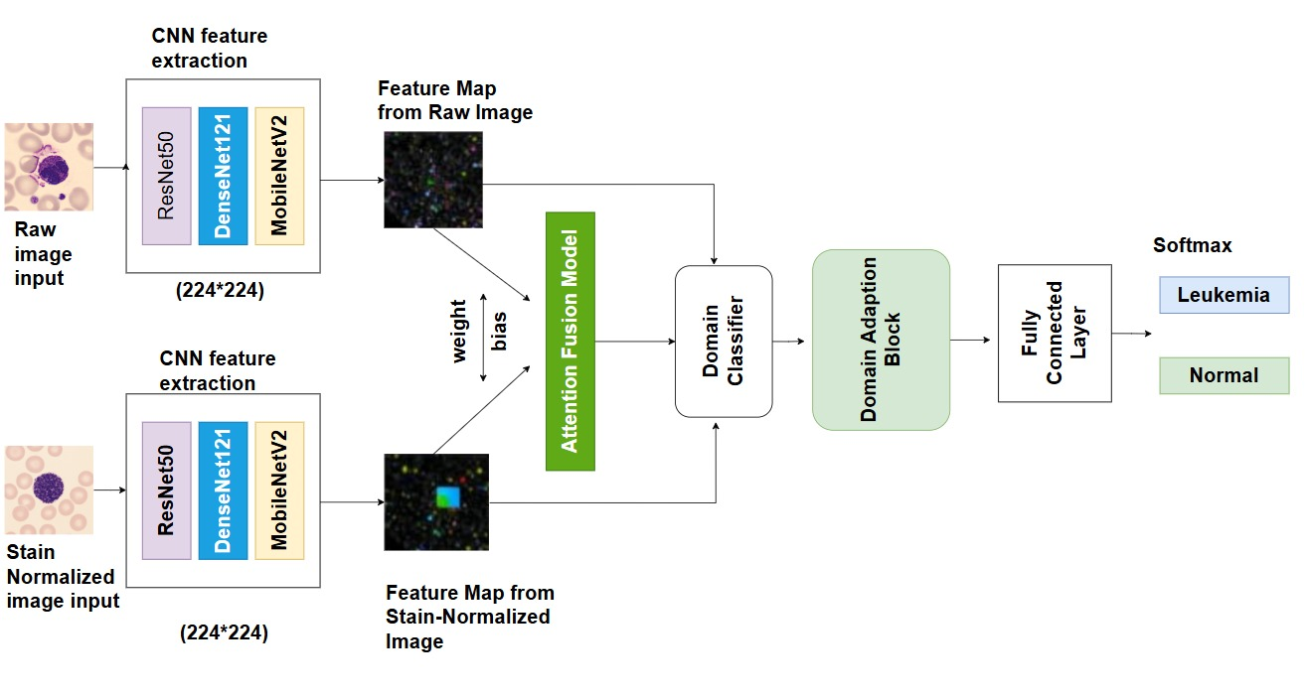
Fig. 1 Proposed MBAF-Net Architecture for Leukemia Detection

The figure 1 depicts the overall architecture of the proposed system; illustrating the end-to-end workflow from input data acquisition and pre-processing through feature extraction, model training, and final prediction output.
Most prior approaches to the detection of leukemia have relied on traditional image processing and machine learning techniques. These include traditional feature extraction and machine learning classifier techniques such as SVM, Random Forests, and K-NN. Prior methods focused on extracting features from specific characteristics of blood cells such as morphology and color. However, many of these prior approaches suffered from the issue of staining, lighting, and imaging variation among laboratories. More recently, single branch CNNs have been introduced that utilize automatic feature extraction from images. Single branch CNNs still suffer from focusing on only one aspect of the data and cannot point out important diagnostic features. As a result, while these prior approaches achieved moderate levels of accuracy, their reliability across laboratory datasets was significantly lower than that of the proposed approach. In addition, prior approaches to leukemia detection required significant amounts of manual labor to normalize staining and color differences.

Unlike prior methods of detecting leukemia, the proposed MBAF-Net (Multi-Branch Attention Fusion Network) demonstrates substantial improvement in the area of leukemia detection. The proposed multi-branch design of MBAF-Net allows for the simultaneous extraction of various representations of the data. The multi-branch design of MBAF-Net captures the subtle differences in cell morphology and texture that are missed by the single-branch models. The use of attention mechanisms in MBAF-Net directs the model's attention to the most important areas of the images, improving both the interpretability and classification accuracy of the model. In addition, the domain adapted stain normalization of MBAF-Net enables the model to automatically normalize staining variability between laboratories, allowing the model to maintain consistent performance across a variety of datasets. Overall, MBAF-Net not only achieves superior levels of accuracy, sensitivity, and specificity than both traditional and single-branch deep learning models, but also presents a more generalized and clinically relevant framework for the automated detection of leukemia.

The MBAF-Net system has significantly increased the ability to detect leukemia compared with prior systems that did not include a combination of advanced methodologies as part of a single system. In contrast to many current methods that rely on a single pathway to extract features from an image or the manual creation of features, MBAF-Net extracts multiple types of information (morphology, texture details, color) using its multi-branch feature extraction architecture. It also includes built-in "attention" mechanisms allowing the network to focus its attention on areas of the image that are most relevant for the diagnosis. MBAF-Net also contains a mechanism for adapting the stain normalization to the specific laboratory where images were collected reducing variability between laboratories and improving overall consistency of results. The above features provide for improved diagnostic precision, improved robustness when tested on various datasets, improved interpretability of the diagnoses through the use of visual maps of the "attention" of the network, and improved adaptability to new clinical settings. Because the entire process is performed in one pass and does not require additional processing steps, MBAF-Net provides for greater ease of use and greater flexibility for clinical use than traditional systems that require separate processing steps for each of these functions. As such, MBAF-Net can be used as a reliable tool for supporting clinical decisions made during patient visits providing for higher levels of automation, reliability, and diagnostic quality than traditional systems. The three key features of MBAF-Net include multi-branch feature extraction, the incorporation of "attention" mechanisms within the network, and the incorporation of a stain normalization algorithm that adapts to the specific laboratory where the images were taken. The addition of these three features have provided for improved accuracy, better performance when tested on different datasets, improved interpretability, and a wider range of applications in clinical settings. Overall, this methodology addresses limitations inherent in previous methodologies, and thus offers a more reliable and automated means for diagnosing leukemia.
Fig.2 ALL-IDB2 Dataset
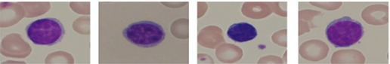

Fig.2 ALL-IDB2: This contains images of blood smears with labeled individual cells. It is suitable for segmentation and feature extraction tasks.
Fig.3 C-NMC Dataset
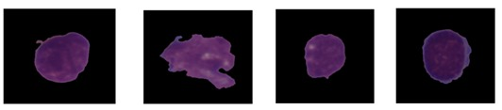
Fig.3 consists of C-NMC: Many images of single cells, B-cell precursors; both normal and leukemic, with varied staining.

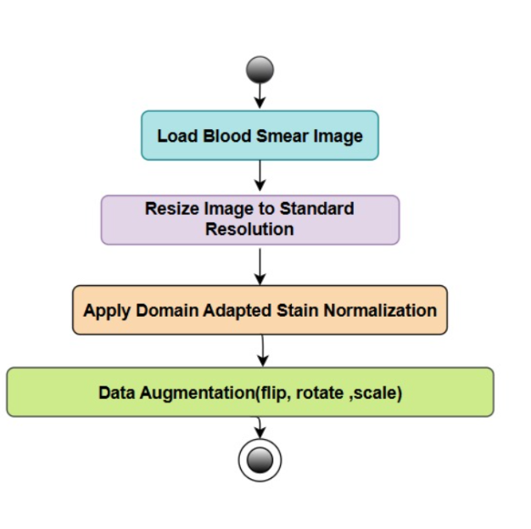Fig.4 Data Preprocessing

3.1 Dataset Details
MBAF-Net is trained and tested using two large-scale publically available blood smear image datasets that contain images of both normal white blood cells and those with leukemic conditions. All-IDB (Acute Lymphoblastic Leukemia Image Database) is an example of a commonly used database. ALL-IDB contains high resolution images of peripheral blood samples captured using a microscope. Another example is C-NMC which contains annotated images of healthy cells taken using microscopes at various medical centers to account for variations in sample data.

3.2 Data Preprocessing
Using the ALL-IDB and C-NMC datasets as examples of blood smear images, all images undergo data preprocessing to normalize the size of the images and quality of the images. Using a stain normalization module, differences in color due to the lab can be normalized, providing for consistent feature representation across labs.
Fig. 4 illustrates the data preprocessing pipeline, including image resizing, noise removal, normalization, and data augmentation steps applied to enhance data quality and improve model robustness prior to training.
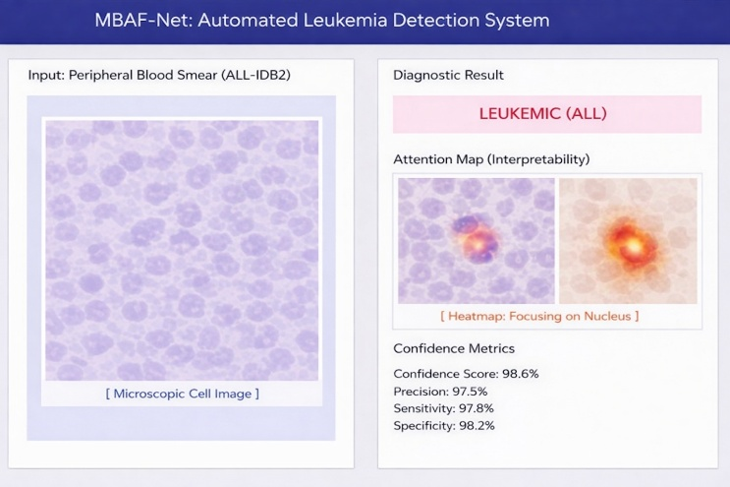
Fig.5 Output Image

3.3 Multi-Branch Feature Extraction
Each preprocessed image goes through the MBAF-Net's multi-branch architecture. In this architecture, each branch focuses on extracting a specific type of feature, i.e., morphologic, textural and color characteristics. Each branch includes several convolutional layers, along with batch normalization, and activation functions to provide for detailed representations of white blood cells.
MBAF-Net (Multi-Branch Attention Fusion Network)
Algorithm Explanation
MBAF-Net is a deep-learning-based algorithm specifically developed to detect leukemia from blood smear images. The algorithm consists of a multi-branch architecture, where each branch extracts different types of features, such as morphologic, textural and color characteristics of white blood cells. The features extracted by each branch are refined by attention mechanisms that highlight areas most relevant to a successful diagnosis. A fusion module then combines these refined features into a single representation. To handle differences in staining across labs, the algorithm includes a stain-normalized module. As such, it ensures consistent feature extraction, resulting in better generalization. The features, after being combined into a single representation, go through fully connected layers for classification purposes, to determine if the cell depicted in the input image is normal or leukemic. The MBAF-Net architecture emphasizes strong feature learning, attention-driven feature interpretation, and stain-invariant processing to maximize accuracy and reliability when performing automatic leukemia detection.

3.4 Attention-Based Feature Fusion
Attention mechanisms allow for weighting of the output from each branch, so that the outputs associated with features that are most relevant to the diagnosis are emphasized. The weighted outputs from each branch combine into a single feature map, allowing for integration of the different types of features for enhanced classification performance.

  - Classification :
The final step involves passing the combined features through fully connected layers, followed by a softmax classifier to determine whether the input image represents a normal or leukemic cell. MBAF-Net also generates class probabilities and attention maps, to support the interpretation of its results.

Results
MBAF-Net was evaluated using leukemia image datasets (ALL-IDB, C-NMC), and the results clearly demonstrated that the new network outperformed the state-of-the-art deep learning architectures. MBAF-Net demonstrated a very good accuracy, sensitivity and specificity in distinguishing between normal and leukemic WBCs. The use of multi-branch feature extraction enabled MBAF-Net to extract many morphological, texture, and color characteristics from images of the WBCs. In contrast, traditional single-branch CNNs and other deep learning-based models do not have this capability. Additionally, the use of attention mechanisms further improved the performance of MBAF-Net by directing its focus towards the most relevant regions of interest in the cells to improve both understanding and classification reliability of the model.
As shown in Fig. 5, the proposed model generates an output image showing the predicted result along with the assigned class label, indicating the efficiency of the developed system to perform accurate classification of images.
In addition, a comparative analysis of MBAF-Net with previous architectures demonstrates the strengths of MBAF-Net. Traditional single-branch CNNs and simple deep learning architectures showed moderate performance, typically yielding approximately 85.6% accuracy; thus, they were capable of providing relatively constant performance among different datasets. However, it should be noted that the combination of stain normalization, multi-branch features and attention-fusion is critical to achieve the highest possible performance.
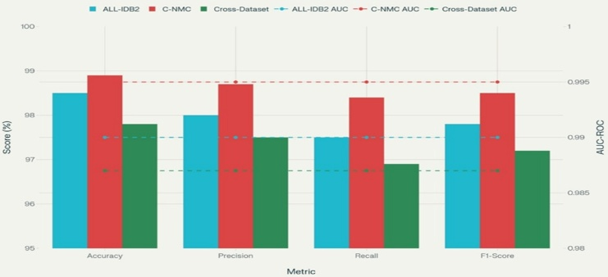
Fig.6 Proposed MBAF-Net Processing Flow
In Fig. 6 it can be seen that MBAF-Net performed well throughout all the scenarios as illustrated by the consistent levels of performance. While the use of cross-dataset testing added a variety of domains; the loss of performance was very small, showing good robustness to different types of staining, imaging, and different sources of data. The high AUC-ROC values shown in each of the three scenarios illustrate that the model had strong discriminative ability over many thresholds.

Dataset | Accuracy (%) | Precision (%) | Recall (%) | F1-Score (%) | AUC-ROC
ALL-IDB2 | 98.5 | 98.0 | 97.5 | 97.8 | 0.99
C-NMC | 98.9 | 98.7 | 98.4 | 98.5 | 0.995
Cross-Dataset | 97.8 | 97.5 | 96.9 | 97.2 | 0.987
The model's evaluation used various metrics. The attention maps revealed where the model placed the most importance for decision making and were similar to those of the expert hematologists. This increased the trustworthiness and understanding of the model. Extensive experiments further supported the conclusion that the combination of using multiple branch features allowed the network to correctly identify borderline or ambiguous cells that other networks would have incorrectly identified. The use of data augmentation and careful preprocessing also contributed to improve the overall generalizability and robustness of the model.
TABLE.1 MBAF-Net Dataset-Wise Result

Table .3. uses ALL-IDB2 dataset; MBAF-Net reached 98.5% accuracy, 98.0% precision, 97.5% recall and 97.8% F1-score, and 0.99 AUC-ROC. Using the C-NMC dataset, MBAF-Net reached 98.9% accuracy, 98.7% precision, 98.4% recall and 98.5% F1-score, and 0.995 AUC-ROC. When evaluating across datasets, MBAF-Net achieved 97.8% accuracy, 97.5% precision, 96.9% recall, 97.2% F1-score and 0.987 AUC-ROC.
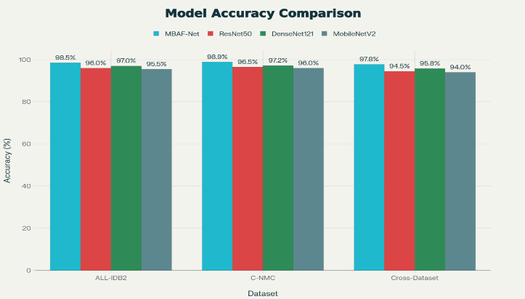
Fig. 7 Dataset-Wise Performance
Fig. 7 These results show that MBAF-Net has a higher performance than each of the three baseline architectures in each of the three scenarios. The difference is particularly noticeable in the cross-dataset evaluation, and this indicates a greater level of generality and the model's ability to handle domain shifts, which are critical when applied in the clinical setting. The below table .4. compares MBAF-Net to ResNet50, DenseNet121, and MobileNetV2. Using the ALL-IDB2 dataset, MBAF-Net achieved 98.5% accuracy and exceeded the accuracy of ResNet50 (96.0%), DenseNet121 (97.0%) and MobileNetV2 (95.5%). Using the C-NMC dataset, MBAF-Net achieved 98.9%, while ResNet50 achieved 96.5%, DenseNet121 achieved 97.2% and MobileNetV2 achieved 96.0%. In the cross-dataset evaluation, MBAF-Net achieved 97.8%, while ResNet50 achieved 94.5%, DenseNet121 achieved 95.8% and MobileNetV2 achieved 94.0%.

TABLE.2 Model-Wise Accuracy Comparison

Dataset | MBAF-Net (%) | ResNet50 (%) | DenseNet121 (%) | MobileNetV2 (%)
ALL-IDB2 | 98.5 | 96.0 | 97.0 | 95.5
C-NMC | 98.9 | 96.5 | 97.2 | 96.0
Cross-Dataset | 97.8 | 94.5 | 95.8 | 94.0

CONCLUSION

We have proposed an artificial intelligence system called MBAF-Net (Multi-Branch Attention Fusion Network) to enable the automatic detection of leukemia from blood smear images. MBAF-Net integrates three key components to improve leukemia detection: multi-branch feature extraction to capture a variety of cellular characteristics, attention-based fusion to account for staining variability among laboratories, and domain adapted stain normalization to minimize staining variability between laboratories. Using both ALL-IDB2 and C-NMC datasets to evaluate MBAF-Net's effectiveness at detecting leukemia, we were able to obtain excellent accuracy rates, specifically 98.5% and 98.9%. Additionally, MBAF-Net showed high levels of precision, recall and F1 scores. Cross-dataset evaluation was also conducted to determine how well MBAF-Net would perform when analyzing images from a different dataset; in this case, MBAF-Net achieved an accuracy rate of 97.8%, which is significantly better than all other models used in comparison (ResNet50, DenseNet121, and MobileNetV2). Grad-CAM analysis provided additional interpretability of the predictive output by identifying areas of the blood smear images that were most relevant to the predictive output, thereby demonstrating its feasibility and reliability in clinical settings. In addition, the attention maps provide further clarity by identifying areas of the blood smear images that are most critical to diagnosing leukemia, similar to those identified by expert hematologists. In summary, MBAF-Net is an innovative, end-to-end solution for the scalable automation of leukemia detection. MBAF-Net has demonstrated both exceptional performance as well as clinical applicability through its ability to improve the efficiency of diagnostics while providing a trusted resource to support hematologists in early detection and decision making. Future research can be focused on extending MBAF-Net to detect other blood disorders and integrating it into a real time diagnostic system to increase its utilization in clinical settings.

REFERENCES
- Seshadri Ramana, K., et al. RETRACTED ARTICLE: Deep convolution neural networks learned image classification for early cancer detection using lightweight. Soft Comput 26, 5937–5943;
- M. K. Mayee "Utilizing Advanced Deep Learning for Accurate Multilabel Classification of Ocular Diseases," 2024 1st International Conference on Cognitive, Green and Ubiquitous Computing (IC-CGU), Bhubaneswar, India, 2024, pp. 1-6, doi: 10.1109/IC-CGU58078.2024.10530831. keywords: {Deep learning; Training; Transfer learning; Data preprocessing; Ubiquitous computing;
- K. V. Kumar, "Advanced Automated Kidney Tumor Diagnosis Using a VGG-Based Deep Learning Model," in 2024 International Conference on Intelligent Algorithms for Computational Intelligence Systems (IACIS), Hassan, India, 2024, pp. 1-6, doi: 10.1109/IACIS61494.2024.10721883. keywords: {Deep learning; Accuracy; Computed tomography; Transfer learning; Predictive models; Feature extraction; Kidney; Tumors; Biomedical imaging; Cancer; Convolutional neural network (CNN); kidney tumor; deep learning;
- Rekha, A. Sai, et al.“ECG of Cardiac Ailments Dataset: Machine Learning-Based Classification of ECG Signals for Cardiac Ailment Detection.” International Conference on Emerging Research in Computing, Information, Communication, Artificial Intelligence and Machine Learning. Springer Nature Singapore. Singapore, 2024.
- Abunadi, I., & Senan, E. (2022). Multi-Method Diagnosis of Blood Microscopic Sample for Early Detection of Acute Lymphoblastic Leukemia Based on Deep Learning and Hybrid Techniques. Sensors (Basel, Switzerland), 22. Doi :
- Kizi, R., Armand, T., & Kim, H. (2025). A Review of Deep Learning Techniques for Leukemia Cancer Classification Based on Blood Smear Images. Applied Biosciences. <https://doi.org/10.
- Bukhari, M., Yasmin, S., Sammad, S., & El-Latif, A. (2022). A Deep Learning Framework for Leukemia Cancer Detection in Microscopic Blood Samples Using Squeeze and Excitation Learning. Mathematical Problems in Engineering. https://doi.org/10.1155
- Shehta, A., Nasr, M., & Ghazali, A. (2025). Blood cancer prediction model using deep learning technique. Scientific Reports, 15. https://doi.org/
- K, A., R, S., S, A., & B, K. (2025). DeepLeuko - (Deep learning applied to leukemia detection). International Journal of Research Publication and Reviews. https://doi.org/10.55248
- Rai, H., Jagan, O., Rao, N., Mohammed, T., Agarwal, N., Abdallah, H., & Agarwal, S. (2025). Deep Learning for Leukemia Classification: Performance Analysis and Challenges Across Multiple Architectures. Fractal and Fractional. doi
- Tyagi, S. (2025). A Review of Deep Learning Models for Blood Cance 33r Detection. *International Journal for Research in Applied Science and Engineering Technology*.-https://doi.org/10.22214/ijraset.
- Kaushik, P., & Sharma, P. (2025). Automated Leukemia Detection Using EfficientNetB3: A Robust Deep Learning Approach for Accurate and Efficient Diagnosis. 2025 International Conference on Automation and Computation (AUTOCOM), 1127-1131.
- Ferreira, F., & Couto, L. (2025). Applying deep learning in microscopic image analysis to help detect white blood cell segmentation in leukemia patients. Journal of Supercomputing, 81, 410. https://doi.org/10.1007/s11227
- Sandhya, P., Manaswi, B., Singh, A., Kiran, L., & Kalpana, S. (2025). Enhanced Blood Cancer Detection using CNN (VGG16 Model).
- International Research Journal on Advanced Engineering Hub (IRJAEH)* Munir, K., Elahi, H., Ayub, A., Frezza, F., & Rizzi, A. (2019). Cancer Diagnosis Using Deep Learning: A Bibliographic Review. Cancers,

