Virtual Kaypro Keyboard
June 17, 2023

Table of Contents
Introduction 1
Connecting to the Kaypro 1
Running the Virtual Keyboard 2

Introduction
The Virtual Kaypro Keyboard is a JAVA app that can be used to replace a broken Kaypro keyboard. It translates PC keystrokes into Kaypro keyboard codes and sends them out a serial port. This serial port can be connected to the Kaypro keyboard port as described below.

Connecting to the Kaypro
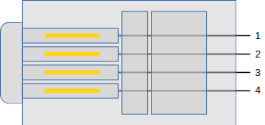
The RJ9 connectors have pin 1 on the right side, when viewing the contact side of the plug:
Here is the connection used for testing the Kaypro “keyboard port”:
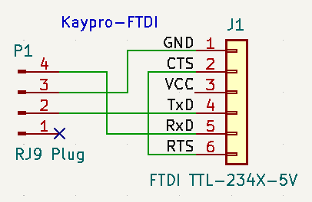
Also note that the Kaypro supplies +5V to the keyboard, and the FTDI cable is also supplying +5V. This is why +5V is left unconnected to the Kaypro.

The following cable can be built to directly connect the keyboard port to an FTDI TTL-234X-5V:

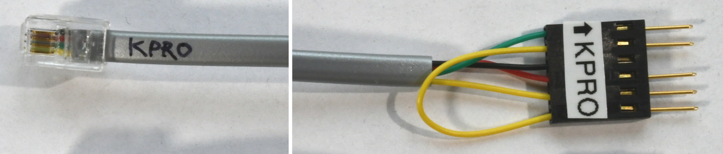

Running the Virtual Keyboard
The JAVA JAR should run on any OS with a JAVA runtime installed. It also requires a separate package “JSerial” (https://fazecast.github.io/jSerialComm/). The JAR is currently built for JSerial v2.9.3, but newer versions may work (if backward compatibility was not broken).

Typical invocation is:

java -cp VirtualKeyboard.jar:/path/to/jSerialComm-2.9.3.jar VirtualKeyboard args...

You may need/want to use a full path to VirtualKeyboard.jar, so that the command will work from any current directory. Replace “/path/to” with the location of the JSerial JAR on your system. For Windows, replace the colon with a semicolon. You may want to put this command in a shell script or batch file, to make running easier.

You may use a properties file, or just specify the serial port and baud on the commandline. args can be either the properties file or specific configuration parameters. The properties recognized in the property file are prefixed with “vkbd_” while the commandline args use the property suffix with an ‘=’. For example, a property file with:

vkbd_tty = /dev/ttyUSB1
vkbd_baud = 300

is the same as using the args:

tty=/dev/ttyUSB1 baud=300

The app will show a window looking something like this:

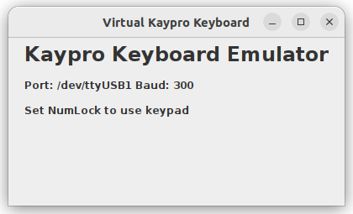
When the computer’s “focus” is set to this window, keys pressed will be translated to Kaypro codes and sent out the serial port. This app will also “beep” when the Kaypro sends the correct code out the keyboard port. Note that the NumLock must be “on” in order to translate codes from the keypad. Also note that the PC keypad ‘+’ key is equivalent to the Kaypro keypad ‘,’ (comma).

