**AWS**

**Create a windows Vm machine in AWS and connect with RDP open CMD in windows share the about system info.**

**Step 1:** Create a Instance (Window_vm)

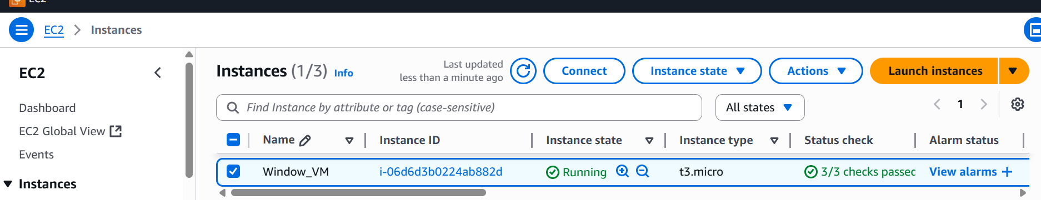

**Step 2:**Decrpt the Password

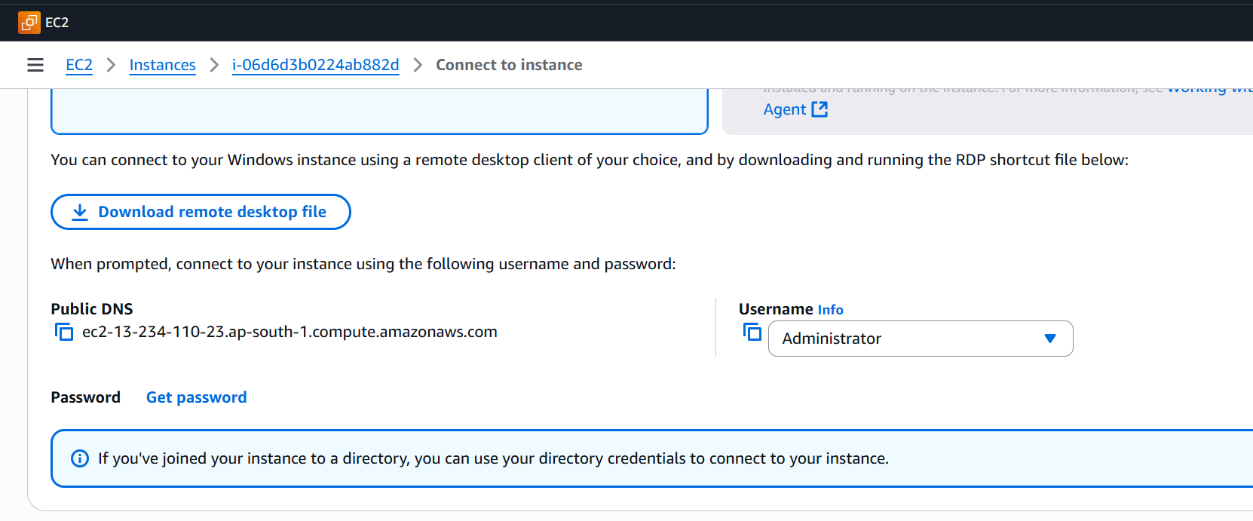

**Step 3:** Connect Window VM using RDP

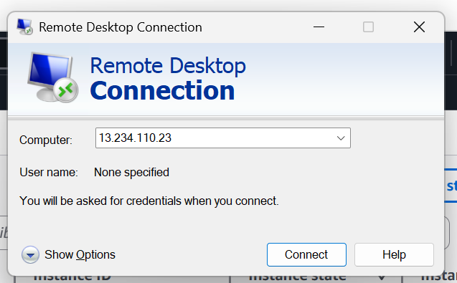

**Step 4:**Open command Prompt and Display System Information

