PROJECT DOCUMENTATION
Title : Product Inventory Management System
1.Introduction
Project Title: Product Inventory Management System
Team ID: 69a7bb3d7efb18082d5c270d
Team Leader: Dhivya M (mmdhivya3@gmail.com)
Team Members:
- Durga Dharshini R (durgadharshini115@gmail.com)
- DURIKA I (durikakumar19@gmail.com)
- Priya Dharshini S(priyabala491@gmail.com)
- Sivasri V(sivasri852007@gmail.com)
2. Project Overview
The Product Inventory Management System is a backend-focused web application developed using Node.js, Express.js, and MongoDB, designed to provide a secure and scalable solution for managing product data through RESTful APIs. The system enables users to create accounts, log in securely, and access protected routes using JWT-based authentication, ensuring that only authorized users can perform operations. It supports complete CRUD functionality, allowing users to add new products, view their inventory, update product details such as price or quantity, and delete items when needed.
Key Objectives:
• Provide secure JWT-based user authentication and authorization for protected API access.
• Enable efficient product inventory management through RESTful CRUD operations.
• Ensure user-specific data isolation so each user can manage only their own products.
• Implement scalable backend architecture using Node.js, Express.js, and MongoDB.
• Deliver fast and reliable API responses with proper validation and error handling.
Target Users:
• Small business owners managing product stock and inventory records.
• Freelancers or sellers tracking items or services in a structured way.
• Developers learning backend API development and authentication workflows.
• Students working on backend or full-stack development projects.
• Anyone needing a secure and simple backend system for managing product data.
3. Architecture
High-level architecture diagram illustrating the three-tier backend structure.
Node.js + Express Backend
• RESTful API architecture
• JWT authentication middleware
• MVC pattern (Models, Controllers, Routes)
• Input validation and error handling
MongoDB Database
• Document-based NoSQL storage
• Mongoose ODM for schema modeling
• Two collections: Users and Contacts
• Indexed fields for optimized queries
TECHNICAL ARCHITECTURE
Backend Architecture (Node.js + Express)
• Controllers: Handle authentication and product logic
• Models: Define database schema
• Routes: API endpoints for authentication and products
• Middleware: JWT verification and error handling
• Configuration: Environment variables and database connection
Database Architecture (MongoDB)
Users Collection:
• _id
• name
• email
• password (hashed)
• timestamps
Products Collection:
• _id
• userId (reference to user)
• name
• price
• quantity
• description
• timestamps
Relationship: One User → Many Products
Indexes:
• email (unique)
• userId
• product name

4. Setup Instructions
PRE-REQUISITES
Software Purpose
Node.js JavaScript runtime for backend
MongoDB Database storage
npm Package manager
VS Code Development environment
Knowledge Requirements
• JavaScript ES6 concepts
• Node.js and Express.js REST API development
• MongoDB and Mongoose ODM
• JWT authentication
• Middleware architecture

5. Folder Structure
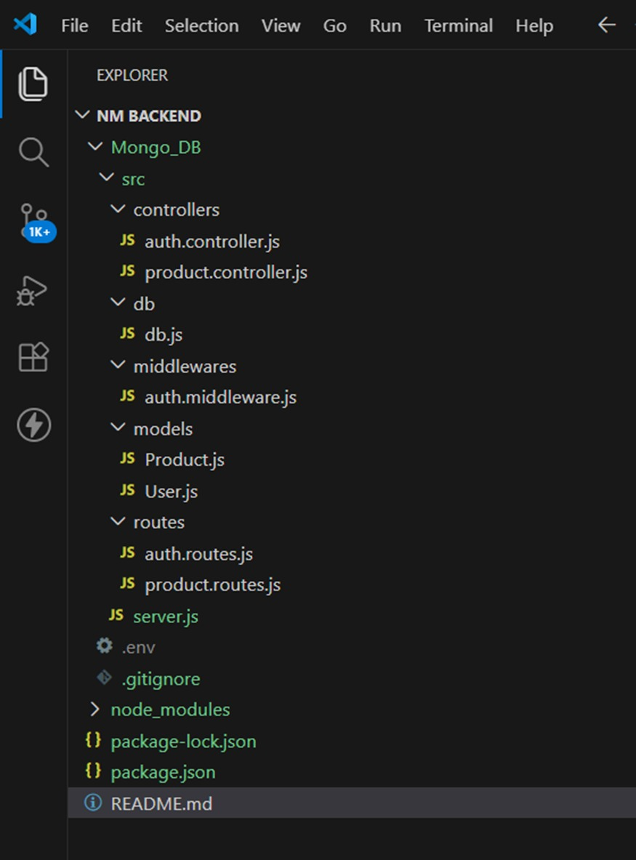

6. Running the Application
To run : npx nodemon src/server.js
Access: Visit http://localhost:5000
7. API Documentation
• User:
– /api/user/register
– /api/user/login
• Projects: 2
– /api/projects/create
– /api/projects/:id
8. Authentication
• JWT-based authentication for secure login
• Middleware protects private routes
9. User Interface
• Landing Page
• Freelancer Dashboard
• Admin Panel
• Project Details Page
10. Testing
• Manual testing during milestones
• Tools: Postman, Chrome Dev Tools

11. Screenshots

