d

Project Name

**Test Plan <Project Name >**

HighWire Press

1454 Page Mill Rd Palo Alto, CA 94304

|  |  |  |  |  |  |
| --- | --- | --- | --- | --- | --- |
| **Document Revision History** | | |  |  |  |
| **Date** | **Version** | **Description** | **Author** | **Reviewer** | **Approver** |
|  |  |  |  |  |  |
|  |  |  |  |  |  |
|  |  |  |  |  |  |
|  |  |  |  |  |  |
|  |  |  |  |  |  |
|  |  |  |  |  |  |

# Table of Contents

1. **INTRODUCTION**
2. **OBJECTIVE**
3. **SCOPE**
   1. Functions to be tested.
   2. Functions not to be tested.
4. **REFERENCES**
5. **TESTING PROCESS OVERVIEW**
6. **TEST STRATERGY**
   1. Testing Types

Black box testing

GUI Testing

Integration Testing

Functional Testing

System Testing

Performance Testing

Security and Access control testing

6.2 Tools

1. **TEST ENVIRONMENT**
2. **TEST APPROACH**
3. **ROLES AND RESPONSIBILITIES**
4. **TEST DELIVERABLE**
5. **[TEST DEPENDENCIES](#_9.Deliverables)**
6. **ENTRY AND EXIT CRITERIA**
7. **SUSPENSION CRITERIA** **AND** **RESUMPTION CRITERIA**
8. **RISK AND MITIGATIONS**

# Introduction

# Objective

# Scope

* 1. **Features to be tested**

Following Modules are to be tested

**3.2 Features not to be tested:**

# References

The Plan prepertaion contains the following documents

Referred URL’s:

|  |  |  |
| --- | --- | --- |
| **File Name** | **File path on shared drive** | **File Size (KB)** |
|  |  |  |
|  |  |  |
|  |  |  |
|  |  |  |
|  |  |  |
|  |  |  |
|  |  |  |

# Testing Process Overview

* 1. ***Process to be followed when sufficient time is available for QA* Understanding Requirements:**

**Preparing Test Cases: <specify the path of shared drive>**

.

**Preparing Test Matrix: <specify the path>**

**Reviewing test cases and matrix: <specifiy the path>**

**Creating Test Data: <specify the path>**

**Executing Test Cases: <specify the path>**

* + **Defect Logging and Reporting:**

**Retesting and Regression Testing:**

**Deployment/Delivery:**

* 1. **Defect lifecycle Process**

Phases in Defect tracking life cycle.

1. New – Defect/Bug posted for first time
2. Assign - Name of the respective person / developer
3. Resolved - By developer
4. Close Bug- By Tester
5. Replicate - QA to replicate and assign back to developer
6. Not an Issue - Close bug by tester

**Attachments:**

|  |  |  |
| --- | --- | --- |
| **File Name** | **File Type** | **File Size (KB)** |
| Defect tracking.png | image/x-png | 30 |

**Bug life cycle** for this project is as follows:

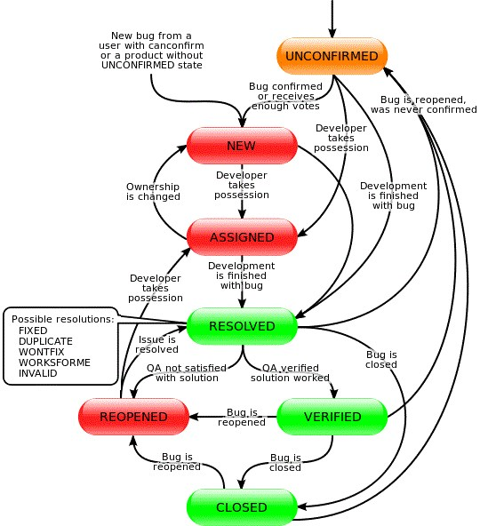

## 6.Test Strategy

**6.1 Testing types**

**Black box testing:**

It is some time called behavioural testing or Partition testing. This kind of testing focuses on the functional requirements of the BenchPress modules . It enables one to derive sets of input conditions that that will fully exercise all functional requirements for a program.

**GUI Testing:**

GUI issues were not considered in BenchPress project.

**Integration Testing:**

Not Applicable for BenchPress Project.

**Functional Testing:**

Functional testing is carried out in order to find out unexpected behaviour of the report. The characteristic of functional testing are to provide correctness, reliability, testability and accuracy of the report output/data.

**System Testing:**

System testing of software is testing conducted on a complete, integrated system to evaluate the system's compliance with its specified requirements on Dev environment.

**Performance Testing:**

Google shared drive:

**Security and Access control testing**

**6.2 Tools**

|  |  |  |
| --- | --- | --- |
| **Tool Name** | **Vender** | **Version** |
|  |  |  |
|  |  |  |
|  |  |  |
|  |  |  |
|  |  |  |
|  |  |  |

## 7. Test Environment

|  |  |
| --- | --- |
| **Server Name** | **URL** |
|  |  |
|  |  |
|  |  |
|  |  |

## 8. Test Approach

**Attachments:**

|  |  |  |
| --- | --- | --- |
| **File Name** | **File Type** | **File Size (KB)** |
|  |  |  |
|  |  |  |
|  |  |  |
|  |  |  |

## 9. Roles and Responsibilities

|  |  |
| --- | --- |
| **Role** | **Responsibilities** |
|  |  |
|  |  |

## 10. Test Deliverables

|  |  |
| --- | --- |
| **Deliverable** | **Responsibility** |
|  |  |
|  |  |
|  |  |

## 11. Test Dependencies

## 12. Entry and Exit Criteria

## 

## 13. Suspension and Resumption Criteria

## 14. Risk and Mitigations