**Job-Portal**

**Project Abstract Report**

**on**

**JOB-Portal Website**

|  |  |
| --- | --- |
| Sathi Ramya sri | 2489644 |
| Pooja Sunil Kamble | 2491238 |
| Pooja Pawar | 2491331 |
| Panjugala Jaya Bharath Reddy | 2488707 |
| Peddamallu Ajeswar Reddy | 2491047 |
| Byrraju Bala Durga Kiran Raju | 2491107 |

|  |  |
| --- | --- |
|  |  |

**By**

Under the guidance of

**Sandip Mohapatra**

**CONTENTS**

|  |  |  |
| --- | --- | --- |
|  | **TITLE** | **PAGE NO.** |
| **1** | **Abstract** | **3** |
| **2** | **Project Overview**  -Modules | **4** |
| **3** | **Objective** | **5** |
| **4** | **Project Analysis** | **5** |
| **5** | **Project Planning** | **6** |
| **6** | **Software Requirements**  -IDE used  -Languages used | **7** |
| **7** | **Forms** | **7-8** |

**Abstract:**

In this competitive era, the education among the people is so increasing that the jobs for them are now decreasing. The companies even want the people who are best in their fields. At that time, it becomes difficult to find the people who are intelligent enough to be hired. The work for the companies also increases to find the people who can fulfill their requirements. Thinking about these problems, one can think about the process which can handle this process and make the work less complex.

This project is about the recruitment process which is done online. The recruitment process here is handled by the system. This project will allow the person to apply for a job in the company for the interested vacancy which would be available at the company. The person will be having the account after registration and will be then called the applied user. If he would be qualified, he would be interacting with the system for the updates. The project is created for fulfilling the requests of the company managers so that the recruitment module can be placed in the company’s website and the users who visit the website can view the vacancies in the company and will be able to apply directly from remote place even. The vacancies will be posted by the administrator on the basis of needs of the manpower in the company.

**Project Overview:-**

**Modules:** There are 5 different pages in our website

1. Home

2) Login Page

3)Registration Page

4) Job-Search

-jobs by category

-jobs by location

5) Contact Us

- Our Contact address

6) Feedback

- Feedback

**Objective:**

The main objective of the Job Portal system is to manage the details of interview ,Employer Call Letter, Employer Registration, Search Job manages at the information about interview Post Job, Search Job, interview.The purpose of the project is to build an application program to reduce the manual work for managing the Interview ,Employer list, Job Call Letter ,tracks all the details about the Call Letter, Employer Registration, Search Job

The project objectives include the following

-To develop a user friendly job portal application interface.

-To develop an online search portal for job seekers

-To facilitate the company to search for the best candidate available

-To build a system that will act as a link connecting job portal application and other websites

**Project Analysis:**

Describes the risks that can possibly arise during software developments well as explains how to assess and reduce the effect of risks. Initially the employer will visit the home page, after that he/she will register in that portal. After that employer have to login to the portal using login page. After registration, he will be taken to a page to see different jobs according to the categories and location he enters. In the Contact & Feedback pages, the Employer can share his view and experience.

**Project Planning:**

Proper project management is essential for the successful completion of a software project. Software project management (responsible for project planning) specifies activities necessary to complete the project. After this a project schedule is prepared to accomplish the specified tasks. The purpose of planning and scheduling is to develop the software according to the user requirements within the allocated time and budget. Project planning is a part of project management, which relates to the use of schedule such as charts to plan and subsequently report progress within the project environment.

▪ Select project

▪ Identifying project’s aims & objectives.

▪ Understanding requirements & specification

▪ Methods of analysis, design & implementation

▪ Documentation

**Software requirements:**

1. IDE used: We are using Following IDE for building this project

* Visual Studio code: We used this IDE for running Angular in it and using node as server.

1. Languages Used:

* HTML: Used for writing webpage or front end code.
* CSS & Bootstrap: Used for Styling of webpages/frontend.

**Forms:**

Login Form:

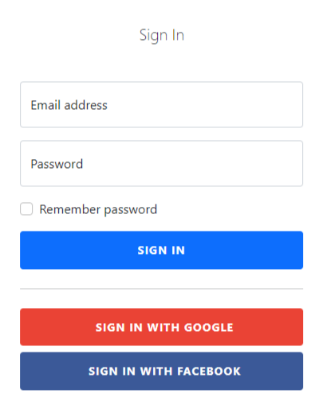

Registration Form:

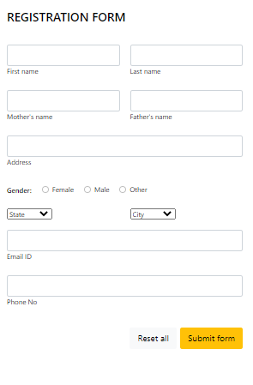

Contact form:

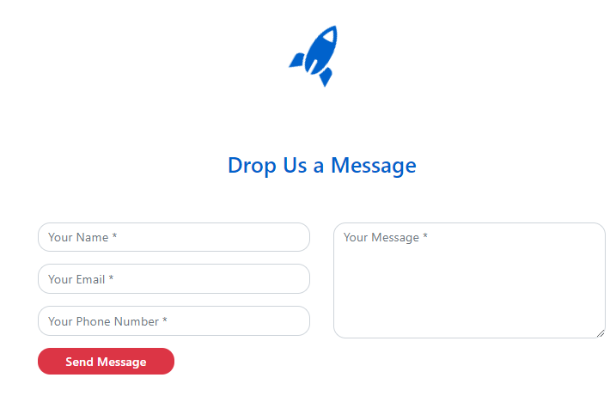

Feedback form:

