SVN Configuration 4
Object – Oriented Programming & Concepts 4
What is OOPS? 4
Why we need OOP? 4
When do we use OOP? 5
Features / Principle of OOPs 5
Object 5
Class 5
Abstraction 5
Encapsulation 7
Abstaction Vs Encapsulation 7
Inheritance 8
Polymorphism 10
Features of Java 11
Java Naming conventions 11
Constructor in Java 12
Execute Java program using command prompt 12
Basic features / Syntax 13
Operators 13
Statements 13
Modifiers 13
Access Specifiers – Private, Protected, Public, Default 13
Static 14
Final 14
Native 15
Synchronised 15
Transient 15
Volatile 15
Immutable Class (Has-a) 15
Abstract Classes and Interfaces (Is-a) 16
Abstract class Vs Interface 16
Duck pond simulation game 16
Wrapper class 16
Constructors 17
Class Methods 17
Instance Methods 17
Why do we need wrapper classes in java? 17
Are wrapper classes mutable in java? 17
JVM 17
Custom Class Loader 19
How does ClassLoader Work? 20
Exception Handling 21
Exception Hierarchy 21
Checked and Unchecked Exception 21
Try, catch and finally 21
Throw and throws 22
Exception Handling Best Practices 22
User Defined Exception 22
String Handling 22
How to create a string? 22
Why we called 'String' object is immutable? 23
String functions 24
Find out longest palindrome in a given string 24
Find number of occurrence of a word inside a String 24
Char array is preferred over String for storing password 24
StringBuilder & StringBuffer 24
Nested Class and Inner Class 24
Definition 24
Why we use Nested classes? 24
Static Nested Classes 25
Member Inner Class 25
Method-Local Inner Classes 25
Anonymous Inner Classes 25
I/O and Serialization 25
Character Streams versus Byte Streams 25
File Handling 25
Load Resource Bundle 26
Finalize method 26
Serialize / Deserialize an Object 26
Externizable Interface 27
Utility or Collection Framework 28
Why Collection Framework 28
What is Collection Framework? 28
Class Hierarchy of Collection Framework 28
Collection Interface 29
Enumeration Interface 29
Iterator Interface 29
How to use Iterator 30
Group Operations 30
Set Interface 30
HashSet, TreeSet, LinkedHashSet 31
List Interface 31
Vector, ArrayList, LinkedList Classes 32
Map Interface 33
Map.Entry Interface 33
HashMap, TreeMap Classes 33
Performance comparison of different ways to iterate over HashMap 33
WeakHashMap Class 34
ConcurrentHashMap Class 34
Comparable Interface 34
Comparator Interface 35
Read only Collections 35
Thread-Safe Collections 35
Hashtable, Properties Classes 35
Stack, Queue, Priority Queue, Blocking Queue 36
Object Cloning 37
What is Cloning 37
Why Cloning Required 38
Shallow Cloning 38
Deep Cloning 38
Cloning with serialization 38
Prototype design pattern 38
Java Concurrency / Multithreading 39
What do mean by Multithreading? 39
Multiprocessing and Multitasking 39
What is a Thread? 39
Life cycle of Thread 39
Different ways to create a Thread 40
Working with a Thread 40
Locks / Thread synchronization 42
Volatile variables 43
Wait – Notify - NotifyAll 44
Inter – Thread Communication 44
Executors, Schedule Executor & Thread Pool 44
Futures and Callables 45
Nonblocking algorithms 45
ReentrantLock 45
Lock vs synchronized 45
Java 5 features 46
For each loop 46
Var-args 46
AutoBoxing 46
Generics 46
Enum 47
Covariant Return 48
Annotation 48
Static Import 51
JDBC Connectivity 51
Types of Driver 51
Install & Configure Database 52
Steps to Create a Database Connection 55
Create few table using SQL Scrapbook 56
Database URL’s 56
Read data from Database using Statement 56
Read data from Database using PreparedStatement 56
Read data from Database using DataSource 57
ResultSet Type 57
ResultSet Concurrency 58
ResultSet Holdability 58
Insert data into Database 58
Update data into Database 58
Delete data from Database 58
Batch Updates 58
Rowset 60
CallableStatement 61
Connection Pooling using JNDI Services 62
Inside Tomcat using Servlet.xml 62
Connection Pooling using Context.xml 64
Java 6 features 65
WebService 65
Rhino 65
Derby DB 66
Deque 66
JavaTM API for XML Processing (JAXP) 66
JDBC 4.0 Enhancements 66
Java 7 features 68
Strings in switch 68
Binary Literals with prefix "0b" 68
Catching Multiple Exception Types 68
The try-with-resources Statement 68
Type Inference for Generic Instance Creation 68
Rethrowing Exceptions with Improved Type Checking 68
JUNIT & TDD 69
Unit tests and unit testing 69
The JUnit framework 69
JUnit naming conventions 69
JUnit test suites 69
TDD Aproach 69
Run your test from the command line 70
Available JUnit annotations 71
Assert statements 72

SVN Configuration
Version Control System is software that helps software developers to work together and also maintains complete history of their work.
- Repository / Repo Browser & URLs
- Trunck (MainLine)
- Branches
- Tags
- Working Copy
- Commit Changes (or Check ins)
- Check out
- Update or Sync
- Merge changes

Examples – SVN, CVS, WinCVS, Harvest, etc.

If you don’t have SVN client then download it from http://tortoisesvn.net/downloads.html
Install Tortoise SVN client

Checkout Project from-
http://amit-core-java.googlecode.com/svn/trunk/CoreJava

Object – Oriented Programming & Concepts

What is OOPS?
Object oriented programming is the approach to oraganized your source code in terms of real world objects.

Object Oriented Programming or OOP is the technique to create programs based on the real world. It is a type of programming in which programmers define not only the data type of a data structure, but also the types of operations (functions) that can be applied to the data structure. In this way, the data structure becomes an object that includes both data and functions. In addition, programmers can create relationships between one object and another.

Simula is considered as the first object-oriented programming language.
The programming paradigm where everything is represented as an object is known as truly object-oriented programming language. Smalltalk is considered as the first truly object-oriented programming language.

Java is based an OOP. It is not a pure Object Oriented Programming Language.
Many languages are Object Oriented. There are seven qualities to be satisfied for a programming language to be pure Object Oriented. They are:
- Encapsulation/Data Hiding
- Inheritance
- Polymorphism
- Abstraction
- All predefined types are objects
- All operations are performed by sending messages to objects
- All user defined types are objects.
Java is not because it supports Primitive datatype such as int, byte, long... etc, to be used, which are not objects.
Contrast with a pure OOP language like Smalltalk, where there are no primitive types, and boolean, int and methods are all objects.

Why Java is popular than Smalltalk?
- Smalltalk is too slow for big project
- Database connection was difficult
- Java is platform independent

Why we need OOP?
Designed / Implement your source code in terms of real world (i.e. Objects) then it is easy to understand, maintain, independent of developers. To remove complexity of codebase.

Let’s see an example of Employee, their Address, role & Department

Address_Data{
Flat, street, locality,city , state, country
}

Role_Data {
roleId, roleName
}

Employee_Data{
empId, name, roleId, mrgId, deptNo, address_data
}

Department_Data{
deptNo, deptName
}

Role_Functions {
addRole(Role_Data)
getRole(roleId)
listRole()
updateRole(Role_Data)
deleteRole(roleId)
}

Employee_Functions {
addEmplyoee(Employee_Data)
getEmployee(empId)
listEmployee()
updateEmployee(Employee_Data)
deleteEmployee(empId)
}

Department_Functions {
addDepartment(Department_Data)
getDepartment(deptNo)
listDepartment()
updateDepartment(Department_Data)
deleteDepartment(deptNo)
}

In procedural approach, all functions should be inside a Main Fucntion where it is difficult to maintain code for a big system in future whereas in OOP since every object (i.e. Employee OR Role OR Department) are separate entity so put a particular object’s state & their behaviour together which will provide code is maintaintable, flexible, reusable, etc.

Therefore, principal advantages of object-oriented programming techniques over procedural programming techniques is that they enable programmers to create modules that do not need to be changed when a new type of object is added. A programmer can simply create a new object that inherits many of its features from existing objects. This makes object-oriented programs easier to modify.

When do we use OOP?
Use Procedural approach where we don’t have detailed idea about all components of a system like in device driver progamming, etc. In this scenario always prefer to do Top-Down approach.

When there are many simple independent tasks / modules to perform & severals programmers to involve completing the system by doing simultanuosly then always preferred to use OOP which flows Bottom-up approach.

Features / Principle of OOPs

Object
Any entity that has state and behavior is known as an object. For example: chair, pen, table, keyboard, bike etc. It can be physical and logical.

Class
Collection of objects is called class. It is a logical entity.
A class is a blueprint or prototype from which objects are created. This section defines a class that models the state and behavior of a real-world object.

Abstraction
In one line definition is– Only exposed what’s necessary.

Hiding internal details and showing functionality is known as abstraction.
Abstraction is the concept of exposing only the required essential characteristics and behavior with respect to a context.
Abstraction simply means generalizing something to hide the complex logic that goes underneath.

For example:
- Real world Example of Abstraction: -
Suppose you have an object Mobile Phone.

Suppose you have 3 mobile phones as following:-

Nokia 1400 (Features:- Calling, SMS)
Nokia 2700 (Features:- Calling, SMS, FM Radio, MP3, Camera)
Black Berry (Features:-Calling, SMS, FM Radio, MP3, Camera, Video Recording, Reading E-mails)

Abstract information (Necessary and Common Information) for the object "Mobile Phone" is make a call to any number and can send SMS."

so that, for mobile phone object you will have abstract class like following:-

abstract class MobilePhone
{
public void Calling();
public void SendSMS();
}

public class Nokia1400 extends MobilePhone
{

}

public class Nokia2700 extends MobilePhone
{
public void FMRadio();
public void MP3();
public void Camera();
}

public class BlackBerry extends MobilePhone
{
public void FMRadio();
public void MP3();
public void Camera();
public void Recording();
public void ReadAndSendEmails();

}

Abstraction means putting all the variables and methods in a class which are necessary.

- People own savings accounts, checking accounts, credit accounts, investment accounts, but not generic bank accounts. In this case, a bank account can be an abstract class and all the other specialized bank accounts inherit from bank account.
- Phone call, we don't know the internal processing.
- In general computer software, when we talk about abstraction the software language itself is an example for the concept of abstraction. When we write a statement as,
a = b + c;
we are adding two values stored in two locations and then storing the result in a new location. We just describe it in an easily human understandable form. What happens beneath? There are registers, instruction sets, program counters, storage units, etc involved. There is PUSH, POP happening. High level language we use abstracts those complex details.
- ATM is a good example of abstraction, we doesn't know what are all the internal processes that are going when we access it. Instead we know only the inquiries, deposit, withdrawl etc

In java, we use abstract class and interface to achieve abstraction.

Encapsulation
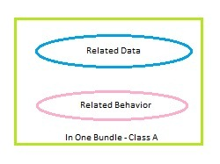
In one line definition is– Hide complexity

Encapsulation in Java you see all member variables are made private so they are well encapsulated you can only change or access this variable directly inside this class. If you want to allow outside world to access these variables is better creating a getter and setter that allows you to do any kind of validation, security check before return loan so it gives you complete control of whatever you want to do and single channel of access for client who is controlled and managed.
Class Loan {
private String loan;

public String getLoan() {
….
return loan;
}
}

Question: Why it is recommended to use getter & settor?

Advantage of Encapsulation in Java and OOPS
Here are few advantages of using Encapsulationwhile writing code in Java or any Object oriented programming language:

1. Encapsulated Code is more flexible and easy to change with new requirements.
2. Encapsulation in Java makes unit testing easy.
3. Encapsulation in Java allows you to control who can access what.
4. Encapsulation also helps to write immutable class in Java which are a good choice in multi-threading
environment.
5. Encapsulation reduce coupling of modules and increase cohesion inside a module because all piece of one thing
are encapsulated in one place.
6. Encapsulation allows you to change one part of code without affecting other part of code.

Important point’s aboue encapsulation in Java-
1. "Whatever changes encapsulate it" is a famous design principle.
2. Encapsulation helps in loose coupling and high cohesion of code.
3. Encapsulation in Java is achieved using access modifier private, protected and public.
4. Factory pattern, Singleton pattern in Java makes good use of Encapsulation

Abstaction Vs Encapsulation
Both are complementary to each other because abstraction states shows only thing which are required to user & encapsulation states that hide the compelxities. Abstraction is more towards design part where as encapsulation is more towards low level implementation.

Encapsulation is wrapping and controlling access of logically related data in a class. One of the aspects of this is by using suitable access modifiers. Abstraction on the other hand is generalizing the concept so that the underlying complex logic is hidden from the user. In java this is achieved by using interfaces and abstract classes.

Abstraction is implemented in Java using interface and abstract class while Encapsulation is implemented using private, package-private and protected access modifier.

Abstraction | Encapsulation
1. Abstraction solves the problem in the design level. | 1. Encapsulation solves the problem in the implementation level.
2. Abstraction is used for hiding the unwanted data and giving relevant data. | 2. Encapsulation means hiding the code and data into a single unit to protect the data from outside world.
3. Abstraction lets you focus on what the object does instead of how it does it | 3. Encapsulation means hiding the internal details or mechanics of how an object does something.
4. Abstraction- Outer layout, used in terms of design.  For Example:-  Outer Look of a Mobile Phone, like it has a display screen and keypad buttons to dial a number. | 4. Encapsulation- Inner layout, used in terms of implementation.  For Example:- Inner Implementation detail of a Mobile Phone, how keypad button and Display Screen are connect with each other using circuits.

For example –
- complex logic is in the circuit board which is encapsulated in a touchpad and a nice interface (buttons) is provided to abstract it out.
- GSM.java => sendMessage(MessageObject)
Abstraction is GSM->MessageDeliveryStatus sendMessage(MessageObject)
Encapsulation is -> + sendMessage(MessageObject)
- isDesviceActive()
- isReceipientPresent()
- isMessageTextValidated()
- isMessageDelivered()
- etc.

Inheritance
Java Inheritance defines an is-a relationship between a superclass and its subclasses. This means that an object of a subclass can be used wherever an object of the superclass can be used. Class Inheritance in java mechanism is used to build new classes from existing classes. The inheritance relationship is transitive: if class x extends class y, then a class z, which extends class x, will also inherit from class y.

Inheritance allows one class to reuse the functionality provided by its superclasses.
class clsName2 extends clsName1
{
// class body
}

Types of Inheritence
- Single Inheritance
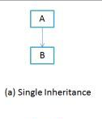
- Multiple Inheritance
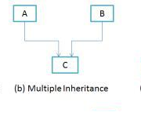
- Mutilevel Inheritance
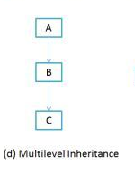
- Hierarchical Inheritance
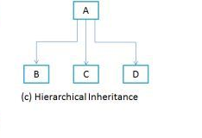
- Hybrid Inheritance
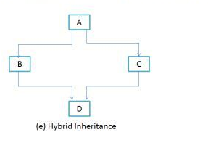

Why java does not support multiple inheritance?
In order to enforce simplicity should be the main reason for omitting multiple inheritance. For instance, we can consider diamond problem of multiple inheritance.
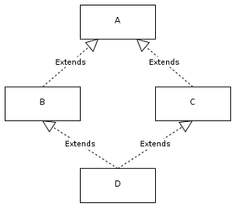
We have two classes B and C inheriting from A. Assume that B and C are overriding an inherited method and they provide their own implementation. Now D inherits from both B and C doing multiple inheritances. D should inherit that overridden method, which overridden method will be used? Will it be from B or C? Here we have an ambiguity.

Polymorphism
Polymorphism literally means taking more than one form. Polymorphism is a characteristic of being able to assign a different behavior or value in a subclass, to something that was declared in a parent class.

Polymorphism means— we can dynamically change the behaviour of a method.
One name many form means method have same name with different behaviour
Real World Example of Polymorphism:
Example-1
A Teacher behaves to student.
A Teacher behaves to his/her seniors.
Here teacher is an object but attitude is different in different situation.
Example-2
Person behaves SON in house at the same time that person behaves EMPLOYEE in office.
Example-3
Your mobile phone, one name but many forms
- As phone
- As camera
- As mp3 player
- As radio

Static or Compile time Polymorphism or Method Overloading
Method overloading in Java occurs when two or more methods shares same name and fulfill at least one of the following condition.
1) Have different number of arguments.
2) Have same number of arguments but their types are different.
3) Have both different numbers of arguments with a difference in their types.

Example – Core Java: com.src.java.polymorphism.overloading – Calculator.java
Note: Return type not part of method overloading.

Dynamic or Runtime Polymorphism or Method Overriding
Method Overriding is possible in the case of inheritance where child class inherits the property of parent class, i.e; if parent class has some method then child class can override the method but keep in mind that signature of the method must be same as on parent class. At runtime JVM will decide which is to call depending upon its reference.
In object oriented terms, overriding means to override the functionality of any existing method.
Rules-
- The argument list must exactly same that of the overridden method. If they don't match, you can end up with an overloaded method.
- The return type must be the same as, or a subtype of, the return type declared in the original overridden method in the superclass (also called covariant return type).
- You cannot override a method marked final.
- You cannot override a method marked static.
- The overriding method must not throw checked exceptions that are new or broader than those declared by the overridden method. For example, a method that declares a FileNotFoundException cannot be overridden by a method that declares a SQLException, Exception, or any other non-runtime exception unless it's a subclass of FileNotFoundException.
Example – Core Java: com.src.java.polymorphism. runtime –
Parent.java
Child.java
TestRuntimePolymorphism.java

Difference between Overloading & Overriding

Features of Java
- Platform Independent / Architecture Neutral
  - Write once and run any where
  - JVM is platform dependent whereas bytecode is platform independent
  - Platform=hardware+Operating System
  - JRE contains JVM and JVM read that byte code and execute it. Different JVM is designed for different OS and byte code is able to run on different OS
- Simple & Powerful
  - Java is Easy to write and more readable
  - Most of the concepts are drawn from C++ thus making Java learning simpler
- Object oriented
- Distributed
  - We can create distributed applications in java. RMI and EJB are used for creating distributed applications. We may access files by calling the methods from any machine on the internet.
  - Support for TCP, UDP, and basic Socket communication is excellent and getting better.
  - The class libraries allov IPv6 to be plugged in easily.
  - A varioty of high-level abstractions for network communication and distributed processing are available including applets, servlets, aglets, remote method invocation (RMI), and more
- Robust & Secure
  - Java program cannot harm other system thus making it secure
  - Java provides a secure means of creating Internet applications
  - Strong memory allocation and automatic garbage collection
- Dynamic
  - Java programs carry with them substantial amounts of run-time type information that is used to verify and resolve accesses to objects at run time
- Performance
  - Bytecodes are highly optimized
  - JVM can executed them much faster
- Multithreaded
  - Java supports programming, which allows the user to write programs that perform many functions simultaneously
  - The two or more part of the program can run concurrently then each part of such a program is called a Thread and this type of programming is called multithreaded programming
  - Each thread defines a separate path of execution. Thus, multithreading is a specialized form of multitasking

Java Naming conventions
Java follows camelcase syntax for naming the class, interface, method and variable.
If name is combined with two words, second word will start with uppercase letter always e.g. actionPerformed(), firstName, ActionEvent, ActionListener etc.
Name | Convention
class name | should start with uppercase letter and be a noun e.g. String, Color, Button, System, Thread, MessagingSystem etc.
interface name | should start with uppercase letter and be an adjective e.g. Runnable, Remote, ActionListener etc.
method name | should start with lowercase letter and be a verb e.g. actionPerformed(), main(), print(), println() etc.
variable name | should start with lowercase letter e.g. firstName, orderNumber etc.
package name | should be in lowercase letter e.g. java, lang, sql, util etc.
constants name | should be in uppercase letter. e.g. RED, YELLOW, MAX_PRIORITY etc.

Constructor in Java
Constructor is a special type of method that is used to initialize the object. Constructor is invoked at the time of object creation. It constructs the values i.e. provides data for the object that is why it is known as constructor.
There are two types of constructors:
- default constructor (no-arg constructor)
- parameterized constructor
- Constructor Chaining (base class constructor called first)
Use super to call parent class constructor / methods
Use this to call invoking object constructor / methods
Example – Core Java: com.src.java.constructor –
- Employee.java
- TestEmployeeClient.java

Execute Java program using command prompt
Install JDK1.7 (as per bit of OS) & set JAVA_HOME

Scenarios-
- How to compile & execute a java program from command prompt?
- How to create jar file & execute class from jar file either from same / different location?
- If my jar file contain a class inside a package at C: drive, how can I use it into my java file which is saved at D: drive & execute it?

- Create a Java program “FirstCommanLineProgram.java” inside “c:\temp” folder
public class FirstCommanLineProgram {
public static void main(String args[]) {
System.out.println("FirstCommanLineProgram");
}
}
- Goto command prompt -> C:\temp
Make sure java in your path by executing “java –version”
- Compile & execute using below commands
javac FirstCommanLineProgram.java
java FirstCommanLineProgram

- Create a Jar file “bundle.jar” at C:\temp
jar -cf bundle.jar FirstCommanLineProgram.class

- Goto another drive let’s say “D:\AmitKumar\Personal\PPT\GPSWorkSpace\CoreJava”
- Execute FirstCommanLineProgram using first.jar from command prompt
java -cp C:\temp\bundle.jar FirstCommanLineProgram
- Create a folder “second” inside “c:\temp”
- Create a Java program “SecondCommanLineProgram.java” inside “c:\temp\second” folder
package second;

public class SecondCommanLineProgram {
public void print() {
System.out.println("Print - SecondCommanLineProgram");
}

public static void main(String args[]) {
System.out.println("SecondCommanLineProgram");
}
}
- Goto command prompt -> C:\temp\second
- Compile javac SecondCommanLineProgram.java
- Cd ..
- Execute java second.SecondCommanLineProgram
- Create a jar file
jar -cvf bundle.jar FirstCommanLineProgram.class second\SecondCommanLineProgram.class
- Goto another drive let’s say “D:\AmitKumar\Personal\PPT\GPSWorkSpace\CoreJava”
- Execute java -cp C:\temp\bundle.jar second.SecondCommanLineProgram
- Create a Java file “TestClient.java” inside “D:\AmitKumar\Personal\PPT\GPSWorkSpace\CoreJava” which is using
SecondCommanLineProgram.class
import second.*;

public class TestClient{
public static void main(String a[]) {
SecondCommanLineProgram sec = new SecondCommanLineProgram();
sec.print();
}
}
- Compile TestClient.java
javac -cp c:\temp\bundle.jar TestClient.java
- Execute TestClient.java
java -cp "c:\temp\bundle.jar;" TestClient

Basic features / Syntax
- Compiler and Interpreter (JVM)
- JDK and JRE
- Path and classpath
- Eclipse IDE Overview & program debugging, Set classpath
- Data Type – int, float, Boolean, char, byte, etc
- Variables
- Command Line Arguments
Example – Core Java: com.src.java.constructor – CommandLineTestProgram.java
To execute this file from command prompt use below command-
java CommandLineTestProgram pratik 10 5

- Array & user input in java
Example – com.src.java.basics –
IntegerArray.java
StringArray.java
- Casting
Example – com.src.java.basics – Casting.java
Example – com.src.java.polymorphism.runtime – TestRuntimePolymorphism.java
- Scope of Local Variable and Instance Variable
Example – com.src.java.basics – ScopeVariables.java

Operators
- Arithmetic
- Bitwise
- Relational
- Logical: Short-circuit Operator
- Assignment
- Instanceof
Example – com.src.java.operators – InstanceOfOperator.java

Statements
- Sequential statement
- Conditional statement
Example – com.src.java.basics – ConditionalStatements.java
- Control statement
Example – com.src.java.basics – ControlStatements.java

Modifiers

Access Specifiers – Private, Protected, Public, Default
Access level modifiers determine whether other classes can use a particular field or invoke a particular method.
The following table shows the access to members permitted by each modifier.
Access Levels
Modifier | Class | Package / Subclass | Outside package + Subclass | World
public | Y | Y | Y | Y
protected | Y | Y | Y | N
default | Y | Y | N | N
private | Y | N | N | N
The first data column indicates whether the class itself has access to the member defined by the access level. As you can see, a class always has access to its own members. The second column indicates whether classes in the same package as the class (regardless of their parentage) have access to the member. The third column indicates whether subclasses of the class declared outside this package have access to the member. The fourth column indicates whether all classes have access to the member.

Example – com.src.java.modifiers & com.src.java.modifiers.basepackage –
BaseClass.java, SubclassInSamePackage.java, SubClassInDifferentPackage.java, ClassInDifferentPackage.java

Static
- All variables inside a class (not declared inside any methods) & not have static type called as instance or member variables. All objects have separate memory space for all instance variables.

- Variable as static type called as Class level variables since all objects of a class share data. So, it is not thread safe. Recommended to use this inside synchronized block (discuss later in Multithreading).

- Method as static don’t require object instance. These method called directly by using class name. Mostly, utility methods / getting instance of singleton class (dicuss later in Cloning) inside project as marked as static type.
Example – com.src.java.modifiers – StaticModifierExample.java
com.src.java.utility – StringUtils.java

- Class as static can be used as nested class (discuss later in Nested class). Never applied with top level class.

- We can’t use non-static varibales / methods inside a static method. For ex- Non-static instance variable can’t be used inside main method of Java program. We need to use non-static into static method via object instance only.
Example – com.src.java.modifiers – StaticModifierExample.java

- Static keyword can also be used to create static block in Java which holds piece of code to execute when class is loaded in Java. This is also known as static initialize block. Static blocks are mainly used to load library files.
Example – com.src.java.basics – ExecutionSteps.java

- Static method can be overloaded but not override (since static method resolve at Compile time only not at runtime)
Example – com.src.java.basics –TestStaticOverriden.java

- Explain System.out.println => System is a Class where out is class variable of PrintStream & println is method defined inside PrintStream.
Question- Can constructor could be static OR why java doesn’t support static constructor?
Everything that is marked static belongs to the class only, for example static method cannot be inherited in the sub class because they belong to the class in which they have been declared. Since each constructor is being called by its subclass during creation of the object of its subclass, so if you mark constructor as static the subclass will not be able to access the constructor of its parent class because it is marked static and thus belong to the class only. This will violate the whole purpose of inheritance concept and that is reason why a constructor cannot be static.

Final
- Can’t change value of variable if marked as final. It is best practice to mark method parameter as final if its value will not changes. Variable must be initialize either using Initializer block / constructor OR assignment during declaration. It is threading safe.

- Method marked as final can’t be override. Generally, those we put final method while defining abstraction functionalty where we can’t changes a defined functionality.

- Class marked as final can’t be inheriting by anyother class. We can only use its functionality by has-a relationship (also called as Composition) i.e. creating a reference inside any class. We required such case where we don’t want that user can change predefined functionality of class.
Has-a relationship is best because with this implementation Client class only use required feature. Is-a relationship (is also called Aggregation) always take more memory since all available methods are also available into client class.
String class is final class that’s why we can’t override its methods.
Example – com.src.java.modifiers – FinalModifierExample.java & TestFinalExample.java & NotFinalExamples.java

Native
The native keyword is used to declare a method which is implemented in platform-dependent code such as C or C++. When a method is marked as native, it cannot have a body and must ends with a semicolon instead. The Java Native Interface (JNI) specification governs rules and guidelines for implementing native methods, such as data type conversion between Java and the native application.
Example – com.src.java.modifiers – NativeModifierExample.java

Synchronised
When more than one thread access same object at a time data could be inconsistent. To overcome this issue, we can use syncrhronised but performance will be impacted.
Used into multithreading (discuss later in Multithreading)

Transient
Variables marked as transient can’t be part of object serialization (discuss later in I/O - serialization)

Volatile
Variable marked as volatile will never be cached thread-locally: all reads and writes will go straight to "main memory" (discuss later in Multithreading & JVM)

Immutable Class (Has-a)
An immutable class is one whose state can not be changed once created. There are certain guidelines to create an class immutable. Example – String class & all utility classes are immutable.
Immutable classes are-
- are simple to construct, test, and use
- are automatically thread-safe and have no synchronization issues
- do not need an implementation of clone

Guidelines to make a class immutable
- Don’t provide “setter” methods — methods that modify fields or objects referred to by fields.
- Make all fields final and private
- Don’t allow subclasses to override methods

final class ImmutableClass {
final private int x;
final private int y;

ImmutableClass(int x, int y) {
this.x = x;
this.y = y;
}

public final int getX() {
return x;
}

public final int getY() {
return y;
}
}
Example – com.src.java.immutable – ImmutableClass.java, TestClient1.java, TestClient2.java
Create your own Logger class inside project.

Abstract Classes and Interfaces (Is-a)
- An abstract class is a class that is declared abstract—it may or may not include abstract methods (which don’t have body). Abstract classes cannot be instantiated, but they can be subclassed.

- An abstract method is a method that is declared without an implementation (without braces, and followed by a semicolon), like this:
abstract void moveTo(double deltaX, double deltaY);

- If a class includes abstract methods, then the class itself must be declared abstract

- When an abstract class is subclassed, the subclass usually provides implementations for all of the abstract methods of its parent class. However, if it does not, then the subclass must also be declared abstract.

- An interface is a collection of abstract methods. A class implements an interface, thereby inheriting the abstract methods of the interface.

- Interface – use to expose method for contract or imposing some rules

Abstract class Vs Interface
- Abstract class can have both abstract / concrete methods whereas interface always have abstract methods

- Members of interface are bydefault public & abstract whereas abstract class members can be private, protected, public & may or may not be abstract.

- An interface can inherits another Java interface only; an abstract class can inherit another Java class and implement multiple Java interfaces. One interface can inherit one or more inteface at time i.e. indirectly provide mutiple inhertence in Java.

- In comparison with java abstract classes, java interfaces are slow as it requires extra indirection.

- We can define constructor inside abstract class which is not possible inside interface.

- Extend is used class & implement is used for interface

If we can’t instantiate abstract class then why we need constructor inside Abstract class?
Yes there is implicit default constructor inside abstact class. To intialize abstarct class member variable, we always need parametrized contructor inside abstract class. These constructors always call from sub class inheritence hierarchy.

Duck pond simulation game
The game SimUDuck show a large variety of ducks species which can fly or quack or both.
Four types of Duck & all duck swims
- MallardDuck – can both quack & fly
- DecoyDuck – can’t either quack or fly
- RubberDuck – can only Squeak but not fly
- RedheadDuck – can both quack & fly

Example – com.src.java.simuduck, com.src.java.simuduck.duck, com.src.java.simuduck.fly, com.src.java.simuduck.quack

Why Has-a relationship is better than Is-a relationship?
- Subclass will not be overload by inheriting any class
- We can do runtime polymorphism using has-a relationship

Wrapper class
Each of Java's eight primitive data types have a class dedicated to it. These are known as wrapper classes, because they "wrap" the primitive data type into an object of that class. So, there is an Integer class that holds an int variable, there is a Double class that holds a double variable, and so on. The wrapper classes are part of the java.lang package, which is imported by default into all Java programs. The following discussion focuses on the Integer wrapper class, but applies in a general sense to all eight wrapper classes.

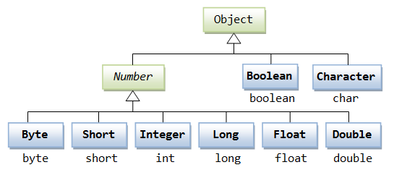

Constructors
Integer(i) constructs an Integer object equivalent to the integer i
Integer(s) constructs an Integer object equivalent to the string s

Class Methods
parseInt(s) returns a signed decimal integer value equivalent to string s
toString(i) returns a new String object representing the integer i

Instance Methods
byteValue() returns the value of this Integer as a byte
doubleValue() returns the value of this Integer as an double
floatValue() returns the value of this Integer as a float
intValue() returns the value of this Integer as an int
longValue() returns the value of this Integer as a long
shortValue() returns the value of this Integer as a short
toString() returns a String object representing the value of this Integer

Example - com.src.java.wrappers – AutoBoxUnBox.java, FindRanges.java, ValueOfDemo.java, WrapperDemo.java

Why do we need wrapper classes in java?
Actually we can use primitive types in many places but not all. In some cases we can’t use primitive values as is, so wrapper classes are needed / required. For example, if we need to store numbers in a collection, we can’t use primitives because collections such as List, Set, and Map need objects as their elements. In such cases you must use wrapper classes.

Are wrapper classes mutable in java?
Like Strings, wrapper classes in java such as Integer, Float, Long, and Double are also “immutable”. Once created, the numbers wrapped within the objects of wrapper classes in java.lang package can’t be changed.

JVM
- JRE consists of JVM and JAVA runtime API
- JVM consists of Class Loader, Bytecode Verifier, Garbage Collector, Security Manager, and Execution Engine
- Java command create an instance of JVM
- Class Loader responsible for bringing class file into the JVM.

- There are 3 types of class loader in java-
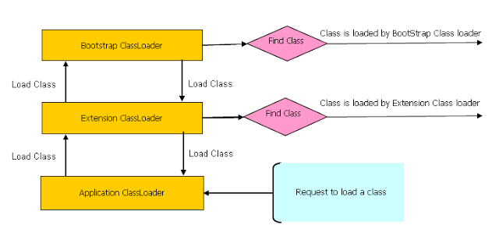
Whenever a new JVM is started by typing java MyMainClass, the "bootstrap class loader" is responsible for loading key Java classes like java.lang.Object and other runtime code into memory first. The runtime classes are packaged inside of the JRE\lib\rt.jar file.
Next come the Java extension class loader. We can store extension libraries, those that provide features that go beyond the core Java runtime code, in the path given by the java.ext.dirs property. The ExtClassLoader is responsible for loading all .jar files kept in the java.ext.dirs path. A developer can add his or her own application .jar files or whatever libraries he or she might need to add to the classpath to this extension directory so that they will be loaded by the extension class loader.
The third and most important class loader from the developer perspective is the AppClassLoader. The application class loader is responsible for loading all of the classes kept in the path corresponding to the classpath environment variable.

- Garbage Collector is used to remove objects which go out of scope

- Java Runtime Memory Area consist Method Area, Heap, Java Stack, and Native Stack
For each thread, there is a separate Java Stack / Native Stack:
For each method inside a Java Stack there is a Java Stack Frame. Stack frame consists of any local variables which are defined inside a method, any arguments which are passing to a method, next instructions to be executed inside method, and also the status of the return type.

- Regardless of no. of Object, there should be only one copy of method is loaded into Method Area. Method Area consist Method Table which get reference of location where methods are loaded into Method Area.

- Instance variables and object lives on Heap. Each object into the heap has a pointer to the Method Table related to its method.

- All static variables get the spaces into the Method Tables which is a global area.
- Gargabe Collection will invoke as and when required to collect all object which go out of scope (Heap & Method Area)
- We can explicitly invoke the GC (System.gc()) but it is not guaranteed.

- Object class belong to lang package
boolean equals(Object)
Object clone()
long hashcode()
void wait()
void wait(long ms)
void notify()
void notifyAll()
Class getClass() – used to apply reflection

Q: If Wait, Notify, NotifyAll are related to Multithreading then why Java kept these methods inside Object class instead of Thread class?

- Whenever classes are loaded into the JVM, the JVM creates the object of class Class for every class loaded into the JVM and puts it into the Hashtable which is maintained by the JVM.

- Class
String getName()
Class getSuperClass()
Class[] getInterfaces()
Methods[] getMethods()
Constructor[] getConstructors()
Field[] getFields()
Method[] getDeclaredMethods()
Constructor[] getDeclaredConstructors()
Field[] getDeclaredFieds()
Object newInstance()
Class forName(String)
Class forName(String, boolean initialize, ClassLoader)
(Discuss later inside Reflection)

Custom Class Loader
Many times during the development you will need to work with different libraries versions which not always backward compatible or from some reason you need to support multiple versions of the same library.

Using standard Java classloaders will not solve this issue since they all use "loadClass" method to load a specific class only once. After that "loadClass" will return the reference of the existing Class instance.

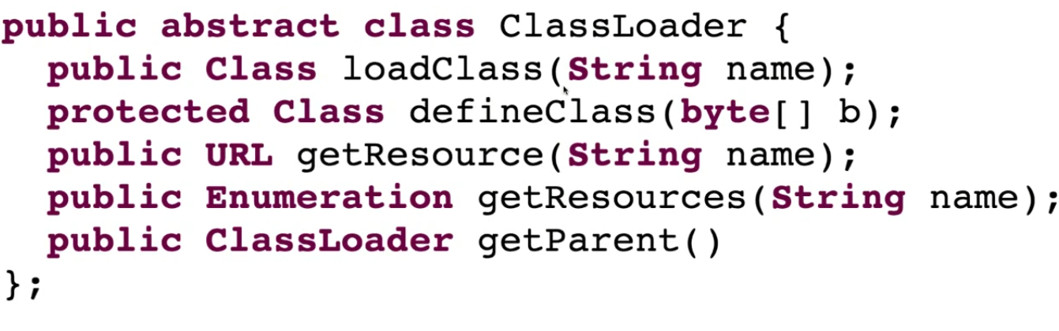
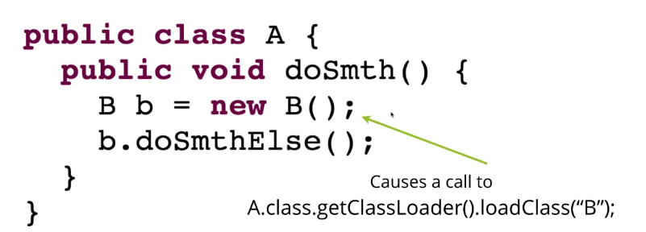

Important Points:
- All classes in a Java application are loaded using some subclass of java.lang.ClassLoader. Loading classes dynamically must therefore also be done using a java.lang.ClassLoader subclass.

When a class is loaded, all classes it references are loaded too. This class loading pattern happens recursively, until all classes needed are loaded. This may not be all classes in the application. Unreferenced classes are not loaded until the time they are referenced.

- Class loaders in Java are organized into a hierarchy. When you create a new standard Java ClassLoader you must provide it with a parent ClassLoader. If a ClassLoader is asked to load a class, it will ask its parent class loader to load it. If the parent class loader can't find the class, the child class loader then tries to load it itself.

- The steps a given class loader uses when loading classes are:
Check if the class was already loaded.
If not loaded, ask parent class loader to load the class.
If parent class loader cannot load class, attempt to load it in this class loader.

- The findClass method of ClassLoader searches for the class in the current class loader if the class wasn't found by the parent class loader. You will probably want to override this method when you instantiate a class loader subclass in your application.

- The class java.net.URLClassLoader serves as the basic class loader for extensions and other JAR files, overriding the findClass method of java.lang.ClassLoader to search one or more specified URLs for classes and resources.

How does ClassLoader Work?
- When JVM requests for a class, it invokes loadClass function of the ClassLoader by passing the fully classified name of the Class.
- loadClass function calls for findLoadedClass() method to check that the class has been already loaded or not. It’s required to avoid loading the class multiple times.
- If the Class is not already loaded then it will delegate the request to parent ClassLoader to load the class.
- If the parent ClassLoader is not finding the Class then it will invoke findClass() method to look for the classes in the file system.
Using another classloader to load the library (or multiple classloaders) & there are several approaches available to achieve that:
- Use an URLClassLoader - This class loader will allow you to load your jars via URLs, or specify a directory for your classes location.
URLClassLoader clsLoader = URLClassLoader.newInstance(new URL[] {new URL("file:/C://Test/test.jar")});
Class cls = clsLoader.loadClass("test.Main");
Method method = cls.getMethod("main", String[].class);
String[]params = new String[2];
method.invoke(null, (Object) params);

- Write your own custom class loader. To load classes from their parent class loader, you can encounter a situation where you will need your custom classloader to load the classes from your specified location first.
Example - com.src.java.classloader – CustomClassLoader.java, TestClient.java

To print out the current project classpath –
http://www.mkyong.com/java/how-to-print-out-the-current-project-classpath/

Assignment –
Let’s suppose we have a UI component i.e. combo box having multiple version. Whenever user selects a version click on Next it load main class from associated Jar files.
Hint – Create Custom ClassLoader

Exception Handling
Exception Hierarchy
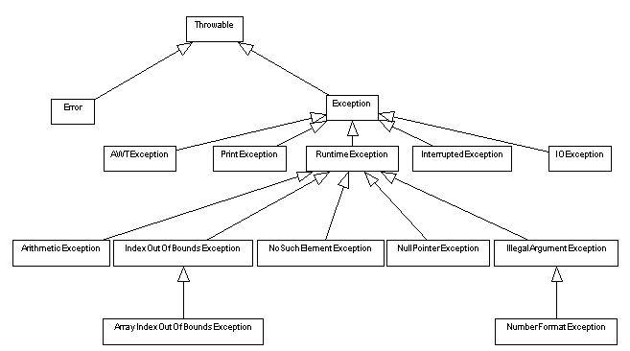

Checked and Unchecked Exception
Checked: are the exceptions that are checked at compile time. If some code within a method throws a checked exception, then the method must either handle the exception or it must specify the exception using throws keyword.

Unchecked are the exceptions that are not checked at compiled time. In Java exceptions under Error and RuntimeException classes are unchecked exceptions, everything else under throwable is checked.
Errors are exceptional scenarios that are out of scope of application and it’s not possible to anticipate and recover from them, for example hardware failure, JVM crash or out of memory error. That’s why we have a separate hierarchy of errors and we should not try to handle these situations. Some of the common Errors are OutOfMemoryError and StackOverflowError.

Try, catch and finally
try {
statements;
} catch (exceptionType1 identifier1) { // one or multiple
statements;
} catch (exceptionType2 identifier2) {
statements;
}
...
} finally { // one or none
statements;
}
- must include either one catch clause or a finally clause
- can be multiple catch clauses but only one finally clause
- try statements are executed until an exception is thrown or it completes successfully
- a compile-error occurs if the code included in the try statement will never throw one of the caught checked exceptions (runtime exceptions never need to be caught)
- if an exception is thrown, each catch clause is inspected in turn for a type to which the exception can be assigned; be sure to order them from most specific to least specific when a match is found, the exception object is assigned to the identifier and the catch statements are executed
if no matching catch clause is found, the exception percolates up to any outer try block that may handle it
a catch clause may throw another exception
- If a finally clause is included, it's statements are executed after all other try-catch processing is complete
the finally clause executes wether or not an exception is thrown or a break or continue are encountered
Throw and throws
The throw keyword (note the singular form) is used to force an exception. It can also pass a custom message to your exception handling module. Moreover throw keyword can also be used to pass a custom message to the exception handling module i.e. the message which we want to be printed. For instance in the above example we have used -
throw new MyException ("can't be divided by zero");
Whereas when we know that a particular exception may be thrown or to pass a possible exception then we use throws keyword. Point to note here is that the Java compiler very well knows about the exceptions thrown by some methods so it insists us to handle them. We can also use throws clause on the surrounding method instead of try and catch exception handler. For instance in the above given program we have used the following clause which will pass the error up to the next level -
static int divide(int first,int second) throws MyException{
- Propagation and catching a exception

Example – com.src.java.exception

Exception Handling Best Practices
- Close or release resource in finally block
- Including cause of Exception in stack-trace
- Always provide meaning full message on Exception
- Avoid overusing Checked Exception
- Converting Checked Exception into RuntimeException –
This is one of the techniques used to limit use of checked Exception in many of frameworks like spring, where most of checked Exception, which …. from JDBC is wrapped into DataAccessException, an unchecked Exception. This Java best practice provides benefits, in terms of restricting specific exception into specific modules, like SQLException into DAO layer and throwing meaningful RuntimeException to client layer.
- Avoid empty catch blocks
- Use Standard Exceptions
- Do not catch top-level exceptions
- Log exceptions just once
- Document Exception thrown by any method

User Defined Exception
Though Java provides an extensive set of in-built exceptions, there are cases in which we may need to define our own exceptions in order to handle the various application specific errors that we might encounter.

Traditionally, we create a DBException class by extending Exception class. Now, every time we are caught in a situation where there needs to thrown exception, we usually create an instance of this class, put some information in form of message and throw it.
Let’s consider there are following situations we have identified in which we need to throw DBException:
- SQL execution error
- No data exist where we expect at least one row
- Multiple rows exist where we expect only single row
- Invalid parameters error
And many more such cases can exist.
Example – com.src.java.exception – BaseException.java, DBExeption.java, TestExceptions.java

String Handling
String class present inside java.lang package & immutable class that means once String object is created its value cannot be altered.

How to create a string?
In Java a String can be created in two ways-
- By String literal
String s=”abc” // String object create inside String pool (1 object get created if not present inside pool)
Whenever a new string is created using String literal an object is created in String constant pool, String constant pool resides under heap memory. If a string with same content is already available in the pool than new String type variable points to the object that is already there in the memory and new object does not created.

- Using new keyword
String s1 = new String(“abc”); // String Object create inside heap Memory. (1 object get created into heap & 1 more into pool if not exists)

- s1.intern() - When the intern() method is invoked, if the pool already contains a string equal to this String object as determined by the equals(Object) method, then the string from the pool is returned. Otherwise, this String object is added to the pool and a reference to this String object is returned.
Example – com.src.java.string – TestStringIntern.java
- Difference between "==" and .equals(). (With String literal)
String s = "javaguys";
String s1 = "javaguys";
s.equals(s1) // true --having same content
s==s1 // true -- pointing to same object
- Difference between "==" and .equals(). (With String new keyword)
String str1 = new String("javaguys");
String str2 = new String("javaguys");
str1.equals(str2) // true --having same content
str1==str2 // false -- pointing to different object

Why we called 'String' object is immutable?
- String Pool –
String s1=”Java”;
s1.concat(“ Rules”);
S.O.P(s1); // Java
Although concat operation is performed on s1 object but the changes are not reflected to s1, s1 is still having unchanged value i.e. "Java". Here a new object with value "Java Rules" is created but reference variable s1 still points to "Java".

You can not share a mutable object with two parties which are unknown to each other. Let's take an hypothetical example, where two reference variable is pointing to same String object:
String s1 = "Java";
String s2 = "Java";
Now if s1 changes the object from "Java" to "C++", reference variable also got values2="C++", which it doesn't even know about it. By making String immutable, this sharing of String literal was possible. In short, key idea of String pool can not be implemented without making String final or Immutable in Java.

- Allow String to Cache its Hashcode - The hashcode of string is frequently used in Java. For example, in a HashMap. Being immutable guarantees that hashcode will always the same, so that it can be cashed without worrying the changes.That means, there is no need to calculate hashcode every time it is used. This is more efficient. This results in good performance gain, given String is heavily used in hash based Maps.

- Security - Java has clear goal in terms of providing a secure environment at every level of service and String is critical in those whole security stuff. String has been widely used as parameter for many Java classes, e.g. for opening network connection, you can pass host and port as String, for reading files in java you can pass path of files and directory as String and for opening database connection, you can pass database URL as String. If String was not immutable, a user might have granted to access a particular file in system, but after authentication he can change the PATH to something else, this could cause serious security issues. Similarly, while connecting to database or any other machine in network, mutating String value can pose security threats.

- Use of String in Class Loading Mechanism - Another reason for making String final or Immutable was driven by the fact that it was heavily used in class loading mechanism. As String been not immutable, an attacker can take advantage of this fact and a request to load standard Java classes e.g. java.io.Reader can be changed to malicious class com.unknown.DataStolenReader. By keeping String final and immutable, we can at least be sure that JVM is loading correct classes.

- Multithreading Benefits - Since Concurrency and Multi-threading was Java's key offering, it made lot of sense to think about thread-safety of String objects. Since it was expected that String will be used widely, making it Immutable means no external synchronization, means much cleaner code involving sharing of String between multiple threads.

String functions
- String x = “airplane”;
S.O.P(x.charAt(2)); //r
- replace / substring / toLowerCase / trim / split / indexOf / lastIndexOf / regionMatches / length() / etc.
Example – com.src.java.string – Filename.java, FilenameDemo.java, RegionMatchesDemo.java, StringToKenizer.java

Find out longest palindrome in a given string
Example – com.src.java.string – LongestPalindromeFinder.java

Find number of occurrence of a word inside a String
Example – com.src.java.string – OccurenceOfWord.java

Char array is preferred over String for storing password
String is immutable in java and stored in String pool. Once it’s created it stays in the pool until unless garbage collected, so even though we are done with password it’s available in memory for longer duration and there is no way to avoid it. It’s a security risk because anyone having access to memory dump can find the password as clear text.
If we use char array to store password, we can set it to blank once we are done with it. So we can control for how long it’s available in memory that avoids the security threat with String.

StringBuilder & StringBuffer
Well, the most important difference between String and StringBuffer/StringBuilder in java is that String object is immutable whereas StringBuffer/StringBuilder objects are mutable.
StringBuffer and StringBuilder have the same methods with one difference and that’s of synchronization. StringBuffer is synchronized (which means it is thread safe and hence you can use it when you implement threads for your methods) whereas StringBuilder is not synchronized (which implies it isn’t thread safe). So, if you aren’t going to use threading then use the StringBuilder class as it’ll be more efficient than StringBuffer due to the absence of synchronization.
- // creates empty builder, capacity 16
StringBuilder sb = new StringBuilder();
// adds 9 character string at beginning
sb.append("Greetings");
will produce a string builder with a length of 9 and a capacity of 16
- Example – com.src.java.string – StringDemo.java, StringBuilderDemo.java

Nested Class and Inner Class

Definition
The Java programming language allows you to define a class within another class. Such a class is called a nested class and is illustrated here:
class OuterClass { // Enclosing class
...
class NestedClass {
...
}
}

Nested classes are divided into two categories: static and non-static.
Nested classes that are declared static are simply called static nested classes.
Non-static nested classes are called inner classes.

A nested class is a member of its enclosing class. Non-static nested classes (inner classes) have access to other members of the enclosing class, even if they are declared private.

Why we use Nested classes?
There are several compelling reasons for using nested classes, among them:
It is a way of logically grouping classes that are only used in one place.
It increases encapsulation.
Nested classes can lead to more readable and maintainable code.

Static Nested Classes
Static nested classes do not have access to other members of the enclosing class. As a member of the OuterClass, a nested class can be declared private, public, protected, or package private.
Example of Nested class– com.src.java.nested – StaticNestedOuterClass.java; com.src.java.classloader- CustomClassLoader.java

Member Inner Class
Member class is instance-specific. It has access to all methods, fields, and the Outer's this reference.
Example of Inner class– com.src.java.nested – InnerClass.java
Method-Local Inner Classes
This inner class access only final members of Enclosing method.
Example of Inner class inside a method – com.src.java.nested - NonStaticMethodInnerClass.java

Anonymous Inner Classes
Example of Anonymous Inner class - com.src.java.nested – NonStaticAnnonymousInnerClass.java,
SortDoubleDimensionalStringArray.java

I/O and Serialization

Character Streams versus Byte Streams
Prior to JDK 1.1, the input and output classes (mostly found in the java.io package) only supported 8-bit byte streams. The concept of 16-bit Unicode character streams was introduced in JDK 1.1. While byte streams were supported via the java.io.InputStream and java.io.OutputStream classes and their subclasses, character streams are implemented by the java.io.Reader and java.io.Writer classes and their subclasses.

The Java IO package is primarily focused on input and output to files, network streams, internal memory buffers etc.

Most of the functionality available for byte streams is also provided for character streams. The methods for character streams generally accept parameters of data type char parameters, while byte streams, you guessed it, work with byte data types. The names of the methods in both sets of classes are almost identical except for the suffix, that is, character-stream classes end with the suffix Reader or Writer and byte-stream classes end with the suffix InputStream and OutputStream. For example, to read files using character streams, you would use the java.io.FileReader class; for reading it using byte streams you would use java.io.FileInputStream.

Unless you are working with binary data, such as image and sound files, you should use readers and writers (character streams) to read and write information for the following reasons-
They can handle any character in the Unicode character set (while the byte streams are limited to ISO-Latin-1 8-bit bytes).
They are easier to internationalize because they are not dependent upon a specific character encoding.
They use buffering techniques internally and are therefore potentially much more efficient than byte streams.

File Handling
File is an abstract representation of file and directory pathnames. It is is used to create objects that provide access to the files and directories of a local file system. The File class does not actually provide for input and output to files. It simply provides an identifier of files and directories.
There are a number of useful methods in File, e.g.:
Boolean exist(); - does the file exist
Boolean canWrite(); - can the file be written to
Boolean canRead(); - can the file be read
Boolean isFile(); - does it represent a file
Boolean isDirectory(); - or a directory
Example of Reader & Writer - com.src.java.io.file – ReadAndWriteFile.java
Example to append file content - com.src.java.io.file – AppendFileContent.java
Example to delete files using FilenameFilter Interface- com.src.java.io.file – DeleteFiles.java
Example to read & write for UTF-8 encoding- com.src.java.io.file – ReadAndWriteUTFEncoding.java
Example to get Disk space details- com.src.java.io.file – DiskSpaceDetail.java

Load Resource Bundle
- How to load a property file / resource bundle
- How to read using current working directory

Example - com.src.java.resource- Application.properties
com.src.java.io.file – PropertyReaderUtil.java, PropertyReaderClient.java

Finalize method
Before an object is garbage collected, the runtime system calls its finalize() method. The intent is for finalize() to release system resources such as open files or open sockets before getting collected.
Your class can provide for its finalization simply by defining and implementing a method in your class named finalize(). Your finalize() method must be declared as follows: protected void finalize () throws throwable
Example - com.src.java.io.file – NonFinalizedClass.java, FinalizedClass.java, TestGarbageCollection.java

Question: What is difference between final, finally & finalize?

Serialize / Deserialize an Object
Definition- Object serialization is the process of saving an object's state to a sequence of bytes, as well as the process of rebuilding those bytes into a live object at some future time. The Java Serialization API provides a standard mechanism for developers to handle object serialization.
Serialization is the process of converting a set of object instances that contain references to each other into a linear stream of bytes, which can then be sent through a socket, stored to a file, or simply manipulated as a stream of data. Serialization is the mechanism used by RMI to pass objects between JVMs, either as arguments in a method invocation from a client to a server or as return values from a method invocation.
Serializable interface are Marker interface which don’t have any methods.
Points to Remember -
1. As mentioned before, only objects marked Serializable OR inherit that implementation from its object hierarchy can be persisted. The java.lang.Object class does not implement that interface. Therefore, not all the objects in Java can be persisted automatically. The good news is that most of them -- like AWT and Swing GUI components, strings, and arrays -- are serializable.
2. Static / transient fields are not part of object searialization.

3. Gotchas - Caching Objects in the Stream - By default, an ObjectOutputStream will maintain a reference to an object written to it. That means that if the state of the written object is written and then written again, the new state will not be saved.
For Example-
ObjectOutputStream out = new ObjectOutputStream(...);
MyObject obj = new MyObject(); // must be Serializable
obj.setState(100);
out.writeObject(obj); // saves object with state = 100
//out.close();

obj.setState(200);
out.writeObject(obj); // does not save new object state

out.close();

There are two ways to control that situation. First, you could make sure to always close the stream after a write call, ensuring the new object is written out each time. Second, you could call the ObjectOutputStream.reset() method, which would tell the stream to release the cache of references it is holding so all new write calls will actually be written. Be careful, though -- the reset flushes the entire object cache, so all objects that have been written could be rewritten.

4. Gotchas – Version Control - Imagine you create a class, instantiate it, and write it out to an object stream. That flattened object sits in the file system for some time. Meanwhile, you update the class file, perhaps adding a new field. What happens when you try to read in the flattened object?
Well, the bad news is that an exception will be thrown -- specifically, the java.io.InvalidClassException -- because all persistent-capable classes are automatically given a unique identifier. If the identifier of the class does not equal the identifier of the flattened object, the exception will be thrown.

If you wish to control versioning, you simply have to provide the serialVersionUID field manually and ensure it is always the same, no matter what changes you make to the classfile. You can use a utility that comes with the JDK distribution called serialver to see what that code would be by default (it is just the hash code of the object by default).
static final long serialVersionUID = 10275539472837495L
Example of Version - com.src.java.io.serialization- Employee.java, SerializeEmployee.java, DeserializeEmployee.java
Question: To serialize / deserialize an employee object whose parent object has not implemented Serializable interface. How do we serialize GpsEmployee with its Address? If we try to serialize it by default parent class not take part in this serialization process.
Example of Version - com.src.java.io.serialization- GpsEmployee.java, TestEmployeeWithAddress.java

Question: Why it is always recommended to provide our own serial version UID inside every POJO instead of JVM generated UID (at runtime)?
Here, if I want to serialize Address class but suppose its source code is not available, then how could I serialize it? For this, we need to implement 2 methods
private void writeObject(ObjectOutputStream out) throws IOException;
private void readObject(ObjectInputStream in) throws IOException, ClassNotFoundException;
Notice that both methods are (and must be) declared private, proving that neither method is inherited and overridden or overloaded. The trick here is that the virtual machine will automatically check to see if either method is declared during the corresponding method call. The virtual machine can call private methods of your class whenever it wants but no other objects can. Thus, the integrity of the class is maintained and the serialization protocol can continue to work as normal. The serialization protocol is always used the same way, by calling either ObjectOutputStream.writeObject() or ObjectInputStream.readObject(). So, even though those specialized private methods are provided, the object serialization works the same way as far as any calling object is concerned.
Add below lines to resolve in above example to serialize Address –
private void writeObject(ObjectOutputStream out) throws IOException {
out.defaultWriteObject();
out.writeObject(getFlatNo());
}

private void readObject(ObjectInputStream in) throws IOException,
ClassNotFoundException {
in.defaultReadObject();
setFlatNo((String) in.readObject());
}

Question: Suppose super class of a new class implement Serializable interface how can you avoid new class to being serialized?
If Super Class of a Class already implements Serializable interface in Java then its already Serializable in Java, since you can not unimplemented an interface its not really possible to make it Non Serializable class but yes there is a way to avoid serialization of new class. To avoid java serialization you need to implement Externizable interface to customize your persistance.

Externizable Interface
Externalization is nothing but serialization but by implementing Externalizable interface to persist and restore the object. Unlike Serializable interface, Externalizable interface is not a marker interface and it provides two methods - writeExternal and readExternal. We must also define a default constructor when we implement the Externalizable interface. It we fail to do so the serialization will fail.
Example of Version - com.src.java.io.serialization- GpsExternalEmployee.java, TestExternalEmployee.java
User.java, TestUser.java

Question: Difference between Serializable & externizable?
Serialiazable persist data in inheritance hierarchy if the entire object implements Serializable interface in inheritance hierarchy whereas using externizable we can persist customizable data only.

Utility or Collection Framework
Why Collection Framework
Collections are nothing but group of objects stored in well defined manner. Earlier, Arrays are used to represent these groups of objects. But, arrays are not re-sizable. Size of the arrays is fixed. Size of the arrays can not be changed once they are defined. This causes lots of problem while handling group of objects. To overcome this drawback of arrays, Collection framework or simply collections are introduced in java from JDK 1.2.

Although, there were classes like Dictionary, Vector, Stack and Properties which handle group of objects better than the arrays. But, each of them handles the objects differently. The way you use Dictionary class is totally different from the way you use Stack class and the way you use Vector class is different from the way you use Properties class. Hence, there needed a central and unifying theme to handle the group of objects. That’s why we need collection framework.

What is Collection Framework?
Collection Framework in java is a centralized and unified theme to store and manipulate the group of objects. Java Collection Framework provides some pre-defined classes and interfaces to handle the group of objects. Using collection framework, you can store the objects as a list or as a set or as a queue or as a map and perform operations like adding an object or removing an object or sorting the objects without much hard work.
Class Hierarchy of Collection Framework
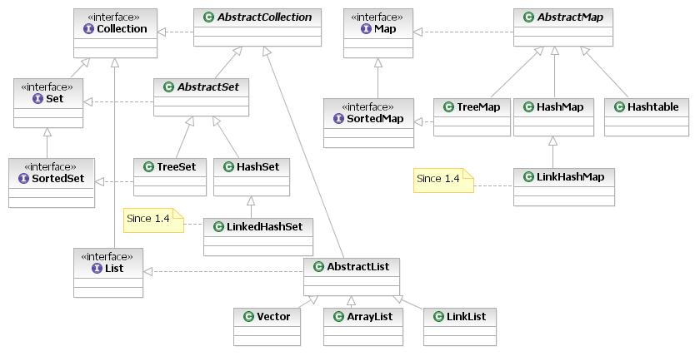
Interface | Implementation |  |  |  | Historical
Set | HashSet |  | TreeSet | LinkedHashSet |  | It handles list of objects which must contain unique element.
List |  | ArrayList |  | LinkedList | Vector  Stack | It handles sequential list of objects.
Map | HashMap |  | TreeMap |  | Hashtable  Properties | This is the one interface in Collection Framework which is not inherited from Collection interface. It handles group of objects as Key/Value pairs
Queue |  | PriorityQueue |  | LinkedList |  | It handles special list of objects in which elements are removed only from the head.
The entire collection framework is divided into four interfaces.
Collection: A collection is an object that represents a group of objects (such as Vector, ArrayList, etc). The primary advantages of a collections framework are that it:
i) Reduces programming effort by providing useful data structures and algorithms so you don't have to
write them yourself.
ii) Increases performance by providing high-performance implementations of useful data structures and
algorithms. Because the various implementations of each interface are interchangeable, programs can be
easily tuned by switching implementations.
iii) Reduces the effort required to learn APIs
iv) Reduces the effort required to design and implement APIs

Collection Interface
There are fourteen collection interfaces. The most basic interface is Collection. These interfaces extend Collection: Set, List, SortedSet, NavigableSet, Queue, Deque, BlockingQueue and BlockingDeque. The other collection interfaces, Map, SortedMap, NavigableMap, ConcurrentMap and ConcurrentNavigableMap do not extend Collection, as they represent mappings rather than true collections. However, these interfaces contain collection-view operations, which allow them to be manipulated as collections.

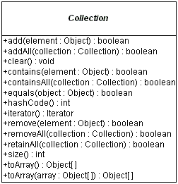
Enumeration Interface
A class that implements Enumeration interface provides access to series of elements one at a time. You need to call nextElement method to get next element in the series. Also hasMoreElements () method gives you status about the availability of next element in the series.
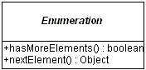
Example - com.src.java.collection – MyEnumeration.java

Question: Why Java1.5 onwards Java has retricted to store Homogenous type of Objects inside any Collection using Generics? OR Why java has introduced Generic Java1.5 onwards?

Iterator Interface
All of the collection classes provides iterator () method to iterate through the collection. The iterator () method returns the Iterator object through which you can access the collection elements in an order. Enumeration also does the same purpose. The difference between Iterator and Enumerations is: Iterators allow the caller to remove elements from the underlying collection during the iteration with well-defined semantics.
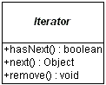
Example - com.src.java.collection – MyCollectionIterator.java, MyItrRemoveElement.java

Question: Difference between Enumeration & Iterator?
Only major difference between Enumeration and iterator is Iterator has a remove () method while Enumeration doesn't. Enumeration acts as Read-only interface, because it has the methods only to traverse and fetch the objects, where as by using Iterator we can manipulate the objects like adding and removing the objects from collection e.g. Arraylist.
Also Iterator is more secure and safe as compared to Enumeration because it does not allow other thread to modify the collection object while some thread is iterating over it and throws ConcurrentModificationException.
ListIterator Interface
The ListIterator interface extends the Iterator interface to support bi-directional access, as well as adding or changing elements in the underlying collection. Using ListIterator, we can iterate all elements of a list in either direction. You can access next element by calling next () method, and also you can access previous element by calling previous () method on the list.
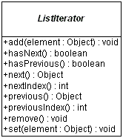

Example - com.src.java.collection – MyListIterator.java

Question: Difference between Iterator & ListIterartor?
Iterator | ListIterator
Iterator () method is available for all collections. That is, Iterator can be used for all collection classes. | ListIterator () method is available for those collections that implement List interface. That is, descendents of List interface only can use ListIterator.
Can do remove operation only on elements | Can remove, add and replace elements

How to use Iterator
There are two kinds of Iterator in Java, fail-safe (ConcurrentHashMap) and fail-fast (ArrayList, HashMap, HashSet, etc). Fail-safe Iterator doesn't throw ConcurrentModificationException during iteration while fail-fast does, if, Iterator realizes any structural change in Collection once Iteration begins.
Example - com.src.java.collection – IteratorHowToUse.java

Group Operations
Other operations the Collection interface supports are tasks done on groups of elements or the entire collection at once:
- boolean containsAll(Collection collection)
- boolean addAll(Collection collection)
- void clear()
- void removeAll(Collection collection)
- void retainAll(Collection collection)
The containsAll() method allows you to discover if the current collection contains all the elements of another collection, a subset. The remaining methods are optional, in that a specific collection might not support the altering of the collection. The addAll() method ensures all elements from another collection are added to the current collection, usually a union. The clear() method removes all elements from the current collection. The removeAll() method is like clear() but only removes a subset of elements. The retainAll() method is similar to the removeAll() method, but does what might be perceived as the opposite. It removes from the current collection those elements not in the other collection, an intersection.

Set Interface
The Set interface extends the Collection interface and, by definition, forbids duplicates within the collection. All the original methods are present and no new methods are introduced. The concrete Set implementation classes rely on the equals() method of the object added to check for equality.
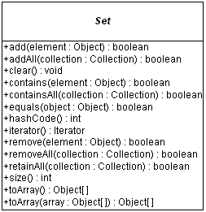

HashSet, TreeSet, LinkedHashSet
HastSet
This class implements the Set interface, backed by a hash table (actually a HashMap instance). It makes no guarantees as to the iteration order of the set; in particular, it does not guarantee that the order will remain constant over time. This class permits the null element.
If we are trying to insert duplicate objects we won't get compile time error and runtime error add() method simply returns false.
Note that this implementation is not synchronized. If multiple threads access a hash set concurrently, and at least one of the threads modifies the set, it must be synchronized externally.
Set s = Collections.synchronizedSet(new HashSet(...));
The iterators returned by this class's iterator method are fail-fast: if the set is modified at any time after the iterator is created, in any way except through the iterator's own removemethod, the Iterator throws a ConcurrentModificationException.

Example - com.src.java.collection – SpellChecker.java
TreeSet
It stores its elements in a red-black tree, orders its elements based on their values; it is substantially slower than HashSet.
The TreeSet implementation is useful when you need to extract elements from a collection in a sorted manner. In order to work property, elements added to a TreeSet must be sortable. The Collections Framework adds support for Comparable elements. It is generally faster to add elements to a HashSet, and then convert the collection to a TreeSet for sorted traversal.
To optimize HashSet space usage, you can tune the initial capacity and load factor. The TreeSet has no tuning options.
Example - com.src.java.collection – TreeSetNaturalOrder.java

LinkedHashSet
It is implemented as a hash table with a linked list running through it, orders its elements based on the order in which they were inserted into the set (insertion-order).

Example - com.src.java.collection – SetComparision.java

Question: Difference among HashSet, TreeSet & LinkedHashSet?
HashSet is fastest, LinkedHashSet is second on performance or almost similar to HashSet but TreeSet is bit slower because of sorting operation it needs to perform on each insertion.
HashSet is backed by a HashMap instance, LinkedHashSet is implemented using HashSet and LinkedList while TreeSet is backed up by NavigableMap in Java and by default it uses TreeMap.
HashSet and LinkedHashSet allow null but TreeSet doesn't allow null but TreeSet doesn't allow null and throw java.lang.NullPointerException when you will insert null into TreeSet. Since TreeSet uses compareTo () method of respective elements to compare them which throws NullPointerException while comparing with null.

List Interface
The List interface extends the Collection interface to define an ordered collection, permitting duplicates.

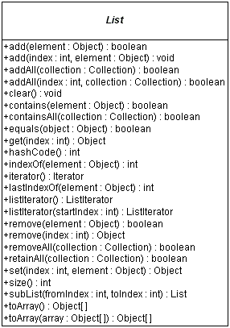

Vector, ArrayList, LinkedList Classes
Vector
Vectors (the java.util.Vector class) are commonly used instead of arrays, because they expand automatically when new data is added to them. The Java 2 Collections API introduced the similar ArrayList data structure. ArrayLists are unsynchronized and therefore faster than Vectors, but less secure in a multithreaded environment. The Vector class was changed in Java 2 to add the additional methods supported by ArrayList.
Example - com.src.java.collection – VectorExample.java

ArrayList
It is resizable-array implementation of the List interface. Implements all optional list operations, and permits all elements, including null. This class is roughly equivalent to Vector, except that it is unsynchronized.
If you need to support random access, without inserting or removing elements from any place other than the end, than ArrayList offers the optimal collection.
Note that this implementation is not synchronized. If multiple threads access an ArrayList instance concurrently, and at least one of the threads modifies the list structurally, it must be synchronized externally.
List list = Collections.synchronizedList(new ArrayList(...));
The iterators returned by this class's iterator and listIterator methods are fail-fast: if the list is structurally modified at any time after the iterator is created, in any way except through the iterator's own remove or add methods, the iterator will throw a ConcurrentModificationException.
Example - com.src.java.collection – SwapArrayList.java

LinkedList
If, however, you need to frequently add and remove elements from the middle of the list and only access the list elements sequentially then LinkedList offers the better implementation. Both ArrayList and LinkedList implement the Cloneable interface. In addition, LinkedList adds several methods for working with the elements at the ends of the list
Example – Mail Box Application always prefer to use LinkList
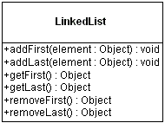
Example - com.src.java.collection – Node.java, SinglyLinkedListImpl.java, SingleLinkedListClient.java
Question- What is difference between Collection & Collections?
Question- How to sort List of Employees based on salary?
Example - com.src.java.collection – Employee.java, SortEmployees.java
Question- What is difference between Array, Vector & ArrayList?
Array is fixed size length data structure whereas Vector & ArrayList are auto expandable. ArrayList is not synchronised which will give better performance whereas Vector preferable to used in Multithreaded environment since it is synchronized.
Question- What is difference between ArrayList & LinkedList?
ArrayList is used for fast searching based on Index whereas LinkedList we can use where lots of insertion & deletion operations are required. ArrayList is slower for insertion & deletion since array element shift their position upto last element which takes more time in comparison to LinkedList.

Map Interface
The Map interface is not an extension of the Collection interface. Instead, the interface starts off its own interface hierarchy, for maintaining key-value associations. The interface describes a mapping from keys to values, without duplicate keys, by definition.
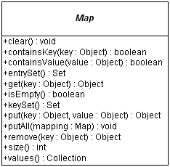

Map.Entry Interface
The entrySet () method of Map returns a collection of objects that implement Map.Entry interface. Each object in the collection is a specific key-value pair in the underlying Map.
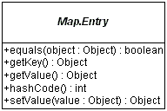

HashMap, TreeMap Classes
For inserting, deleting, and locating elements in a Map, the HashMap offers the best alternative. If, however, you need to traverse the keys in a sorted order, then TreeMap is your better alternative. Depending upon the size of your collection, it may be faster to add elements to a HashMap, and then convert the map to a TreeMap for sorted key traversal. Using a HashMap requires that the class of key added have a well-defined hashCode () implementation. With the TreeMap implementation, elements added to the map must be sortable.
To optimize HashMap space usage, you can tune the initial capacity and load factor. The TreeMap has no tuning options, as the tree is always balanced.

The Hashtable and Properties classes are historical implementations of the Map interface.

HashMap
Example - com.src.java.collection – HashMapDemo.java, Account.java, TestMutableKey.java

Question- How to sort a Map either based on key / value?
Example - com.src.java.collection – SortMapByKeyAndValue.java

Performance comparison of different ways to iterate over HashMap
To compare traversal in hash map in java. HashMap is very frequently used class and most of the times we just fetch the value using get(Object key) method provided by class. But at times it is required to iterate over whole Map and fetch all key-value pairs stored in it. For example, analyzing all request parameters sent from client. If you are using this for every client you will be iterating whole map at least once in your code.
If you are using this type of iteration many places in code and there are large number of requests then you surely would like to optimize your iteration code to make best use of it.

Now let’s compare their performances for a common data set stored in map. I am storing 10 lacs key value pairs in map and will iterate over map in all four ways. I will also fetch key and value from map for all 10 lacs entries in best suitable way. Then i will capture the time taken by each way.

Observations- 10 lacs is very big number of most the application requirements. Even though the difference is not very substantial in milliseconds, as compare to it was very big in case of for loops. I believe most of us can live with such a minor difference.
But if you want to be very specifically make the conclusion, using entry set is more powerful and yields better performance as comparing to using key set for iteration. Result varies from 20% -- 50% when above program is executed multiple times.

Example - com.src.java.collection – DifferentWaysToIterateOverHashMap.java

TreeMap
Example - com.src.java.collection – MyTreeMapComparator.java, SortMapByKeyAndValue.java

WeakHashMap Class
A hashtable-based Map implementation with weak keys. An entry in a WeakHashMap will automatically be removed when its key is no longer in ordinary use. More precisely, the presence of a mapping for a given key will not prevent the key from being discarded by the garbage collector, which is, made finalizable, finalized, and then reclaimed. When a key has been discarded its entry is effectively removed from the map, so this class behaves somewhat differently than other Map implementations. Both null values and the null key are supported.
Like most collection classes, this class is not synchronized. A synchronized WeakHashMap may be constructed using the Collections.synchronizedMap method.
Example - com.src.java.collection – WeakHashMapExample.java
Question- Where can we use WeakHashMap?
WeakHashMap to avoid memory leaks. WeakHashMap can also be used fairly straightforwardly as a cache that can be cleared automatically when JVM memory is low.

ConcurrentHashMap Class
The ConcurrentHashMap is very similar to the java.util.HashTable class, except that ConcurrentHashMap offers better concurrency than HashTable does. ConcurrentHashMap does not lock the Map while you are reading from it. Additionally, ConcurrentHashMap does not lock the entire Map when writing to it. It only locks the part of theMap that is being written to, internally.
Another difference is that ConcurrentHashMap does not throw ConcurrentModificationException if theConcurrentHashMap is changed while being iterated. The Iterator is not designed to be used by more than one thread though.
Example - com.src.java.collection – ConcurrentHashMapExample.java

Comparable Interface
This interface imposes a total ordering on the objects of each class that implements it. This ordering is referred to as the class's natural ordering, and the class's compareTo method is referred to as its natural comparison method.
Lists (and arrays) of objects that implement this interface can be sorted automatically by Collections.sort (and Arrays.sort). Objects that implement this interface can be used as keys in a sorted map or elements in a sorted set, without the need to specify a comparator.
The natural ordering for a class C is said to be consistent with equals if and only if (e1.compareTo((Object)e2) == 0) has the same boolean value as e1.equals((Object)e2) for every e1 and e2 of class C. Note that null is not an instance of any class, and e.compareTo(null) should throw a NullPointerException even though e.equals(null) returns false.
Example - com.src.java.collection – GPSEmployee.java, ComparableExample.java

Comparator Interface
Comparator interface is used when an extra logic is required to sort the objects. One need to override compare(Object obj1, Object obj2) method. For example you want the list of Person object to be sorted on the basis of complete name i.e "name lastName" but also on the other hand doesnt want to change the Person class default sorting implementation or Person class is a jar so so no code modification in it can be done. First create a Custom Comparator.
Example - com.src.java.collection – EmployeeVO.java, EmployeeVOComparator.java, ComparatorExample.java

Read only Collections
After you've added all the necessary elements to a collection, it may be convenient to treat that collection as read-only, to prevent the accidental modification of the collection. To provide this capability, the Collections class provides six factory methods, one for each of Collection, List, Map, Set, SortedMap, and SortedSet.
- Collection unmodifiableCollection(Collection collection)
- List unmodifiableList(List list)
- Map unmodifiableMap(Map map)
- Set unmodifiableSet(Set set)
- SortedMap unmodifiableSortedMap(SortedMap map)
- SortedSet unmodifiableSortedSet(SortedSet set)
Once you've filled the collection, the best way to make the collection read-only is to replace the original reference with the read-only reference. If you don't replace the original reference, then the collection is not read-only, as you can still use the original reference to modify the collection. The following program demonstrates the proper way to make a collection read-only. In addition, it shows what happens when you try to modify a read-only collection.
Example - com.src.java.collection – ReadOnlyCollectionExample.java
When run and the last add () operation is attempted on the read-only set, an UnsupportedOperationException is thrown.

Thread-Safe Collections
The key difference between the historical collection classes and the new implementations within the Collections Framework is the new classes are not thread-safe. This was done such that if you don't need the synchronization, you don't use it, and everything works much faster. If, however, you are using a collection in a multi-threaded environment, where multiple threads can modify the collection simultaneously, the modifications need to be synchronized. The Collections class provides for the the ability to wrap existing collections into synchronized ones with another set of six methods:
- Collection synchronizedCollection(Collection collection)
- List synchronizedList(List list)
- Map synchronizedMap(Map map)
- Set synchronizedSet(Set set)
- SortedMap synchronizedSortedMap(SortedMap map)
- SortedSet synchronizedSortedSet(SortedSet set)
Unlike when making a collection read-only, you synchronize the collection immediately after creating it. You also must make sure you do not retain a reference to the original collection, or else you can access the collection unsynchronized. The simplest way to make sure you don't retain a reference is to never create one:
Set set = Collections.synchronizedSet(new HashSet());
Making a collection unmodifiable also makes a collection thread-safe, as the collection can't be modified. This avoids the synchronization overhead.

Hashtable, Properties Classes
The Hashtable implementation is a generic dictionary that permits storing any object as its key or value (besides null). With the Java 2 SDK, version 1.2. The class has been reworked into the Collections Framework to implement the Map interface. So, when using, you can use the original Hashtable methods or the newer Map methods. If you need a synchronized Map, using Hashtable is slightly faster than using a synchronized HashMap.
Example - com.src.java.collection – HashTableDemo.java
The Properties implementation is a specialized Hashtable for working with text strings. While you have to cast valued retrieved from a Hashtable to your desired class, the Properties class allows you to get text values without casting. The class also supports loading and saving property settings from and input stream or to a output stream. The most commonly used set of properties is the system properties list, retrieved by
System.getProperties().
Properties props = new Properties();
props.load(new FileInputStream(“filename”));
String value = props.getProperty(“key”);
Property only allows String Value as key/value where HaspMap/HashTable allowing Objects as key/value.
Question- What is difference between HashTable & HashMap?
Hashtable is synchronised whereas HashMap is not. Null as a key OR value is allowed in HashMap whereas we can’t put null as a key/value into HashTable. The iterator in Hashmap is fail-fast iterator while the enumerator for Hashtable is not. Hashtable is a subclass of Dictionary class which is now obsolete in Jdk 1.7 ,so ,it is not used anymore. It is better off externally synchronizing a HashMap or using a ConcurrentMap.
Question- What is difference between HashTable & ConcurrentHashMap?
Question- Why HashMap allows one null key / null value?
Hashtable was introduced in earlier version of Java whereas HashMap provided by latter where Java have introduced special handling to allow null as key / values. In real time project, we can use null as a key to represent default functionality with HashMap. For ex-
Let’s suppose you have a "schedules" which can be associated to the "jobs". The "schedules" contains information on at what time a job should be executed and when should it be repeated. There is a simple check which we have put in. If the job schedule is null, we execute the job only once. Else we execute it as per schedule. This type of scenario we can handle by using HashMap with null key.

Stack, Queue, Priority Queue, Blocking Queue
Stack
The Stack class extends Vector to implement a standard list-in-first-out (LIFO) stack, with push() and pop() methods. Be careful though. Since the Stack class extends the Vector class, you can still access or modify a Stack with the inherited Vector methods.
Example - com.src.java.collection.stack – Stack.java, EmptyStackException.java, FullStackException.java, TestStack.java

Queue
Since Queue is an interface you need to instantiate a concrete implementation of the interface in order to use it. You can choose between the following Queue implementations in the Java Collections API-
- java.util.LinkedList
- java.util.PriorityQueue - We know that Queue follows First-In-First-Out model but sometimes we need to process the objects in the queue based on the priority. For example, let’s say we have an application that generates stocks reports for daily trading session and it processes a lot of data and takes time to process it. So customers are sending request to the application that is actually getting queued but we want to process premium customers first and standard customers after them. So in this case PriorityQueue implementation in java can be really helpful. PriorityQueue doesn’t allow null values and we can’t create PriorityQueue of Objects that are non-comparable.
Example - com.src.java.collection.queue – Customer.java, PriorityQueueExample.java

BlockingQueue with CountDownLatch
It is a queue which is thread safe to insert or retrieve elements from it. Also, it provides a mechanism which blocks requests for inserting new elements when the queue is full or requests for removing elements when the queue is empty, with the additional option to stop waiting when a specific timeout passes. This functionality makes a nice way of implementing the Producer-Consumer pattern, as the producing thread can insert elements until the upper limit of BlockingQueue while the consuming thread can retrieve elements until the lower limit is reached and of course with the support of the aforementioned blocking functionality.

CountDownLatch was introduced with JDK 1.5. This class enables a java thread to wait until other set of threads completes their tasks. E.g. Application’s main thread want to wait, till other service threads which are responsible for starting framework services have completed started all services.

CountDownLatch works by having a counter initialized with number of threads, which is decremented each time a thread complete its execution. When count reaches to zero, it means all threads have completed their execution, and thread waiting on latch resume the execution.

Pseudo code for CountDownLatch can be written like this:
//Main thread start
//Create CountDownLatch for N threads
//Create and start N threads
//Main thread wait on latch
//N threads completes there tasks are returns
//Main thread resume execution

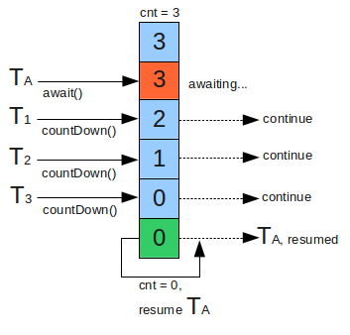
Example - com.src.java.collection.queue – BlockingQueueExample.java

Object Cloning

What is Cloning
A clone is an exact copy of the original. In java, it essentially means the ability to create an object with similar state as the original object. The clone () method provides this functionality.

By default, java cloning is ‘field by field copy’ i.e. as the Object class does not have idea about the structure of class on which clone () method will be invoked. So, JVM when called for cloning, do following things:
- If the class has only primitive data type members then a completely new copy of the object will be created and the reference to the new object copy will be returned.
- If the class contains members of any class type then only the object references to those members are copied and hence the member references in both the original object as well as the cloned object refer to the same object.

Every language which supports cloning of objects has its own rules and so does java. In java, if a class needs to support cloning it has to do following things:
- You must implement Cloneable interface.
- You must override clone () method from Object class.

Creates and returns a copy of this object. The precise meaning of "copy" may depend on the class of the object.
The general intent is that, for any object x, the expression:
- x.clone() != x will be true
- x.clone ().getClass () == x.getClass () will be true, but these are not absolute requirements.
- x.clone ().equals(x) will be true; this is not an absolute requirement.

Example - com.src.java.cloning – Department.java, Employee.java, CreateEmployeeClone.java

The most probable reason for creating a local copy of an object is because you plan to modify the object, and you don't want to modify the method caller's object. If you decide that you need a local copy, you can perform the operation by using the clone () method of the Object class. The clone () method is defined as protected, but you must redefine it as public in all subclasses that you might want to clone.

By default, classes in Java do not support cloning; the default implementation of the clone () method throws a CloneNotSupportedException. You should override implementation of the clone () method. Remember that you must make it public and, inside the method, your first action must be super.clone (). Classes that want to allow cloning must implement the marker interface Cloneable. Since the default implementation of Object.clone only performs a shallow copy, classes must also override clone to provide a custom implementation when a deep copy is desired.

Why Cloning Required
Example - com.src.java.cloning – GPSEmployee.java, WhyCloneRequired.java

Shallow Cloning
This is default implementation in java. In overridden clone method, if you are not cloning all the object types (not primitives), then you are making a shallow copy.
Example - com.src.java.cloning – ShallowClone.java

Deep Cloning
We need to override the clone() method for the classes having non-primitive type members to achieve Deep Copy as Deep Copy requires the member objects to be cloned as well, which is not done by the default cloning mechanism. Why is it not done by the default cloning? Because clone() is a method of the Object class and at that level it's not known what a typical class can have as its members and hence only a field-by-field copy approach has been provided as the default cloning mechanism.

Implementing Deep Copy in Java
For Deep Copy, we need to ensure that the member classes also implement the Cloneable interface otherwise calling the clone () method on the objects of those classes will result into CloneNotSupportedException. So, to implement Deep Copy, we first need to ensure that all the member classes (at all the levels - like if the member class itself has a member of some class type then that class as well... and so on) are implementing the Cloneable interface. After that we override the clone () method in all those classes (even in the classes where we have only primitive type members otherwise we would not be able to call the protected clone () method of Object class on the instances of those classes inside some other class ... a typical restriction of the protected access.

Example - com.src.java.cloning.deep – DeepClone.java

If any member class does not support cloning then in clone method, one must create a new instance of that member class and copy all its attributes one by one to new member class object. This new member class object will be set in cloned object.

Cloning with serialization
Just serialize the object to be cloned and de-serialize it. It involves serializing the object to bytes and from bytes to object again.

Example - com.src.java.cloning.deep – SerializableClass.java, SerializeDeepClone.java

Prototype design pattern
Prototype pattern is used when the Object creation is a costly affair and requires a lot of time and resources and you have a similar object already existing. So this pattern provides a mechanism to copy the original object to a new object and then modify it according to our needs. This pattern uses java cloning to copy the object.
Prototype design pattern mandates that the Object which you are copying should provide the copying feature. It should not be done by any other class. However whether to use shallow or deep copy of the Object properties depends on the requirements and it’s a design decision.
A prototype is a template of any object before the actual object is constructed. In java also, it holds the same meaning. Prototype design pattern is used in scenarios where application needs to create a number of instances of a class, which has almost same state or differs very little.
In this design pattern, an instance of actual object (i.e. prototype) is created on starting, and thereafter whenever a new instance is required, this prototype is cloned to have another instance. The main advantage of this pattern is to have minimal instance creation process which is much costly than cloning process.

Scenario - creating an entertainment application that will require instances of Movie, Album and Show classes very frequently. I do not want to create their instances everytime as it is costly. So, I will create their prototype instances and everytime when i will need a new instance, I will just clone the prototype.
Example - com.src.java.cloning.prototype – TestPrototypePattern.java (Both Prototype & Singleton Design)
Example - com.src.java.cloning.prototype – TestSingletonDesign.java

Java Concurrency / Multithreading

What do mean by Multithreading?
Multithreading basically means a lightweight process. Threads are lightweight processes.
Threads are separate paths of execution which are functionally independent on each other.
To make use the CPU time in better way.

Multiprocessing and Multitasking
Multiprocessing means many user processes which are being processed by a single processor. For example- On UNIX System 10 user’s processes can be processed at a time by Unix Server.
Multitasking means single user many processes which are being processed by a single processor. For example – On UNIX System, a user can issue a single foreground command and many background commands to execute on Unix Server.
Multithreading means within single processes there are separate paths of execution. There is not more than one process here. For example- In word document while tying auto save, spell check are getting executed parallel.

Therefore, in case of multitasking and multiprocessing each process has a process id; it has its own memory space to work with. In case of multithreaded application, all threads share the same memory space.

What is a Thread?
Thread is a sequence of code executed independently with other threads of control with in a single executed program.
Every thread has a priority. Threads with higher priority are executed in preference to threads with lower priority. Each thread may or may not also be marked as a daemon.

Life cycle of Thread
The life cycle of the thread in java is controlled by JVM. The java thread states are as follows:
- New
- Runnable
- Running
- Non-Runnable (Blocked)
- Terminated
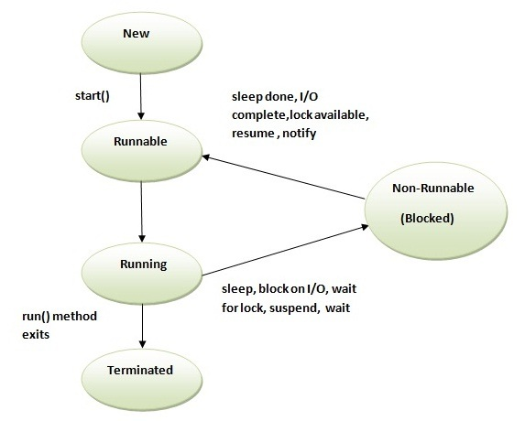

- New - The thread is in new state if you create an instance of Thread class but before the invocation of start() method
- Runnable - The thread is in runnable state after invocation of start () method, but the thread scheduler has not selected it to be the running thread.
- Running - The thread is in running state if the thread scheduler has selected it.
- Non-Runnable (Blocked) - This is the state when the thread is still alive, but is currently not eligible to run.
- Terminated - A thread is in terminated or dead state when its run () method exits.
- From Runnable to Running, we invoke a start() method which intern invoke run() {} method
- From Running to Non-Runnable state, there are 3 ways:
Using sleep(ms) method: After specified period thread automatically comes back to running state
Using suspend() method: If we call resume(), then only suspended thread comes back to running state
Using wait() method : If we call notify() / notifyAll(), then only suspended thread comes back to running state
- From Running state to Terminated state: Control come out of the run() method
- It is the run () method where entire execution of a thread is defined.
- Since JDK1.2 stop (), suspend () and resume () have been deprecated.

Question- Why is Thread.stop() has been deprecated?
This method is deprecated for the simple reason that it's unsafe and may lead the program to some unexpected circumstances. Thread.stop() when called, it causes the thread to release all the acquired monitors and throw a ThreadDeath error, which ultimately causes the thread to die. Since, the thread releases all the acquired monitors immediately, so it may leave few objects (whose monitors were acquired by the thread) in an inconsistent state. Such objects are called damaged objects and obviously they may result into some arbitrary behavior.

Question- Why are Thread.suspend and Thread.resume deprecated?
Thread.suspend is inherently deadlock-prone. If the target thread holds a lock on the monitor protecting a critical system resource when it is suspended, no thread can access this resource until the target thread is resumed. If the thread that would resume the target thread attempts to lock this monitor prior to calling resume, deadlock results. Such deadlocks typically manifest themselves as "frozen" processes.

Different ways to create a Thread
- Two ways for creating a thread
1) Extending from Thread class
2) Implementing Runnable Interface

- Steps to create a Thread by extending Thread class
1) Extend Thread class into your class
2) Override run() method // Optional
3) Create an instance of your class (Will give you thread instance)
4) Start the thread

- Steps to create a Thread by implementing Runnable Interface
1) Implement Runnable interface into your class
2) Override run() method
3) Create an instance of your class (Will give you runnable instance)
4) Create a Thread object by passing Runnable object as parameter
5) Start the thread

Question- Which one the above way is preferred?

Question- Can I call run () method directly?

Example of Runnable- com.src.java.multithreading – DisplayBanner.java, TestBanner.java
Example of Thread Class- com.src.java.multithreading – DisplayThread.java, TestThread.java

Working with a Thread
- Following classes and interface: Thread; ThreadGroup; Runnable; All these resides in the lang package.

- Every thread have their own properties-
Every thread has a name- getName () / setName ()
Every thread has a priority- getPriority () / setPriority(): 1-10
Every thread belongs to a Group- getThreadGroup() : default is main
For example - main thread: main / 5/ main

- By default thread name is assigned by thread API: Thread0, Thread1, and Thread2…
By default thread group name always based on the name of the parent group.
Normal priority of any thread is 5. 1 is minimum and 10 is maximum. If we provide priority out this range, then will get an illegalArgumentException.

- Thread.Sleep () Method-
Sleep method in Thread tells the currently executing thread to sleep for specified amount of time.
Sleep method accepts the time in MilliSeconds. However, these sleep times are not guaranteed to be precise, because they are limited by the facilities provided by the underlying OS.
It can throw interruptedException. So it should be embedded in the try catch block.
Once the thread completes or out of its sleep state, it can move to Running or Runnable state.
Example - com.src.java.multithreading – SleepMessages.java

- threadObject.Join () throws InterruptedException: It is used to impose order on execution of multiple Threads. The join () method waits for a thread to die.
In other words, it causes the currently running threads to stop executing until the thread it joins with completes its task. However, as with sleep, join is dependent on the OS for timing, so you should not assume that join will wait exactly as long as you specify.

Question- You have three threads T1, T2 and T3, How do you ensure that they finish in order T1, T2, T3 ?

Example - com.src.java.multithreading – ThreadJoinExample.java, MyRunnable.java, JoinExample.java

- Threads work in 2 ways-
1) pre-emptive multithreading where all threads get chance to execute
2) co-operative multithreading which is also called as selfish thread where highest get chance to execute first. If we want to make it unselfish, we can use yield () method provided that all threads having same priority. Yield will gives up execution of current thread and will go in running state. So that next thread comes and running.

- isAlive()

- ThreadGroup.setMaxPriority()
ThreadGroup tg1 = new ThreadGroup();
t1, t2, and t3 belongs to tg1
t1.setPriority(9);
tg1.setMaxPriority(8);
t2.setPriority(9);
t3.setPriority(6);
S.O.P(t1.getPriority()); // 9
S.O.P(t2.getPriority()); // 8
S.O.P(t3.getPriority()); // 6
t1.setPriority(10);
S.O.P(t1.getPriority()); // 8

- There are 2 types of Thread-
User thread and Daemon Thread (System thread running in background like Garbage collector which is having low priority).
User Thread- When we create a thread object and call start () method then it is a User Thread
Daemon Thread- When we create a thread object and before calling start () method if we call setDaemon(true) and then call start() method then it is a Daemon thread.
Once we start a thread we can’t change the type of a thread.
Any thread which is a Daemon thread, within which we are creating a child thread, then children will also be a Daemon thread.
IsDaemon () method return the type of thread.
JVM run till all the user threads are alive. Once all users thread ends then JVM has responsibility to kill all Daemon thread and get out of the execution from your program. That’s why we can’t define same task inside a user thread instead of a Daemon thread.
User can’t kill a Daemon thread otherwise it will give an exception.

- What's the difference between the methods sleep () and wait ()?
Sleep ():
It is a static method on Thread class. It makes the current thread into the "Not Runnable" state for specified
amount of time. During this time, the thread keeps the lock (monitors) it has acquired.

Wait ():
It is a method on Object class. It makes the current thread into the "Not Runnable" state. Wait is called on an
object, not a thread. Before calling wait () method, the object should be synchronized, means the object should
be inside synchronized block.
The call to wait () releases the acquired lock.

Question- I have method run () in a Class SimpleSchedular. I want to create a schedular so those run () get called in every 5mins interval.
com.src.java.multithreading – SimpleSchedular.java

Locks / Thread synchronization
- Synchronization is built around an internal entity known as the intrinsic lock or monitor lock. Every object has an intrinsic lock associated with it. By convention, a thread that needs exclusive and consistent access to an object's fields has to acquire the object's intrinsic lock before accessing them, and then release the intrinsic lock when it's done with them. A thread is said to own the intrinsic lock between the time it has acquired the lock and released the lock. As long as a thread owns an intrinsic lock, no other thread can acquire the same lock. The other thread will block when it attempts to acquire the lock.

- When a thread invokes a synchronized method, it automatically acquires the intrinsic lock for that method's object and releases it when the method returns. The lock release occurs even if the return was caused by an uncaught exception.

- You might wonder what happens when a static synchronized method is invoked, since a static method is associated with a class, not an object. In this case, the thread acquires the intrinsic lock for the Class object associated with the class. Thus access to class's static fields is controlled by a lock that's distinct from the lock for any instance of the class.

- The synchronized keyword in Java ensures that only a single thread can execute a block of code at the same time.

- Either synchronized a method OR synchronize a block using Synchronized modifier.
Synchronized public void m() {
}
OR
public void m() {
Synchronized(<object>) {
}
}
Example - com.src.java.multithreading.lock – PrintDemo.java, ThreadDemo.java, SyncrinizedThreadExample.java, SynchronizedThreadDemo.java

- Scenario - Let’s suppose we have an online banking system, where people can log in and access their account information. Whenever someone logs in to their account online, they receive a separate and unique thread so that different bank account holders can access the central system simultaneously.
Let’s say that there’s a husband and wife - Jack and Jill - who share a joint account. They currently have 3,000 in their account. They both log in to their online bank account at the same time, but from different locations.
They both decide to deposit 1000 each into their account through a wire transfer from other bank accounts that they have at the same time. So, the total account balance after these 2 deposits should be 3,000 + (1000 * 2), which equals 5,000.
Now, the processor is running the thread for Jack, who is also depositing 1000 into their account. When Jack’s thread deposits 1000, the account balance is still only $1,000, because the variable accountBalance has not yet been updated in Jill’s thread. Remember that Jill’s thread stopped execution right before the accountBalance variable was updated.
So, Jack’s thread runs until it completes the deposit function, and then updates the value of the accountBalance variable to 4000. After this, control returns to Jill’s thread, where newAccountBalance has the value of 4000. Then, it just assigns this value of 4000 to accountBalance and returns. And that is the end of execution.
What is the result of these 2 deposits of 1000? Well, the accountBalance variable ends up being set to only 4000, when it should have been 5000. This means Jack and Jill lost 1000. This is good for the bank, but a huge problem for Jack and Jill, and any other of the bank's customers.
Example - com.src.java.multithreading.lock – BankAccount.java, DepositMoney.java, WithdrawMoney.java, AccountTesting.java

- Few important points-
  - Synchronized keyword can be used only with methods and code blocks. These methods or blocks can be static or non-static both.
  - When ever a thread enters into java synchronized method or block it acquires a lock and whenever it leaves java synchronized method or block it releases the lock. Lock is released even if thread leaves synchronized method after completion or due to any Error or Exception.
  - Java synchronized keyword is re-entrant in nature it means if a java synchronized method calls another synchronized method which requires same lock then current thread which is holding lock can enter into that method without acquiring lock.
  - Java Thread acquires an object level lock when it enters into an instance synchronized java method and acquires a class level lock when it enters into static synchronized java method.
  - Java Synchronization will throw NullPointerException if object used in java synchronized block is null.
  - One Major disadvantage of Java synchronized keyword is that it doesn't allow concurrent read, which can potentially limit scalability. By using concept of lock stripping and using different locks for reading and writing, you can overcome this limitation of synchronized in Java. You will be glad to know that java.util.concurrent.locks.ReentrantReadWriteLock provides ready made implementation of ReadWriteLock in Java.
  - One more limitation of java synchronized keyword is that it can only be used to control access of shared object within the same JVM. If you have more than one JVM and need to synchronized access to a shared file system or database, the Java synchronized keyword is not at all sufficient. You need to implement a kind of global lock for that.
  - Java synchronized block is better than java synchronized method in Java because by using synchronized block you can only lock critical section of code and avoid locking whole method which can possibly degrade performance.

Volatile variables
The Java volatile keyword is used to mark a Java variable as "being stored in main memory". More precisely that means, that every read of a volatile variable will be read from the computer's main memory, and not from the CPU cache, and that every write to a volatile variable will be written to main memory, and not just to the CPU cache.
In a multithreaded application where the threads operate on non-volatile variables, each thread may copy variables from main memory into a CPU cache while working on them, for performance reasons. If your computer contains more than one CPU, each thread may run on a different CPU. That means that each thread may copy the variables into the CPU cache of different CPUs.
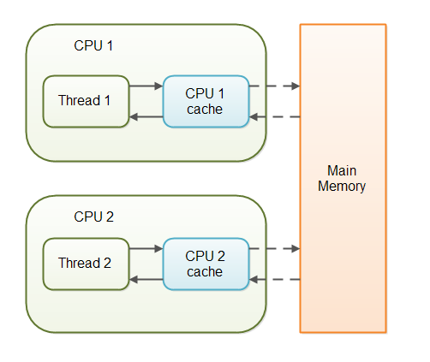
With non-volatile variables there are no guarantees about when the Java Virtual Machine (JVM) reads data from main memory into CPU caches, or writes data from CPU caches to main memory.

Scenario-
public class SharedObject { public int counter = 0;}
Thread 1 could read a shared counter variable with the value 0 into its CPU cache, increment it to 1 and not write the changed value back into main memory. Thread 2 could then read the same counter variable from main memory where the value of the variable is still 0, into its own CPU cache. Thread 2 could then also increment the counter to 1, and also not write it back to main memory. Thread 1 and Thread 2 are now practically out of sync. The real value of the shared counter variable should have been 2, but each of the threads has the value 1 for the variable in their CPU caches, and in main memory the value is still 0. It is a mess! Even if the threads eventually write their value for the shared counter variable back to main memory, the value will be wrong.

By declaring the shared counter variable volatile the JVM guarantees that every read of the variable will always be read from main memory, and that all writes to the variable will always be written back to main memory. If Thread A writes to a volatile variable and Thread B subsequently reads the same volatile variable, then all variables visible to Thread A before writing the volatile variable, will also be visible to Thread B.
public class SharedObject { public volatile int counter = 0;}
Reading and writing of volatile variables causes the variable to be read or written to main memory. Reading from and writing to main memory is more expensive than accessing the CPU cache.

Wait – Notify - NotifyAll
- Dead Lock - Dining Philospher problem

/**The dining philosophers problem is summarized as five silent philosophers
* sitting at a circular table doing one of two things: eating or thinking.
* While eating, they are not thinking, and while thinking, they are not eating.
* A large bowl of Rice is placed in the center, which requires two forks
* to serve and to eat. A fork is placed in between
* each pair of adjacent philosophers, and each philosopher may only use the
* fork to his left and the fork to his right. However, the philosophers do not
* speak to each other. Deadlock would arise if every philosopher held a left
* fork and waited perpetually for a right fork (or vice versa). Originally used
* as a means of illustrating the problem of deadlock, this system reaches
* deadlock when there is a 'cycle of unwarranted requests'. In this case
* philosopher P1 waits for the fork grabbed by philosopher P2 who is waiting
* for the fork of philosopher P3 and so forth, making a circular chain.
*/
Example - com.src.java.multithreading.lock – Fork.java, Philospher.java, Dining.java

- To resolve Producer-consumer issue we can use Wait / Notify / NotifyAll
Example - com.src.java.multithreading.lock – Stock.java, Producer.java, Consumer.java, ProducerConsumerTestClient.java

Inter – Thread Communication
In multithreading, a thread has a local data which is required to be passed to another thread and based upon data another thread get processed it. This approach is called as Inter-thread communication. An inter-thread communication always achieved via pipes. This is the place where we use PipedInputStream / PipedOutputStream class or PipedReader / PipedWriter class.

Scenario - There is two threads: Number Generator thread always generating a random number and passed through pipes which will be used by Average Generator thread to calculate the average.

Example - com.src.java.multithreading.lock – PipeTest.java, NumGen.java, RunningAvg.java

Executors, Schedule Executor & Thread Pool
Thread pools manage a pool of worker threads. The thread pool contains a work queue which holds tasks waiting to get executed.

A thread pool can be described as a collection of Runnable objects (work queue) and a connection of running threads. These threads are constantly running and are checking the work query for new work. If there is new work to be done they execute this Runnable. The Thread class itself provides a method, e.g. execute (Runnable r) to add a new Runnable object to the work queue.

The Executor framework provides example implementation of the java.util.concurrent.Executor interface, e.g. Executors.newFixedThreadPool (int n) which will create n worker threads. The ExecutorService adds life cycle methods to the Executor, which allows to shutdown the Executor and to wait for termination.

ScheduledThreadExecutor provides multiple working threads by using Thread pool. This class extends ThreadPoolExecutor class and uses thread pool to have a pool of threads to execute multiple tasks in parallel.
Example - com.src.java.multithreading.lock – MyRunnable.java, ExecutorServiceExample.java, ScheduleExecutorServiceExample.java

Futures and Callables
The executor framework presented above works with Runnables. Runnable do not return result. In case you expect your threads to return a computed result you can use java.util.concurrent.Callable. The Callable object allows returning values after completion.

The Callable interface is similar to Runnable, in that both are designed for classes whose instances are potentially executed by another thread. A Runnable, however, does not return a result and cannot throw a checked exception.

The Callable object uses generics to define the type of object which is returned.
If you submit a Callable object to an Executor the framework returns an object of type java.util.concurrent.Future. This Future object can be used to check the status of a Callable and to retrieve the result from the Callable.
On the Executor you can use the method submit to submit a Callable and to get a future. To retrieve the result of the future we can use the get () method.
A Future represents the result of an asynchronous computation. Methods are provided to check if the computation is complete, to wait for its completion, and to retrieve the result of the computation. The result can only be retrieved using method get when the computation has completed
Example - com.src.java.multithreading.lock – MyCallable.java, CallableFutures.java

Nonblocking algorithms
Java 5.0 provides supports for additional atomic operations. This allows to develop algorithm which are non-blocking algorithm, e.g. which do not require synchronization, but are based on low-level atomic hardware primitives such as compare-and-swap (CAS). A compare-and-swap operation checks if the variable has a certain value and if it has this value it will perform this operation. This operation takes three parameters, the memory address, the expected current value and the new value. It atomically update the value at the given memory address if the current value is the expected.
Non-blocking algorithm are usually much faster then blocking algorithms as the synchronization of threads appears on a much finer level (hardware).
Example - com.src.java.multithreading.lock – Counter.java, UniqueCounter.java, AtomicTest.java

ReentrantLock
This is the most widely used implementation class of Lock interface. This class implements the Lock interface in similar way as synchronized keyword. Apart from Lock interface implementation, ReentrantLock contains some utility methods to get the thread holding the lock, threads waiting to acquire the lock etc.

Example - com.src.java.multithreading.lock – Resource.java, ConcurrencyLockExample.java, ConcurrencyLockClient.java

Lock vs synchronized
- Lock provides more visibility and options for locking, unlike synchronized where a thread might end up waiting indefinitely for the lock, we can use tryLock () to make sure thread waits for specific time only.
- Synchronization code is much cleaner and easy to maintain whereas with Lock we are forced to have try-finally block to make sure Lock is released even if some exception is thrown between lock() and unlock() method calls.
- Synchronization blocks or methods can cover only one method whereas we can acquire the lock in one method and release it in another method with Lock API.

Java 5 features

For each loop

Iterating over a collection is uglier than it needs to be. Consider the following method, which takes a collection of timer tasks and cancels them:
void cancelAll(Collection<TimerTask> c) {
for (Iterator<TimerTask> i = c.iterator(); i.hasNext(); )
i.next().cancel();
}
The iterator is just clutter. Furthermore, it is an opportunity for error. The iterator variable occurs three times in each loop: that is two chances to get it wrong. The for-each construct gets rid of the clutter and the opportunity for error. Here is how the example looks with the for-each construct:
void cancelAll(Collection<TimerTask> c) {
for (TimerTask t : c)
t.cancel();
}
When you see the colon (:) read it as “in.” The loop above reads as “for each TimerTask t in c.”
Example - com.src.java.java5 – MainClass.java, ForEachLoop.java

Var-args
Last argument can only be used as variable argument.
Example - com.src.java.java5 – VarGridLayout.java, VarArgsExample.java

AutoBoxing
Java 5 (and hence AspectJ 1.5) supports automatic conversion of primitive types (int, float, double etc.) to their object equivalents (Integer, Float, Double,...) in assignments and method and constructor invocations. This conversion is known as autoboxing.
Java 5 also supports automatic unboxing, where wrapper types are automatically converted into their primitive equivalents if needed for assignments or method or constructor invocations.
For example:
int i = 0;
i = new Integer(5); // auto-unboxing

Integer i2 = 5; // autoboxing

Generics
Generics allow you to abstract over types.
Note: Already discussed most of the concept of Generics inside Collection.

Upper Bounded Wildcards
You can use an upper bounded wildcard to relax the restrictions on a variable. For example, say you want to write a method that works on List<Integer>, List<Double>, and List<Number>; you can achieve this by using an upper bounded wildcard.
To declare an upper-bounded wildcard, use the wildcard character ('?'), followed by the extends keyword, followed by its upper bound. Note that, in this context, extends is used in a general sense to mean either "extends" (as in classes) or "implements" (as in interfaces).
To write the method that works on lists of Number and the subtypes of Number, such as Integer, Double, and Float, you would specify List<? extends Number>. The term List<Number> is more restrictive than List<? extends Number> because the former matches a list of type Number only, whereas the latter matches a list of type Number or any of its subclasses.
For example-
The sumOfList method returns the sum of the numbers in a list:
public static double sumOfList(List<? extends Number> list) {
double s = 0.0;
for (Number n : list)
s += n.doubleValue();
return s;
}
The following code, using a list of Integer objects, prints sum = 6.0:
List<Integer> li = Arrays.asList(1, 2, 3);
System.out.println("sum = " + sumOfList(li));
A list of Double values can use the same sumOfList method. The following code prints sum = 7.0:
List<Double> ld = Arrays.asList(1.2, 2.3, 3.5);
System.out.println("sum = " + sumOfList(ld));

Lower Bounded Wildcards
The Upper Bounded Wildcards section shows that an upper bounded wildcard restricts the unknown type to be a specific type or a subtype of that type and is represented using the extends keyword. In a similar way, a lower bounded wildcard restricts the unknown type to be a specific type or a super type of that type.
A lower bounded wildcard is expressed using the wildcard character ('?'), following by the super keyword, followed by its lower bound: <? super A>.

Note: You can specify an upper bound for a wildcard, or you can specify a lower bound, but you cannot specify both.

Say you want to write a method that puts Integer objects into a list. To maximize flexibility, you would like the method to work on List<Integer>, List<Number>, and List<Object> — anything that can hold Integer values.
To write the method that works on lists of Integer and the supertypes of Integer, such as Integer, Number, and Object, you would specify List<? super Integer>. The term List<Integer> is more restrictive than List<? super Integer> because the former matches a list of type Integer only, whereas the latter matches a list of any type that is a supertype of Integer.
The following code adds the numbers 1 through 10 to the end of a list:
public static void addNumbers(List<? super Integer> list) {
for (int i = 1; i <= 10; i++) {
list.add(i);
}
}

Enum
We can use this to define GLOBAL Constants inside our application.
An enum type is a type whose fields consist of a fixed set of constants. Common examples include compass directions (values of NORTH, SOUTH, EAST, and WEST) and the days of the week.
Because they are constants, the names of an enum type's fields are in uppercase letters.
In the Java programming language, you define an enum type by using the enum keyword. For example, you would specify a days-of-the-week enum type as:
public enum Day {
SUNDAY, MONDAY, TUESDAY, WEDNESDAY,
THURSDAY, FRIDAY, SATURDAY
}

You should use enum types any time you need to represent a fixed set of constants. That includes natural enum types such as the planets in our solar system and data sets where you know all possible values at compile time—for example, the choices on a menu, command line flags, and so on.
Example - com.src.java.java5 – Day.java, EnumTest.java, MyConstants.java, EnumMyConstantExample.java

Covariant Return
A covariant return type means changing a method's return type when overriding it in a subclass.

For Example-
// Classes used as return types:

class A {
}

class B extends A {
}

// Classes demonstrating method overriding:

class C {
A getFoo() {
return new B();
}
}

class D extends C {
B getFoo() {
return new B();
}
}
For Example-
interface X {

}

class A implements X{
A a() {
return new A();
}
}

class B extends A {
A a() {
return new B();
}
}

class C extends B {
A a() {
return new C();
}
}

class D implements X {
X a() {
X interf = new D();
return new D();
}
}
public class CovariantReturn {

}

Annotation
- Annotations are generally a way to add meta-data information to an element (an element can be a class, method, field, or anything) and these meta-data are processed by the tools (compilers, javadoc, etc.). Annotations are differentiated from other elements like class, interface etc., by preceeding a '@' symbol before it.
An annotation definition looks like the following,
public @interface TestAnnotation {
////
}
- Metadata are data about data. In the context of computer programs, metadata are data about the code.
- For annotating any element, we need to define 2 basic things:
1) Target Annotation- The argument to @Target Annotation can be one from the possible set of values of any Java Element, which is defined in a well-defined Enum called ElementType. Here are the possible values taken by this Enum,
  - TYPE – Applied only to Type. A Type can be a Java class or interface or an Enum or even an Annotation.
  - FIELD – Applied only to Java Fields (Objects, Instance or Static, declared at class level).
  - METHOD – Applied only to methods.
  - PARAMETER – Applied only to method parameters in a method definition.
  - CONSTRUCTOR – Can be applicable only to a constructor of a class.
  - LOCAL_VARIABLE – Can be applicable only to Local variables. (Variables that are declared within a method or a block of code).
  - ANNOTATION_TYPE – Applied only to Annotation Types.
  - PACKAGE – Applicable only to a Package.
2) Retention Annotation- We has mechanism through which we can say that to what extent the Annotations should be retained. The three possible ways of telling this are,
- Retain the Annotation in the Source Code only
- Retain the Annotation in the Class file also
- Retain the Annotation Definition during the Run-time so that JVM can make use of it
The Annotation that is used to achieve this is @Retention and it takes a possible value of SOURCE, CLASS and RUNTIME defined in RetentionPolicy Enumeration.
For Example-
@Target(ElementType.METHOD)
@Retention(RetentionPolicy.CLASS)
public @interface TestAnnotation
{
// Property Definitions here.
}

- Built-in Annotation in Java
There are some pre-defined annotations available in the Java Programming language. They are:
Override, Deprecated, SuppressWarnings
- For Example-
Suppress Warnings can be used on various Java elements like Class/Interface, Method, Constructor etc. When applied on any of the Java Elements along with a value, it provides a hint to the Compiler to turn-off the warnings.
@SuppressWarnings("unchecked")
public static List toList(Object[] array)
{
return Arrays.asList(array);
}

Java Annotation Types
There are three annotation types:
- Marker: Marker type annotations have no elements, except the annotation name itself.
Example:
public @interface MyAnnotation {
}
Usage:
@MyAnnotation
public void mymethod() {
....
}
- Single-Element: Single-element, or single-value type, annotations provide a single piece of data only. This can be represented with a data=value pair or, simply with the value (a shortcut syntax) only, within parenthesis.
Example:
public @interface MyAnnotation
{
String doSomething();
}
Usage:
@MyAnnotation ("What to do")
public void mymethod() {
....
}
- Full-value or multi-value: Full-value type annotations have multiple data members. Therefore, you must use a full data=value parameter syntax for each member.
Example:
public @interface MyAnnotation {
String doSomething();
int count(); String date();
}
Usage:
@MyAnnotation (doSomething="What to do", count=1,
date="09-09-2005")
public void mymethod() {
....
}

  - Rules to define Java annotation Type
Annotation declaration should start with an 'at' sign like @, following with an interface keyword, following with the annotation name.
Method declarations should not have any parameters.
Method declarations should not have any throws clauses.
Return types of the method should be one of the following: primitives, String, Class, enum,array of these types
- User-defined Annotations-
We need to define annotation interface as well as annotation processor using reflection.
Example - com.src.java.java5 – Author.java, Version.java, AnnotatedClass.java, AnnotationReader.java

Static Import
In order to access static members, it is necessary to qualify references with the class they came from. For example, one must say:
double r = Math.cos(Math.PI * theta);
The static import construct allows unqualified access to static members without inheriting from the type containing the static members. Instead, the program imports the members, either individually:
import static java.lang.Math.PI;
OR
import static java.lang.Math.*;

Once the static members have been imported, they may be used without qualification:
double r = cos(PI * theta);

The static import declaration is analogous to the normal import declaration. Where the normal import declaration imports classes from packages, allowing them to be used without package qualification, the static import declaration imports static members from classes, allowing them to be used without class qualification.

JDBC Connectivity

Types of Driver
There are 4 types of drivers:
- Type I – also called as “JDBC - ODBC” driver.
JAVA API talks to Native API and then it talks to the Database.
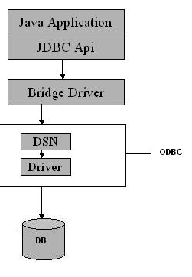
- Type II – also called as “Thick / Native” OR Partial Java driver.
There is a Native API which will talks to the Database.
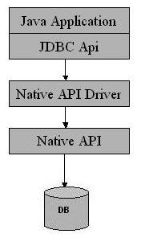
- Type III – also called as “All Java/Net Protocol” driver.
It is the driver which is based on 3-tier architecture. Client talks to the server using Net Protocol
driver and then server talks to the Database using any of the other driver (I / II / IV). It would be use where lots of concurrency to access to a database, lots of traffic to access to a database.
It requires another server application to install and maintain. Traversing the recordset may take longer, since the data comes through the backend server.

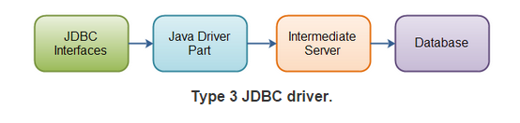

- Type IV – also called as “Thin / Pure” driver.
It is Pure JAVA API which directly talks to the database. Most often we use Type IV driver. Therefore, type IV is faster and most popular driver 4 types of JDBC Driver
With type 4 drivers, the user needs a different driver for each database.
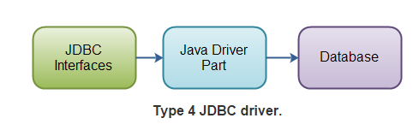

Install & Configure Database
Install any database like mysql, hsqldb, etc
- For HSQLDB, download it from - http://sourceforge.net/projects/hsqldb/files/hsqldb/hsqldb_2_3/

- Inside Eclipse-> Window -> Show View -> Other -> Data Source Explorer

- Right click on “Database Connection” -> Select “HSQLDB” as connection profile -> Select driver using New driver definition -> Specify Jar file “hsqldb.jar” inside hsqldb-2.3.2\hsqldb\lib

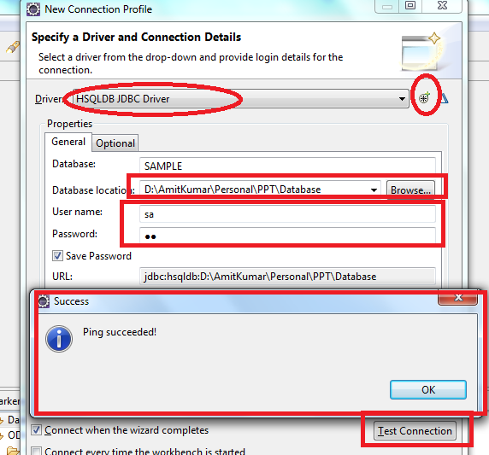

- Provide database location, password & then Test Connection -> Ping succeeded

- Next -> Finish

- Add driver into your classpath

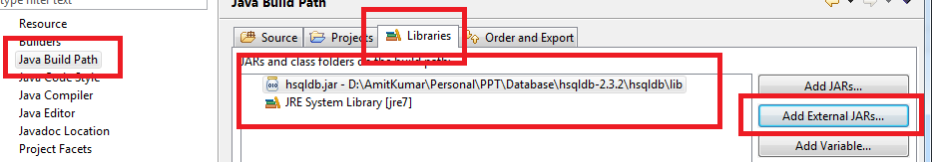

- Install MySQL 5.5 Database (default port: 3306, Username: root & Password: root)

- Install Client App like navicat100_lite_en to connect to database

- Open Navicat -> Create new Database Connection using MySQL
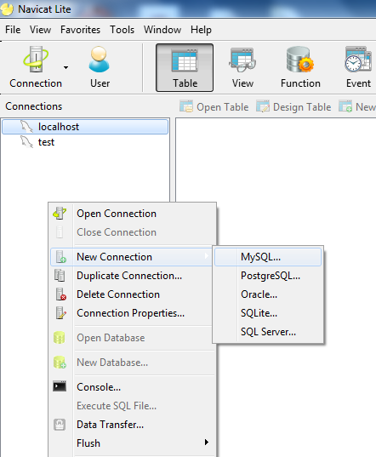
- “GpsConnection” & Test Connection -> finally OK
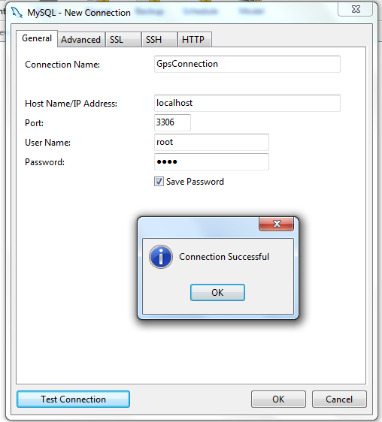
- Create new database “gpsdb” & set mysql-connector-java java to classpath

Steps to Create a Database Connection
- Steps to Create a JDBC Connection are:
- Loading the driver using class.forName
Class.forName(driver).newInstance();
- Establishing JDBC Connection either using Driver Manager / Data Source
Connection con = DriverManager.getConnection(url+db, user, pass);
OR
Connection con = new DataSource().getConnection();
- Prepare SQL Statement / Prepared Statement
String SQL = “SELECT * FROM employee”;
- Execute the query
ResultSet res = st.executeQuery( SQL);
- Process the Result
while (res.next()) {
String employeeName = res.getInt( " employee_name " );
System.out.println( employeeName );
}
- Close the Connection
con.close();

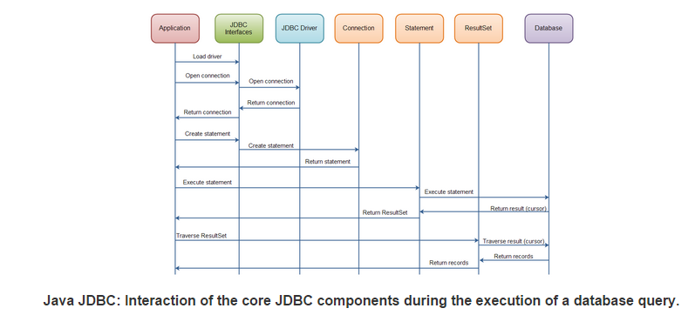

Create few table using SQL Scrapbook
Create table Employee (
EmpID varchar(200),
EmpName varchar(200),
EmpSalary float,
EmpAge int
);

insert into Employee values ('GPS0001','Amit',222.2,34);
insert into Employee values ('GPS0002','Amit1',223.2,35);
insert into Employee values ('GPS0003','Amit2',224.2,36);
commit;

Database URL’s
RDBMS | JDBC driver name | URL format
MySQL | com.mysql.jdbc.Driver | jdbc:mysql://hostname/ databaseName
ORACLE | oracle.jdbc.driver.OracleDriver | jdbc:oracle:thin:@hostname:port Number:databaseName
DB2 | COM.ibm.db2.jdbc.net.DB2Driver | jdbc:db2:hostname:port Number/databaseName
Sybase | com.sybase.jdbc.SybDriver | jdbc:sybase:Tds:hostname: port Number/databaseName

Read data from Database using Statement
Example - com.src.java.jdbc – ReadData.java

Read data from Database using PreparedStatement
Example - com.src.java.jdbc – ReadDataByPS.java

Question: Difference between Statement and PreparedStatement?
A Statement is usually parsed and executed each time it is submitted to the database. A PreparedStatement may be parsed once and executed repeatedly with different parameters.
Most relational databases handle a JDBC / SQL query in four steps:
1. Parse the incoming SQL query
2. Compile the SQL query
3. Plan/optimize the data acquisition path
4. Execute the optimized query / acquire and return data
A Statement will always proceed through the four steps above for each SQL query sent to the database. A PreparedStatement pre-executes steps (1) - (3) in the execution process above. Thus, when creating a PreparedStatement some pre-optimization is performed immediately. The effect is to lessen the load on the database engine at execution time

Read data from Database using DataSource
Example - com.src.java.jdbc – ReadDataByPSusingDataSource.java

Question: What is difference between DataSource and DriverManager of JDBC?
Connection object got from Datasource.getConnection() ,when closed will be returned back to connection pool..but will not be closed permanently whereas Connection object retrieved from DriverManager.getConnection() when closed will be returned permanently.
One difference between both is that Datasource has properties with it, which represents the Source of data it represents.
Other is, DataSource supports the JNDI Service, so we can give any logical name to that datasource eg. MSSQLDataSource to MS SQL server, MySQLDataSource to MySQL.
One more is, DataSource can be separately created and managed and can be accessed from any of the Application through lookup facility of JNDI. DataSource is the standard interface in JDBC, which need to be implemented by database Driver, can be implemented to maintain the pool of connections.

Question: Do we need to close ResultSet before closing connection?
Yes but depend upon scenario. Most Java programmers close a connection with database directly without closing the ResultSet. This is okay with standalone Java programs, where the Java compiler automatically closes the Resultset for you, but when we deploy this code in a servlet, and then we are not guaranteed this behavior. So to be safe, remember to close the ResultSet explicitly before closing the Connection.

ResultSet Type
When you create a ResultSet there are three attributes you can set. These are-
- Type
- Concurrency
- Holdability
You set these already when you create the Statement or PreparedStatement, like this:
Statement statement = connection.createStatement(ResultSet.TYPE_FORWARD_ONLY,
ResultSet.CONCUR_READ_ONLY, ResultSet.CLOSE_CURSORS_OVER_COMMIT);
PreparedStatement statement = connection.prepareStatement(sql,
ResultSet.TYPE_FORWARD_ONLY, ResultSet.CONCUR_READ_ONLY, ResultSet.CLOSE_CURSORS_OVER_COMMIT
);
At the time of writing there are three ResultSet types:
- ResultSet.TYPE_FORWARD_ONLY
- ResultSet.TYPE_SCROLL_INSENSITIVE
- ResultSet.TYPE_SCROLL_SENSITIVE
The default type is TYPE_FORWARD_ONLY
TYPE_FORWARD_ONLY means that the ResultSet can only be navigated forward. That is, you can only move from row 1, to row 2, to row 3 etc. You cannot move backwards in the ResultSet.
TYPE_SCROLL_INSENSITIVE means that the ResultSet can be navigated (scrolled) both forward and backwards. You can also jump to a position relative to the current position, or jump to an absolute position. The ResultSet is insensitive to changes in the underlying data source while the ResultSet is open. That is, if a record in theResultSet is changed in the database by another thread or process, it will not be reflected in already openedResulsSet's of this type.
TYPE_SCROLL_SENSITIVE means that the ResultSet can be navigated (scrolled) both forward and backwards. You can also jump to a position relative to the current position, or jump to an absolute position. The ResultSet is sensitive to changes in the underlying data source while the ResultSet is open. That is, if a record in the ResultSet is changed in the database by another thread or process, it will be reflected in already opened ResulsSet's of this type.

ResultSet Concurrency
A ResultSet can have one of two concurrency levels:
- ResultSet.CONCUR_READ_ONLY
- ResultSet.CONCUR_UPDATABLE
CONCUR_READ_ONLY means that the ResultSet can only be read.
CONCUR_UPDATABLE means that the ResultSet can be both read and updated.

ResultSet Holdability
The ResultSet holdability determines if a ResultSet is closed when the commit() method of the underlyingconnection is called.
There are two types of holdability:
- ResultSet.CLOSE_CURSORS_OVER_COMMIT
- ResultSet.HOLD_CURSORS_OVER_COMMIT
The CLOSE_CURSORS_OVER_COMMIT holdability means that all ResultSet instances are closed when connection.commit() method is called on the connection that created the ResultSet.
The HOLD_CURSORS_OVER_COMMIT holdability means that the ResultSet is kept open when the connection.commit() method is called on the connection that created the ResultSet.
The HOLD_CURSORS_OVER_COMMIT holdability might be useful if you use the ResultSet to update values in the database. Thus, you can open a ResultSet, update rows in it, call connection.commit() and still keep the sameResultSet open for future transactions on the same rows.
Insert data into Database
Example - com.src.java.jdbc – InsertData.java

Update data into Database
Example - com.src.java.jdbc – UpdateData.java

Delete data from Database
Example - com.src.java.jdbc – DeleteData.java

Batch Updates
A batch update is a batch of updates grouped together, and sent to the database in one "batch", rather than sending the updates one by one.
Sending a batch of updates to the database in one goes, is faster than sending them one by one, waiting for each one to finish. There is less network traffic involved in sending one batch of updates (only 1 round trip), and the database might be able to execute some of the updates in parallel. The speed up compared to executing the updates one by one, can be quite big.
You can batch SQL inserts, updates and deletes. It does not make sense to batch select statements.
Example of Statement Batch Updates
Statement statement = null;
try{
statement = connection.createStatement();
statement.addBatch("update people set firstname='John' where id=123");
statement.addBatch("update people set firstname='Eric' where id=456");
statement.addBatch("update people set firstname='May' where id=789");
int[] recordsAffected = statement.executeBatch();
} finally {
if(statement != null) statement.close();
}
Example of PreparedStatement Batch Updates
String sql = "update people set firstname=? , lastname=? where id=?";
PreparedStatement preparedStatement = null;
try{
preparedStatement = connection.prepareStatement(sql);
preparedStatement.setString(1, "Gary");
preparedStatement.setString(2, "Larson");
preparedStatement.setLong (3, 123);
preparedStatement.addBatch();
preparedStatement.setString(1, "Stan");
preparedStatement.setString(2, "Lee");
preparedStatement.setLong (3, 456);
preparedStatement.addBatch();
int[] affectedRecords = preparedStatement.executeBatch();
}finally {
if(preparedStatement != null) {
preparedStatement.close();
}
}

Rowset
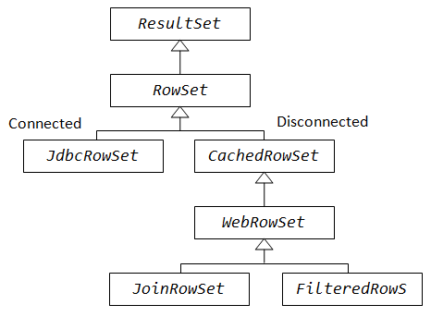
RowSet interface is basically an extension of JDBC ResultSet and is a part of thejavax.sql package. RowSet object holds tabular data in a way that makes it more flexible and easier to use than a result set. A RowSet object is considered either connected or disconnected.
Connected RowSet are those which establish a connection with the database and retain it until the application terminates.
Disconnected RowSet on the other hand establishes a connection, executes a query such as retrieving data from the database and closes the connection.

According to the implementation there are five different categories of RowSet – JdbcRowSet, CachedRowSet, WebRowSet, FilteredRowSet, and JoinRowSet.
Out of these five only JdbcRowSet is connected RowSet, rest of them are disconnected row sets.

JdbcRowSet
It basically acts as a wrapper around the ResultSet object with some additional functionality. The primary advantage of using JdbcRowSet is that it enables theResultSet object to be used as a JavaBeans component.
Example - com.src.java.jdbc – JdbcRowSetDemo.java

CachedRowSet
It is a disconnected RowSet that acts as a container for database records and caches them in memory. In a sense we may think of it as a subset of actual records maintained in memory. This reminds us somewhat of the concept of 'VIEW' we create from the actual table through SQL. Being disconnected, CachedRowSet is more lightweight. On the downside, connection has to be established every time to reflect any changes, performance may be slower than JdbcRowSet but on the upside it is lightweight and we can get a better efficiency when working with large amount of data.

WebRowSet
It extends CachedRowSet capabilities but is very special in the sense that in addition to providing all the features of CachedRowSet, it can read and write XML document. This is particularly seen in an enterprise application scenario or in web service communication. Records fetched from the database can be shipped across tiers over internet protocol in an enterprise application without having to maintain an active connection.
Example - com.src.java.jdbc – WebRowSetDemo.java

FilteredRowSet
It is an extension of WebRowSet. So it has all the capabilities of WebRowSet as well as CachedRowSet. With this RowSet we can apply filtering criteria to fetch selected rows from the data source so that we can work with the relevant data. This RowSet object paves the way for a disconnected yet live filtering mechanism without firing a query into the database every time. We can limit what we want to visualize from the record list without the involvement of a database connection. It is something like using the WHERE clause without writing an SQL.

JoinRowSet
It also extends WebRowSet. In addition to the capabilities of WebRowSet and CachedRowSet, we can perform a SQL JOIN operation without connecting to a data source. ThisRowSet enables us to create SQL JOIN between RowSet objects. Related records from different RowSets can be combined to form thisRowSet object.
Question: What is difference between ResultSet and RowSet?
- A ResultSet maintains a connection to a database and because of that it can’t be serialized and also we can’t pass the Resultset object from one class to other class across the network.
- RowSet is a disconnected, serializable version of a JDBC ResultSet and also the RowSet extends the ResultSet interface so it has all the methods of ResultSet. The RowSet can be serialized because it doesn’t have a connection to any database and also it can be sent from one class to another across the network.

Question: What is difference between Connected and Disconnected RowSet?
- Disconnected database connected to the database only when they want to read or write, all the times they are disconnected from the database, on the other hand, Connected database keep JDBC connection alive all time.
- Only JdbcRowSet from JDBC 4.1 API is connected, rest like CachedRowSet, WebRowSet are disconnected RowSet implementation.
- Disconnected RowSet are Serializable and that's why suitable for sending over the network

CallableStatement
The interface used to execute SQL stored procedures. The JDBC API provides a stored procedure SQL escape syntax that allows stored procedures to be called in a standard way for all RDBMSs. This escape syntax has one form that includes a result parameter and one that does not.

To call stored procedures, you invoke methods in the CallableStatement class. The basic steps are:
- Invoke the Connection.prepareCall method to create a CallableStatement object.
- Invoke the CallableStatement.setXXX methods to pass values to the input (IN) parameters.
- Invoke the CallableStatement.registerOutParameter method to indicate which parameters are output-only (OUT) parameters, or input and output (INOUT) parameters.
- Invoke one of the following methods to call the stored procedure:
CallableStatement.executeUpdate
Invoke this method if the stored procedure does not return result sets.
CallableStatement.executeQuery
Invoke this method if the stored procedure returns one result set.
CallableStatement.execute
Invoke this method if the stored procedure returns multiple result sets.
- If the stored procedure returns result sets, retrieve the result sets.
- Invoke the CallableStatement.getXXX methods to retrieve values from the OUT parameters or INOUT parameters.
- Invoke the CallableStatement.close method to close the CallableStatement object when you have finished using that object.
Eaxmple- Using CallableStatement methods for a stored procedure call with parameter markers
int ifcaret;
int ifcareas;
int xsbytes;
String errbuff;
Connection con;
CallableStatement cstmt;
ResultSet rs;
...
cstmt = con.prepareCall("CALL DSN8.DSN8ED2(?,?,?,?,?)"); 1
// Create a CallableStatement object
cstmt.setString (1, "DISPLAY THREAD(*)"); 2
// Set input parameter (DB2 command)
cstmt.registerOutParameter (2, Types.INTEGER); 3
// Register output parameters
cstmt.registerOutParameter (3, Types.INTEGER);
cstmt.registerOutParameter (4, Types.INTEGER);
cstmt.registerOutParameter (5, Types.VARCHAR);
cstmt.executeUpdate(); // Call the stored procedure 4
ifcaret = cstmt.getInt(2); // Get the output parameter values 6
ifcareas = cstmt.getInt(3);
xsbytes = cstmt.getInt(4);
errbuff = cstmt.getString(5);
cstmt.close();

Example- Retrieving known result sets from a stored procedure
CallableStatement cstmt;
ResultSet rs;
int i;
String s;
...
cstmt.execute(); // Call the stored procedure 1
rs = cstmt.getResultSet(); // Get the first result set 2
while (rs.next()) { // Position the cursor 3
i = rs.getInt(1); // Retrieve current result set value
System.out.println("Value from first result set = " + i);
// Print the value
}
cstmt.getMoreResults(); // Point to the second result set 4a
// and close the first result set
rs = cstmt.getResultSet(); // Get the second result set 4b
while (rs.next()) { // Position the cursor 4c
s = rs.getString(1); // Retrieve current result set value
System.out.println("Value from second result set = " + s);
// Print the value
}
rs.close(); // Close the result set
cstmt.close(); // Close the statement

Connection Pooling using JNDI Services

Inside Tomcat using Servlet.xml
For Example-
<Context path="/pE" docBase="c:/temp/pE" debug="0" reloadable="true" >
<Resource name="jdbc/myDataSource" auth="Container" type="javax.sql.DataSource" />
<ResourceParams name="jdbc/myDataSource">
<parameter>
<name>factory</name>
<value>org.apache.commons.dbcp.BasicDataSourceFactory</value>
</parameter>
<parameter>
<name>dataSourceName</name>
<value>myDataSource</value>
</parameter>
<parameter>
<name>maxActive</name>
<value>25</value>
</parameter>
<parameter>
<name>maxIdle</name>
<value>10</value>
</parameter>
<parameter>
<name>maxWait</name>
<value>10000</value>
</parameter>
<parameter>
<name>url</name>
<value>jdbc:Microsoft:sqlserver://localhost:1433;DatabaseName=pE</value>
</parameter>
<parameter>
<name>username</name>
<value>sa</value>
</parameter>
<parameter>
<name>password</name>
<value>sql</value>
</parameter>
<parameter>
<name>driverClassName</name>
<value>com.microsoft.jdbc.sqlserver.SQLServerDriver</value>
</parameter>
</ResourceParams>
</Context>

Make an entry inside web.xml:
<resource-ref>
<res-ref-name>jdbc/myDataSource</res-ref-name>
<res-type>javax.sql.DataSource</res-type>
<res-auth>Container</res-auth>
</resource-ref>

How we get Connection using JNDI inside Servlet?
import java.io.*;
import java.sql.*;
import javax.naming.*;
import javax.servlet.*;
import javax.servlet.http.*;
import javax.sql.*;

public class validateLogin extends HttpServlet
{
private Connection conn = null;
private ResultSet rs = null;
private PreparedStatement psmt = null;

private String login,password,sql,UserName;;
private boolean userExist=false;
private DataSource ds=null;

public void init(ServletConfig config) throws ServletException
{
try
{
Context initCtx = new InitialContext();
ds = (DataSource) initCtx.lookup("java:comp/env/jdbc/myDataSource");
}
catch (Exception e)
{
throw new ServletException(e.getMessage());
}
}

private Connection getConnection() throws SQLException
{
return ds.getConnection();
}

public void doPost(HttpServletRequest request, HttpServletResponse response) throws ServletException, IOException
{
login = request.getParameter("txtLogin");
password = request.getParameter("txtPassword");

try
{
conn = getConnection();

sql = "select * from jobSeekerDetails where UserName=? and Password=?";
psmt = conn.prepareStatement(sql);
psmt.setString(1,login);
psmt.setString(2,password);

rs = psmt.executeQuery();

if(rs.next())
{
userExist = true;

HttpSession session = request.getSession(true);
session.setAttribute("userLogin",login);
response.sendRedirect("../");
return;
}
else
{
response.sendRedirect("../errorPage.jsp");
}
}
catch(Exception e)
{
System.out.println(e.getMessage() + " validateLogin.jsp Line No : " + 51);
}
finally
{
try
{
rs.close();
conn.close();
}
catch(Exception e){}
}
}
}

Connection Pooling using Context.xml
Tomcat JDBC connection pool can be configured with META-INF/context.xml.
<Context>
<Resource name="jdbc/EmployeeDB"
auth="Container"
type="javax.sql.DataSource"
username="dbusername"
password="dbpassword"
driverClassName="org.hsql.jdbcDriver"
url="jdbc:HypersonicSQL:database"
maxActive="8"
maxIdle="4"/>
</Context>

To use the DataSource in your Java code:
Context initCtx = new InitialContext();
DataSource ds = (DataSource) initCtx.lookup("java:comp/env/jdbc/EmployeeDB");
Connection conn = ds.getConnection();
// ... use this connection to access the database ...
conn.close();

In contrast to Tomcat documentation, there's no need to declare resource-ref in web.xml.

Java 6 features

WebService
Easy way of creating Web Services. Exposing web services with a simple annotation.
Step1 – Create a webservice endpoint interface
Example - com.src.java.java6 – HelloWorld.java
Step2 – Create a webservice endpoint implementation
Example - com.src.java.java6 – HelloWorldImpl.java
Step3 – Create an endpoint publisher
Example - com.src.java.java6 – HelloWorldPublisher.java
Ster4 – Create Webservice client
Example - com.src.java.java6 – HelloWorldClient.java

Rhino
It is Java script engine to ability to run JS from Java. Rhino is written in Java.
Embedded JavaScript can be used for a variety of purposes. Since it is more flexible and easier to configure than hard-coded Java, it can often be used to code business rules that may change often. Scripting expressions are evaluated using the eval() method. Any variables used in the scripting environment can be assigned from within your Java code using the put() method.
ScriptEngineManager manager
= new ScriptEngineManager();
ScriptEngine engine
= manager.getEngineByName("js");
engine.put("age", 21);
engine.eval(
"if (age >= 18){ " +
" print('Old enough to vote!'); " +
"} else {" +
" print ('Back to school!');" +
"}");

> Old enough to vote!

The eval() method also accepts a Reader object, which makes it easy to store scripts in files or other external sources, as in the following example:
ScriptEngineManager manager
= new ScriptEngineManager();
ScriptEngine engine
= manager.getEngineByName("js");
engine.put("age", 21);
engine.eval(new FileReader("c:/voting.js"));

You can also access Java classes and resources from within scripts. The Rhino JavaScript engine supports the importPackage()function, which allows you to import Java packages. Once imported, you can instantiate Java objects within the script just as you would in Java:
engine.eval("importPackage(java.util); " +
"today = new Date(); " +
"print('Today is ' + today);");

Calling methods on Java classes is also easy to do, both on object instances passed to the script engine, and on static class members.
engine.put("name","John Doe");
engine.eval(
"name2 = name.toUpperCase();" +
"print('Converted name = ' + name2);");
> Converted name = JOHN DOE

Why we need it?
One of the more ambitious goals of the JSR 223 specification is to provide for integration of non-Java scripting pages (such as PHP) into a Java web application. This is designed to allow both non-Java scripting pages to be integrated as part of a Java web application, but also for Java classes to be invoked from the scripting pages.

Using scripting languages from Java can be useful in many situations, such as providing extensions to your Java application so that users can write their own scripts to extend or customize the core functionalities. Scripting languages are both simpler to understand and easier to write, so they can be ideal to give (technical) end users the possibility to tailor your product to their needs.

Example - com.src.java.java6 – JavaScriptRunner.java

Derby DB
Java 6 comes with preinstalled relational database, Oracle release of Apache Derby project.
Java DB is installed automatically as a part of JDK.
For a Java DB installation, set the DERBY_HOME environment variable.

Deque
A double-ended queue (dequeue or deque) is an abstract data type that generalizes a queue, for which elements can be added to or removed from either the front or rear. Deque differs from the queue abstract data type or First-In-First-Out List (FIFO), where elements can only be added to one end and removed from the other.
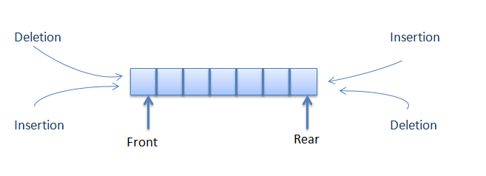
Example - com.src.java.java6 – ArrayDequeExample.java, DoubleEndedQueueImpl.java

JavaTM API for XML Processing (JAXP)
The Java API for XML Processing (JAXP) enables applications to parse, transform, validate and query XML documents using an API that is independent of a particular XML processor implementation. JAXP provides a pluggability layer to enable vendors to provide their own implementations without introducing dependencies in application code. Using this software, application and tool developers can build fully-functional XML-enabled Java applications for e-commerce, application integration, and web publishing.
The Java Platform, Standard Edition version 6.0 includes JAXP 1.4. JAXP 1.4 is a maintenance release of JAXP 1.3 with support for the Streaming API for XML (StAX).
Example - com.src.java.resource - Access.xml
com.src.java.java6 – Access.java, ParseXML.java

JDBC 4.0 Enhancements
Java SE 6 includes several enhancements to the Java Database Connectivity (JDBC) API. These enhancements will be released as JDBC version 4.0. The main objectives of the new JDBC features are to provide a simpler design and better developer experience.
The major features added in JDBC 4.0 include:
    - Auto-loading of JDBC driver class
In JDBC 4.0, we no longer need to explicitly load JDBC drivers using Class.forName(). When the method getConnection is called, the DriverManager will attempt to locate a suitable driver from among the JDBC drivers that were loaded at initialization and those loaded explicitly using the same class loader as the current application.
Connection conn = DriverManager.getConnection(Urldatabase,Username,Password);

    - Support of RowId SQL type. In JDBC 4.0, RowID interface is added to support the ROWID data type which is supported by databases such as Oracle and DB2.
Example - com.src.java.java6 – RowIdExample.java

    - Exception Handling enhancements
It raised a chained exception using enhanced for-loop.
Example - com.src.java.java6 – JdbcExceptionHandling.java

    - JDBC 4.0 SQL XML Support
SQLXML is a mapping in the Java programming language for the XML data type in SQL. XML is a built-in type that stores an XML value as a column value in a row of the target table. By default, drivers implement an SQLXML object as a logical pointer to the XML data rather than the data itself. An SQLXMLobject is valid for the duration of the transaction in which it was created.
SQLXML sqlxml = rs.getSQLXML(column);
InputStream binaryStream = sqlxml.getBinaryStream();
DocumentBuilder parser = DocumentBuilderFactory.newInstance().newDocumentBuilder();
Document doc = parser.parse(binaryStream);

    - Enhance support for Large Objects (BLOBs & CLOBs)

Java 7 features

Strings in switch
Before JDK 7, only integral types can be used as selector for switch-case statement. In JDK 7, you can use a String object as the selector.
Example - com.src.java.java7 – StringConstant.java

Binary Literals with prefix "0b"
In JDK 7, you can express literal values in binary with prefix '0b' (or '0B') for integral types (byte, short, int and long), similar to C/C++ language. Before JDK 7, you can only use octal values (with prefix '0') or hexadecimal values (with prefix '0x' or '0X').
You are also permitted to use underscore (_) to break the digits to improve the readability but you must start and end with a digit.
Example - com.src.java.java7 – BinaryLiteralExample.java

Catching Multiple Exception Types
In JDK 7, a single catch block can handle more than one exception types. The new Use separate catch blocks quick assist allows you to replace a multi-catch clause with individual catch blocks, one for each exception in the multi-catch clause.
try{
….
} catch (FileNotFoundException | IOException | Exception e) {
}

The try-with-resources Statement
Before JDK 7, we need to use a finally block, to ensure that a resource is closed regardless of whether the try statement completes normally or abruptly. The code is messy!
JDK 7 introduces a try-with-resources statement, which ensures that each of the resources in try(resources) is closed at the end of the statement. This results in cleaner codes.

Example - com.src.java.java7 – FileCopyPreJDK7.java, FileCopyJDK7.java

Type Inference for Generic Instance Creation
JDK 7 supports limited type inference for generic instance creation

Example - com.src.java.java7 – JDK7GenericExample.java

Rethrowing Exceptions with Improved Type Checking
- With Java 6
void oldWayRethrow(boolean notFound) throws IOException {
try {
if (notFound) {
throw new FileNotFoundException();
} else {
throw new MalformedURLException();
}
} catch (IOException e) {
throw e;
}
}
- With Java 7
void java7Rethrow(boolean notFound) throws FileNotFoundException,
MalformedURLException {
try {
if (notFound) {
throw new FileNotFoundException();
} else {
throw new MalformedURLException();
}
} catch (IOException e) {
throw e; // 1.6 compiler error:
// "unhandled exception type IOException"
}
}

JUNIT & TDD

Unit tests and unit testing
A unit test is a piece of code written by a developer that executes a specific functionality in the code to be tested. The percentage of code which is tested by unit tests is typically called test coverage.

Unit tests ensure that code works as intended. They are also very helpful to ensure that the code still works as intended in case you need to modify code for fixing a bug or extending functionality. Having high test coverage of your code allows you to continue developing features without having to perform lots of manual tests.

There are several testing frameworks available for Java. The most popular ones are JUnit and TestNG.

The JUnit framework
JUnit in version 4.x is a test framework which uses annotations to identify methods that specify a test. Typically a JUnit test is a method contained in a class which is only used for testing. This is called a Test class.
To write a test with the JUnit 4.x framework you annotate a method with the @org.junit.Test annotation. In this method you use a method provided by the JUnit framework to check the expected result of the code execution versus the actual result.

JUnit naming conventions
There are several potential naming conventions for JUnit tests. In widespread use is to use the name of the class under test and to add the "Test" suffix to the test class.
For the test method names it is frequently recommend to use the word "should" in the test method name, as for example "ordersShouldBeCreated" or "menuShouldGetActive" as this gives a good hint what should happen if the test method is executed.
As a general rule, a test name should explain what the test does so that it can be avoided to read the actual implementation.

JUnit test suites
If you have several test classes, you can combine them into a test suite. Running a test suite will execute all test classes in that suite in the specified order.

The following example code shows a test suite which defines that two test classes (MYClassTest and MySecondClassTest) should be executed. If you want to add another test class you can add it to @Suite.SuiteClasses statement.

@RunWith(Suite.class)
@SuiteClasses({ MyClassTest.class, MySecondClassTest.class })
public class AllTests {
}

TDD Aproach
Traditional approach
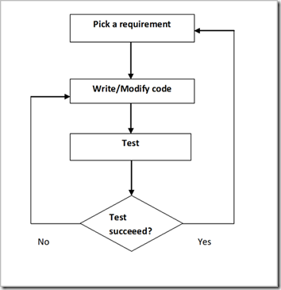

Test driven development
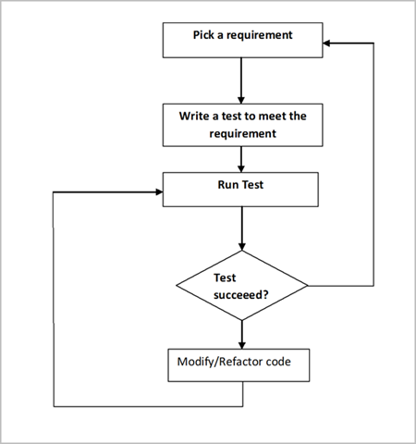

Run your test from the command line
You can also run your JUnit tests outside Eclipse via standard Java code. Build frameworks like Apache Ant or Apache Maven are typically used to execute tests automatically on a regular basis.
The org.junit.runner.JUnitCore class provides the runClasses () method which allows you to run one or several tests classes. As a return parameter you receive an object of the type org.junit.runner.Result. This object can be used to retrieve information about the tests.
The following class demonstrates how to run the MyClassTest. This class will execute your test class and write potential failures to the console.

public static void main(String[] args) {
Result result = JUnitCore.runClasses(MyClassTest.class);
for (Failure failure : result.getFailures()) {
System.out.println(failure.toString());
}
}

Available JUnit annotations
JUnit 4.x uses annotations to mark methods and to configure the test run. The following table gives an overview of the most important available annotations.
Annotation | Description
@Test  public void method() | The @Test annotation identifies a method as a test method.
@Test (expected = Exception.class) | Fails if the method does not throw the named exception.
@Test(timeout=100) | Fails if the method takes longer than 100 milliseconds.
@Before  public void method() | This method is executed before each test. It is used to prepare the test environment (e.g., read input data, initialize the class).
@After  public void method() | This method is executed after each test. It is used to cleanup the test environment (e.g., delete temporary data, restore defaults). It can also save memory by cleaning up expensive memory structures.
@BeforeClass  public static void method() | This method is executed once, before the start of all tests. It is used to perform time intensive activities, for example, to connect to a database. Methods marked with this annotation need to be defined as static to work with JUnit.
@AfterClass  public static void method() | This method is executed once, after all tests have been finished. It is used to perform clean-up activities, for example, to disconnect from a database. Methods annotated with this annotation need to be defined asstatic to work with JUnit.
@Ignore | Ignores the test method. This is useful when the underlying code has been changed and the test case has not yet been adapted. Or if the execution time of this test is too long to be included.

Assert statements
JUnit provides static methods in the Assert class to test for certain conditions. These assertion methods typically start with assertand allow you to specify the error message, the expected and the actual result. An assertion method compares the actual value returned by a test to the expected value, and throws an AssertionException if the comparison test fails.
The following table gives an overview of these methods. Parameters in [] brackets are optional.
Statement | Description
fail(String) | Let the method fail. Might be used to check that a certain part of the code is not reached or to have a failing test before the test code is implemented. The String parameter is optional.
assertTrue([message], boolean condition) | Checks that the boolean condition is true.
assertFalse([message], boolean condition) | Checks that the boolean condition is false.
assertEquals([String message], expected, actual) | Tests that two values are the same. Note: for arrays the reference is checked not the content of the arrays.
assertEquals([String message], expected, actual, tolerance) | Test that float or double values match. The tolerance is the number of decimals which must be the same.
assertNull([message], object) | Checks that the object is null.
assertNotNull([message], object) | Checks that the object is not null.
assertSame([String], expected, actual) | Checks that both variables refer to the same object.
assertNotSame([String], expected, actual) | Checks that both variables refer to different objects.

Examples - com.src.java.testables – Rectangle.java, RandomEmailGenerator.java, MathUtils.java, DomainUtils.java

com.src.java.testables.junit – RectangleTest.java, RandomEmailGeneratorTest.java, MathUtilsTest.java,
DomainUtilsTest.java

com.src.java.testsuite – RunAllTestCases.java

