**CONTENTS**

1. Abstract

2. Introduction

3. Objectives of System

4. Requirements Specification

* Hardware and Software Requirements
* Programming Languages Used

4. ER Diagram and Schema Diagram

6. Modules

7. Conclusion and Future Enhancements

**ABSTRACT**

The aim of the study was to develop a Web-based course feedback system serving for students. The system includes generation and analysis of course feedback pages, provision of feedback, and a summary. Student feedback system is developed for the engineering college students. Students give opinion about their faculty members and vice versa.

The purpose of this feedback system is to gather information on learning experience as well as the about lecturer(s) performance in the class. Student after login into the system, then only they can give feedback. Student has to login with registration number and password assigned. He/she will give the feedback to the faculty member by subject wise. They will have 10 Questions with remarks Excellent, very good etc and student has to select one of the five options about faculty in his feedback form. There are different area he has to cover individually while giving the feedback like voice strength, Teaching style, Subject knowledge, Behaviour and Timing sense. Then student should submit his feedback with the system.

Administrator module to avail the facilities college has to register with the system. college has to provide branch name, branch code, course name and number of students. faculty members has to register themselves with his/her (teaching) subject details.

Head of department can view and export all the feedback details which are given by the students to the faculty member by login-in himself with hod login.

**Features:**

* This system is developed mainly for the purpose of students to give their feedback about their teachers and their course studying.
* Student can give feedback to each respective subject studying.
* This system is developed for the exclusively for the engineering colleges students and lecturers for Computer science branch.
* Student, Faculty and Head of Department has to register themselves with a system.
* Student has to login with the registration number and password.
* Faculty and HOD can Login by using their names and password.

**INTRODUCTION**

Student feedback system is developed for the exclusively for the purpose of students and lectures. The purpose of this feedback questionnaire is to gather information on your learning experience, as well as your response(s). While clicking the answers, you have to think of these questions as your subjective perceptions on various aspects of the course and the teacher(s) involved in the program.

The opinion or information provided by the students is useful for the teacher(s) as well as the University in the ongoing efforts and enhance the quality of education. The opinion provided by the student will be kept confidential. The evolution will be calculated on the basis of total scores from the responses from all students. Student(s) has to mention only his register number, need not to mention his name. Student(s) will give their opinion voice strength, teaching style, subject knowledge, and behaviour and timing sense. He has select one option from five options (excellent, very good, good, satisfactory, not satisfactory) and also he has to mention faculty name, subject, branch, and department. This information has to submit with the system.

In admin module only college has to register with the system. College has to add branches with the code number and course name. Maintainer has to register faculty members with respected course and department and their total personal details. University or college has to add subject details in particular branch with syllabus.

Registered faculty members are appointed to the respective branches. They have to add feedback questions to the system.

Then total average feedback details are viewed by HOD and also HOD can export all the feedback details in pdf format. It will give information about faculty members; they have to improve their performance or vice versa will be notified.

**Features:**

* It is useful to analyse the performance of the faculty members in engineering college.
* Students can view their results, attendance by branch wise and id number.
* Students will give their review about the faculty members in a questionnaire
* Lecturer(s) appointed to the respective departments, with their experience and qualification.
* Administrator will introduce the new colleges to the students and lecturers.

**OBJECTIVES**

The main objective of the system is that to provide quality education with proper resources to the students in a reasonable expenditure. Improve the quality of education and also improve the lab facilities, teaching qualities, classroom facilities and other facilities for the students.

**Objectives:** -

* The System is composed with convenient modules of setting and editing the convenient modules for the students to give their opinions about the lecturers and know about the college details.
* Modules are designed user friendly they can reach anywhere directly without any confusion.
* This system is designed to save the time and reduce the paper work for taking opinions and making assessments.
* To improve the quality of education considering the opinions of students.

**HARDWARE & SOFTWARE SPECIFICATIONS**

**HARDWARE REQUIREMENTS:**

Processor: Intel Pentium or Above

RAM: Minimum 512MB RAM

Hard Disk: Minimum 1 GB of Free Space

**SOFTWARE REQUIREMENTS:**

Operating System: Windows or Linux

Server Application: Xampp

**PROGRAMMING LANGUAGES:**

Front-End: HTML, CSS, JavaScript.

Back-End: PHP, MySQL (For Database).

**ER DIAGRAM AND SCHEMA DIAGRAM**

This chapter of the report describes the structure of the project, followed by Entity Relationship Diagram, Schema Diagram and the table structures.

**ER Diagram with relationships and cardinality ratio**

An entity relationship model, also called an entity-relationship (ER) diagram, is a graphical representation of entities and their relationships to each other, typically used in computing in regard to the organization of data within databases or information systems. An entity is a piece of data-an object or concept about which data is stored.

The cardinality or fundamental principle of one data aspect with respect to another is a critical feature. The relationship of one to the other must be precise and exact between each other in order to explain how each aspect links together. In simple words Cardinality is a way to define the relationship between two entities.

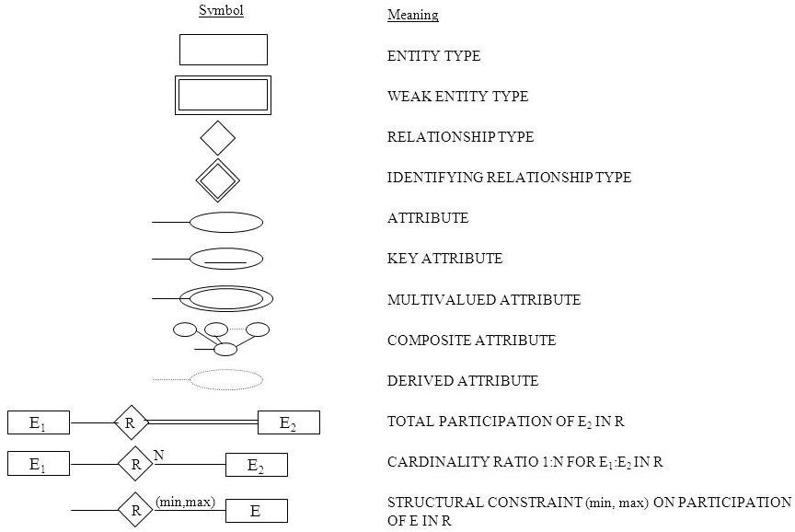The following are the notations of the ER diagram.

**MODULES**

1. **Student Login / Signup**

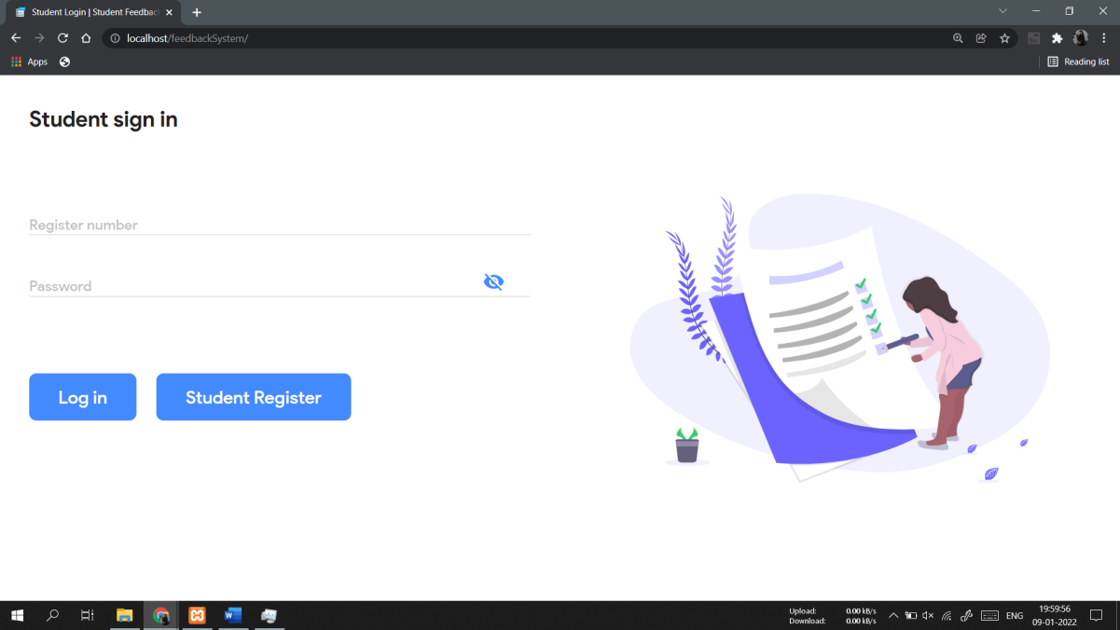

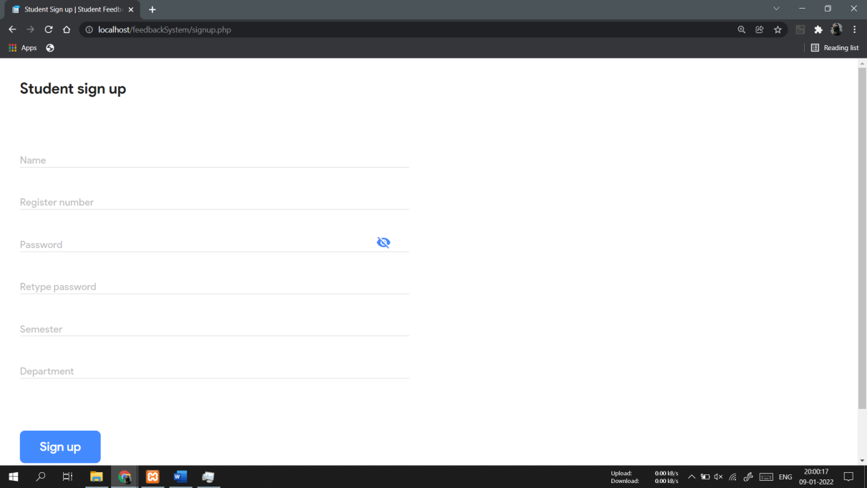

1. **Student Dashboard**

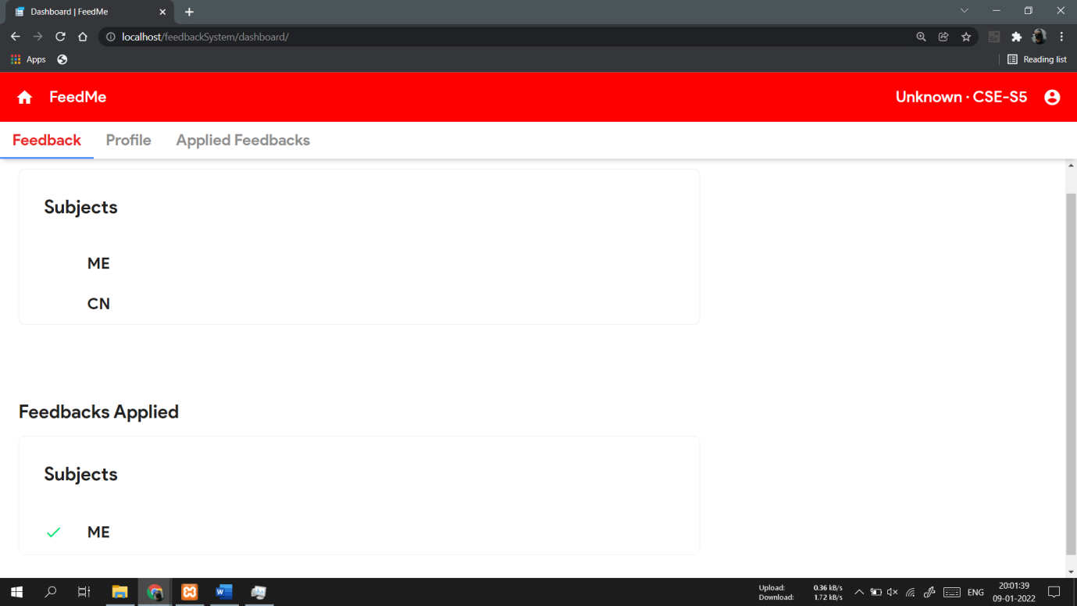

1. **Feedback View**

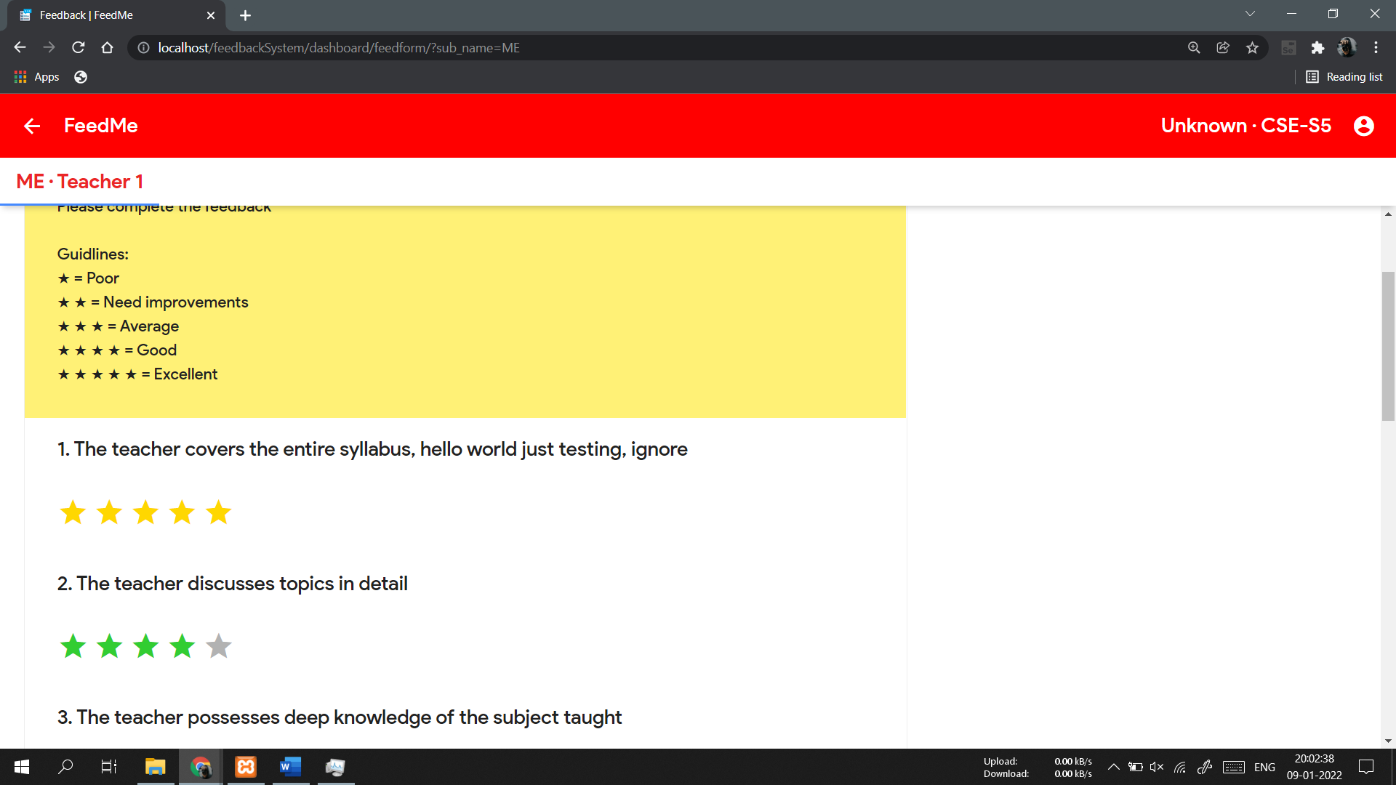

1. **Student Profile View**

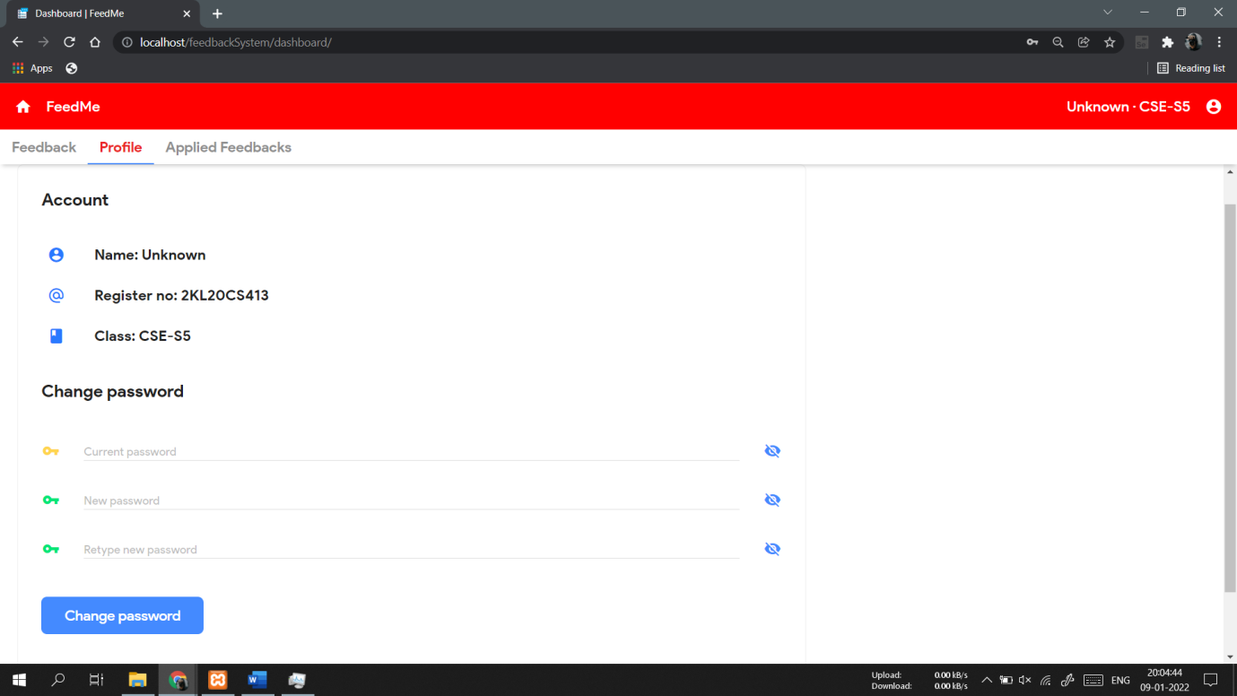

1. **Applied Feedbacks View**

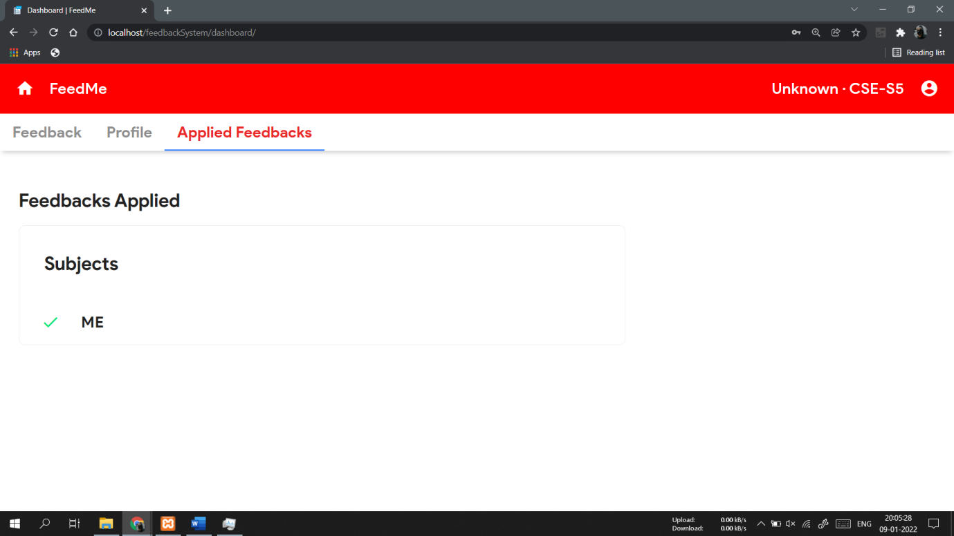

1. **Teachers Login / Signup**

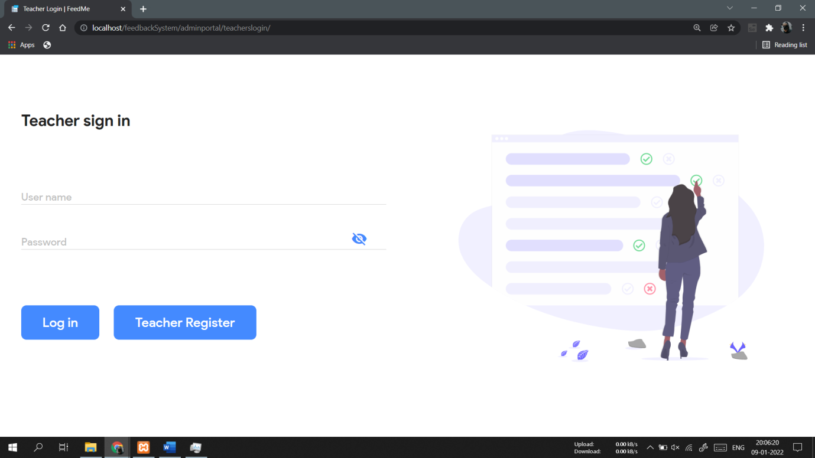

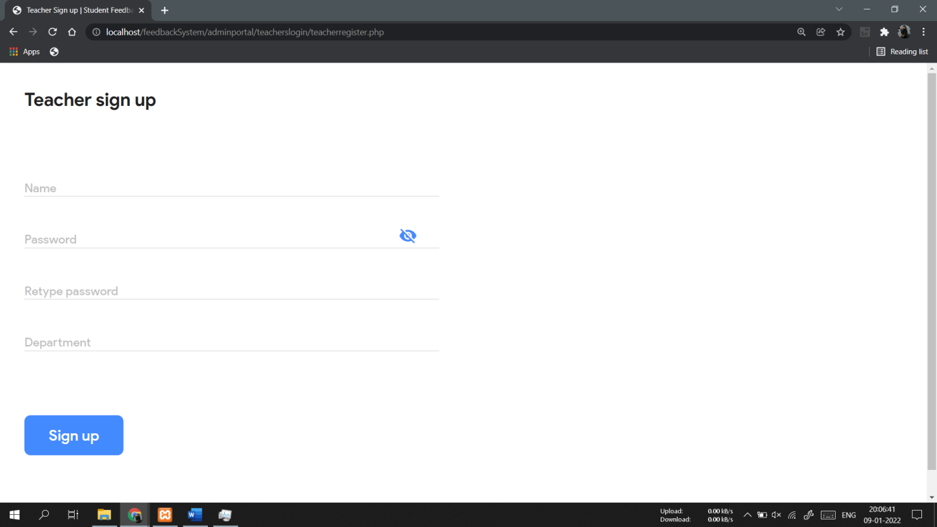

1. **Teacher Dashboard**

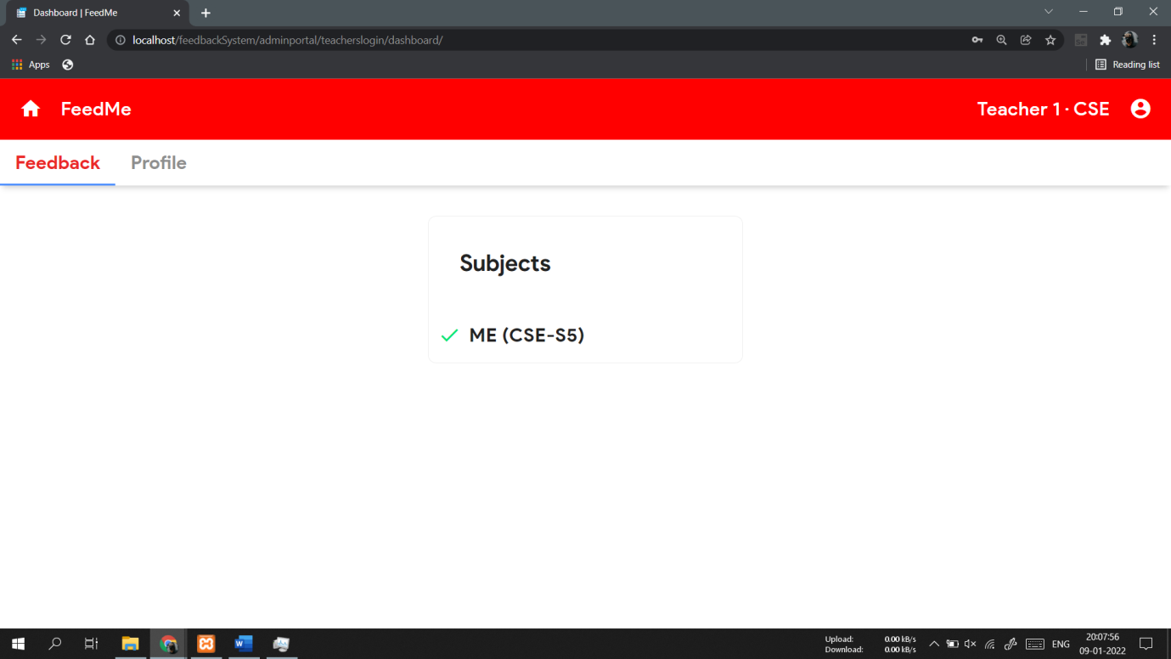

1. **Teacher’s Profile View**

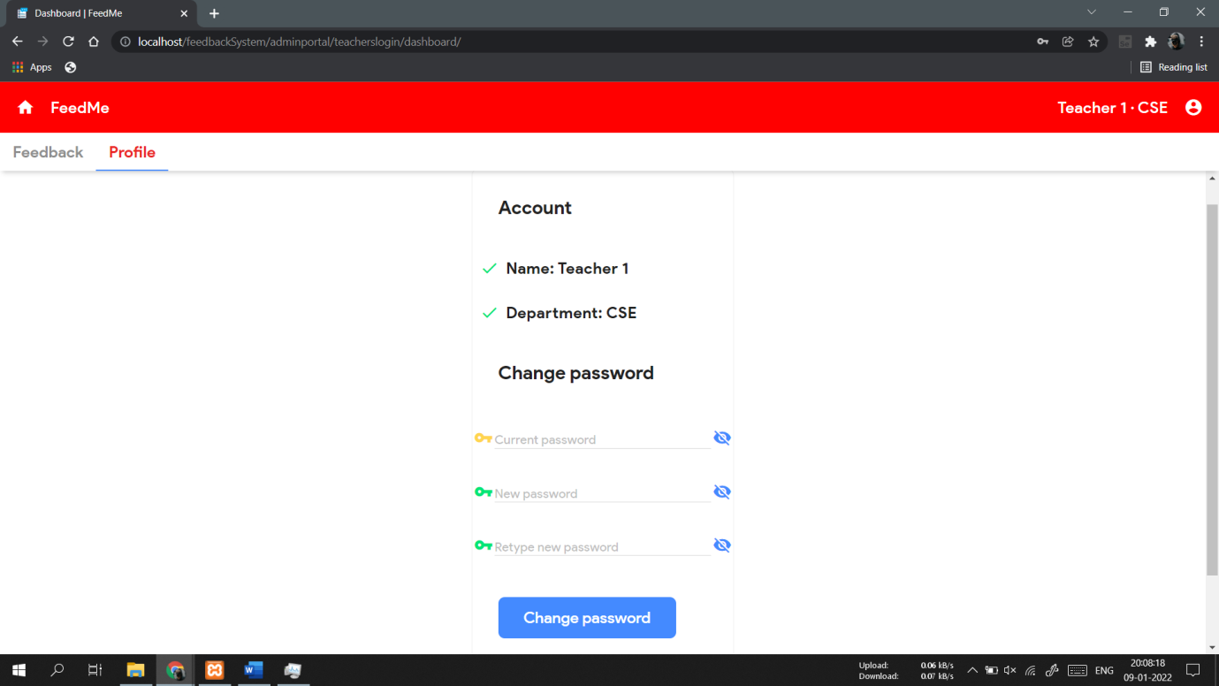

1. **Teacher’s Feedbacks View**

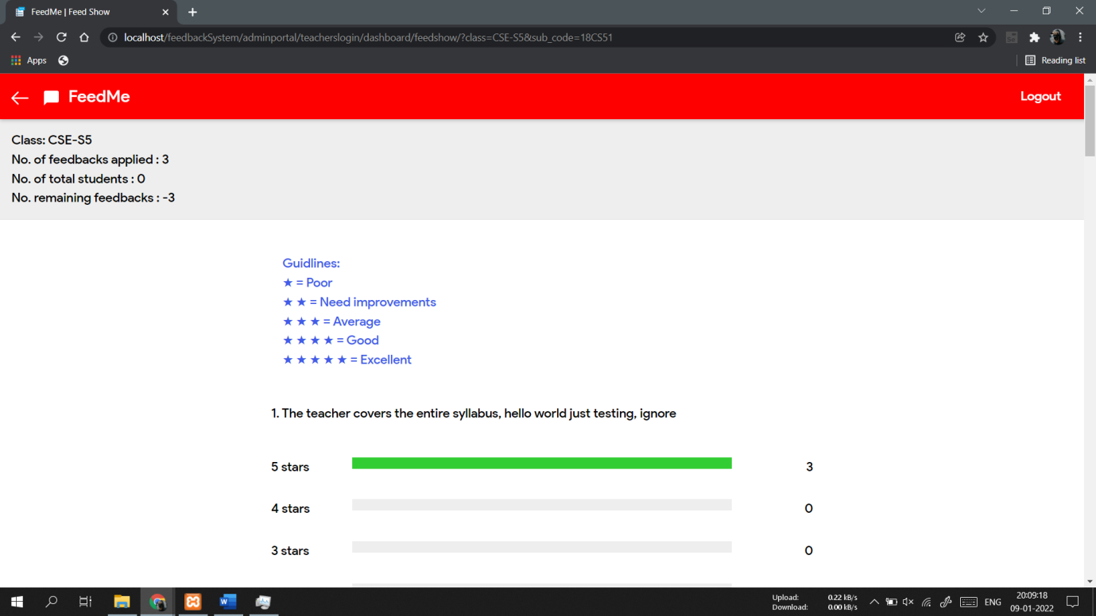

1. **HOD Login / Signup**



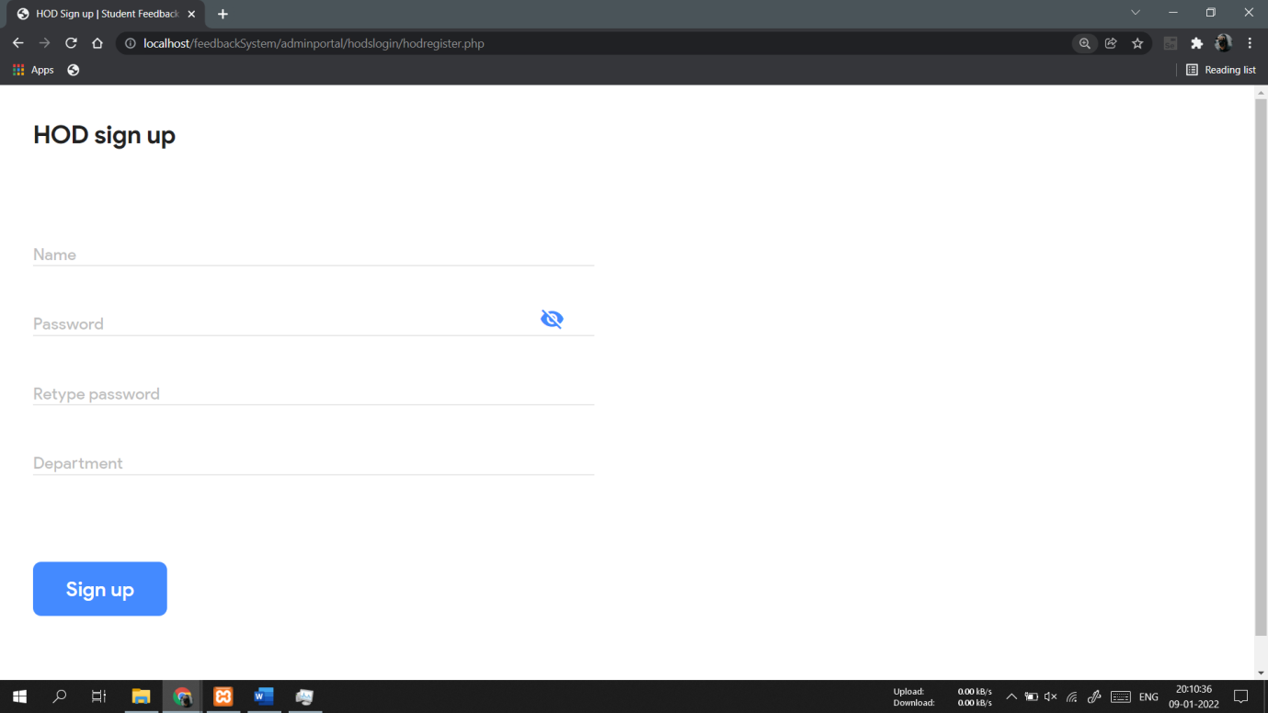

1. **HOD Dashboard**

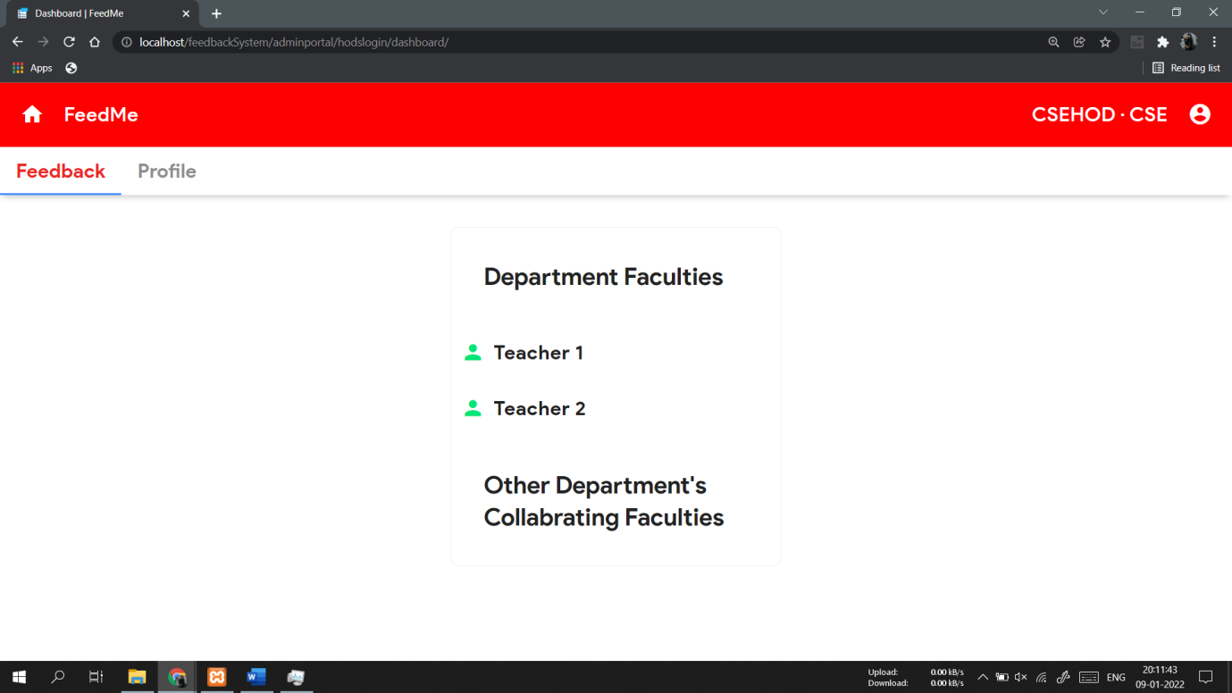

1. **HOD Teacher’s Class View**

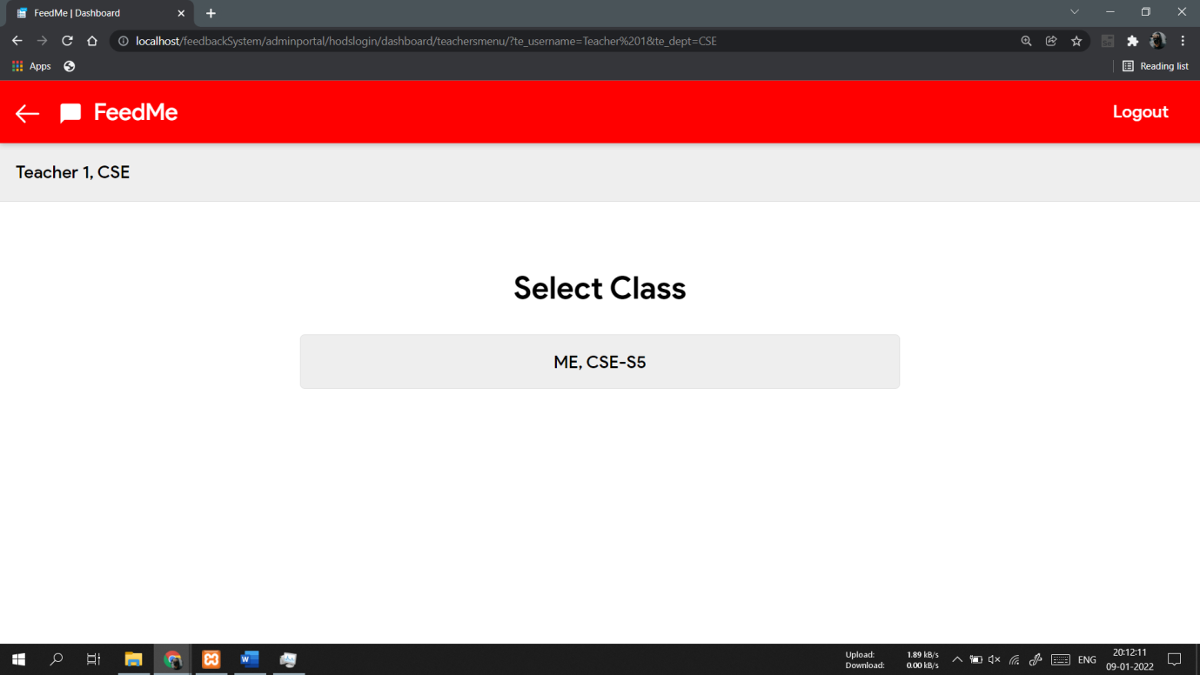

1. **Teacher’s Score Card View**

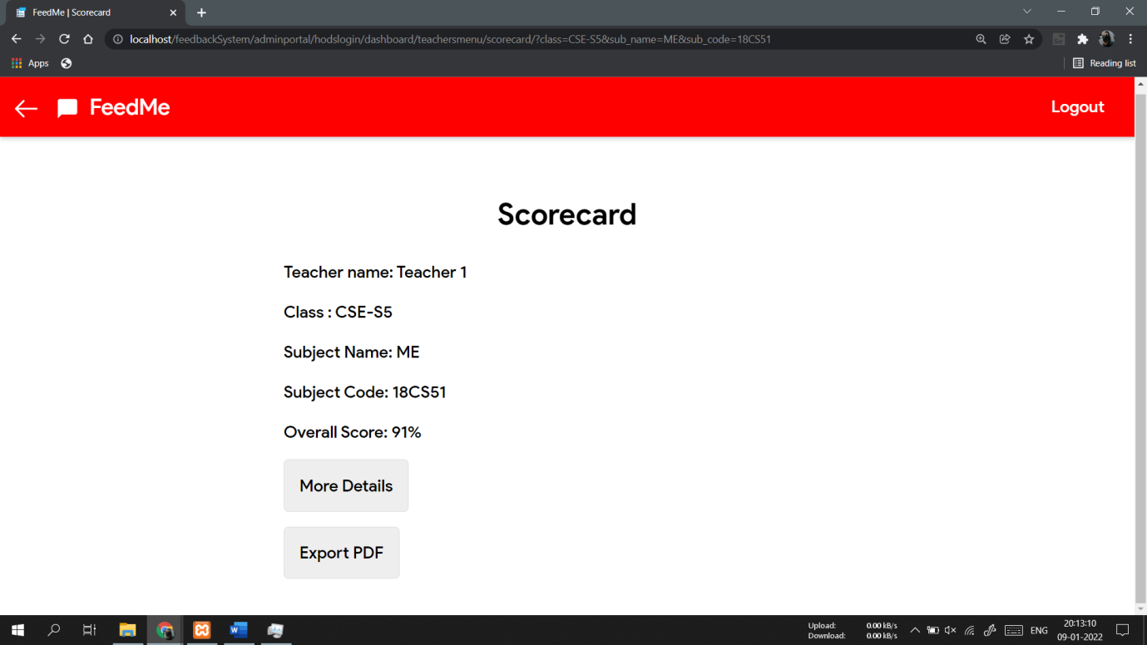

1. **Maintainer’s Login**

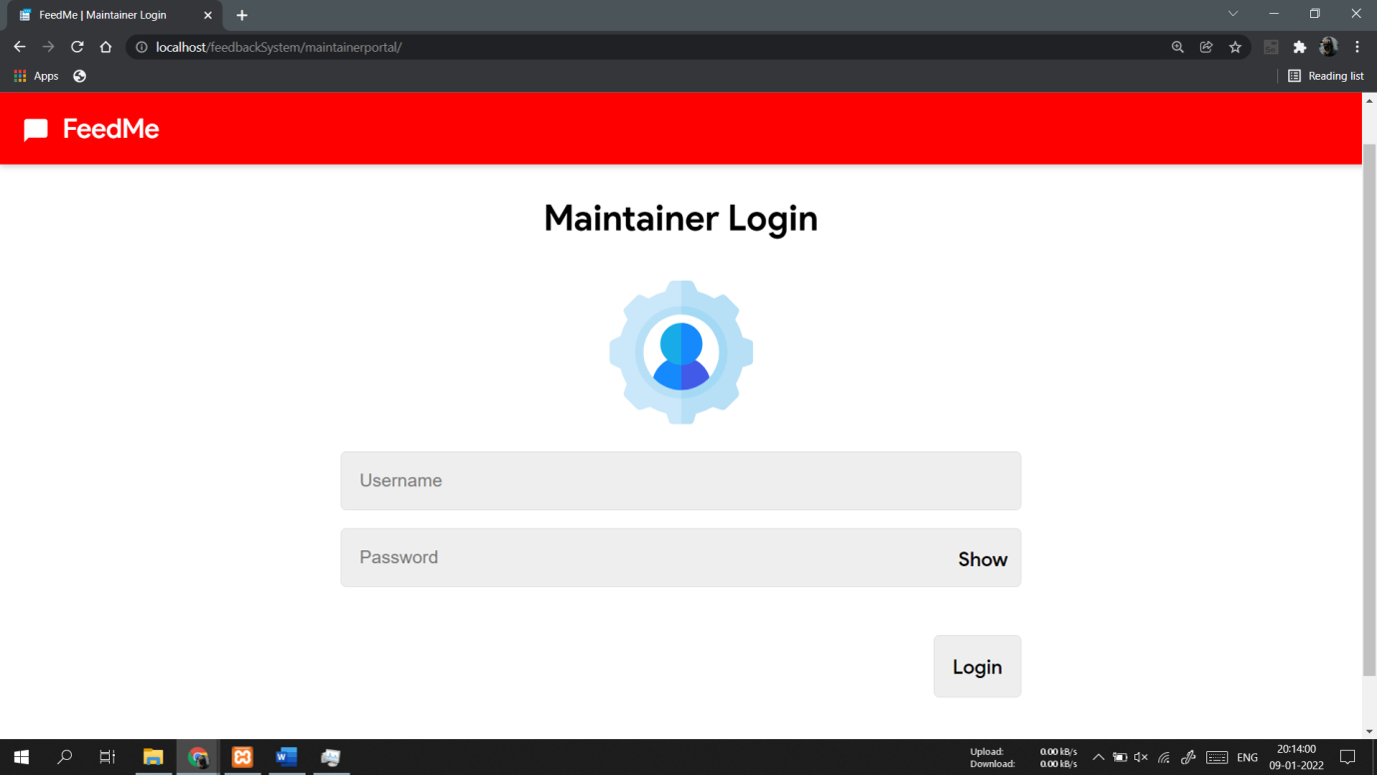

1. **Maintainer’s Dashboard**

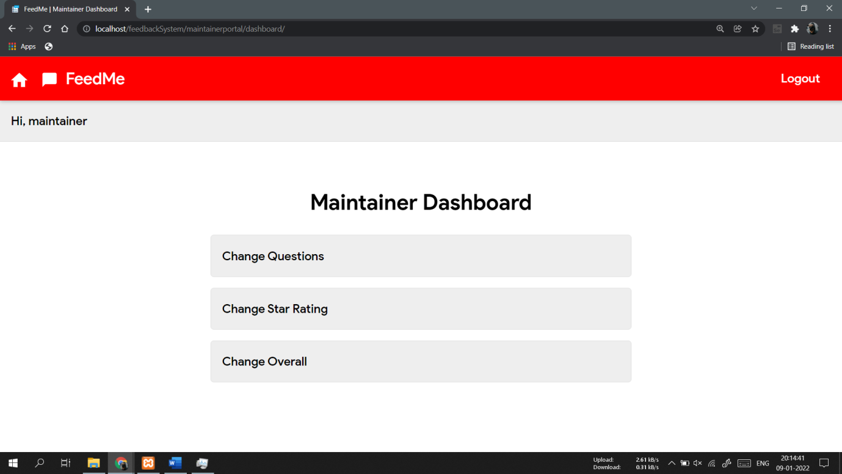

1. **Change Questions View**

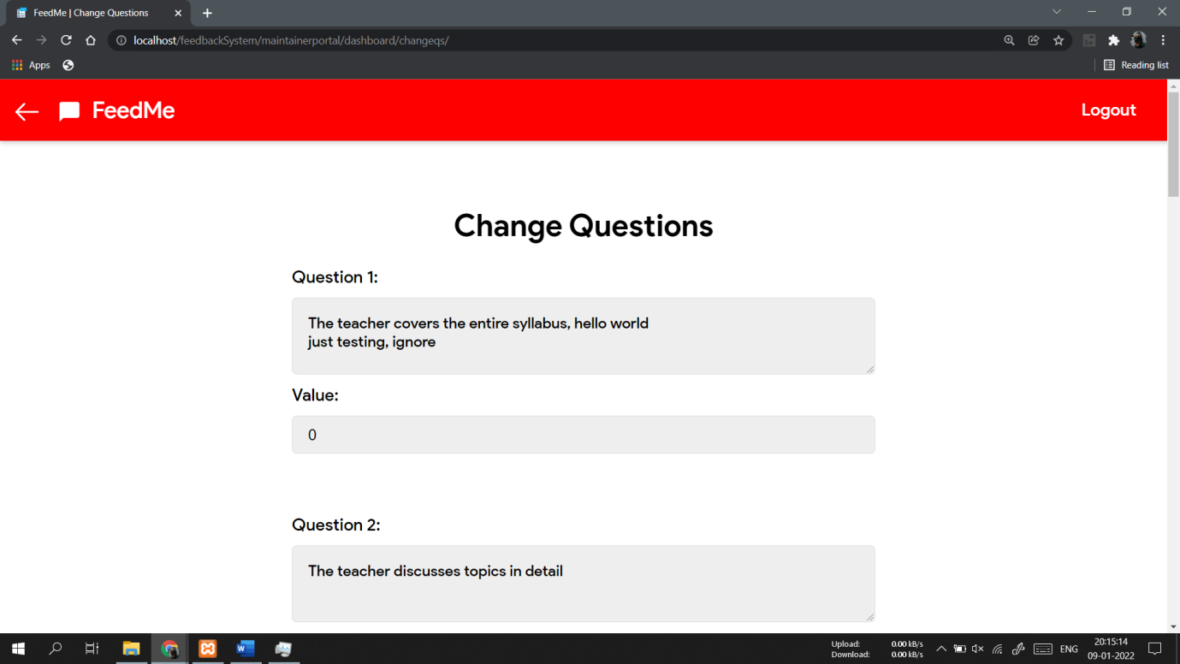

1. **Change Star Rating**

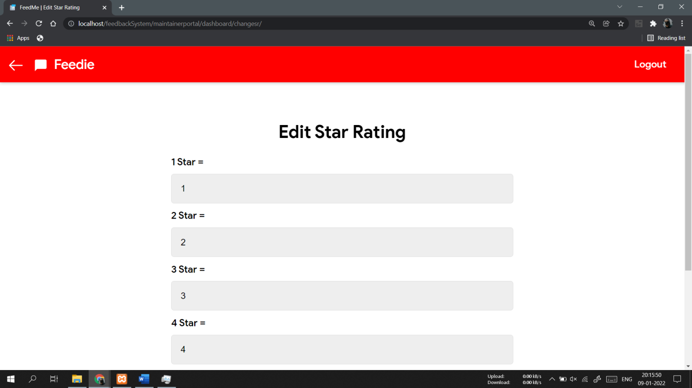

**CONCLUSION**

Normally conventional system we use maximum manual applications. It consumes lots of time and paper. But this system totally Web based, it means that student can enter into the system very easily.

All the modules are designed in a way that a layman can understand the system very easily. Student /college can reach the place where they want to reach in a very minimum amount of time.

**FUTURE ENHANCEMENTS**

Future enhancements:

* The student can view Results and assessment details online.
* Providing feedback for inter collaborating Faculties.