UNIFIED POWER FACTOR CONTROL (UPFC)

ABSTRACT
The project is designed to achieve unity power factor for inductive loads. Power factor is defined as the ratio of real power to apparent power. This definition is often mathematically represented as KW/KVA, where the numerator is the active (real) power and the denominator is the (active + reactive) or apparent power. Reactive power is the non working power generated by the magnetic and inductive loads, to generate magnetic flux. The increase in reactive power increases the apparent power, so the power factor also decreases. In industries having less power factor the industry needs more energy to meet its demand, so the efficiency decreases.
In this proposed system the time lag between the zero voltage pulse and zero current pulse duly generated by suitable operational amplifier circuits in comparator mode are fed to two interrupt pins of the microcontroller. The microcontroller used is of PIC family. It displays the time lag between the current and voltage on an LCD. The program takes over to actuate appropriate number of anti-parallel SCR’s at its output for bringing shunt capacitors into the load circuit to get the power factor till it reaches unity.
Further this project can be enhanced by using large number of shunt capacitors each connected through thyristors for achieving very precise power factor.

BLOCK DIAGRAM
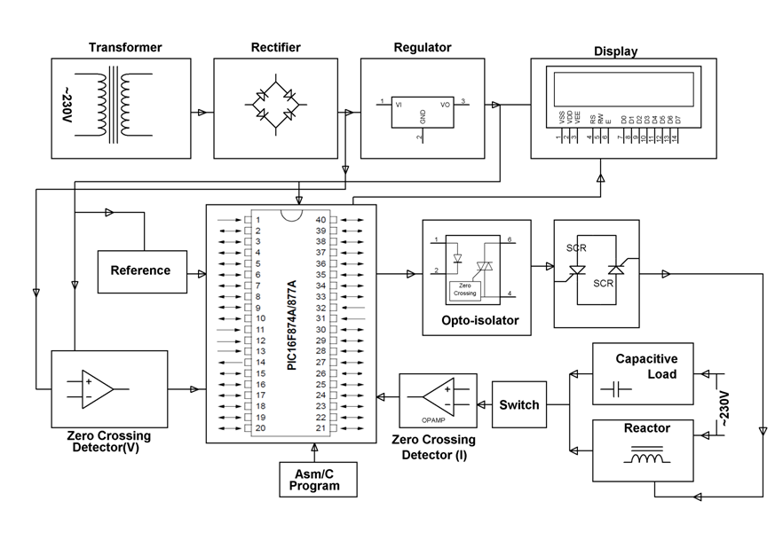

HARDWARE REQUIREMENTS:
PIC series Microcontroller, Op-amps, LCD, Shunt Capacitors, SCR, Current Transformer, Choke, Crystal, Switches, Slide Switch, Resistors, Capacitors, Diodes, Transformer, Voltage Regulator, Lamp.
SOFTWARE REQUIREMENTS:
HI-TECH PICC Tool suite
Languages: Embedded C or Assembly

