**Sample Ecommerce Application High level Design Document**

Design:

1. Presentation layer- HTML, CSS, Javascript
2. Server Side- JSP
3. Business layer- JAVA
4. Design Pattern for designing Web Application- MVC
5. Backend- SQL server

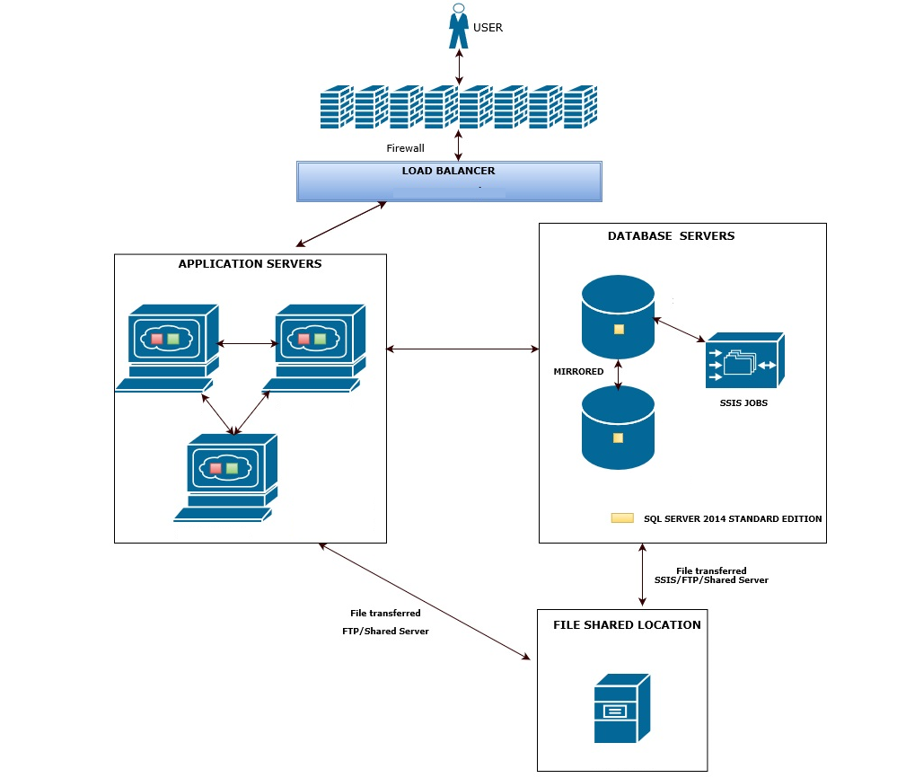

**Data Ingestion Design**

**E-commerce Web Application**

**APIs**

Search Engine

Processing

**Data Stage**

**Business user interface**

Inventory

Documents

Product Date

**BIG DATA**

**ANALYTICS**

**Ordering Process Architecture:**