**Digital Nurture 4.0 Deep Skilling**

**Week 8**

**EXERCISE-1**

**OUTPUT:**

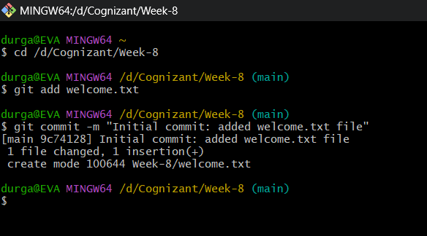

**EXERCISE-2**

**OUTPUT:**

**EXERCISE-3**

**OUTPUT:**

**EXERCISE-4**

**OUTPUT:**

**EXERCISE-5**

**OUTPUT:**

