PROGRAM-1: PRINT HELLO,WORLD

*************************************
package main

import "fmt"

func main() {
fmt.Printf("hello, world\n")
}
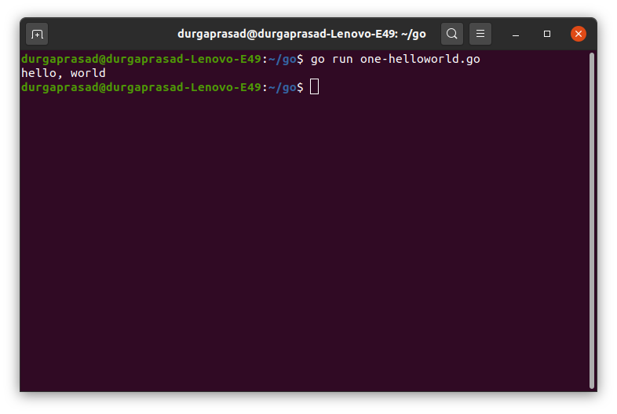

TO BUILD FILE
BELOW COMMAND
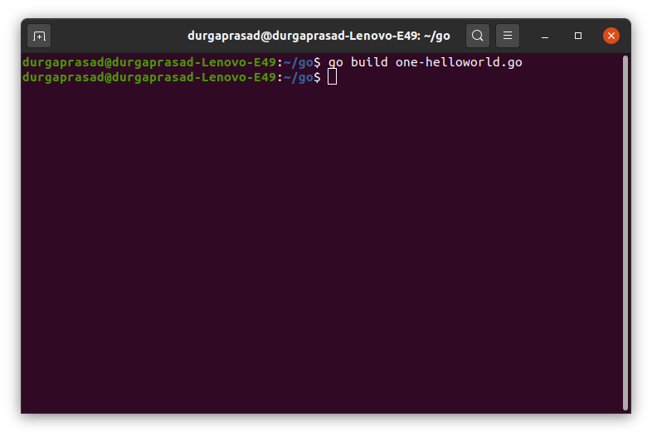

THEN EXECUTE BUILD FILE
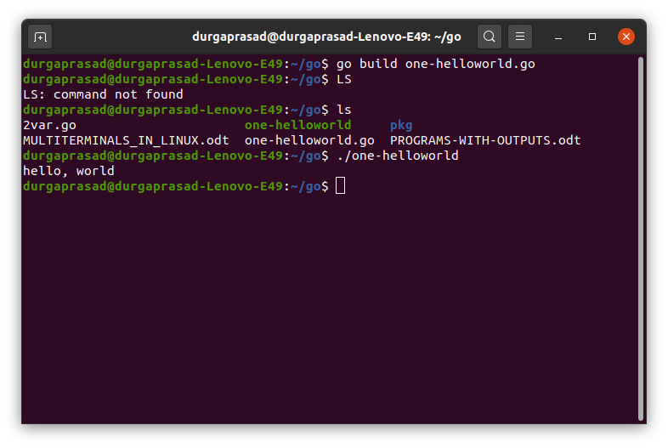

errors-1:

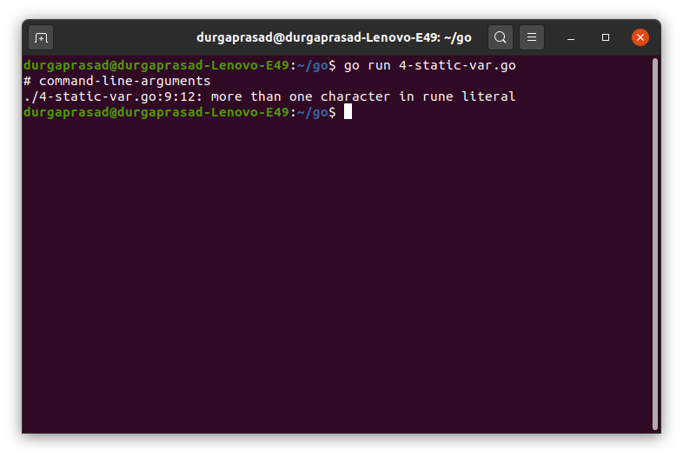

mt.Printf(‘i=’,i)---→mt.Printf("i=",i)
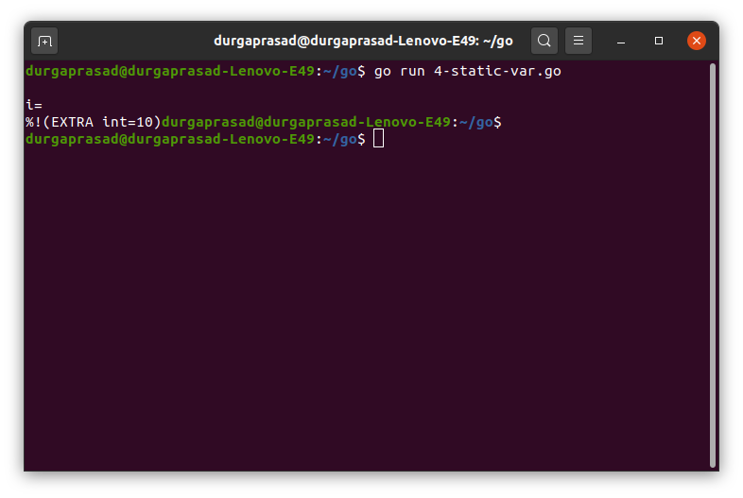
fmt.Printf("i=%d\n",i)
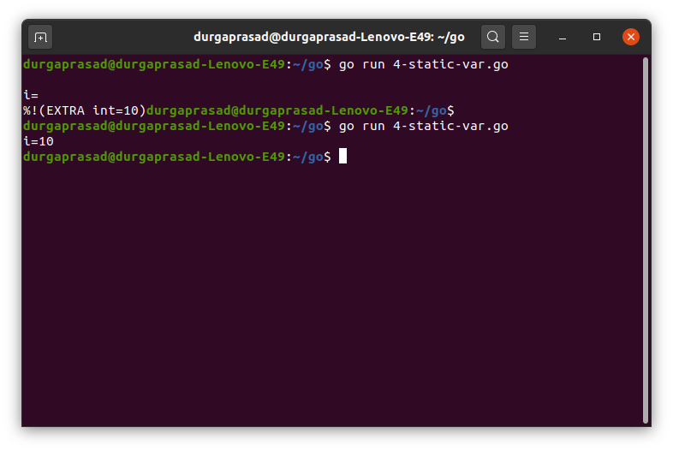

PROGRAM-2:
4-static-var.go
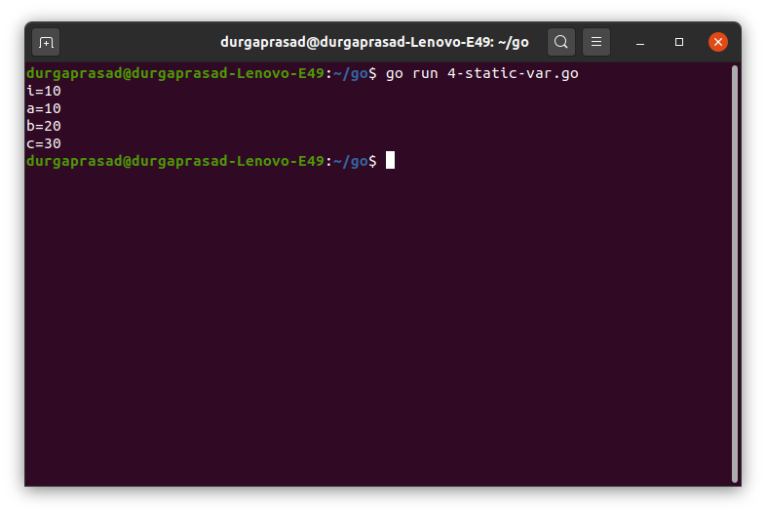

program-3:
5-dynamic-var.go
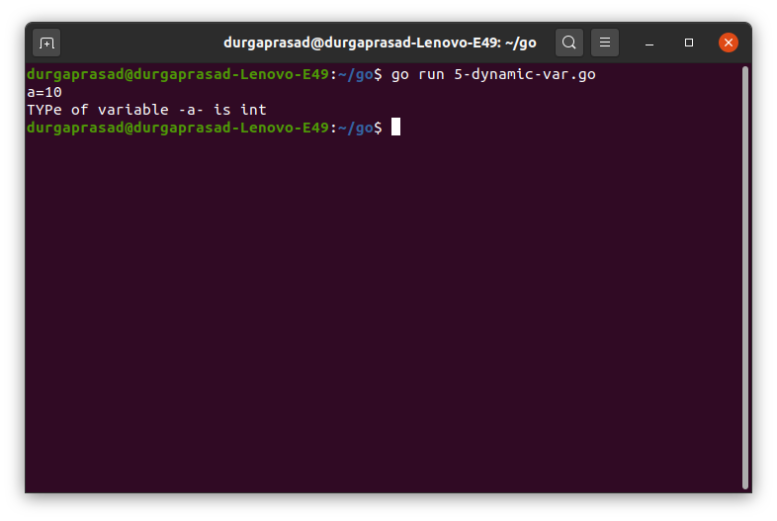

program-4:
6-staticdynamic-var.go
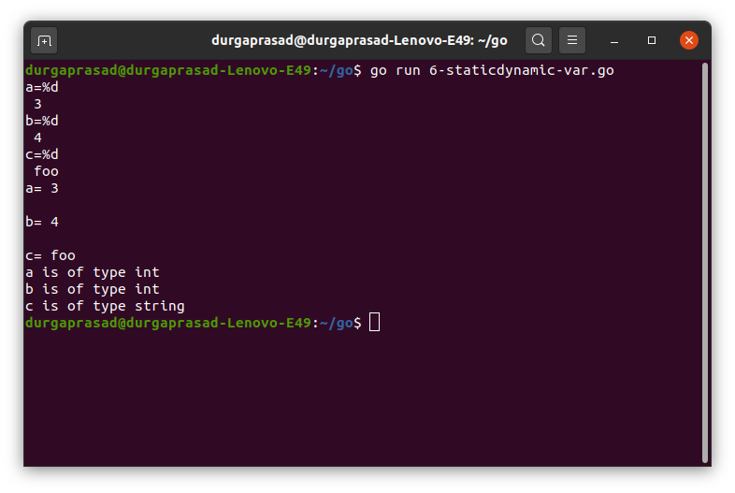

LINUX COMMAND TO MOVE ALL FILES EXCEPT SOME:

