Git clone: The git clone command is used to create a copy of a specific repository or branch within a repository. Here I am copying the repository documents in my computer folder.

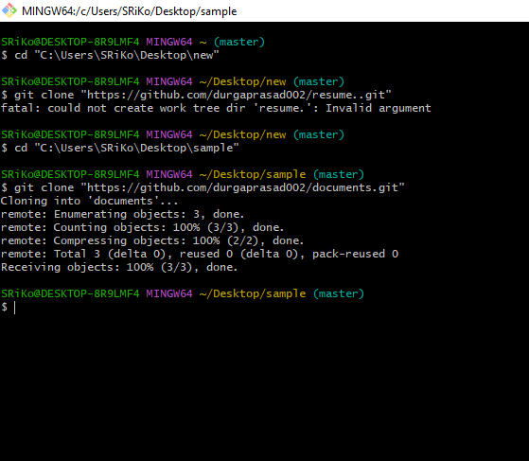

Git fork: A fork creates a completely independent copy of Git repository. Forking just contains a separate copy of the repository and there is no command involved. Here I have forked w3 school.

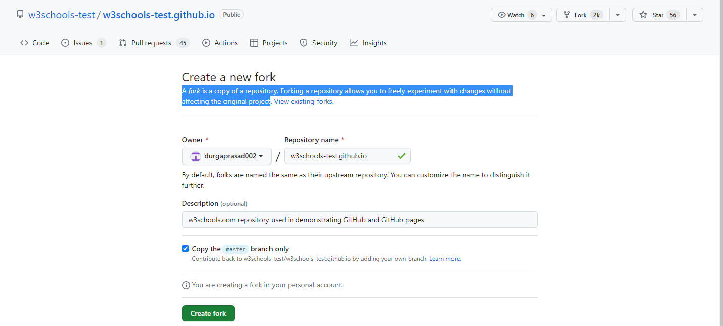

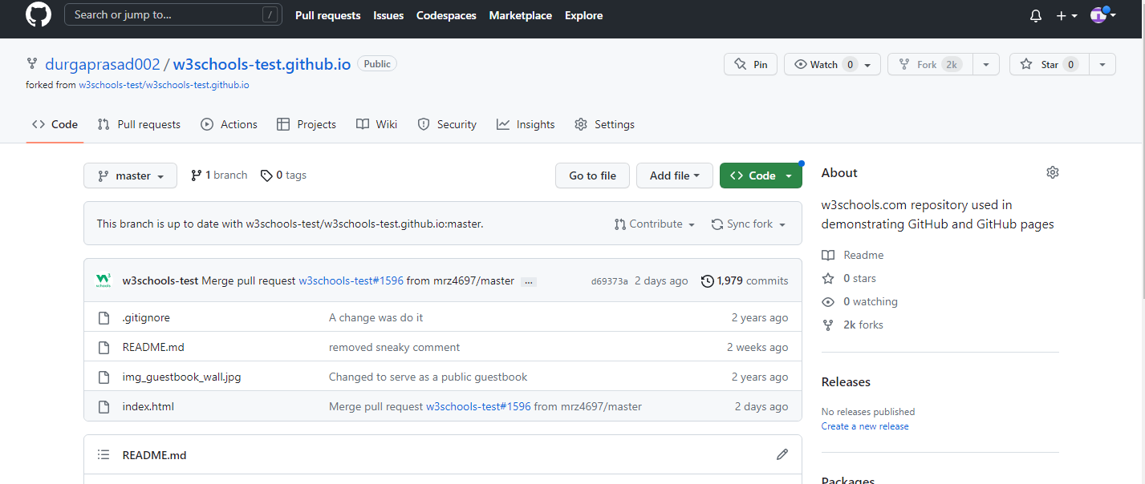

Gitignore: A gitignore file specifies intentionally untracked files that Git should ignore. Ignored files are tracked in a special file named .gitignore that is checked in at the root of your repository.

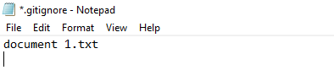

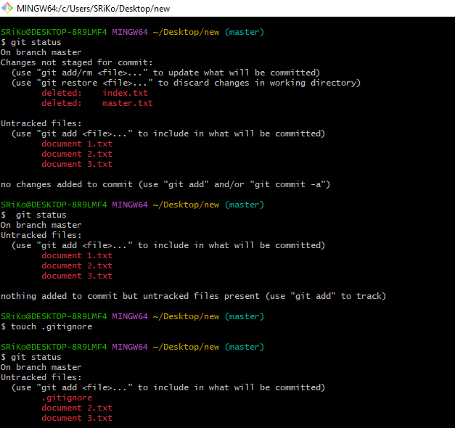

Git pull: The git pull command is used to fetch and download content from a remote repository and immediately update the local repository to match that content.

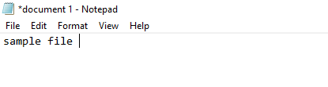

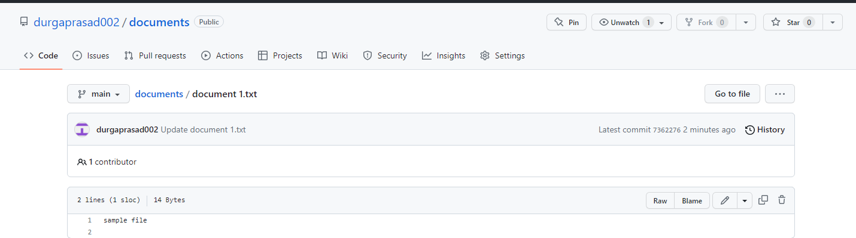

Branch: Branches allow you to develop features, fix bugs, or safely experiment with new ideas in a contained area of your repository. You always create a branch from an existing branch.

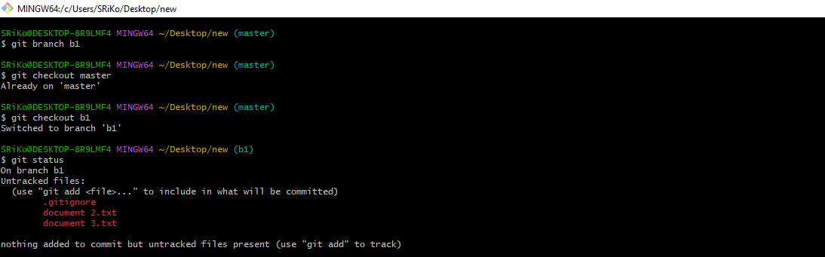

Gitrevert: The git revert command is used for undoing changes to a repository's commit history. Other 'undo' commands like git checkout and git reset, move the HEAD and branch ref pointers to a specified commit.

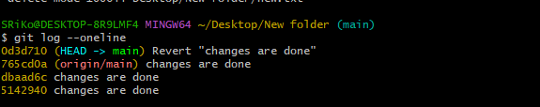

Gitreset: we use it when we want to move the repository back to a previous commit, discarding any changes made after that commit. After the previous chapter, we have a part in our commit history we could go back to.

