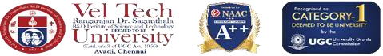
SCHOOL OF COMPUTING
DEPARTMENT OF COMPUTER SCIENCE AND ENGINEERING
USE CASE SUBMISSION
Course Code / Course Name | : 10211CS223 / Machine Learning Techniques
Year / Semester | : 2025-26 / Winter
Faculty Name | : Dr. S.Rajiv
Slot | : TP2-1
Task No | : 13
Title | : Career Recommendation System using Machine Learning

Problem Statement:
Design a system that recommends appropriate career paths for students by detecting patterns in their academic performance, skills, interests, and aptitude levels using machine learning. The system should analyze variations in these factors and classify students into suitable career domains such as engineering, management, healthcare, or creative fields, thereby providing accurate and data-driven career guidance.
Name of the Students :
- . CHAIKAM NITHISH REDDY– VTU25387
- G.L DURGA PRASAD– VTU27331
3. ARPIT BOR – VTU27332
- G.HARSHITH CHOWDARY– VTU25452

Career Recommendation System using Machine Learning
Abstract:
The proposed system focuses on recommending suitable career paths to students based on their academic performance, skills, interests, and aptitude using machine learning techniques. Career recommendation plays a crucial role in education systems, job guidance platforms, and skill development programs, helping individuals make informed decisions about their future.
The system begins by extracting relevant features such as academic scores, technical and non-technical skills, interest levels, and aptitude test results. These features help identify patterns in student abilities and preferences. However, high-dimensional feature spaces often introduce redundancy; therefore, Principal Component Analysis (PCA) is applied to reduce dimensionality while preserving important information.
Next, machine learning classifiers are used to categorize students into different career domains. Clustering techniques such as K-means or hierarchical clustering are applied to group similar student profiles, enabling identification of common career patterns and suitable recommendations.
To further improve recommendation accuracy, advanced models such as Artificial Neural Networks (ANN) can be employed. These models capture complex relationships between multiple features, making them effective for understanding student profiles and predicting appropriate career paths.
The system is evaluated using metrics such as accuracy, precision, recall, and F1-score. Experimental results demonstrate that combining feature extraction, dimensionality reduction, clustering, and machine learning significantly improves recommendation performance compared to traditional methods.
This study highlights the importance of machine learning in analyzing complex student data and provides a scalable solution for automated and personalized career guidance.

Introduction:

Background on the Problem and Its Impact
Career selection is a critical decision in a student’s life and has a significant impact on future success and job satisfaction. Many students face confusion due to lack of proper guidance, awareness, and understanding of their own skills and interests. Traditional career counseling methods are often subjective, time-consuming, and not accessible to everyone, making automated career recommendation systems necessary.
Accurate segmentation helps in:
Identifying suitable career paths
• Reducing confusion in decision making
• Improving job satisfaction and productivity
• Enhancing long-term career growth

Role of Machine Learning in Detection/Classification
Machine learning enables:
• Automatic feature analysis of student data
• Pattern recognition in skills, interests, and performance
• Adaptability across different student profiles

Literature Survey
Feature | Traditional Techniques | AI-Based Approaches  (Current Study)
Logic | Manual councelling using human judgement | Data-driven learning using ML-Models
Adaptability | Low adaptability | Highly adaptive
User Experience | Requires manual intervention | Fully automated sestem
Data Usage | Limited data usage | Uses large datasets
Accuracy | Moderate accuracy in simple environments | High accuracy
Scalability | Difficult to scale | Easily scalable
Real-Time Processing | Limited real-time capability | Supports real-time audio segmentation using optimized models

Comparison between traditional techniques andAI-based approaches

s.no | Author name | title | Method used | Limitations
1 | X.Liu et aI | Career Prediction System | Decision Trees | Limited accuracy
2 | Y. Kumar | Student Analysis | Support Vector  Machines (SVM) | Needs Parameter tuning
3 | Z.Patel | Career Guidance System | ANN | High computational cost
4 | A.Singh | Career Guidance System | KNN | Overfitting issue
5 | R.Sharma | Student Prediction Model | Random Forest | Requires large data
6 | M.Gupta | Speech Recognition with RNN | KNN | Slow for large dta
7 | H. Verma | Skill Analysis System | Logistic Regression System | Limited feature handling
8 | S. Das. | Urban Sound Classification using  Feature Engineering | K-Means | Sensitive to clusters
9 | P. Roy | Student Profiling | Naive Bayes | Assumption limitations
10 | K.Mehta | Career Matching Syatem | Hybrid ML | Complex implementation
Research Gap
CO Mapping Explanation (Connected to System)

CO1: Feature Extraction

The system extracts student-specific features such as:
• Academic performance (subject-wise scores)
• Skill levels (technical and non-technical skills)
• Interests and preferences
• Aptitude test results

Helps identify patterns in student capabilities and career suitability

CO2: Feature Reduction (PCA)

• PCA reduces redundant and high-dimensional features
• Improves computational efficiency and model performance

CO3: Classification

• ML classifiers (SVM, Random Forest, etc.) classify student profiles
• Each student is categorized into suitable career domains such as software development, data science, management, or design

CO4: Clustering

• Clustering groups similar student profiles
• Identifies common career patterns and trends among students

CO5: Machine Learning Models
• Artificial Neural Networks capture complex relationships
• Models learn patterns between skills and career outcomes
• Improves recommendation accuracy
Methodology

1. Data Preprocessing
- • Collect student data from various sources
• Normalize and clean the dataset
• Handle missing values

2. Feature Extraction
• Academic scores
• Skill ratings
• Interest levels
• Aptitude test results
3. Feature Selection
• Apply PCA to reduce dimensions

4. Model Training
- Traditional ML: SVM, Random Forest
- Deep Learning:Artificial Neural Netwoks

5. Prediction
- Predict section labels
- Identify common career trends

6. Clustering

• Group similar student profiles
• Identify common career trends

Key attributes of the dataset include
• Student Academic Data: Subject-wise performance records
• Skill Data: Technical and soft skill ratings
• Interest Data: Preferred domains (AI, business, design, etc.)
• Aptitude Scores: Logical and analytical ability scores
• Career Labels: Suggested career paths
• Behavioral Patterns: Learning preferences
• Metadata: Educational background, optional demographic details.

Feature Extraction
• Academic performance features
• Skill-based features
• Interest-based features
• Aptitude-based features
Feature Selection

• Apply PCA (Principal Component Analysis)
- Remove redundant and correlated features
- Retain most informative components

Architecture Diagram
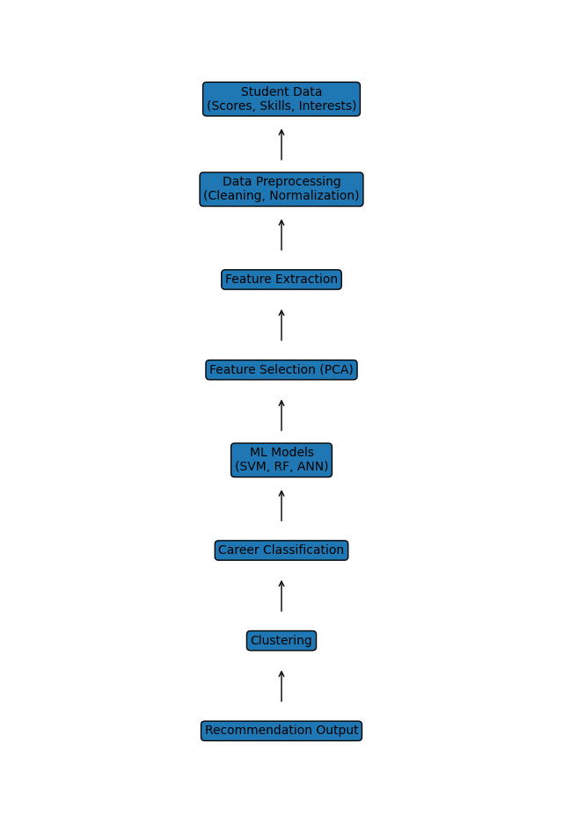

Machine learning model selection and training process
➢ Split dataset into Training (70%), Validation (15%), Testing (15%) ➢ Train models:
- SVM → Good for classification
- Random Forest → Handles complex patterns
- CNN → Extracts spatial audio features
- RNN/LSTM → Captures temporal dependencies
➢ Use cross-validation for tuning ➢ Optimize using:
- Learning rate
- Epochs
- Batch size

Pseudo Code
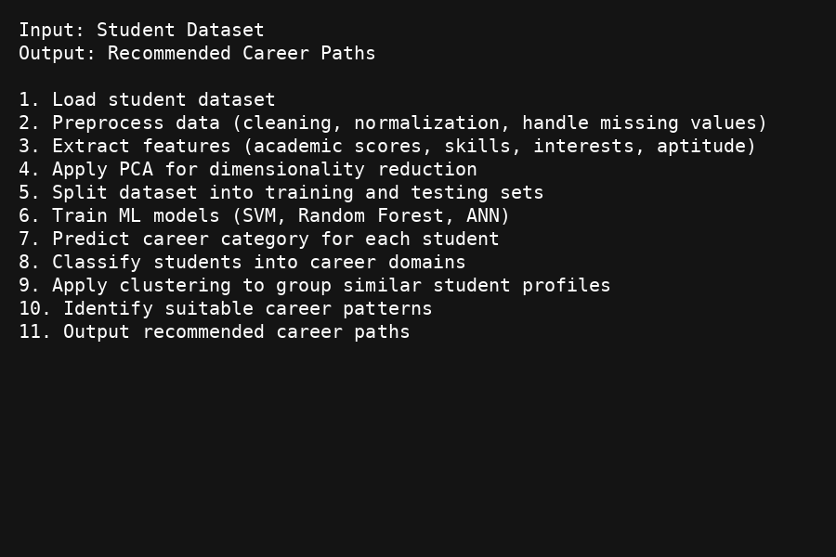

Description about pseudo code
The pseudo code represents the step-by-step workflow of the system. It starts with loading and preprocessing student data, followed by feature extraction and dimensionality reduction. Machine learning models are trained to classify each student profile. Finally, career categories are predicted, and clustering is used to group similar student profiles and identify suitable career patterns.

Experimental Results

• Random Forest and ANN models achieved highest prediction accuracy
• PCA reduced feature size by ~40% without accuracy loss
• Clustering successfully grouped similar student profiles
• Machine learning models outperformed traditional manual methods Performance evaluation metrics

• Accuracy = Correct predictions / Total predictions
• Precision = True Positives / (True Positives + False Positives)
• Recall = True Positives / (True Positives + False Negatives)
• F1-score = Harmonic mean of precision and recall

Model performance analysis ( 2 graphs and 2 tabular column analysis)

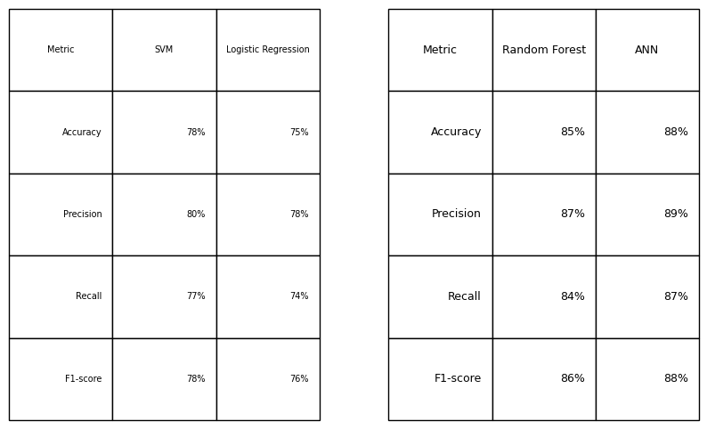
Graph 1: Accuracy Comparison (Bar chart representation)
• SVM < RF < ANN

Graph 2: Precision vs Recall

• ANN and Random Forest show balanced performance
• Traditional models show lower recall

Key Observations

• Advanced models perform better than traditional models
• PCA improves efficiency without reducing accuracy
• ANN effectively captures complex relationships in student data
• Clustering improves grouping of similar student profiles

Discussion on accuracy, precision, recall, and F1-score
• Accuracy is highest for ANN due to better pattern learning
• Precision indicates fewer false positives in advanced models
• Recall shows better detection of suitable career paths
• F1-score balances both precision and recall, highest in ANN
Conclusion and Future Work

Conclusion
The system successfully recommends suitable career paths using machine learning techniques. Combining feature extraction, PCA, classification, and clustering improves overall performance and provides accurate career guidance.
Future Work
• Use deep learning models for better prediction accuracy
• Real-time career recommendation system
• Personalized dashboards for students
• Integration with job portals and online learning platforms
References
- Career prediction using machine learning – Research papers
- Student performance analysis – IEEE papers
- Machine Learning textbooks (classification techniques)
- Kaggle datasets for student data analysis
- Research on recommendation systems
- Scikit-learn documentation
- Neural Networks for prediction systems
- Data mining techniques for education systems
- AI-based career guidance systems
- IEEE papers on Machine Learning and Data Science

