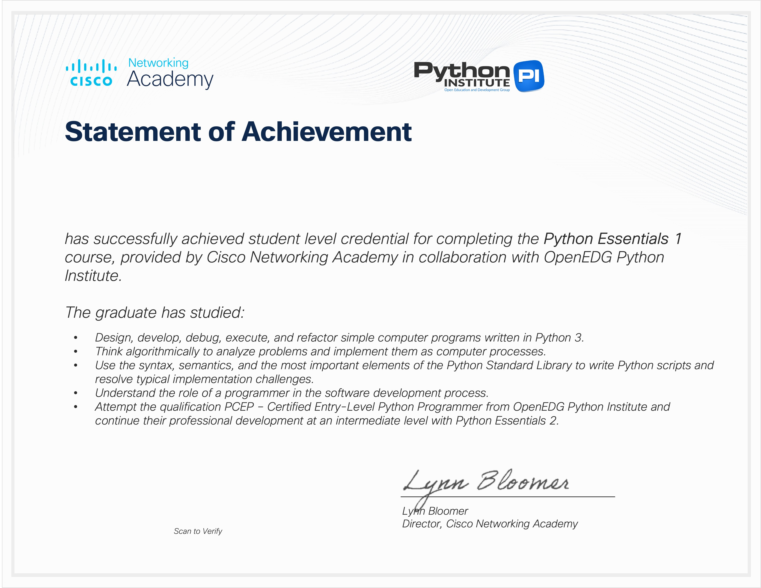

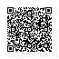
DURGA PRASAD KADALI
Issued on: Aug 15, 2025

