**Spotify Database Project**

**About Company:**

The Spotify database serves as the foundation of one of the world's premier music streaming platforms, connecting millions of users with a vast library of music from across the globe. At its core, the database is structured around several key entities that enable users to seamlessly navigate and interact with the platform's extensive collection of music content.

Central to the Spotify experience are user profiles, which store individual preferences, interaction history, and personalized settings. Through their profiles, users can curate their music listening experience, create playlists, follow favorite artists, and engage with other members of the Spotify community. Artists and albums are meticulously cataloged within the database, providing users with rich metadata and detailed insights into their favorite musicians and their discographies.

The heart of the Spotify database lies in its extensive collection of tracks, each meticulously indexed with metadata such as titles, durations, genres, and popularity ratings. This vast repository of music content forms the basis for Spotify's sophisticated recommendation algorithms, which leverage user preferences, listening history, and behavioral data to deliver personalized music recommendations tailored to each individual user.

Besides personalized recommendations, Spotify lets users explore new music through handpicked playlists, highlighted albums, and browsing by genre. These carefully selected options, powered by the Spotify database, offer users various ways to discover music, ensuring there’s always something fresh to enjoy.

Spotify’s database not only helps you find and recommend music, but also targets ads similarly to things you may like. This is another way that Spotify can make revenue as an app and keep updating itself to fit users’ interests. In addition, Spotify offers different subscriptions for customers. For example, Spotify offers many different premium plans which include solo, duo, family, and students. All plans have different pricing and may be more ideal for a person or family depending on the current situation.

Spotify manipulates their data to create a social platform on their music application, their database sets the stage for a better music streaming experience, providing personalized recommendations, curated playlists, and ways to make money. It also allows users to share with each other and listen to one another’s playlists. With smart algorithms and organized data, Spotify aims to keep users happy and the business growing strong.

**ER – Diagram:**

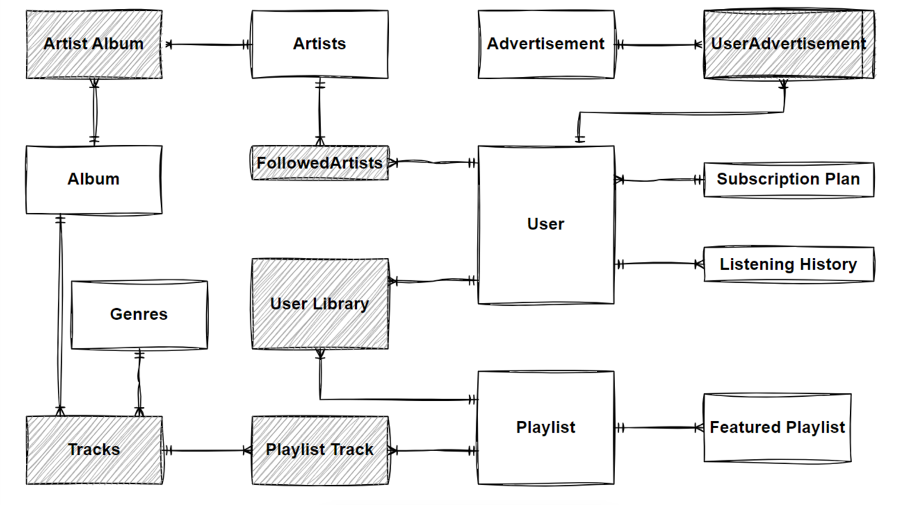

**ER Diagram with attributes:**

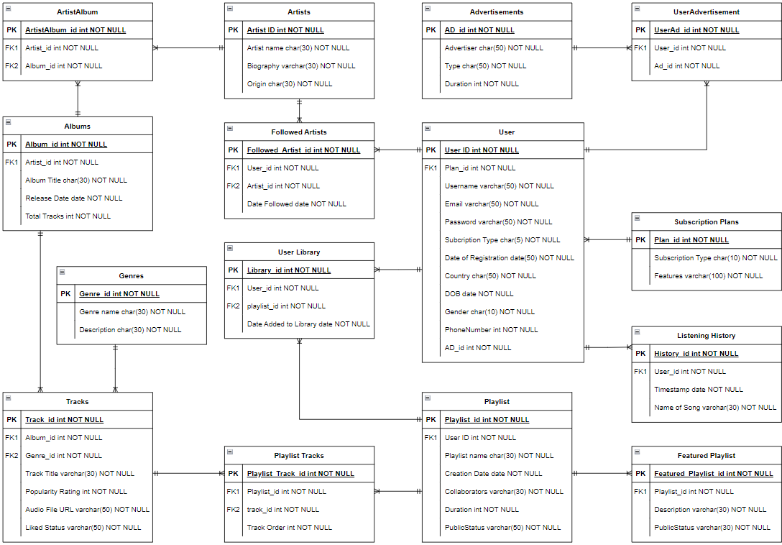

**Database Design with list of tables:**

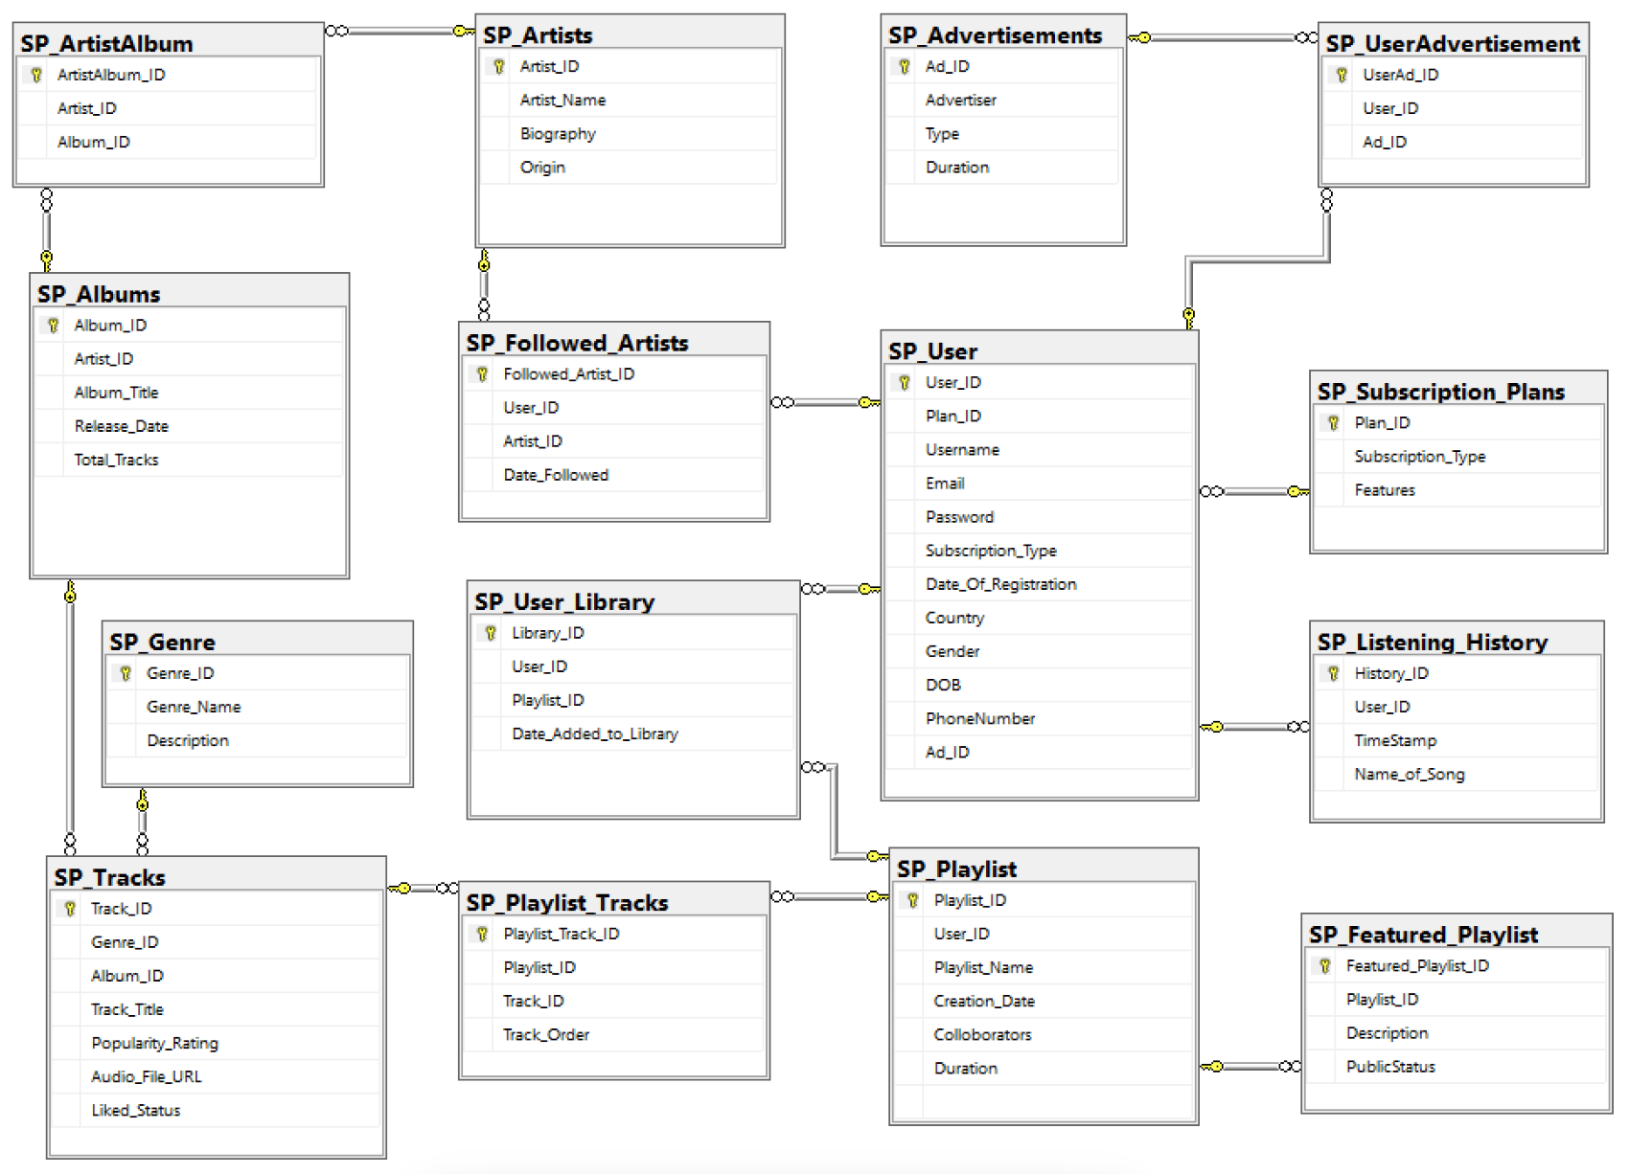

**QUERIES**:

--1) Who are all having spotify premium accounts ?

select Username, Subscription_Type, Gender

from SP_User

where Plan_ID in ('1','2','3','4')

order by Subscription_Type

--2) Customers who are targeted by business commercials

select* from SP_User where Ad_ID in

(select Ad_ID from SP_UserAdvertisement where Ad_ID in

(select Ad_ID

from SP_Advertisements where Type='Insurance'))

--3) Display Drake's albums.

select Artist_Name, Album_Title, Release_Date, Total_Tracks

from SP_Albums SA, SP_ArtistAlbum SAA, SP_Artists SAAA

where SA.Artist_ID=SAA.Artist_ID and SAA.Artist_ID=SAAA.Artist_ID and Artist_Name='Drake'

--4) Show all SPOTIFY  featured playlist

 select Playlist_Name from SP_Featured_Playlist where playlist_ID in

(select Playlist_ID from SP_Playlist where USER_ID in

(select USER_ID from SP_User_Library))

--5) What are the top rated songs in spotify?

select Genre_Name,Track_Title,Description, Popularity_Rating

from SP_Genre SG, SP_Tracks ST

where SG.Genre_ID=ST.Genre_ID and Popularity_Rating>='8'

order by Popularity_Rating desc

--6) Find the number of tracks in an album id 1100

SELECT t.Track_Title

FROM SP_Albums a

JOIN SP_Tracks t ON a.Album_ID = t.Album_ID

where t.Album_ID='1100'

--7) Display which album have the genre type R&B

SELECT DISTINCT a.Album_ID, a.Album_Title

FROM SP_Albums a

JOIN SP_Tracks t ON a.Album_ID = t.Album_ID

JOIN SP_Genre g ON t.Genre_ID = g.Genre_ID

WHERE g.Genre_Name = 'R&B';

--8) Dispaly the total number of playlists created by each user

SELECT SP_user.username, COUNT(SP_Playlist.Playlist_ID) AS Total_Playlists

FROM SP_user

LEFT JOIN SP_Playlist ON SP_user.user_id = SP_Playlist.User_ID

GROUP BY SP_user.username

--9) Display users who have followed more than 5 artists.

SELECT SP_user.username, COUNT(SP_Followed_Artists.Artist_ID) AS Total_Followed

FROM SP_user

LEFT JOIN SP_Followed_Artists ON SP_user.user_id = SP_Followed_Artists.User_ID

GROUP BY SP_user.username

HAVING COUNT(SP_Followed_Artists.Artist_ID) >= 1

--10) Display users who have subscribed to the 'Duo' plan and what features does they get

SELECT Username, Features

FROM SP_user s , SP_Subscription_Plans p

WHERE s.Subscription_Type=s.Subscription_Type and p.Subscription_Type='Duo'

--11) List all tracks with a popularity rating greater than 8 and its geners

SELECT Track_Title, Popularity_Rating

FROM SP_Tracks t, SP_Genre g

WHERE t.Genre_ID=g.Genre_ID and  Popularity_Rating > 8

--12) Count the number of tracks in each genre:

 SELECT Genre_Name, COUNT(Track_ID) AS track_count

FROM SP_Tracks t, SP_Genre g

where t.Genre_ID=g.Genre_ID

GROUP BY Genre_Name

--13) Display the names of all artists and the titles of their albums.

SELECT A.Artist_Name, AL.Album_Title

FROM SP_Artists A,SP_ArtistAlbum AA ,SP_Albums Al

where A.Artist_ID=AA.Artist_ID AND AA.Album_ID=Al.Album_ID;

--14) Display the names of all artists followed by the user with the ID '800'.

SELECT Artist_Name

FROM SP_Artists

WHERE Artist_ID IN (

SELECT Artist_ID

FROM SP_Followed_Artists

WHERE Followed_Artist_ID = 800);

--15) Display username, email, and phone number of users who have a student subscription plan

SELECT u.Username, u.Email, u.PhoneNumber

FROM SP_User u

JOIN SP_Subscription_Plans s ON u.Plan_ID = s.Plan_ID

WHERE s.Subscription_Type = 'Student';

-- 16) Display which ad targeted which user

SELECT U.Username, A.Advertiser

FROM  SP_User U,  SP_UserAdvertisement UA, SP_Advertisements A

where UA.User_ID = U.User_ID and  UA.Ad_ID = A.Ad_ID;

--17) User gender and subscription plan

SELECT  U.Gender, S.Subscription_Type

FROM SP_User U

JOIN SP_Subscription_Plans S ON U.Plan_ID = s.Plan_ID

order by Gender

--18) Display all the user playlist in the library along with the created date.

Select Playlist_Name, Colloborators,Creation_Date

from SP_User_Library A, SP_Playlist B

where A.Playlist_ID=B.Playlist_ID

--19) List all the songs of user '100' from user history

select Username, Name_of_Song

from SP_User s, SP_Listening_History h

where s.User_ID = h.User_ID and s.User_ID='100'

--20) Display all users who have not added any tracks to their library.

SELECT u.username

FROM SP_user u

LEFT JOIN SP_User_Library ul ON u.user_id = ul.User_ID

WHERE ul.Library_ID IS NULL