Creating a database using mongodb and mongoose:

NAME : KOLA DURGA RAKESH
EMAIL :durgarakesh22@gmail.com PHONE NO :7995761174
ROLL NO : 20T91A0542 (CSE)
COLLEGE NAME : GIET Engineering College
Database using mongoose:

- Creating database and collection:

Used commands:
-use (database name)
-db.createCollection.(“collection name”)

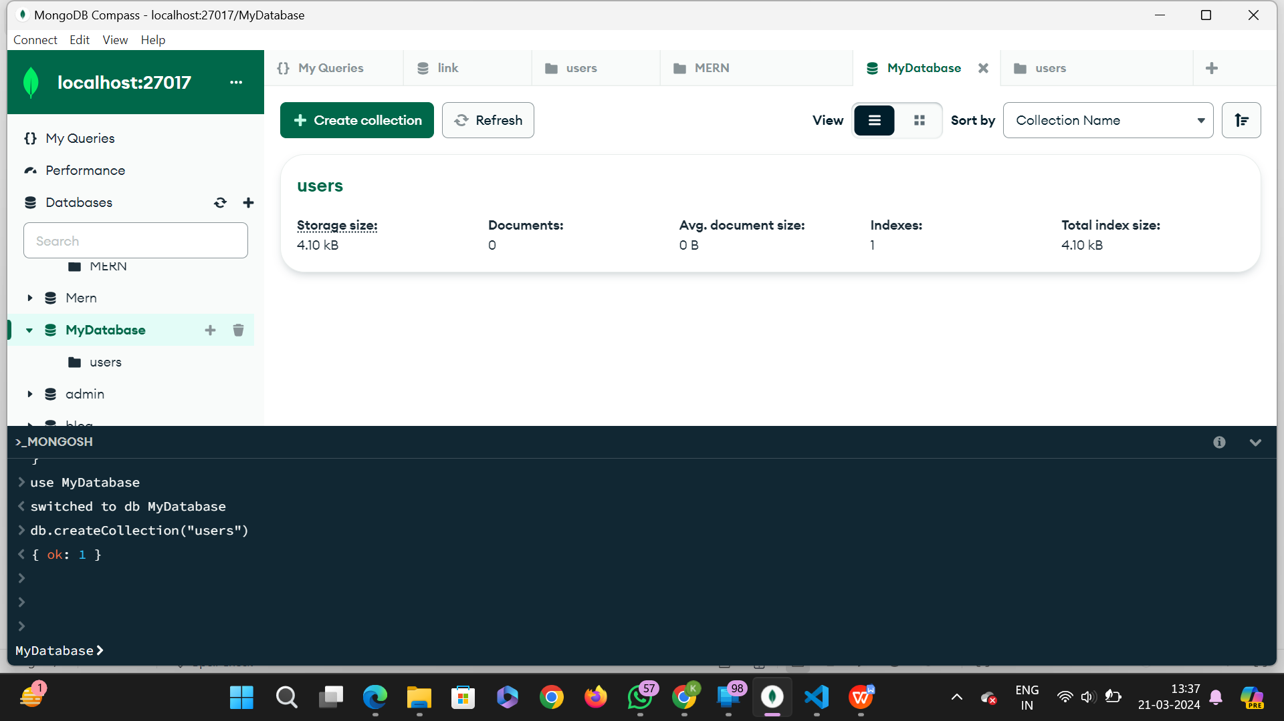

- Inserting documents:

Used commands:
-db.collectionName.insertMany([{data1},{data2},{data3}])

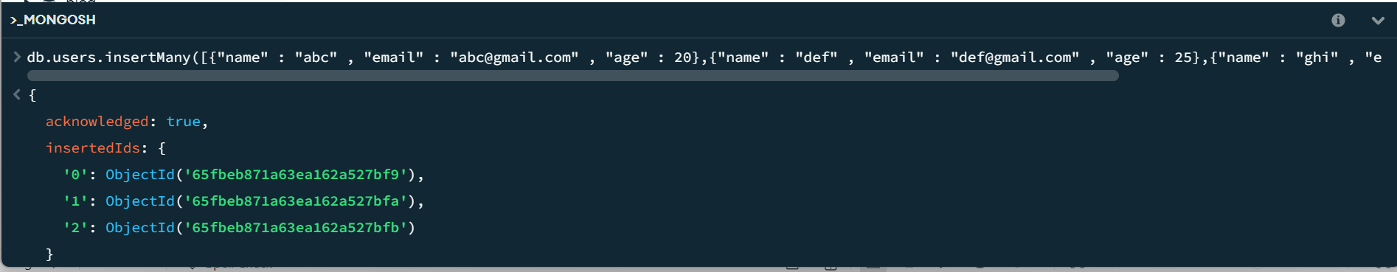

Output:

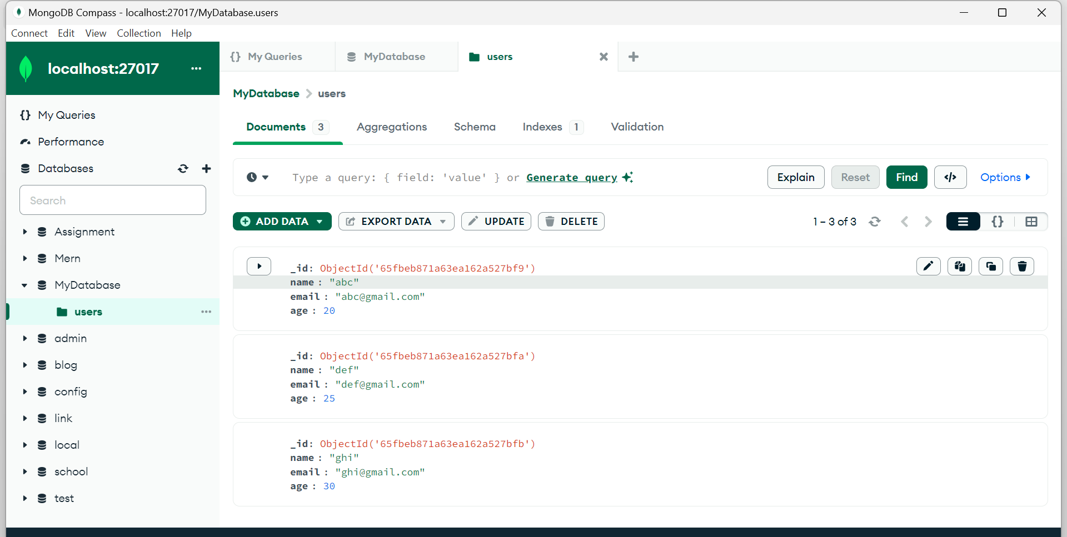

- mongoose query to retrieve “all users from the users collection“:

Used commands:
-db.users.find({})

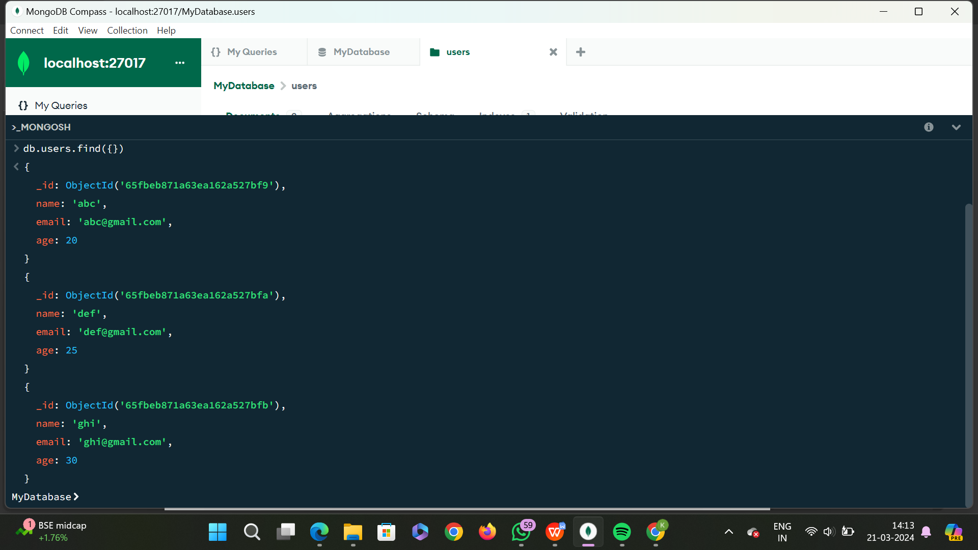

- mongoose query to “Users with an age greater than or equal to 30. ” :

Used commands:
-db.collectionName.find({parameters})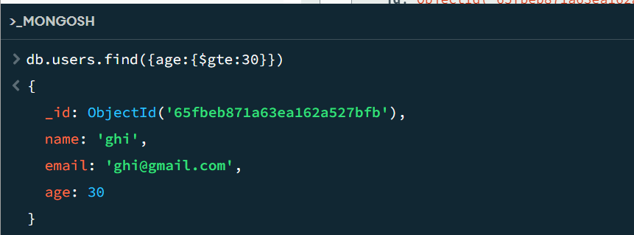

- Update the age of a user with a specific email address.

Used commands:
-db.collectionName.updateOne({default value}, {update value})

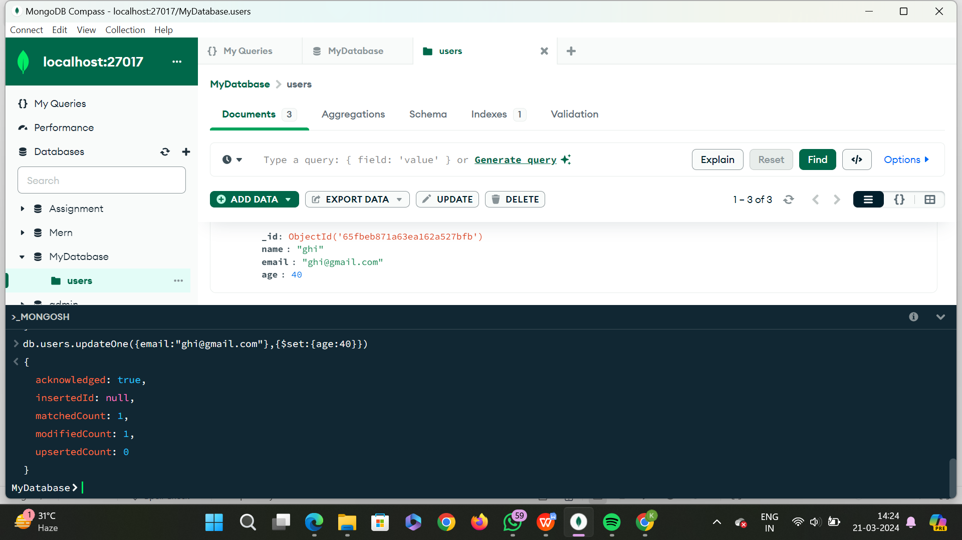

- Delete a user document based on a specific email address.

Used commands:
-db.collectionName.deleteOne
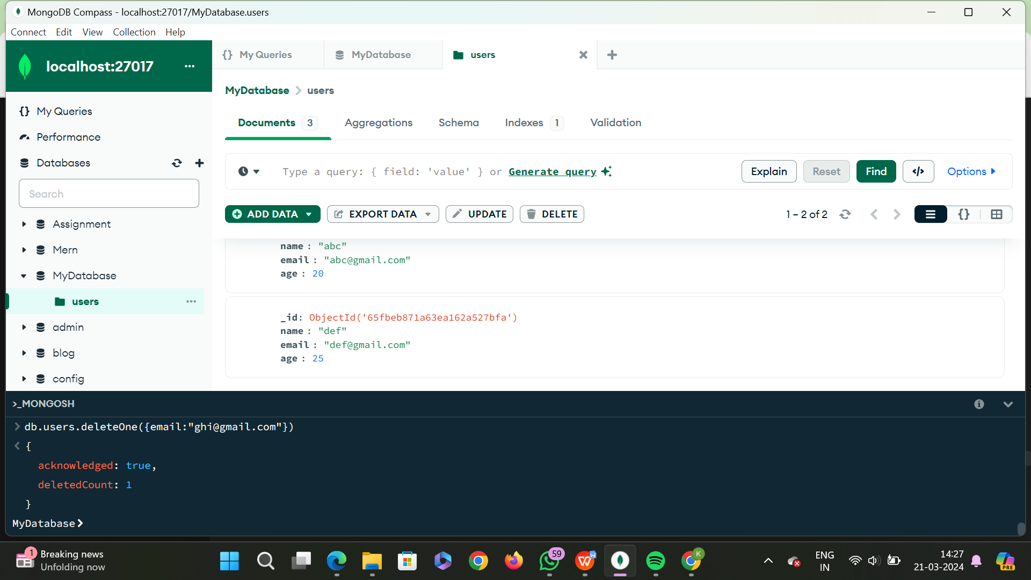

- Create an index on the email field of the users collection.

