**RESUME**

**Name : G. DURGARAM PRASAD**

**Mobile: 7702513057**

**E-mail: gajjela.durgaram18@ifheindia.org durgarams1289@gmail.com**

**CAREER OBJECTIVE: -**

To obtain a challenging position in a company where I can exercise my skills to the maximum, learn innovative ideas and to become a force behind the dynamic growth of the company.

**EDUCATIONAL QUALIFICATION: -**

|  |  |  |  |  |
| --- | --- | --- | --- | --- |
| **Name of the Course** | **University/Board** | **Name of the institution** | **Year of**  **Completion** | **Aggregate (%)** |
| B.Tech (ECE) | IFHE, Hyderabad | IFHE, Hyderabad | 2018-2022 | 6.2 |
| Intermediate (M.P.C) | Board of  Intermediate  Education,  Telangana | Narayana IAS academy,  Hyderabad | 2016-2018 | 75 |
| 10th | SSC | Triveni school,  kothagudem | 2015-2016 | 71 |

**TECHNICAL SKILLS: -**

- HTML CODING

- JAVA SCRIPT

- CSS

- VERILOG CODING

**PREVIOUS EXPERIENCES: -**

* internship base on web development at Cognoshore company.
* Worked on jamming technology as a Special Project.
* Worked on license plate recognition system using Verilog as a special project.

**INTRESTS: -**

* Reading books.
* Playing football.
* Browsing net.

**PERSONAL DETAILS: -**

|  |  |  |
| --- | --- | --- |
| **Name** |  | GAJJELA. DURGARAM PRASAD |
| **Father’s Name** |  | GAJJELA.NARASMIHA RAO |
| **Date of Birth** |  | 15TH November, 2001 |
| **Nationality** |  | Indian |
| **Religion** |  | Hindu |
| **Languages** |  | Telugu, English, Hindi, |
| **Address** | | Houseno-1-103,kothagudem, Telangana. |

**DECLARATION: -**

I hereby declare that the information furnished above is true to the best of my knowledge.

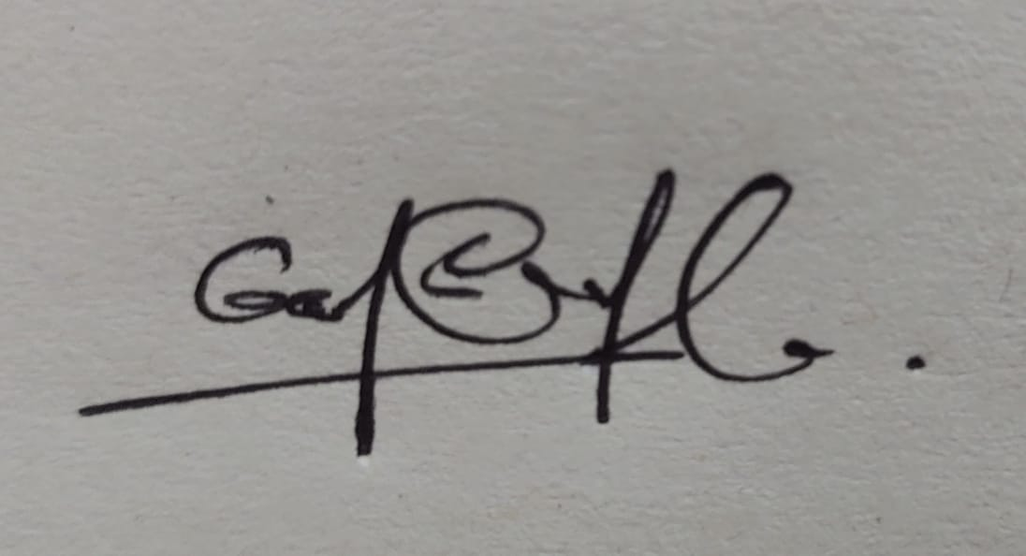

**Place:** Hyderabad,

**Date**: 22,05,2021. **SIGNATURE**