1. Setting up Kubernetes using minikube.
   1. <https://minikube.sigs.k8s.io/docs/start/>
   2. If already setup in your machine inorder to bring up the cluster just give **minikube start**
2. Setup Kubernetes using Kubeadm.
   1. Virtual Box and Vagrant need to be installed in your local.
   2. Get the code for Vagrant to setup 3 virtual machines in virtual box, in which we will be using 1 as master and 2 as worker nodes. <https://github.com/kodekloudhub/certified-kubernetes-administrator-course>
   3. Initially Check the status

* 1. Run the following command to provision the Virtual machines

* 1. Verify the Status of Virtual machines

* 1. To ssh in to one of the node, lets login to master node

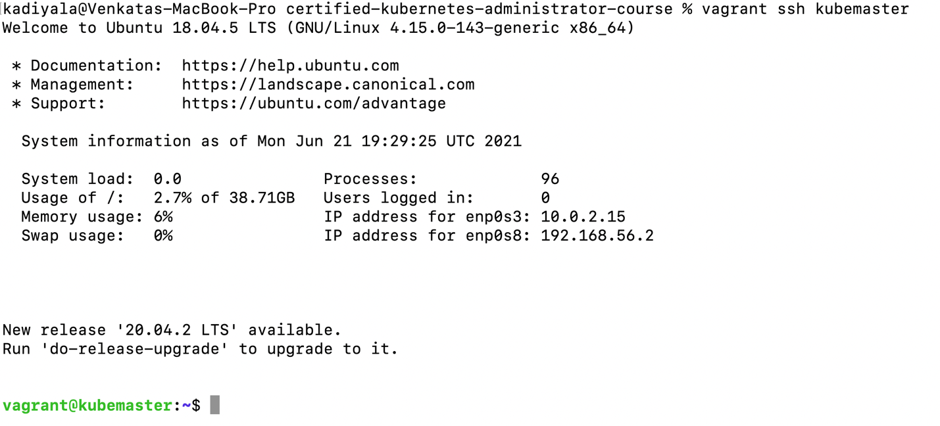

* 1. Install kubeadm on master node

<https://kubernetes.io/docs/setup/production-environment/tools/kubeadm/install-kubeadm/>

* 1. Setup Kubernetes cluster using Kubeadm.

<https://kubernetes.io/docs/setup/production-environment/tools/kubeadm/create-cluster-kubeadm/>

* 1. We should initialize the control plane node and arguemens needed are --pod-network-cidr and --apiserver-advertise-address=<ip-address of the Master(kubeapi server)>
     1. Command looks like follows

* 1. Set up pod networking

<https://kubernetes.io/docs/setup/production-environment/tools/kubeadm/create-cluster-kubeadm/#pod-network>

<https://www.weave.works/docs/net/latest/kubernetes/kube-addon/>

* 1. Join nodes to master and check the status

* 1. Test by creting and deleting pods

