Performance Analysis of Intrusion Detection Systems Using a Feature Selection Method

OBJECTIVE:
The primary goal of this project is to determine whether the Performance Analysis of Intrusion Detection Systems Using a Feature Selection Method whether the result is Attack are not know this we used Support Vector Machine (SVM), k-Nearest-Neighbour (KNN), Logistic Regression (LR), Artifcial Neural Network (ANN), XGBoost and Decision Tree (DT) classification techniques.
ABSTRACT:
Computer networks intrusion detection systems (IDSs) and intrusion prevention systems (IPSs) are critical aspects that contribute to the success of an organization. Over the past years, IDSs and IPSs using different approaches have been developed and implemented to ensure that computer networks within enterprises are secure, reliable and available. In this paper, we focus on IDSs that are built using machine learning (ML) techniques. IDSs based on ML methods are effective and accurate in detecting networks attacks. However, the performance of these systems decreases for high dimensional data spaces. Therefore, it is crucial to implement an appropriate feature extraction method that can prune some of the features that do not possess a great impact in the classification process. Moreover, many of the ML based IDSs suffer from an increase in false positive rate and a low detection accuracy when the models are trained on highly imbalanced datasets. In this paper, we present an analysis the UNSW-NB15 intrusion detection dataset that will be used for training and testing our models. Moreover, we apply a flter-based feature reduction technique using the XGBoost algorithm. We then implement the following ML approaches using the reduced feature space: Support Vector Machine (SVM), k-Nearest-Neighbour (KNN), Logistic Regression (LR), Artifcial Neural Network (ANN) and Decision Tree (DT). In our experiments, we considered both the binary and multiclass classification configurations. The results demonstrated that the XGBoost-based feature selection method allows for methods such as the DT to increase its test accuracy for the binary classification scheme.
Keywords: Support Vector Machine (SVM), k-Nearest-Neighbour (KNN), Logistic Regression (LR), XGBoost, Artifcial Neural Network (ANN) and Decision Tree (DT).

EXISTING SYSTEM:
The increasing growth of machine learning, computer techniques divided into traditional methods and machine learning methods. This section describes the related works of Performance Analysis of Intrusion Detection Systems prediction and how machine learning methods are better than traditional methods. The existing method in this project have a certain flow is used for model development. SVM and ANN are used algorithms in existing system. But it requires large memory and result is not accurate.
Disadvantages:
- Accuracy low
- Operating cost is high
- difficult to handle

PROPOSED SYSTEM:
Proposed several machine learning models to classify attack are not, but none have adequately addressed this misdiagnosis problem. That can be used for this purpose are Stevens Multi Parameter Performance Analysis of Intrusion Detection Systems. Also, similar studies that have proposed models for evaluation of such tumors mostly do not consider the heterogeneity and the size of the data Therefore, we propose a machine learning-based approach which combines a new technique of preprocessing the data for features transformation, KNN (K-Nearest Neighbour), LG (Logistic Regression), XGBoost. Decision Tree ML algorithm give the best accuracy techniques to eliminate the bias and the deviation of instability and performing classifier tests based.
Flow Chart:
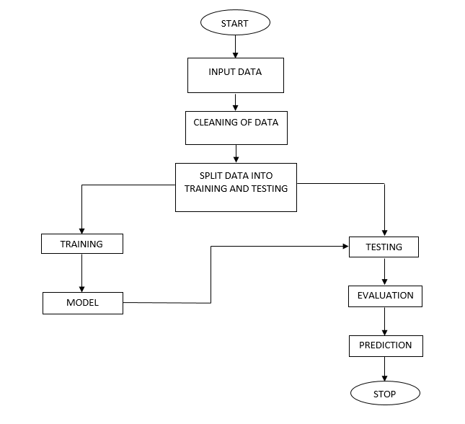

Fig: Block Diagram
Advantages:
- Highest accuracy
- Reduces time complexity.
.

SOFTWARE AND HARDWARE REQUIREMENTS:
Hardware:
Operating system : Windows 7 or 7+
RAM : 8 GB
Hard disc or SSD : More than 500 GB
Processor : Intel 3rd generation or high or Ryzen with 8 GB Ram
Software:
Software’s : Python 3.6 or high version
IDE : PyCharm.
Framework : Flask
LEARNING OUTCOMES:
- About Classification in machine learning.
- About preprocessing techniques.
- About k-Nearest-Neighbour (KNN).
- About Logistic Regression (LR).
- About XGBoost.
- About Support Vector Machine (SVM).
- About Decision Tree (DT).
- About Artifcial Neural Network (ANN)
- Knowledge on PyCharm Editor.

