# Objective

* Designed and developed to organize projects along with the support tickets created.
* Clients can able to raise support tickets directly with their respective logins and have keen records of accomplishment.
* Able to track individual log hours that is being elapsed on both their tickets and tasks.

# Application Overview

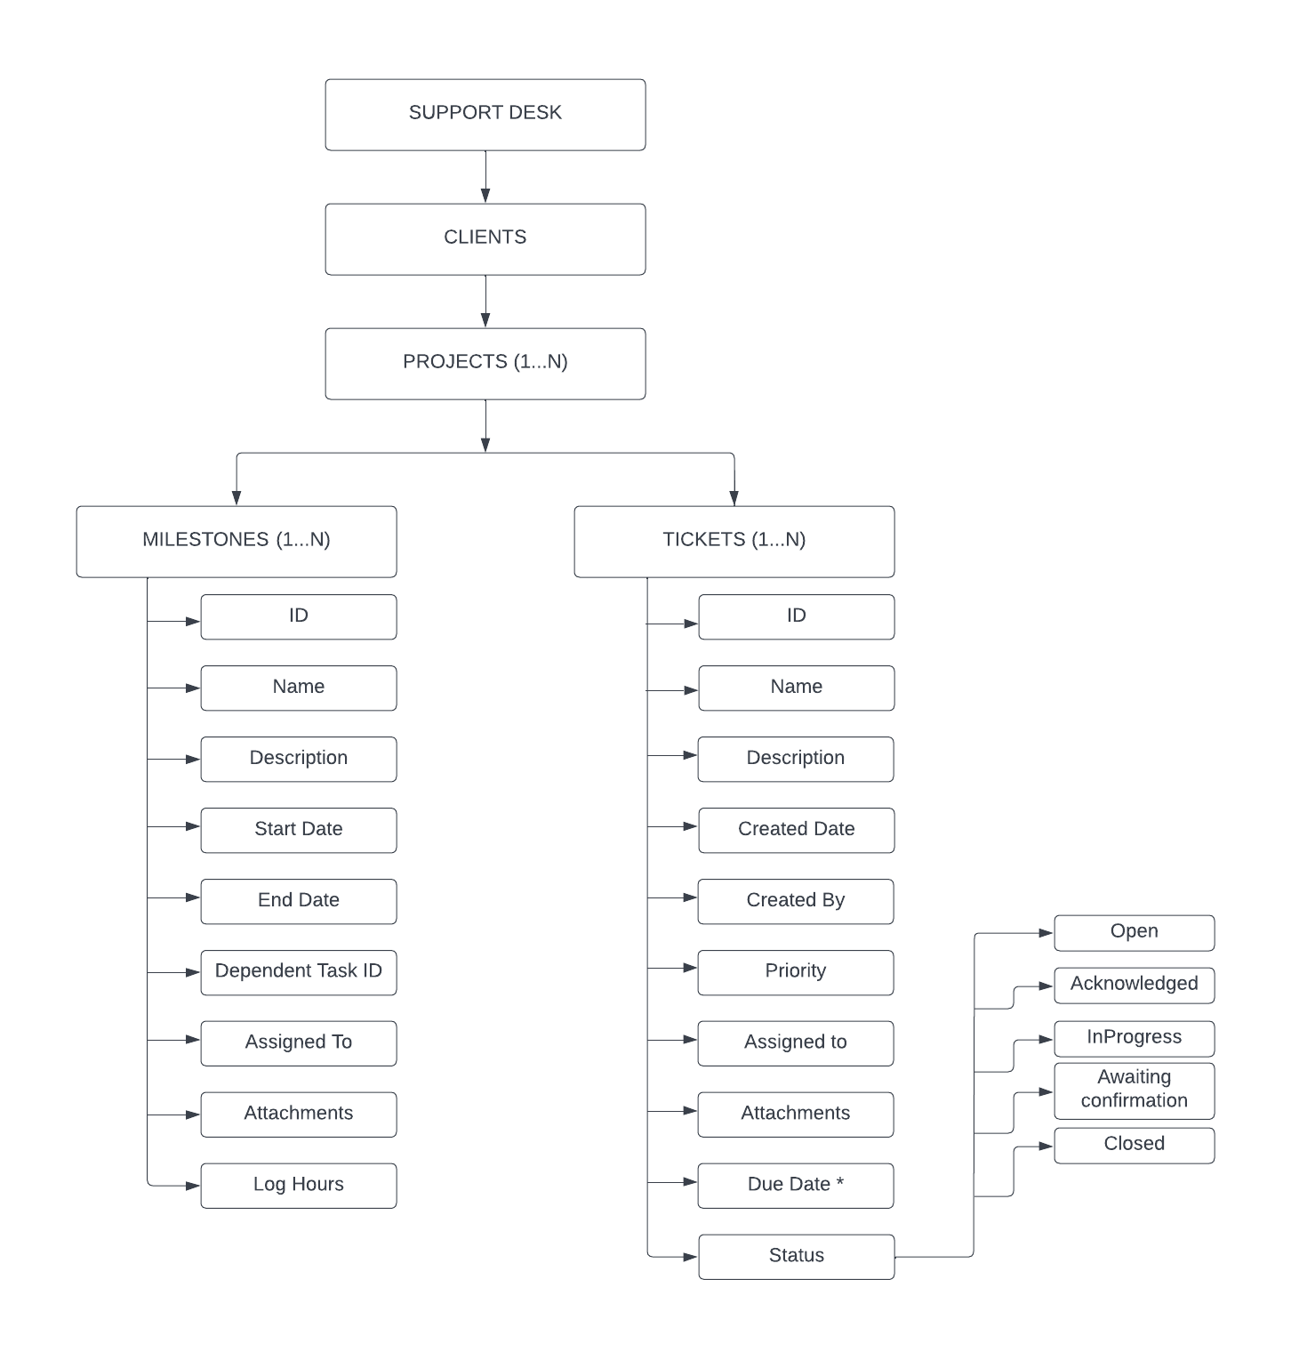

# Key Points

* Projects
  + **‘N’** users can assigned to a project.
  + A Project can have **‘N’** Milestones.
  + A Milestone can have **‘N’** Tasks.
* Tasks
  + Field **‘start date’** needs to be optional.
  + Field **‘Dependent task’** needs to be optional.
  + Field **‘Assigned to’** have **‘Unassigned’** as default value.
  + Log Hours can be of either Timer or Text Entry based upon validations.
* Tickets
  + Due Date is only for Internal purpose.
* Email Alerts will be triggered only on following occasions
  + Ticket Created by Client.
  + Consultants change the Status.