ASSIGNMENT-1

1)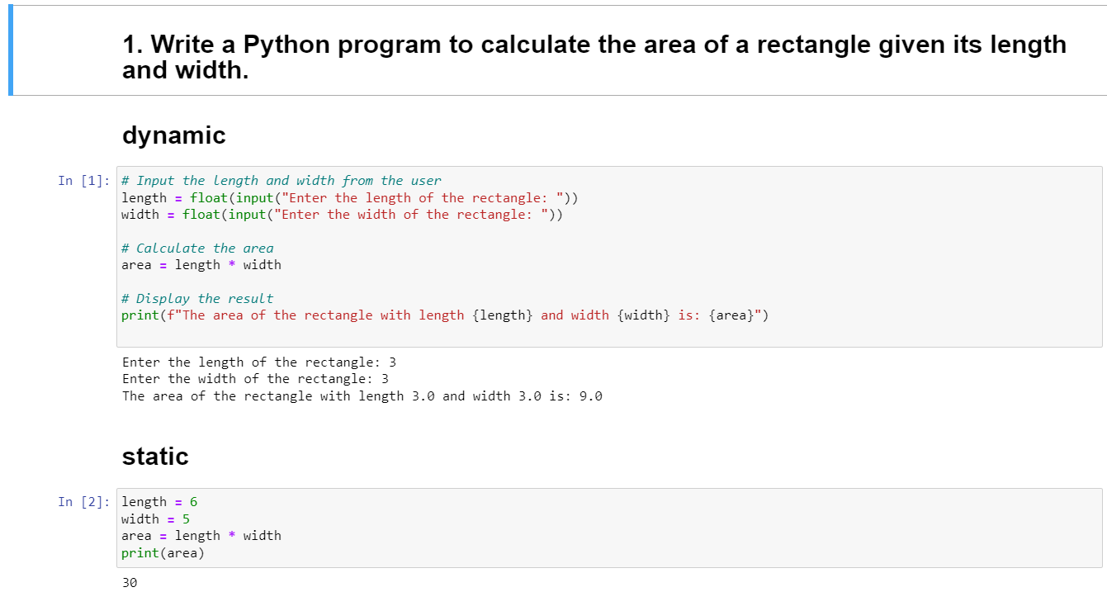

2)

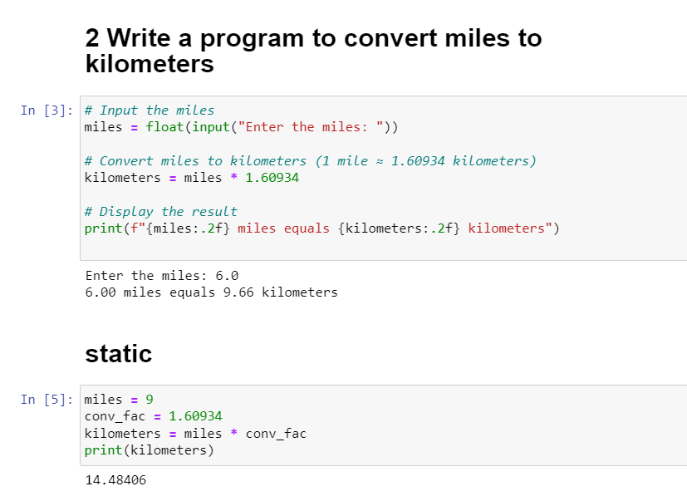

**3)**

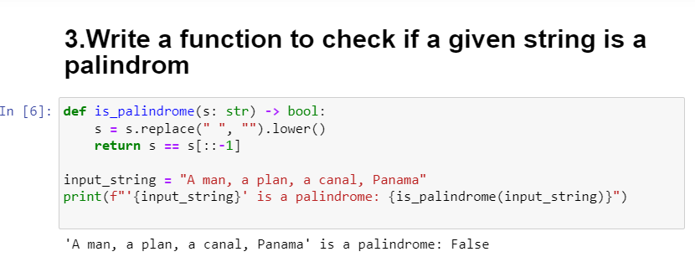

4)

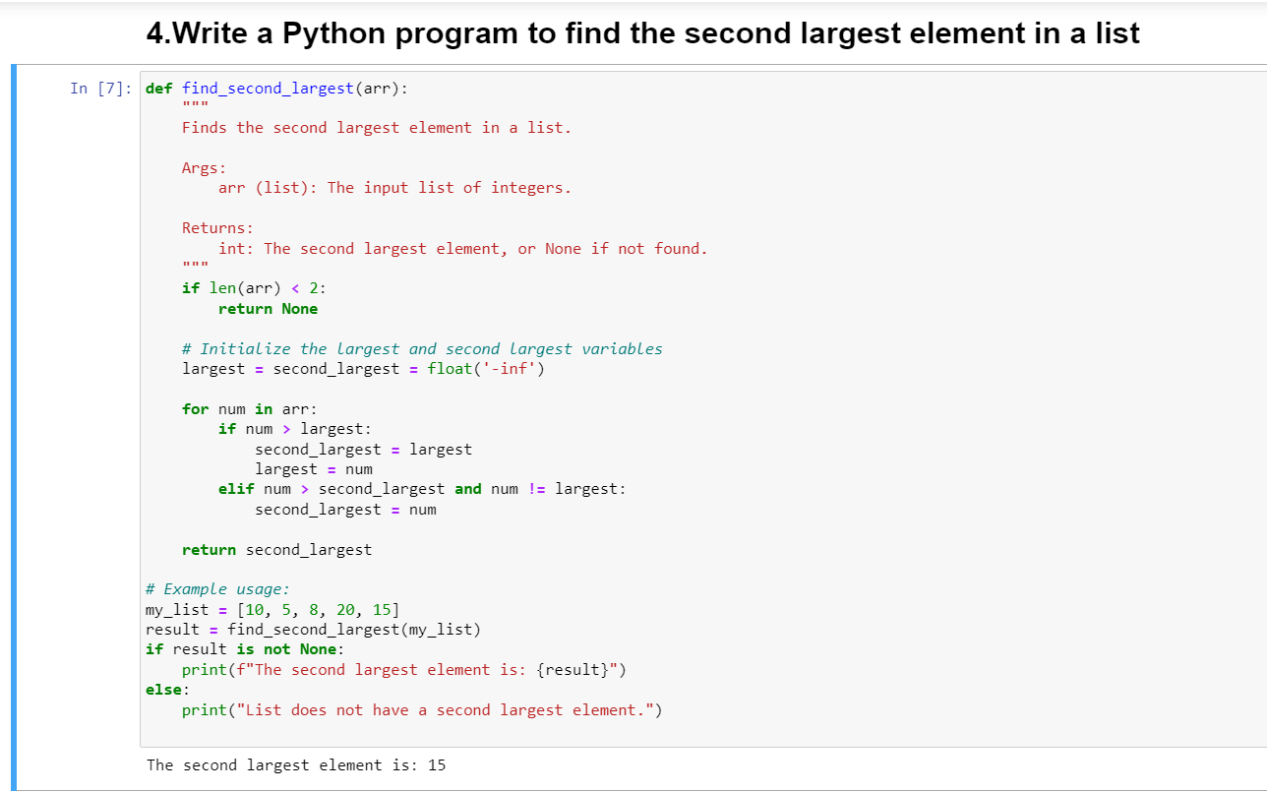

**5) Explain what indentation means in Python**

**Ans:** In Python, indentation refers to the use of whitespace at the beginning of lines to define the structure and scope of code blocks. Unlike many other programming languages that use braces or keywords to delineate blocks of code, Python uses indentation for this purpose. The primary purpose of indentation is to improve code readability.

Here are some key points about indentation in Python:

1. **Whitespace matters**: Python is sensitive to whitespace, particularly indentation. The amount of indentation (typically four spaces) determines the level of nesting within the code.
2. **Consistency is crucial**: In Python, you must maintain consistent indentation throughout your code. Mixing tabs and spaces for indentation can lead to syntax errors or unexpected behavior. It's generally recommended to use spaces for indentation to avoid compatibility issues.
3. **Code blocks**: Indentation is used to denote blocks of code such as loops, conditional statements, and function definitions. Everything indented at the same level is considered part of the same block.
4. **No explicit block delimiters**: Unlike languages like C, Java, or JavaScript, which use curly braces {} to delimit blocks of code, Python relies solely on indentation. This makes Python code visually cleaner and encourages developers to write more readable code.
5. **Indentation level**: Nested blocks of code are indented further to the right. When you decrease the level of indentation, you're ending a block of code.

In summary, indentation is a fundamental aspect of Python syntax used to structure code blocks. It enhances code readability and enforces consistent coding practices across Python projects.

**6)**

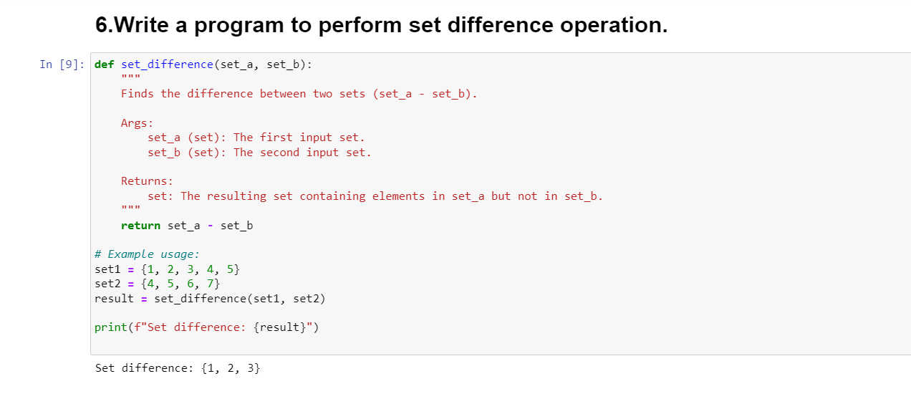7)

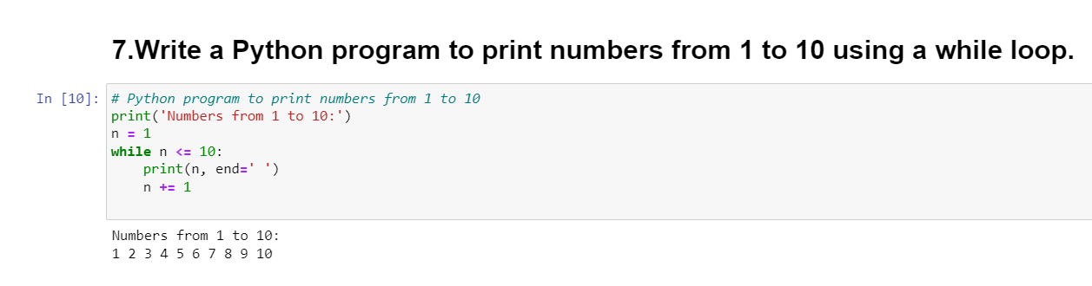

8)

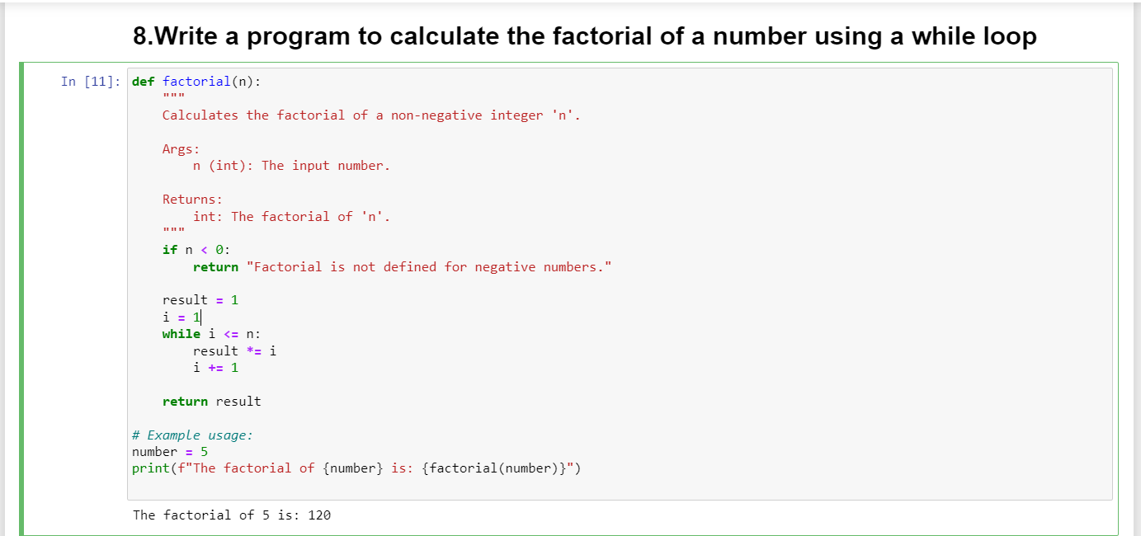

9)

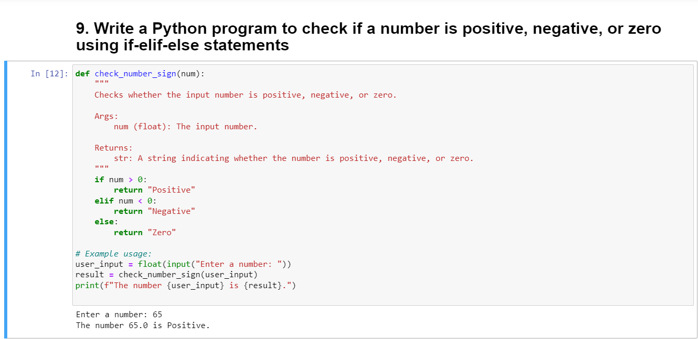

10)

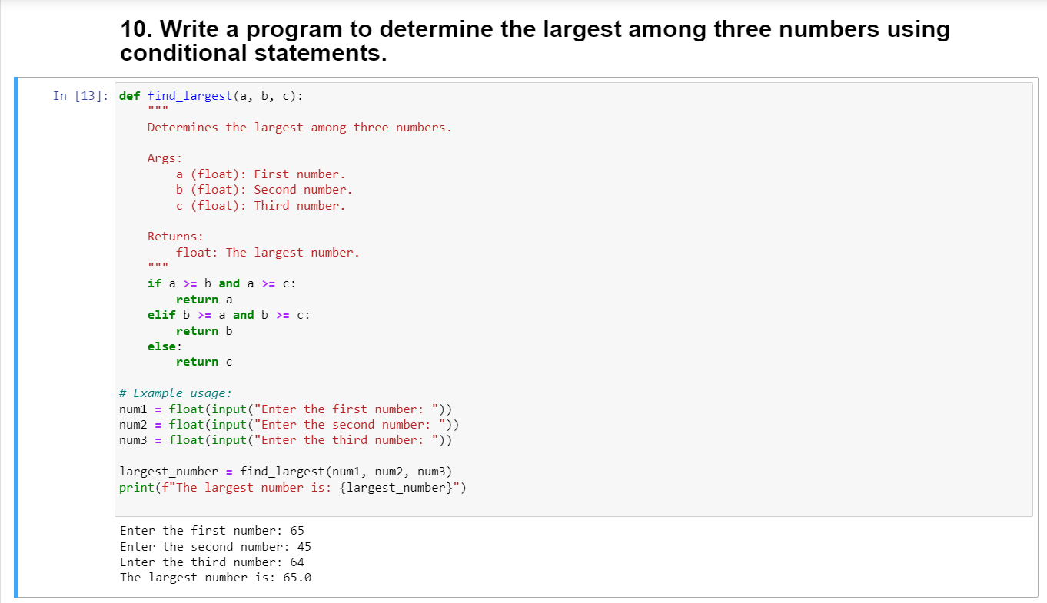

11)

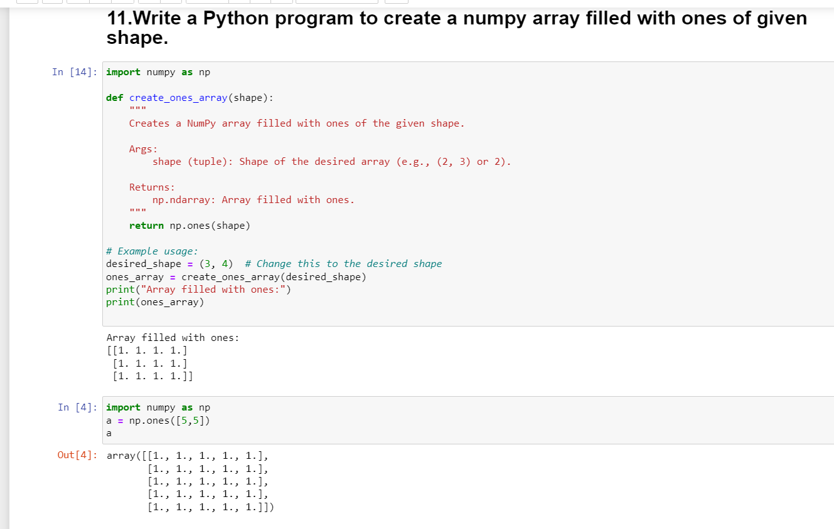

12)

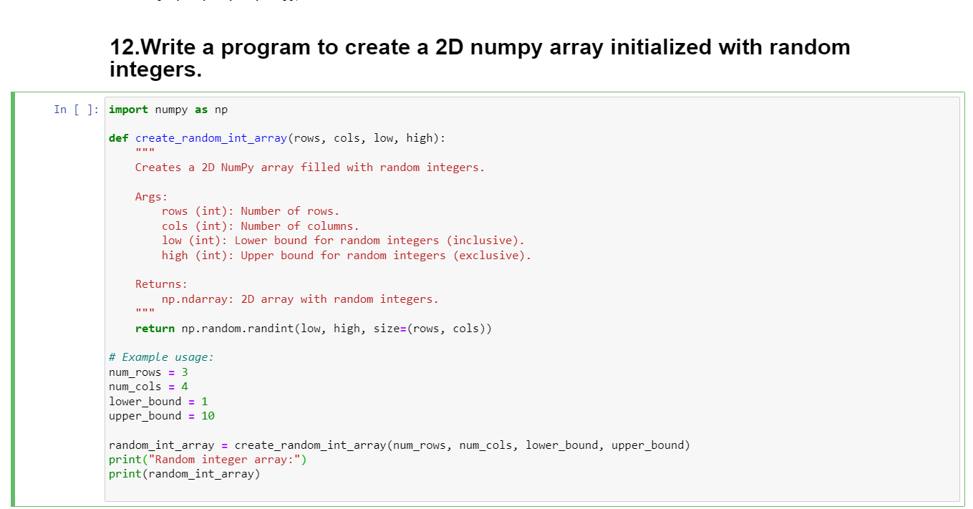

13)

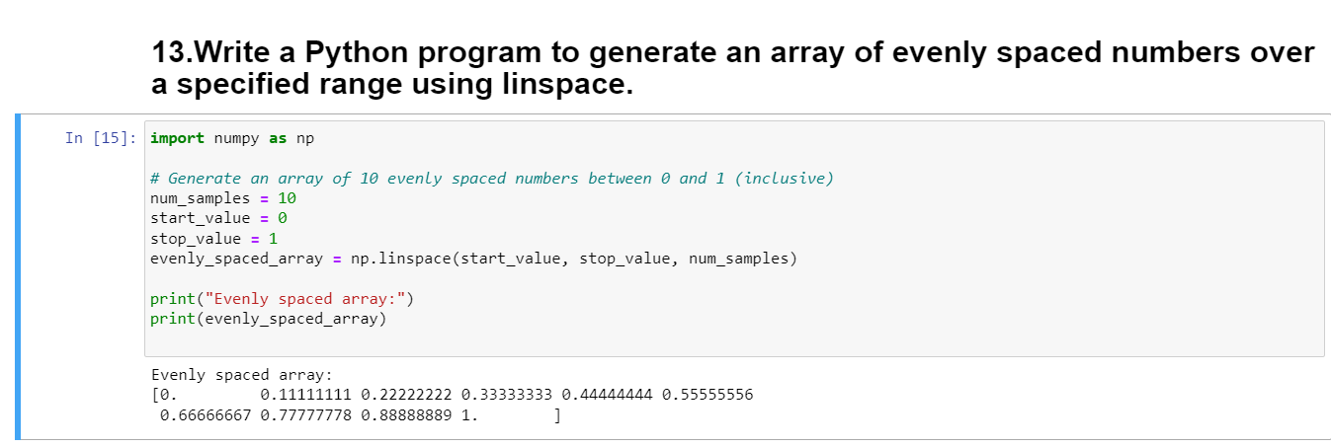

14)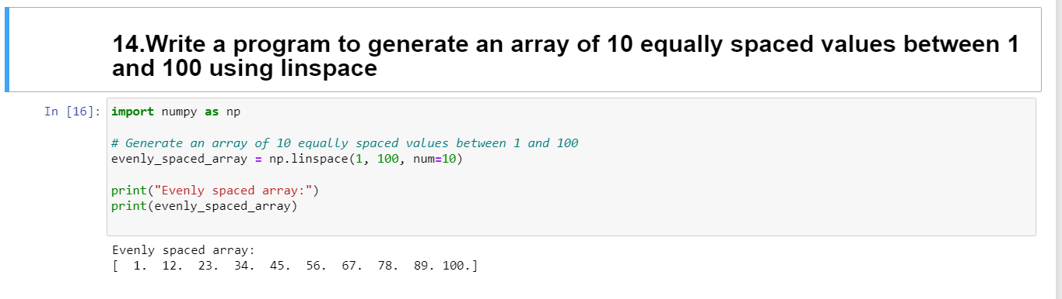

15)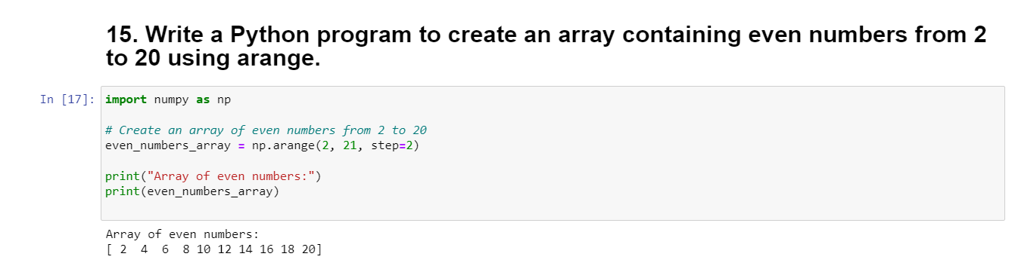

16)