**TOPIC-ReactJS-HOL**

**Q.1.) Create a new React Application with the name “myfirstreact”, Run the application to print “welcome to the first session of React” as heading of that page.**

**Solution:**

**Code:-**

**Path:**src/App.js

import React from 'react';

function App() {

return (

<div>

<h1>Welcome to the first session of React</h1>

</div>

);

}

export default App;

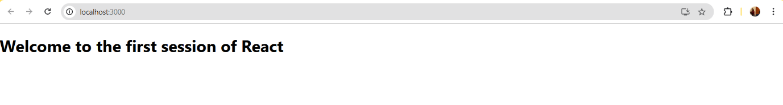**OUTPUT:**

**Q.2.) Create a react app for Student Management Portal named StudentApp and create a component named Home which will display the Message “Welcome to the Home page of Student Management Portal”. Create another component named About and display the Message “Welcome to the About page of the Student Management Portal”. Create a third component named Contact and display the Message “Welcome to the Contact page of the Student Management Portal”. Call all the three components.**

**Solution:**

**Code:-**

**Path:**src/Components/Home.js

import React from 'react';

function Home() {

return (

<div>

<h2>Welcome to the Home page of Student Management Portal</h2>

</div>

);

}

export default Home;

**Path:**src/Components/About.js

import React from 'react';

function About() {

return (

<div>

<h2>Welcome to the About page of the Student Management Portal</h2>

</div>

);

}

export default About;

**Path:**src/Components/Contact.js

import React from 'react';

function Contact() {

return (

<div>

<h2>Welcome to the Contact page of the Student Management Portal</h2>

</div>

);

}

export default Contact;

**Path:**src/App.js

import React from 'react';

import './App.css';

import Home from './Components/Home';

import About from './Components/About';

import Contact from './Components/Contact';

function App() {

return (

<div className="App">

<Home />

<About />

<Contact />

</div>

);

}

export default App;

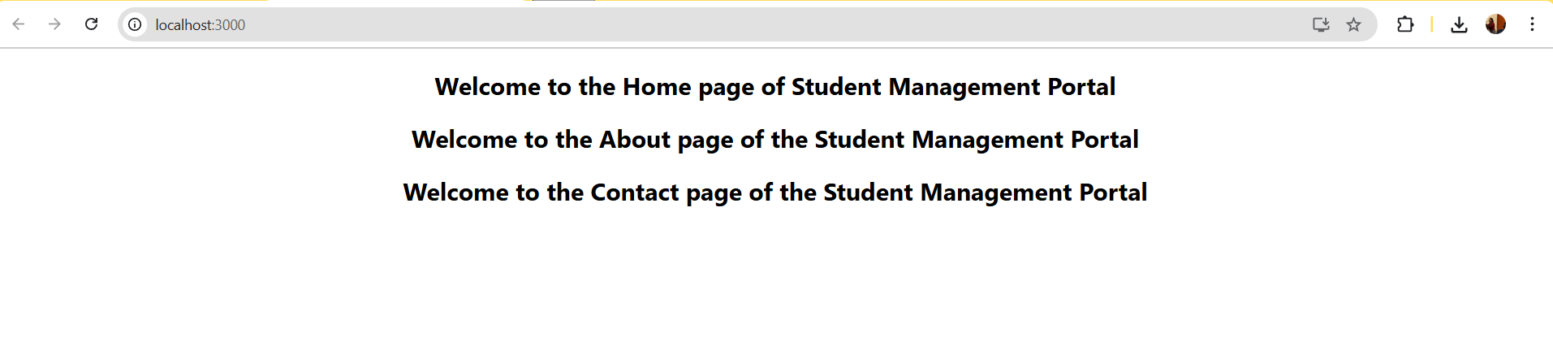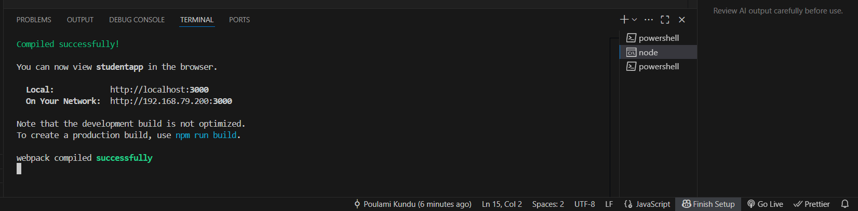**OUTPUT:-**

**Q.3.)Create a react app for Student Management Portal named scorecalculatorapp and create a function component named “CalculateScore” which will accept Name, School, Total and goal in order to calculate the average score of a student and display the same.**

**Solution:**

**Code:-**

**Path:**src/Components/CalculateScore.js

import React from 'react';

import '../Stylesheets/mystyle.css';

const CalculateScore = ({ name, school, total, goal }) => {

const average = total / goal;

return (

<div className="score-card">

<h2>Student Score Calculator</h2>

<p><strong>Name:</strong> {name}</p>

<p><strong>School:</strong> {school}</p>

<p><strong>Total Marks:</strong> {total}</p>

<p><strong>Number of Subjects (Goal):</strong> {goal}</p>

<p><strong>Average Score:</strong> {average.toFixed(2)}</p>

</div>

);

};

export default CalculateScore;

**Path:**src/Components/CalculateScore.js

.score-card {

background-color: #f0f8ff;

border: 2px solid #007acc;

border-radius: 10px;

padding: 20px;

width: 400px;

margin: 30px auto;

font-family: Arial, sans-serif;

box-shadow: 0 4px 8px rgba(0, 0, 0, 0.2);

}

.score-card h2 {

color: #007acc;

text-align: center;

}

**Path:** src/App.js

import React from 'react';

import CalculateScore from './Components/CalculateScore';

function App() {

return (

<div className="App">

<CalculateScore

name="Aditi Sharma"

school="Green Valley School"

total={425}

goal={5}

/>

</div>

);

}

export default App;

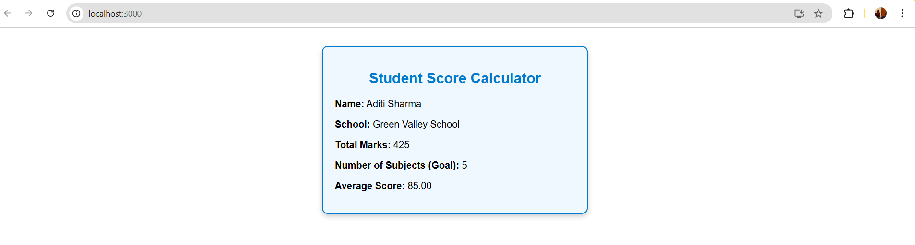**OUTPUT:**

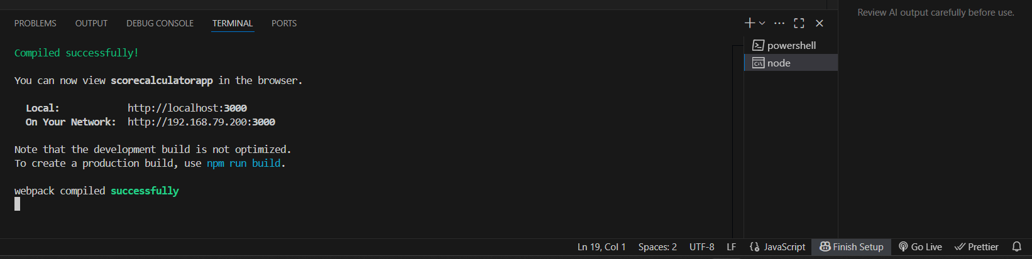

**Q.4.) Create a new react application using *create-react-app* tool with the name as “blogapp”.**

**Solution:**

**Code:-**

**Path:**src/Post.js

import React from 'react';

class Post extends React.Component {

render() {

return (

<div>

<h2>{this.props.title}</h2>

<p>{this.props.body}</p>

</div>

);

}

}

export default Post;

**Path:**src/Posts.js

import React, { Component } from 'react';

import Post from './Post';

class Posts extends Component {

constructor(props) {

super(props);

this.state = {

posts: [],

error: null,

};

}

loadPosts() {

fetch('https://jsonplaceholder.typicode.com/posts')

.then(response => {

if (!response.ok) throw new Error('Network response was not ok');

return response.json();

})

.then(data =>this.setState({ posts: data }))

.catch(error =>this.setState({ error }));

}

componentDidMount() {

this.loadPosts();

}

componentDidCatch(error, info) {

alert('An error occurred: ' + error);

}

render() {

const { posts, error } = this.state;

if (error) {

return <div>Error: {error.message}</div>;

}

return (

<div>

<h1>Blog Posts</h1>

{posts.slice(0, 10).map(post => (

<Post key={post.id} title={post.title} body={post.body} />

))}

</div>

);

}

}

export default Posts;

**Path:**src/App.js

import React from 'react';

import './App.css';

import Posts from './Posts';

function App() {

return (

<div className="App">

<Posts />

</div>

);

}

export default App;

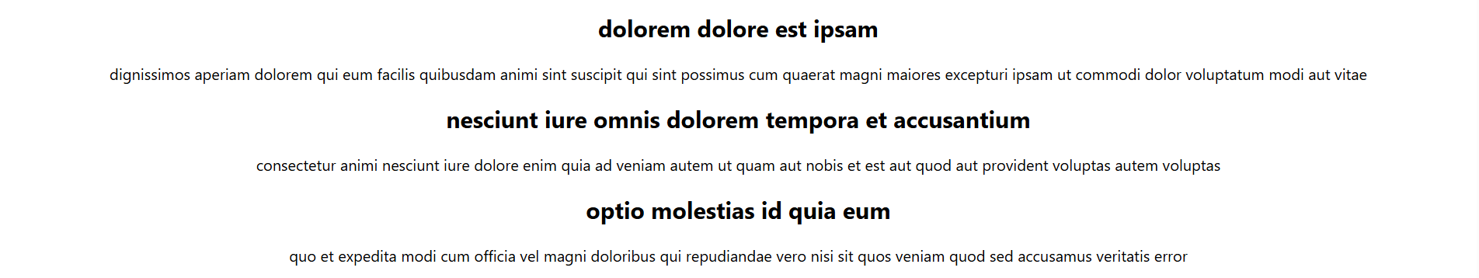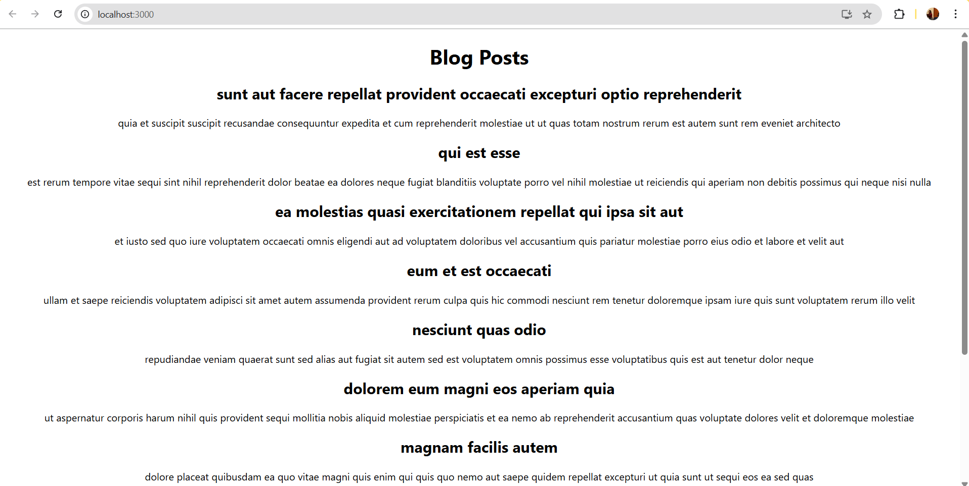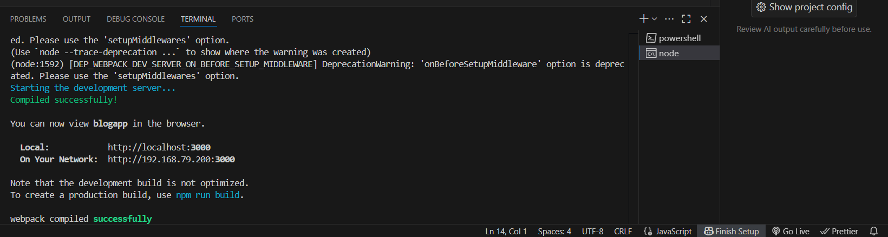**OUTPUT:**

**Q.5.)My Academy team at Cognizant want to create a dashboard containing the details of ongoing and completed cohorts. A react application is created which displays the detail of the cohorts using react component. You are assigned the task of styling these react components.**

**Solution:**

**Code:-**

**Step 1: Create the CSS Module file**

**/* CohortDetails.module.css */**

.box {

width: 300px;

display: inline-block;

margin: 10px;

padding: 10px 20px;

border: 1px solid black;

border-radius: 10px;

}

dt {

font-weight: 500;

}

**Step 2: Create or Update the React Component**

import React from 'react';

import styles from './CohortDetails.module.css'; // Importing CSS Module

function CohortDetails(props) {

const{ title, status, startDate, endDate } = props;

constheadingStyle = {

color: status === 'ongoing' ? 'green' : 'blue',

};

return (

<div className={styles.box}>

<h3 style={headingStyle}>{title}</h3>

<dl>

<dt>Status:</dt>

<dd>{status}</dd>

<dt>Start Date:</dt>

<dd>{startDate}</dd>

<dt>End Date:</dt>

<dd>{endDate}</dd>

</dl>

</div>

);

}

export default CohortDetails;

**Use the Component in App.js to Test**

import React from 'react';

import CohortDetails from './CohortDetails';

function App() {

return (

<div>

<h1>Cohort Dashboard</h1>

<CohortDetails

title="React Basics"

status="ongoing"

startDate="2025-07-01"

endDate="2025-08-15"

/>

<CohortDetails

title="Spring Boot Advanced"

status="completed"

startDate="2025-05-01"

endDate="2025-06-30"

/>

</div>

);

}

export default App;

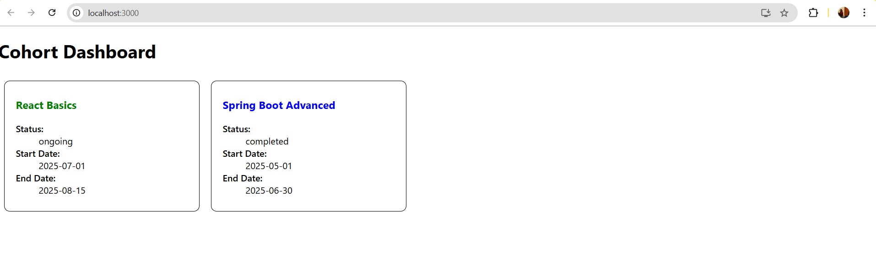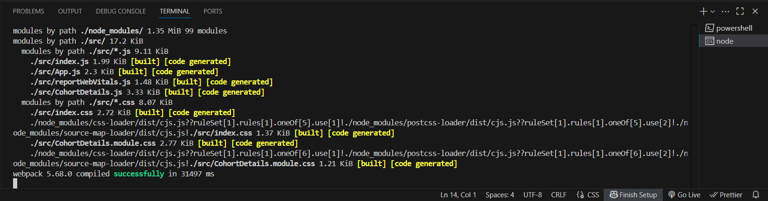**OUTPUT:**