SAFERTECH BACKEND PYTHON OUTPUTS

2100032248

P. DURGA VIJAY

1st output :

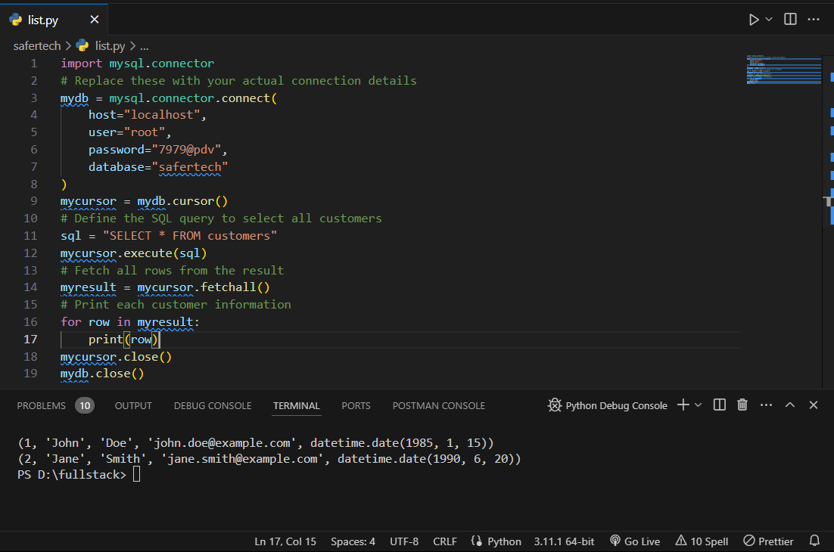

2nd output :

3rd output :

4th output :

5th output :

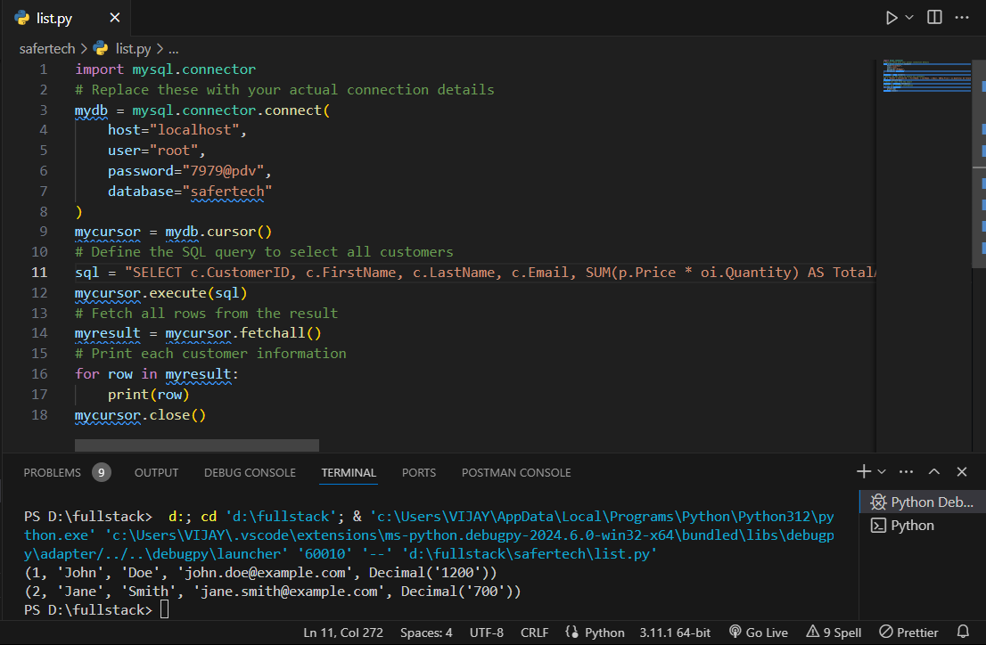

6th output :

7th output :

8th output :

