SAFERTECH-BACKEND EXAM (SQL QUERIES)

**210032248**

**P. DURGA VIJAY**

1st output :

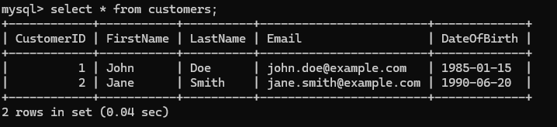

2nd output :

3rd output :

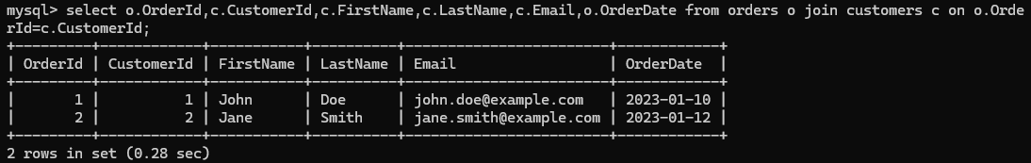

4th output :

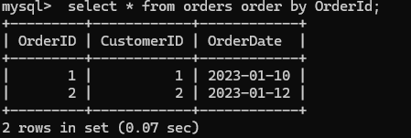

5th output :

6th output :

7th output :

8th output :

