**SHRI GOVINDRAM SEKSARIA INSTITUTEOF TECHNOLOGY AND SCIENCE, INDORE**



**DEPARTMENT OF ELECTRONICS &TEELECOMMUNICATION**

**ENGINEERING**

(EC 25992)

A PROJECT ON

**“Audio Music Amplifier”**

**(Batch:2017-21)**

**SUBMITTED TO: SUBMITTED BY:**

Mr. Ashwin Srivastava Sir DurgeshYadav(0801EC171031)

Mr. Gopikrishnan Sir Naman Jain (0801EC171052)

**CONTENT:**

1. CERTIFICATE

2. ACKNOWLEDGEMENT

3. INTRODUCTION

4. CIRCUIT DIAGRAM

6. WORKING

7. APPLICATION

8. BIBLOGRAPHY

9. RESULT & CONCLUSION

**CERTIFICATE**

This is to be certified that the project entitled “AUTOMATIC CAR WITH OBJECT DETECTION” is an original work carried out by *Durgesh Yadav, Naman Jain, Pankaj Kumar* in partial fulfillment for the award of degree of Bachelor of Engineering of Shri Govindram Seksaria Institute of Technology & Science, Indore, during the year 2018-19. The report has been approved as it satisfies the academic requirements and the students have worked under my guidance as directed.

Signature-

Mr. Ashwin Srivastava Sir

Mr. Gopikrishnan Sir

**ACKNOWLEDGEMENT**

I am thankful to the director of this college, Dr. R K Saxena sir for giving me the opportunity to make this project. The kind of learning I have gained while working on this project has proved to be invaluable.

I am extremely grateful to Mr. Ashwin Srivastava Sir and Mr. Gopikrishnan Sir my supervisor and mentor for always showing me the way and guiding me through the process of my internship.

I would like to thank my friends for giving me all the support I required and making all necessary arrangements for me to complete this research as well as the freedom to take my work in the direction I desired.

I am thankful for all of my respondents without whom this study would not have been possible.

I Would also like to thank to my parents and team members for supporting me.

**INTRODUCTION**

Amplifier is a basic component of all the music systems available in market. The need of this intermediate circuitry exists so that we can hear crystal clear music from the music systems. Mini Audio Amplifier project is a mini version of such amplifier systems. This is easy to implement and test with the help of audio jack.

**LIST OF COMPONENETS**

* **(Battery**
* **Audio Jack**
* **Buzzer**
* **Audio Amplifier IC**
* **Resistors**
* **Capacitors**
* **Transistors**
* **Cables and Connectors**
* **Diodes**
* **PCB and Breadboards**
* **LED**
* **Transformer/Adapter**
* **Push Buttons**
* **Switch**
* **IC Sockets**

**CIRCUIT DIAGRAM**

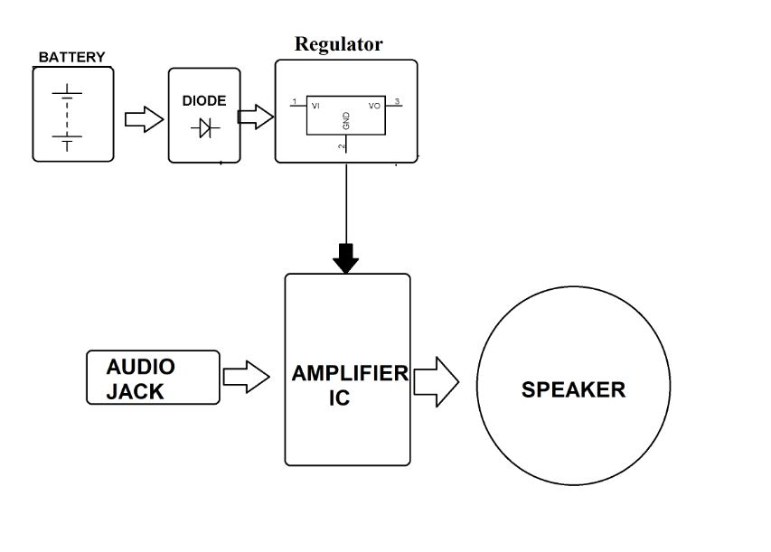

**WORKING**

This is easy to implement and test with the help of audio jack. The signals given by an audio transmitter device such as cell phone through a 3.5mm audio jack cable is very low in amplitude. Such a signal if given to the speaker, the sound output given by the speaker will be very less and might not be audible even to a nearby person. So instead we given the audio input to the amplifier circuitry. The amplifier circuitry amplifies this audio signal. The amplified version of the audio input is fed to the input of the speaker which then converts it into sound output. Audio frequency range lies in the frequency range of 20Hz – 20KHz. The purpose of audio amplifier lies in to increase the amplitude of signals lying in this frequency range and suppress the rest. So the audio amplifier circuitry is configures in such way that it will multiply the audible range signals with a positive gain factor. With the help of two potentiometers we can vary the gain factor or the volume of the audio amplifier.

**BIBLIOGRAPHY**

1. [www.google.com](http://www.google.com)
2. www.wikipedia.com
3. [www.scribd](http://www.scribd).com
4. [www.alldatasheet.com](http://www.alldatasheet.com)

**RESULT & CONCLUSION**

This project teaches us about sensor transmitter and receiver, Various ICs like LM358 op-amp, L293D motor driver and 7805 voltage regulator. Also it teaches about motor driver ICs, H Bridge and comparator working.