Download the application from the git.

Setup database:

Run the script (blog.sql)

Open web.config file from the project and give the database server name.

Run the project It will show below page

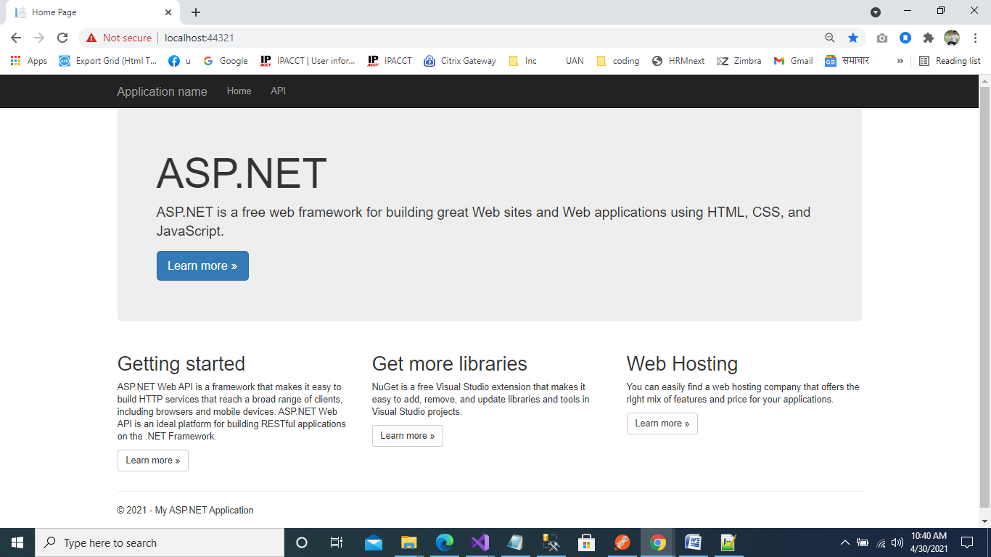

Application is now running.

Check the get response (get articles)

https://localhost:44321/api/article?id=1

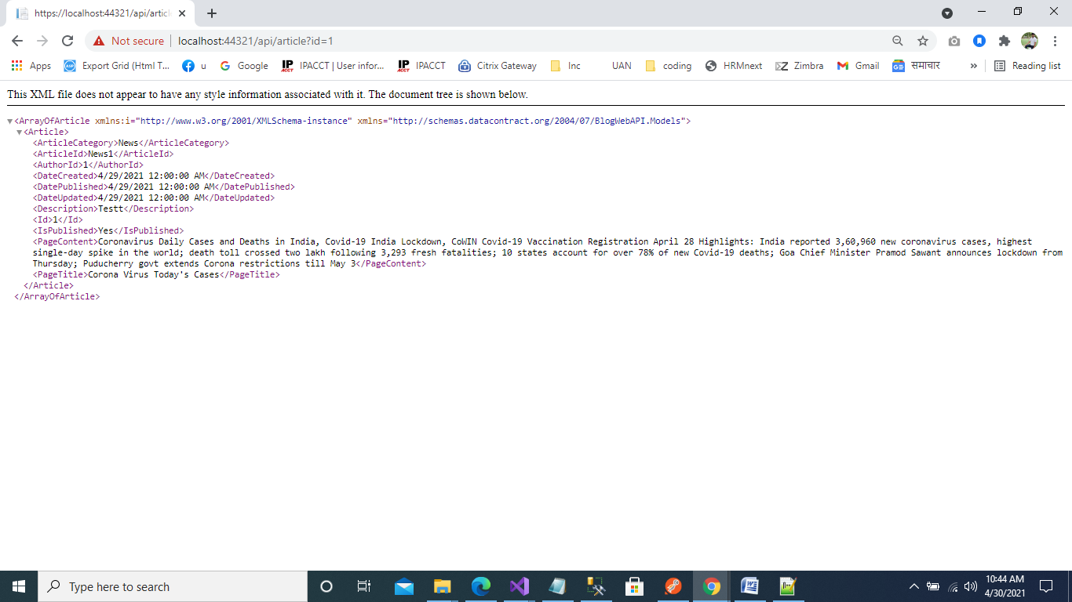

To get all the article details pass null value

https://localhost:44321/api/article?id=null

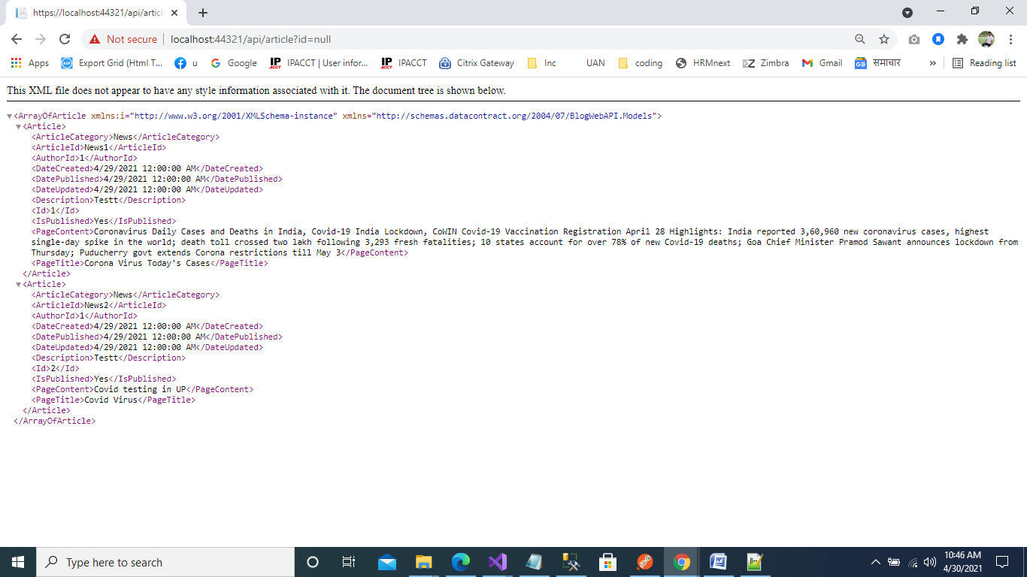

Use Postman, To post, put and delete the data

