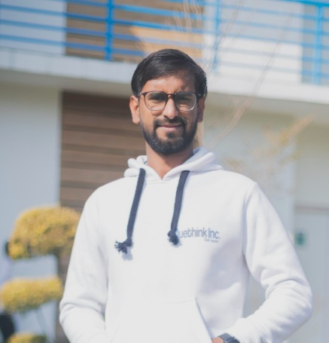

**Project Experience**

I have total 2-year experience as a Java Developer. I have demonstrated a strong understanding of various technologies, particularly Spring MVC, Spring Boot. I am able to grasp complex concepts and apply them effectively in my projects.

**Profile**

* Developed and maintained a secure Banking System using Java.
* Led the implementation of a user-friendly Hospital Management System using Java JSP and MySQL.
* Designed and developed an efficient Attendance Management System using Java and MySQL.
* Worked on the Dashboard and Recommendation Engine of Zee5 at Zee Entertainment Enterprises Limited, utilizing Spring Boot and Docker.
* Developed Bpm-Core software with 5 panels and distinct responsibilities, involving Rest-Api design, coding, and deployment. Utilized Spring Boot, Hibernate, MySQL, and JPA.

. 

[durgeshyadavalld@gmail.com](mailto:%20%20durgeshyadavalld@gmail.com)

+91-8090123604

**Durgesh Kumar**

**Technical Skills**

Noida, U.P., India, 201014

**Social Links**

* **Frameworks**: Spring Boot, Micronaut, Apache Tomcat Server.
* **Software**: Postman, Git, Swagger-UI, Docker.
* **Databases**: MySQL, Oracle, H2.

**SkillsHighlights**

**Language**

* [**Linkedin**](https://www.linkedin.com/in/durgesh-kumar-90758717b/)
* [**HackerRank**](https://www.hackerrank.com/durgeshyadavalld?hr_r=1)
* [**GitHub**](https://github.com/durgesh145)

**Experience**

* **Java**
* **Spring Boot**
* **Git**
* **Tomcat Server**
* **Swagger**
* **Rest Api**
* **Html/CSS**
* **Bootstrap**
* **JPA**

**Language**

* **English**
* **Hindi**

**Hobbies**

* **Writing**
* **Cricket**
* **Traveling**
* **Reading**

Bachelor of Technology (Computer Science and Engineering)

Krishna Engineering college Ghaziabad

CGPA: 7.2

2018 -2022

**Software Developer *Uway Software Solution***

**Grater Noida *Jul 2023 - Present***

• Developed and maintained secure Banking System in Java.

* Led implementation of user-friendly Hospital Management System (Java JSP, MySQL).
* Designed efficient Attendance Management System (Java, MySQL).
* Resolved complex technical issues and optimized performance.
* Implemented continuous integration and delivery practices.
* Mentored junior developers and facilitated collaboration.
* Stayed updated with industry trends and recommended innovations.

**Software Developer *Ventur7***

**Faridabad *Feb 2022-Jun 2022***

* Created multiple reports and document as per requirement for development.
* Work on the health Management System, using .Net,HTML,CSS and Bootstrap.

**Java Developer *BlueThink Inc.***

**Noida *Nov 2022 - Jul 2023***

* Hands on experience of CRUD operations on Spring MVC, Spring Boot and

Micronut framework.

* Developed a Java-based web application with an intuitive UI that increased engagement of users.
* Developed a REST API that enabled integration with third-party services, resulting in an increase in customer retention.
* Designed and implemented a secure user authentication system.
* Oaths for user authorization and authentication. Developed a RESTful API that handled as per requests per day with response times.

**Education**