WEEK 1

Aim
To create an ATS-friendly resume webpage using basic HTML elements.

Description:
This experiment demonstrates the creation of a structured resume using basic HTML. The webpage includes personal details, contact information, career objective, educational qualifications, technical skills, work experience, projects, certifications, strengths, languages known, and declaration. HTML elements such as headings, paragraphs, lists, tables, images, and horizontal lines are used to organize the resume.

Program:
ATS Friendly Resume Using Basic HTML

Program Code:
<!DOCTYPE html>
<html>

<head>
<title>My Resume</title>
<meta charset="UTF-8">
<meta name="description" content="Using Basic HTML Elements">
<meta name="author" content="Adimolu Veera Venkata Naga Durgesh">
</head>

<body>

<div align="center">

<table border="1">
<tr>
<td width="200" height="300" align="center">
<img src="img.jpg" alt="My Photo" width="200" height="300">
</td>
</tr>
</table>

<h2>ADIMOLU VEERA VENKATA NAGA DURGESH</h2>
<h4>AI & ML Student | Python Developer | Machine Learning Enthusiast</h4>

</div>

<hr>

<h2 style="color:blue;"><strong>Contact Information</strong></h2>

<table border="1" width="600" height="200">

<tr>
<th>Information</th>
<th>Details</th>
</tr>

<tr>
<td>Email</td>
<td style="color:blue;">durgeshadimolu143@gmail.com</td>
</tr>

<tr>
<td>Phone</td>
<td>6281056955</td>
</tr>

<tr>
<td>LinkedIn</td>
<td style="color:blue;">
https://www.linkedin.com/in/durgesh-adimolu-636759392
</td>
</tr>

<tr>
<td>GitHub</td>
<td style="color:blue;">
https://github.com/yourusername
</td>
</tr>

<tr>
<td>Location</td>
<td>East Godavari, Andhra Pradesh, India</td>
</tr>

</table>

<hr>

<h2 style="color:blue;"><strong>Career Objective</strong></h2>

<p>
Aspiring to leverage my Artificial Intelligence and Machine Learning
skills to build innovative software solutions while continuously
improving my technical knowledge and problem-solving abilities.
</p>

<hr>

<h2 style="color:blue;"><strong>Educational Qualification</strong></h2>

<table border="1" width="650" height="200">

<tr>
<th>Degree</th>
<th>University</th>
<th>Year</th>
<th>Percentage/CGPA</th>
</tr>

<tr>
<td>B.Tech (Computer Science and Engineering with AI/ML)</td>
<td>Anil Neerukonda Institute of Technology and Sciences</td>
<td>2028</td>
<td>9.5 CGPA</td>
</tr>

<tr>
<td>Intermediate</td>
<td>Narayana Junior College</td>
<td>2024</td>
<td>98.1%</td>
</tr>

<tr>
<td>SSC (10th)</td>
<td>A.P Model School</td>
<td>2022</td>
<td>96.4%</td>
</tr>

</table>

<hr>

<h2 style="color:blue;"><strong>Technical Skills</strong></h2>

<ul>
<li>HTML</li>
<li>CSS</li>
<li>JavaScript</li>
<li>Python</li>
<li>C Programming</li>
<li>MySQL</li>
<li>Git & GitHub</li>
<li>Machine Learning</li>
</ul>

<hr>

<h2 style="color:blue;"><strong>Work Experience</strong></h2>

<ol>

<li><b>Machine Learning Training</b></li>

<ul type="circle">
<li>Completed Machine Learning training using Python.</li>
</ul>

<li><b>Academic Project</b></li>

<ul type="circle">
<li>Developed an AI-based Drug-Drug Interaction Prediction System.</li>
</ul>

</ol>

<hr>

<h2 style="color:blue;"><strong>Projects</strong></h2>

<table border="1" width="650" height="200">

<tr>
<th>Project</th>
<th>Technology</th>
<th>Description</th>
</tr>

<tr>
<td>Drug-Drug Interaction Prediction System</td>
<td>Python, Pandas, Machine Learning</td>
<td>
Predicts drug interactions and their severity using Machine Learning.
</td>
</tr>

<tr>
<td>Student Management System</td>
<td>Python, MySQL</td>
<td>
Console-based application for managing student records.
</td>
</tr>

</table>

<hr>

<h2 style="color:blue;"><strong>Certifications</strong></h2>

<ul>
<li>Python Programming</li>
<li>Machine Learning Fundamentals</li>
<li>Git & GitHub</li>
<li>MySQL Basics</li>
</ul>

<hr>

<h2 style="color:blue;"><strong>Strengths</strong></h2>

<ul>
<li>Quick Learner</li>
<li>Problem Solving Skills</li>
<li>Good Communication</li>
<li>Team Player</li>
<li>Time Management</li>
</ul>

<hr>

<h2 style="color:blue;"><strong>Languages Known</strong></h2>

<ul>
<li>English</li>
<li>Telugu</li>
</ul>

<hr>

<h2 style="color:blue;"><strong>Declaration</strong></h2>

<p>
I hereby declare that the above information is true and correct to the best
of my knowledge and belief.
</p>

<br>

<div align="right">
<b>Signature</b>
<br><br>
ADIMOLU VEERA VENKATA NAGA DURGESH
</div>

<div align="left">
<b>Date: __________________</b>
</div>

<br><br><br>

</body>

</html>
Details About Program:
Saved in: Week 1 folder of the repository.
File used: HTML file with an image stored in the images folder.
Technology used: HTML.
Execution: The HTML file is opened in a web browser.
Working: Basic HTML elements are used to create and organize different sections of the resume. Tables are used for contact, education, and project details, while lists are used for skills, experience, certifications, strengths, and languages.

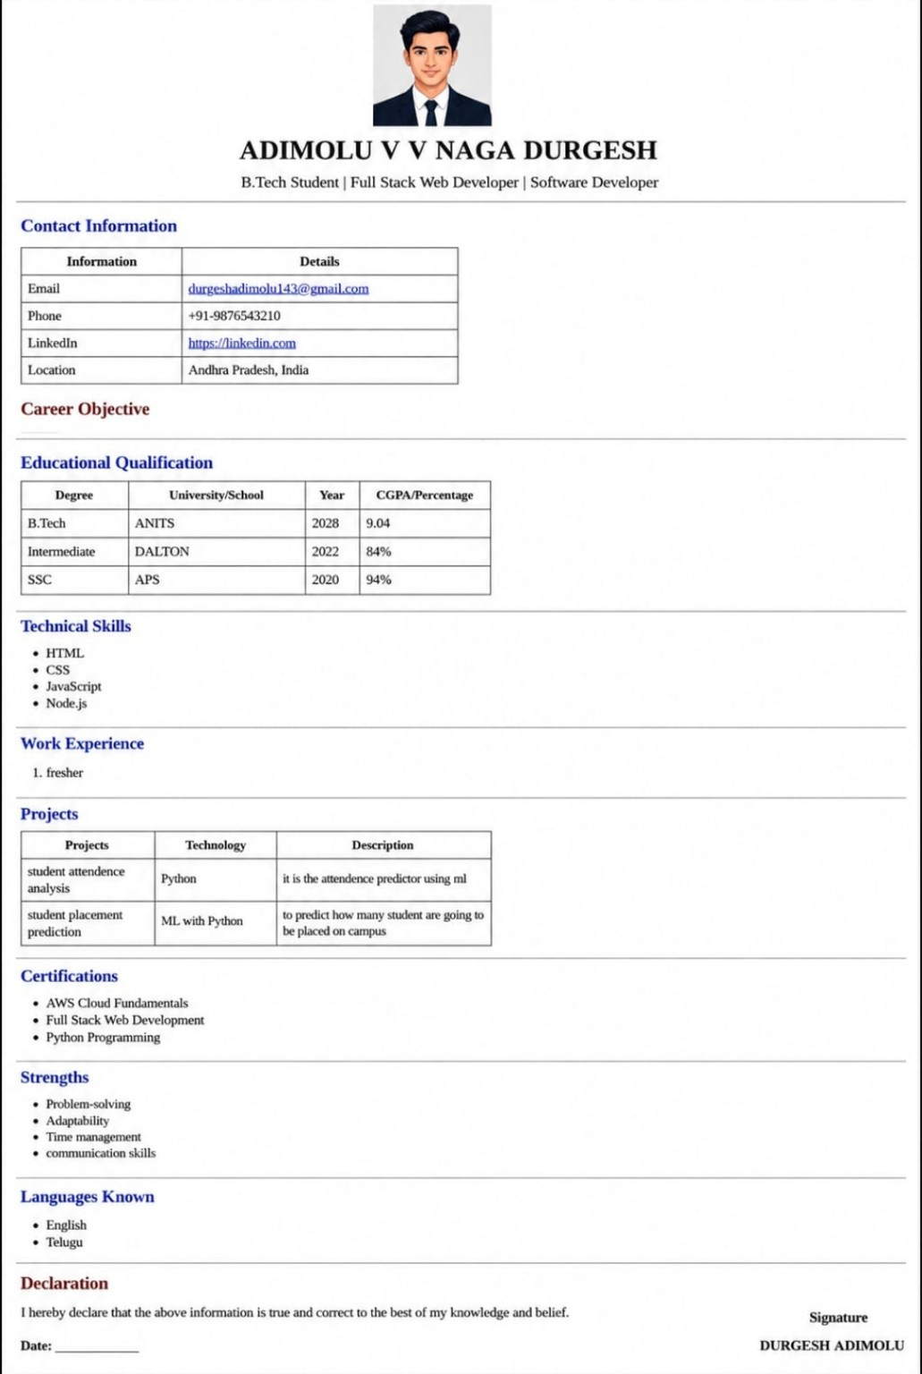
Result:
The ATS-friendly resume webpage was successfully created using basic HTML elements and displayed in a web browser.

