PROJECT REPORT
ON
ONLINE EXAMINATION

SUBMITTED IN PARTIAL FULFILLMENT FOR AWORD OF THE DIPLOMA OF 'O' LEVEL IN INFORMATION TECHNOLOGY

SUBMITTED BY :-

Durgesh Giri
‘B-tech’-CSE
Roll no-1836110019

ACKNOWLEDGMENT

Now, when my project "DISTRICT CRIME MONITORING" has been Successfully completed I would like to thank all those people who made all this possible.

First I would like to thanks my guide. Shivam for his commissar guidance. Limitless. Support endlees optimism and motivation while carrying out this project work.

I express my harmful thanks to my dear my friends for study by mein all times and all stops numbers of Lucknow for providing the necessary faculty and valuable data set to accomplish the project work.

I am deeply in depended in gratitude to my parents for their faith in me throughout, for their inspiration and for being with me through all trouble and tribulations. I dedicated my work to them. I also thanks my brother his support all along.

Last but not least I thanks all the those who have helped me directly or indirectly at various stages of this project work.

Durgesh giri
B-tech
Roll no-1836110019

CERTIFICATE

This is to certify that the Project/Dissertation entitled, "Online Examination" is a bonafide work done by Durgesh Giri (Roll. No. 1836110019) in fulfillment of examination and similar report on the topic has not been submitted for any other examination and does not form part of any other course undergone by the candidate.

Signature of Guide/Supervisor : Signature
Name Shivam sir
Place :
Date :

DECLARATION

I hereby declared that this submission is my won work and that, to the best of my knowledge and belief, it contains no material previously published or written by an other person nor material which has been accepted for the award of the Lucknow, except where due acknowledgement has been made in the text.

Durgesh Giri
B-tech
Roll. No. 1836110019

HOME PAGE

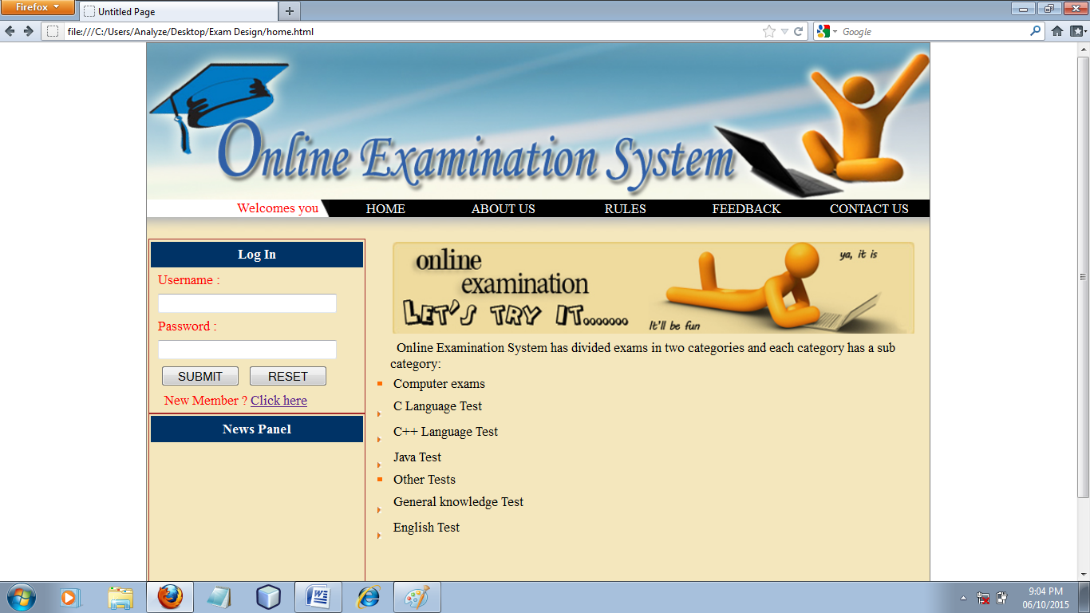

<!DOCTYPE html PUBLIC "-//W3C//DTD XHTML 1.0 Transitional//EN" "http://www.w3.org/TR/xhtml1/DTD/xhtml1-transitional.dtd">

<html xmlns="http://www.w3.org/1999/xhtml">
<head runat="server">
<title>Untitled Page</title>
<link rel="stylesheet" href="style.css">
<style type="text/css">
.link{display:block;color:White;background-color:Black;text-decoration:none;text-align: center;}
.link:hover{color:black;background-color:white;}
.style1{color:red;}

</style>
</head>
<body>

<center>

<div style="width:900px;border:1px solid gray;">

<div style="width:900px;height:180px;">

<img src="images/adminBanner.jpg">

</div>
<div style="width:900px">
<table style="width:900px;" border="0" cellpadding="0" cellspacing="0";>
<tr style="width:900px">
<td style="height:20px;width:200px;"><marquee scrollamount="3" class="style1">Welcomes you all in Online Examination ........</marquee></td>
<td style="height:20px;width:10px">
<img src="images/nav1.png">
</td>
<td style="height:20px;width:130px;background-color:Black;"><a class="link" href="home.html"> HOME </a></td>
<td style="height:20px;width:140px;background-color:Black;"><a class="link" href="about.html"> ABOUT US </a></td>
<td style="height:20px;width:140px;background-color:Black;"><a class="link" href="rules.html"> RULES </a></td>
<td style="height:20px;width:140px;background-color:Black;"><a class="link" href="feedback.html"> FEEDBACK </a></td>
<td style="height:20px;width:140px;background-color:Black;"><a class="link" href="contact.html"> CONTACT US </a></td>
</tr>
</table>
</div>

<div style="width:900px;height:25px;">

<img src="Images/home_bor_top.jpg" style="border-width:0px;" />

</div>

<div style="width:900px;height:400px;background-color: #F4E7BD;">

<div style="width:250px;margin-left:2px;height:400px;float:left;background-color: #F4E7BD;">
<form action="" method="post">
<table style="width:250px;height:200px;border:1px solid brown;">

<tr>
<td style="background-color: #003366;text-align:center;height:30px;">
<span style="color:white;font-weight:bold;">Log In</span>
</td>
</tr>
<tr>
<td style="text-align:left;color:red;"> &nbsp;&nbsp;Username :</td>
</tr>
<tr>
<td style="text-align:left;"> &nbsp;&nbsp;<input type="text" name="t1" style="width:200px;"> </td>
</tr>
<tr>
<td style="text-align:left;color:red;"> &nbsp;&nbsp;Password :</td>
</tr>
<tr>
<td style="text-align:left;"> &nbsp;&nbsp;<input type="password" name="t2" style="width:200px;"> </td>
</tr>
<tr>
<td style="text-align:left;">
&nbsp;&nbsp;&nbsp;<input type="submit" name="s" value="SUBMIT" style="width:90px;">
&nbsp;&nbsp;<input type="reset" name="r" value="RESET" style="width:90px;">
</td>
</tr>
<tr>
<td style="text-align:left;color:red;"> &nbsp;&nbsp;&nbsp;&nbsp;New Member ? <a href="reg.html"> Click here </a> </td>
</tr>
</table>
</form>

<table style="width:250px;height:200px;border:1px solid brown;">

<tr>
<td style="background-color: #003366;text-align:center;height:30px;">
<span style="color:white;font-weight:bold;">News Panel</span>
</td>
</tr>
<tr>
<td style="text-align:left;color:red;">

<marquee scrollamount="4" direction="up" style="color:black;height:120px;" onmouseover="this.stop();" onmouseout="this.start();">

* You can freely register here <br> <hr> <br>
* You can freely register here <br> <hr> <br>
* You can freely register here <br> <hr> <br>

</marquee>

</td>
</tr>

</table>

</div>

<div style="width:648px;height:400px;float:left;background-color: #F4E7BD;">

<table style="width: 648px;">
<tr>
<td style="width: 4px">
&nbsp;</td>
<td style="width: 640px; text-align: center;">
<img id="ctl00_ContentPlaceHolder1_Image3" src="Images/funPicture1.jpg" style="border-width:0px;" />
</td>
<td style="width: 4px">
&nbsp;</td>
</tr>
<tr>
<td style="width: 4px">
&nbsp;</td>
<td style="width: 640px">
<table style="width: 640px; text-align: left;">
<tr>
<td style="width: 10px">
&nbsp;</td>
<td style="width: 630px">
&nbsp; Online Examination System has divided exams in two categories and each category has a sub category:
</td>
</tr>
<tr>
<td style="width: 10px">
<img id="ctl00_ContentPlaceHolder1_Image6" src="Images/bulet.jpg" style="border-width:0px;" />
</td>
<td style="width: 630px">
&nbsp;Computer exams&nbsp;</td>
</tr>
<tr>
<td style="width: 10px">
&nbsp;
<img id="ctl00_ContentPlaceHolder1_Image7" src="Images/bullet.jpg" style="border-width:0px;" />
</td>
<td style="width: 630px">
&nbsp;C Language Test&nbsp;</td>
</tr>
<tr>
<td style="width: 10px">
&nbsp;
<img id="ctl00_ContentPlaceHolder1_Image8" src="Images/bullet.jpg" style="border-width:0px;" />
</td>
<td style="width: 630px">
&nbsp;C++ Language Test&nbsp;</td>
</tr>
<tr>
<td style="width: 10px">
&nbsp;
<img id="ctl00_ContentPlaceHolder1_Image9" src="Images/bullet.jpg" style="border-width:0px;" />
</td>
<td style="width: 630px">
&nbsp;Java Test&nbsp;</td>
</tr>
<tr>
<td style="width: 10px">
<img id="ctl00_ContentPlaceHolder1_Image10" src="Images/bulet.jpg" style="border-width:0px;" />
</td>
<td style="width: 630px">
&nbsp;Other Tests&nbsp;</td>
</tr>
<tr>
<td style="width: 10px">
&nbsp;
<img id="ctl00_ContentPlaceHolder1_Image11" src="Images/bullet.jpg" style="border-width:0px;" />
</td>
<td style="width: 630px">
&nbsp;General knowledge Test&nbsp;</td>
</tr>
<tr>
<td style="width: 10px">
&nbsp;
<img id="ctl00_ContentPlaceHolder1_Image12" src="Images/bullet.jpg" style="border-width:0px;" />
</td>
<td style="width: 630px">
&nbsp;English Test&nbsp;</td>
</tr>
</table>
</td>
<td style="width: 4px">
&nbsp;</td>
</tr>
<tr>
<td style="width: 4px">
&nbsp;</td>
<td style="width: 640px">
&nbsp;</td>
<td style="width: 4px">
&nbsp;</td>
</tr>
<tr>
<td style="width: 4px">
&nbsp;</td>
<td style="width: 640px">
&nbsp;</td>
<td style="width: 4px">
&nbsp;</td>
</tr>
<tr>
<td style="width: 4px">
&nbsp;</td>
<td style="width: 640px">
&nbsp;</td>
<td style="width: 4px">
&nbsp;</td>
</tr>

</table>

</div>

</div>

<div style="width:900px;height:25px;">

<img src="images/home_bor_bottom.jpg" style="border-width:0px;" />

</div>

<div style="width: 900px;">

<table style="width: 900px; background-color: #808080" cellpadding="0" cellspacing="0" border="0">
<tr>
<td style="width: 250px">
</td>
<td style="width: 340px">
</td>
<td style="width: 60px">

&nbsp;</td>
<td style="width: 65px">

&nbsp;</td>
<td style="width: 95px">
<label style="color:red;">New member?</label>
</td>
<td style="width: 90px">
<a href="reg.html">Register here</a>
</td>
</tr>
<tr>
<td style="width: 250px">
&nbsp;</td>
<td style="width: 340px">
<center>
<label style="color:white;">
Copyright reserved to Online Examination System
</label>
</center>
</td>
<td style="width: 60px">
&nbsp;</td>
<td style="width: 65px">
&nbsp;</td>
<td style="width: 95px">
&nbsp;</td>
<td style="width: 90px">
&nbsp;</td>
</tr>
<tr>
<td style="width: 250px">
&nbsp;</td>
<td style="width: 340px">
<center> Powered By: Online Exam Team </center>
</td>
<td style="width: 60px">
&nbsp;</td>
<td style="width: 65px">
&nbsp;</td>
<td style="width: 95px">
&nbsp;</td>
<td style="width: 90px">
&nbsp;</td>
</tr>
</table>

</div>

</div>

</center>

</body>
</html>

ABOUT US PAGE

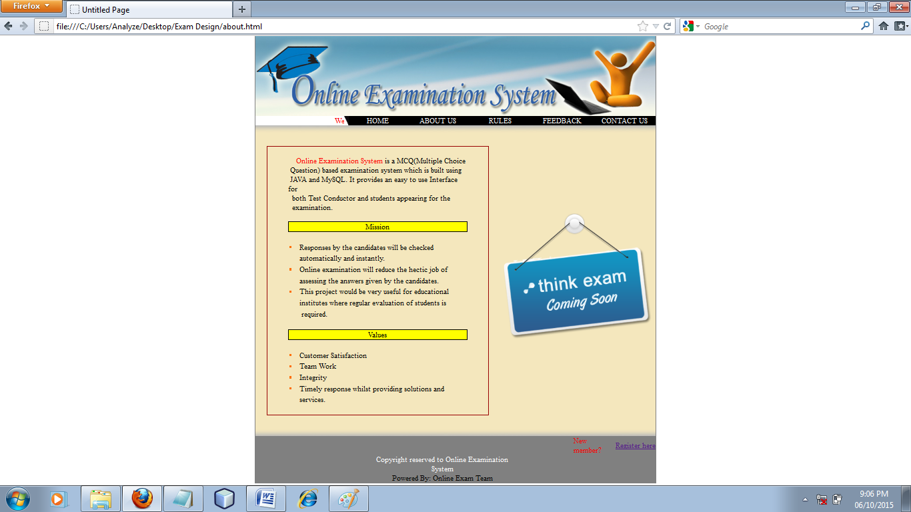

<!DOCTYPE html PUBLIC "-//W3C//DTD XHTML 1.0 Transitional//EN" "http://www.w3.org/TR/xhtml1/DTD/xhtml1-transitional.dtd">

<html xmlns="http://www.w3.org/1999/xhtml">
<head runat="server">
<title>Untitled Page</title>
<link rel="stylesheet" href="style.css">
<style type="text/css">
.link{display:block;color:White;background-color:Black;text-decoration:none;text-align: center;}
.link:hover{color:black;background-color:white;}
.style1{color:red;}

</style>
</head>
<body>

<center>

<div style="width:900px;border:1px solid gray;">

<div style="width:900px;height:180px;">

<img src="images/adminBanner.jpg">

</div>
<div style="width:900px">
<table style="width:900px;" border="0" cellpadding="0" cellspacing="0";>
<tr style="width:900px">
<td style="height:20px;width:200px;"><marquee scrollamount="3" class="style1">Welcomes you all in Online Examination ........</marquee></td>
<td style="height:20px;width:10px">
<img src="images/nav1.png">
</td>
<td style="height:20px;width:130px;background-color:Black;"><a class="link" href="home.html"> HOME </a></td>
<td style="height:20px;width:140px;background-color:Black;"><a class="link" href="about.html"> ABOUT US </a></td>
<td style="height:20px;width:140px;background-color:Black;"><a class="link" href="rules.html"> RULES </a></td>
<td style="height:20px;width:140px;background-color:Black;"><a class="link" href="feedback.html"> FEEDBACK </a></td>
<td style="height:20px;width:140px;background-color:Black;"><a class="link" href="contact.html"> CONTACT US </a></td>
</tr>
</table>
</div>

<div style="width:900px;height:25px;">

<img id="ctl00_Image3" src="Images/home_bor_top.jpg" style="border-width:0px;" />

</div>

<div style="width:900px">

<table style="width:900px" border="0" cellpadding="0" cellspacing="0">
<tr style="width:900px">
<td style="width:900px">

<div style="width: 900px; background-color: #F4E7BD;">
<table style="width: 900px;" border="0" cellpadding="0" cellspacing="0">
<tr>
<td style="width: 550px">
<div>
<table style="width: 550px;" border="0" cellpadding="0" cellspacing="0">
<tr>
<td style="width: 25px">
&nbsp;</td>
<td style="width: 500px">
&nbsp;</td>
<td style="width: 25px">
&nbsp;</td>
</tr>
<tr>
<td style="width: 25px">
&nbsp;</td>
<td style="width: 500px">
<table style="border: 2px solid #990000; width: 500px; text-align: left; font-size: 17px;"
border="0" cellpadding="0" cellspacing="0">
<tr>
<td style="width: 50px">
&nbsp;</td>
<td style="width: 400px">
&nbsp;</td>
<td style="width: 50px">
&nbsp;</td>
</tr>
<tr>
<td style="width: 50px">
&nbsp;</td>
<td style="width: 400px">
&nbsp;&nbsp;&nbsp;&nbsp;<font color=red>Online Examination System</font> is a
MCQ(Multiple Choice </td>
<td style="width: 50px">
&nbsp;</td>
</tr>
<tr>
<td style="width: 50px">
&nbsp;</td>
<td style="width: 400px">
&nbsp;Question) based examination system which is built using &nbsp;</td>
<td style="width: 50px">
&nbsp;</td>
</tr>
<tr>
<td style="width: 50px">
&nbsp;</td>
<td style="width: 400px">
&nbsp;JAVA and MySQL.&nbsp;It provides an easy to use Interface for</td>
<td style="width: 50px">
&nbsp;</td>
</tr>
<tr>
<td style="width: 50px">
&nbsp;</td>
<td style="width: 400px">
&nbsp; both Test Conductor and students appearing for the</td>
<td style="width: 50px">
&nbsp;</td>
</tr>
<tr>
<td style="width: 50px">
&nbsp;</td>
<td style="width: 400px">
&nbsp; examination.&nbsp;</td>
<td style="width: 50px">
&nbsp;</td>
</tr>
<tr>
<td style="width: 50px">
&nbsp;</td>
<td style="width: 400px">
&nbsp;</td>
<td style="width: 50px">
&nbsp;</td>
</tr>
<tr>
<td style="width: 50px">
&nbsp;</td>
<td style="border: 2px solid #000000; width: 400px; background-color: #FFFF00;">
<center>Mission</center>
</td>
<td style="width: 50px">
&nbsp;</td>
</tr>
<tr>
<td style="width: 50px">
&nbsp;</td>
<td style="width: 400px">
&nbsp;</td>
<td style="width: 50px">
&nbsp;</td>
</tr>
<tr>
<td style="width: 50px">
&nbsp;</td>
<td style="width: 400px">
<table style="width: 400px;">
<tr>
<td style="width: 5px">
<img id="ctl00_ContentPlaceHolder1_Image5" src="Images/bulet.jpg" style="border-width:0px;" />
</td>
<td style="width: 5px">
&nbsp;</td>
<td style="width: 390px">
&nbsp;Responses by the candidates will be checked &nbsp;</td>
</tr>
<tr>
<td style="width: 5px">
&nbsp;</td>
<td style="width: 5px">
&nbsp;</td>
<td style="width: 390px">
&nbsp;automatically and instantly.&nbsp;</td>
</tr>
<tr>
<td style="width: 5px">
<img id="ctl00_ContentPlaceHolder1_Image6" src="Images/bulet.jpg" style="border-width:0px;" />
</td>
<td style="width: 5px">
&nbsp;</td>
<td style="width: 390px">
&nbsp;Online examination will reduce the hectic job of &nbsp;</td>
</tr>
<tr>
<td style="width: 5px">
&nbsp;</td>
<td style="width: 5px">
&nbsp;</td>
<td style="width: 390px">
&nbsp;assessing the answers given by the candidates.&nbsp;</td>
</tr>
<tr>
<td style="width: 5px">
<img id="ctl00_ContentPlaceHolder1_Image7" src="Images/bulet.jpg" style="border-width:0px;" />
</td>
<td style="width: 5px">
&nbsp;</td>
<td style="width: 390px">
&nbsp;This project would be very useful for educational&nbsp;</td>
</tr>
<tr>
<td style="width: 5px">
&nbsp;</td>
<td style="width: 5px">
&nbsp;</td>
<td style="width: 390px">
&nbsp;institutes where regular evaluation of students is &nbsp;</td>
</tr>
<tr>
<td style="width: 5px">
&nbsp;</td>
<td style="width: 5px">
&nbsp;</td>
<td style="width: 390px">
&nbsp; required.</td>
</tr>
</table>
</td>
<td style="width: 50px">
&nbsp;</td>
</tr>
<tr>
<td style="width: 50px">
&nbsp;</td>
<td style="width: 400px">
&nbsp;</td>
<td style="width: 50px">
&nbsp;</td>
</tr>
<tr>
<td style="width: 50px">
&nbsp;</td>
<td style="border: 2px solid #000000; width: 400px; background-color: #FFFF00;">
<center>Values</center>
</td>
<td style="width: 50px">
&nbsp;</td>
</tr>
<tr>
<td style="width: 50px">
&nbsp;</td>
<td style="width: 400px">
&nbsp;</td>
<td style="width: 50px">
&nbsp;</td>
</tr>
<tr>
<td style="width: 50px">
&nbsp;</td>
<td style="width: 400px">
<table style="width: 400px;">
<tr>
<td style="width: 5px">
<img id="ctl00_ContentPlaceHolder1_Image8" src="Images/bulet.jpg" style="border-width:0px;" />
</td>
<td style="width: 5px">
&nbsp;</td>
<td style="width: 390px">
&nbsp;Customer Satisfaction</td>
</tr>
<tr>
<td style="width: 5px">
<img id="ctl00_ContentPlaceHolder1_Image9" src="Images/bulet.jpg" style="border-width:0px;" />
</td>
<td style="width: 5px">
&nbsp;</td>
<td style="width: 390px">
&nbsp;Team Work&nbsp;</td>
</tr>
<tr>
<td style="width: 5px">
<img src="Images/bulet.jpg" style="border-width:0px;" />
</td>
<td style="width: 5px">
&nbsp;</td>
<td style="width: 390px">
&nbsp;Integrity&nbsp;</td>
</tr>
<tr>
<td style="width: 5px">
<img id="ctl00_ContentPlaceHolder1_Image11" src="Images/bulet.jpg" style="border-width:0px;" />
</td>
<td style="width: 5px">
&nbsp;</td>
<td style="width: 390px">
&nbsp;Timely response whilst providing solutions and &nbsp;</td>
</tr>
<tr>
<td style="width: 5px">
&nbsp;</td>
<td style="width: 5px">
&nbsp;</td>
<td style="width: 390px">
&nbsp;services.&nbsp;</td>
</tr>
</table>
</td>
<td style="width: 50px">
&nbsp;</td>
</tr>
<tr>
<td style="width: 50px">
&nbsp;</td>
<td style="width: 400px">
&nbsp;</td>
<td style="width: 50px">
&nbsp;</td>
</tr>
</table>
</td>
<td style="width: 25px">
&nbsp;</td>
</tr>
<tr>
<td style="width: 25px">
&nbsp;</td>
<td style="width: 500px">
&nbsp;</td>
<td style="width: 25px">
&nbsp;</td>
</tr>
</table>
</div>
</td>
<td style="width: 350px">
<div>
<table style="width: 350px;" border="0" cellpadding="0" cellspacing="0">
<tr>
<td style="width: 25px">
&nbsp;</td>
<td style="width: 300px">
<img id="ctl00_ContentPlaceHolder1_Image12" src="Images/think_exam_banner.png" style="border-width:0px;" />
</td>
<td style="width: 25px">
&nbsp;</td>
</tr>
<tr>
<td style="width: 25px">
&nbsp;</td>
<td style="width: 300px">
&nbsp;</td>
<td style="width: 25px">
&nbsp;</td>
</tr>
</table>
</div>
</td>
</tr>
</table>
</div>

</td>
</tr>
</table>

</div>

<div style="width:900px;height:25px;">

<img src="Images/home_bor_bottom.jpg" style="border-width:0px;" />

</div>

<div style="width: 900px;">

<table style="width: 900px; background-color: #808080" cellpadding="0" cellspacing="0" border="0">
<tr>
<td style="width: 250px">
</td>
<td style="width: 340px">
</td>
<td style="width: 60px">

&nbsp;</td>
<td style="width: 65px">

&nbsp;</td>
<td style="width: 95px">
<label style="color:red;">New member?</label>
</td>
<td style="width: 90px">
<a href="reg.html">Register here</a>
</td>
</tr>
<tr>
<td style="width: 250px">
&nbsp;</td>
<td style="width: 340px">
<center>
<label style="color:white;">
Copyright reserved to Online Examination System
</label>
</center>
</td>
<td style="width: 60px">
&nbsp;</td>
<td style="width: 65px">
&nbsp;</td>
<td style="width: 95px">
&nbsp;</td>
<td style="width: 90px">
&nbsp;</td>
</tr>
<tr>
<td style="width: 250px">
&nbsp;</td>
<td style="width: 340px">
<center> Powered By: Online Exam Team </center>
</td>
<td style="width: 60px">
&nbsp;</td>
<td style="width: 65px">
&nbsp;</td>
<td style="width: 95px">
&nbsp;</td>
<td style="width: 90px">
&nbsp;</td>
</tr>
</table>

</div>

</div>

</center>

</body>
</html>

RULES PAGE

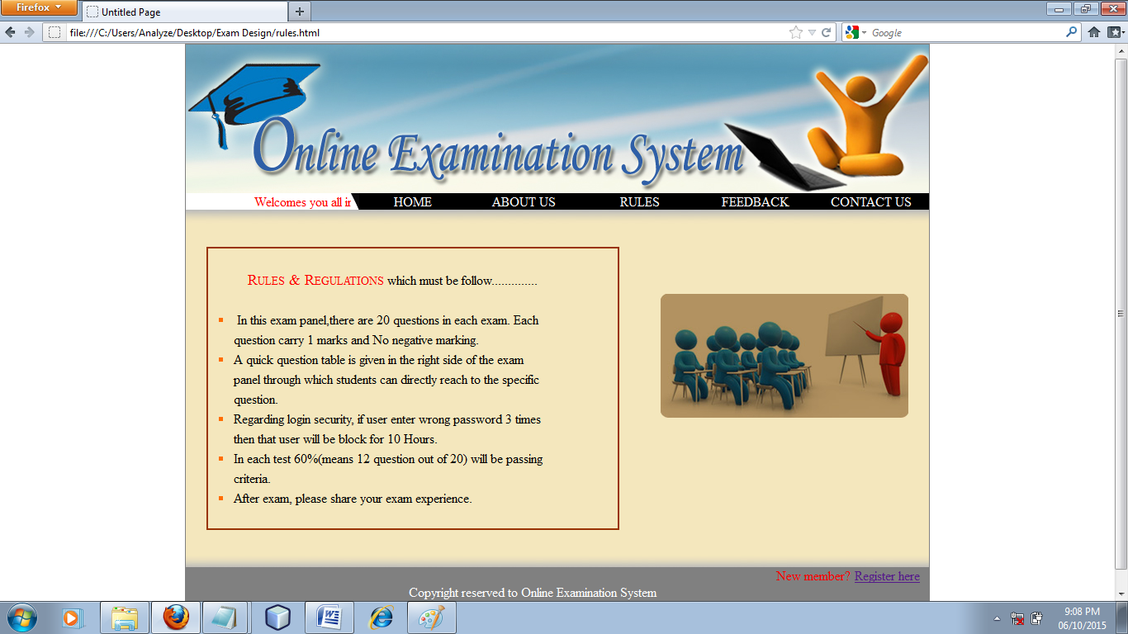

<!DOCTYPE html PUBLIC "-//W3C//DTD XHTML 1.0 Transitional//EN" "http://www.w3.org/TR/xhtml1/DTD/xhtml1-transitional.dtd">

<html xmlns="http://www.w3.org/1999/xhtml">
<head runat="server">
<title>Untitled Page</title>
<link rel="stylesheet" href="style.css">
<style type="text/css">
.link{display:block;color:White;background-color:Black;text-decoration:none;text-align: center;}
.link:hover{color:black;background-color:white;}
.style1{color:red;}

</style>
</head>
<body>

<center>

<div style="width:900px;border:1px solid gray;">

<div style="width:900px;height:180px;">

<img src="images/adminBanner.jpg">

</div>
<div style="width:900px">
<table style="width:900px;" border="0" cellpadding="0" cellspacing="0";>
<tr style="width:900px">
<td style="height:20px;width:200px;"><marquee scrollamount="3" class="style1">Welcomes you all in Online Examination ........</marquee></td>
<td style="height:20px;width:10px">
<img src="images/nav1.png">
</td>
<td style="height:20px;width:130px;background-color:Black;"><a class="link" href="home.html"> HOME </a></td>
<td style="height:20px;width:140px;background-color:Black;"><a class="link" href="about.html"> ABOUT US </a></td>
<td style="height:20px;width:140px;background-color:Black;"><a class="link" href="rules.html"> RULES </a></td>
<td style="height:20px;width:140px;background-color:Black;"><a class="link" href="feedback.html"> FEEDBACK </a></td>
<td style="height:20px;width:140px;background-color:Black;"><a class="link" href="contact.html"> CONTACT US </a></td>
</tr>
</table>
</div>

<div style="width:900px;height:25px;">

<img id="ctl00_Image3" src="Images/home_bor_top.jpg" style="border-width:0px;" />

</div>

<div style="width:900px">

<table style="width:900px" border="0" cellpadding="0" cellspacing="0">
<tr style="width:900px">
<td style="width:900px">

<div style="width: 900px; background-color: #F4E7BD;">
<table style="width: 900px;" border="0" cellpadding="0" cellspacing="0">
<tr>
<td style="width: 550px">
<div>
<table style="width: 550px;" border="0" cellpadding="0" cellspacing="0">
<tr>
<td style="width: 25px">
&nbsp;</td>
<td style="width: 500px">
&nbsp;</td>
<td style="width: 25px">
&nbsp;</td>
</tr>
<tr>
<td style="width: 25px">
&nbsp;</td>
<td style="width: 500px">
<table style="border: 2px solid #993300; width: 500px; font-size: 16px; text-align: left;">
<tr>
<td style="width: 5px">
&nbsp;</td>
<td style="width: 5px">
&nbsp;</td>
<td style="width: 390px">
&nbsp;</td>
</tr>
<tr>
<td style="width: 5px">
&nbsp;</td>
<td style="width: 5px">
&nbsp;</td>
<td style="width: 390px">
<font color=red style="font-variant: small-caps; font-size: large;"> &nbsp;&nbsp;&nbsp;&nbsp; Rules &amp; Regulations</font> which must be
follow..............</td>
</tr>
<tr>
<td style="width: 5px">
&nbsp;</td>
<td style="width: 5px">
&nbsp;</td>
<td style="width: 390px">
&nbsp;</td>
</tr>
<tr>
<td style="width: 5px">
&nbsp;</td>
<td style="width: 5px">
<img id="ctl00_ContentPlaceHolder1_Image5" src="Images/bulet.jpg" style="border-width:0px;" />
</td>
<td style="width: 390px">
&nbsp; &nbsp;In this exam panel,there are 20 questions in each exam. Each
&nbsp;</td>
</tr>
<tr>
<td style="width: 5px">
&nbsp;</td>
<td style="width: 5px">
&nbsp;</td>
<td style="width: 390px">
&nbsp; question carry 1 marks and No negative marking.&nbsp;</td>
</tr>
<tr>
<td style="width: 5px">
&nbsp;</td>
<td style="width: 5px">
<img id="ctl00_ContentPlaceHolder1_Image6" src="Images/bulet.jpg" style="border-width:0px;" />
</td>
<td style="width: 390px">
&nbsp; A quick question table is given in the right side of the exam&nbsp;</td>
</tr>
<tr>
<td style="width: 5px">
&nbsp;</td>
<td style="width: 5px">
&nbsp;</td>
<td style="width: 390px">
&nbsp; panel through which students can directly reach to the specific&nbsp;</td>
</tr>
<tr>
<td style="width: 5px">
&nbsp;</td>
<td style="width: 5px">
&nbsp;</td>
<td style="width: 390px">
&nbsp; question.&nbsp;</td>
</tr>
<tr>
<td style="width: 5px">
&nbsp;</td>
<td style="width: 5px">
<img id="ctl00_ContentPlaceHolder1_Image7" src="Images/bulet.jpg" style="border-width:0px;" />
</td>
<td style="width: 390px">
&nbsp; Regarding login security, if user enter wrong password 3 times&nbsp;</td>
</tr>
<tr>
<td style="width: 5px">
&nbsp;</td>
<td style="width: 5px">
&nbsp;</td>
<td style="width: 390px">
&nbsp; then that user will be block for 10 Hours.&nbsp;</td>
</tr>
<tr>
<td style="width: 5px">
&nbsp;</td>
<td style="width: 5px">
<img id="ctl00_ContentPlaceHolder1_Image8" src="Images/bulet.jpg" style="border-width:0px;" />
</td>
<td style="width: 390px">
&nbsp; In each test 60%(means 12 question out of 20) will be passing &nbsp;</td>
</tr>
<tr>
<td style="width: 5px">
&nbsp;</td>
<td style="width: 5px">
&nbsp;</td>
<td style="width: 390px">
&nbsp; criteria.&nbsp;</td>
</tr>
<tr>
<td style="width: 5px">
&nbsp;</td>
<td style="width: 5px">
<img id="ctl00_ContentPlaceHolder1_Image9" src="Images/bulet.jpg" style="border-width:0px;" />
</td>
<td style="width: 390px">
&nbsp; After exam, please share your exam experience.&nbsp;</td>
</tr>
<tr>
<td style="width: 5px">
&nbsp;</td>
<td style="width: 5px">
&nbsp;</td>
<td style="width: 390px">
&nbsp;</td>
</tr>
</table>
</td>
<td style="width: 25px">
&nbsp;</td>
</tr>
<tr>
<td style="width: 25px">
&nbsp;</td>
<td style="width: 500px">
&nbsp;</td>
<td style="width: 25px">
&nbsp;</td>
</tr>
</table>
</div>
</td>
<td style="width: 350px">
<div>
<table style="width: 350px;" border="0" cellpadding="0" cellspacing="0">
<tr>
<td style="width: 25px">
&nbsp;</td>
<td style="width: 300px">
&nbsp;</td>
<td style="width: 25px">
&nbsp;</td>
</tr>
<tr>
<td style="width: 25px">
&nbsp;</td>
<td style="width: 300px">
<img id="ctl00_ContentPlaceHolder1_Image10" src="Images/rules_banner.jpg" style="border-width:0px;" />
</td>
<td style="width: 25px">
&nbsp;</td>
</tr>
<tr>
<td style="width: 25px">
&nbsp;</td>
<td style="width: 300px">
&nbsp;</td>
<td style="width: 25px">
&nbsp;</td>
</tr>
<tr>
<td style="width: 25px">
&nbsp;</td>
<td style="width: 300px">
&nbsp;</td>
<td style="width: 25px">
&nbsp;</td>
</tr>
<tr>
<td style="width: 25px">
&nbsp;</td>
<td style="width: 300px">
&nbsp;</td>
<td style="width: 25px">
&nbsp;</td>
</tr>
<tr>
<td style="width: 25px">
&nbsp;</td>
<td style="width: 300px">
&nbsp;</td>
<td style="width: 25px">
&nbsp;</td>
</tr>
<tr>
<td style="width: 25px">
&nbsp;</td>
<td style="width: 300px">
&nbsp;</td>
<td style="width: 25px">
&nbsp;</td>
</tr>
</table>
</div>
</td>
</tr>
</table>
</div>

</td>
</tr>
</table>

</div>

<div style="width:900px;height:25px;">

<img src="Images/home_bor_bottom.jpg" style="border-width:0px;" />

</div>

<div style="width: 900px;">

<table style="width: 900px; background-color: #808080" cellpadding="0" cellspacing="0" border="0">
<tr>
<td style="width: 250px">
</td>
<td style="width: 340px">
</td>
<td style="width: 60px">

&nbsp;</td>
<td style="width: 65px">

&nbsp;</td>
<td style="width: 95px">
<label style="color:red;">New member?</label>
</td>
<td style="width: 90px">
<a href="reg.html">Register here</a>
</td>
</tr>
<tr>
<td style="width: 250px">
&nbsp;</td>
<td style="width: 340px">
<center>
<label style="color:white;">
Copyright reserved to Online Examination System
</label>
</center>
</td>
<td style="width: 60px">
&nbsp;</td>
<td style="width: 65px">
&nbsp;</td>
<td style="width: 95px">
&nbsp;</td>
<td style="width: 90px">
&nbsp;</td>
</tr>
<tr>
<td style="width: 250px">
&nbsp;</td>
<td style="width: 340px">
<center> Powered By: Online Exam Team </center>
</td>
<td style="width: 60px">
&nbsp;</td>
<td style="width: 65px">
&nbsp;</td>
<td style="width: 95px">
&nbsp;</td>
<td style="width: 90px">
&nbsp;</td>
</tr>
</table>

</div>

</div> </center></body></html>
FEEDBACK PAGE

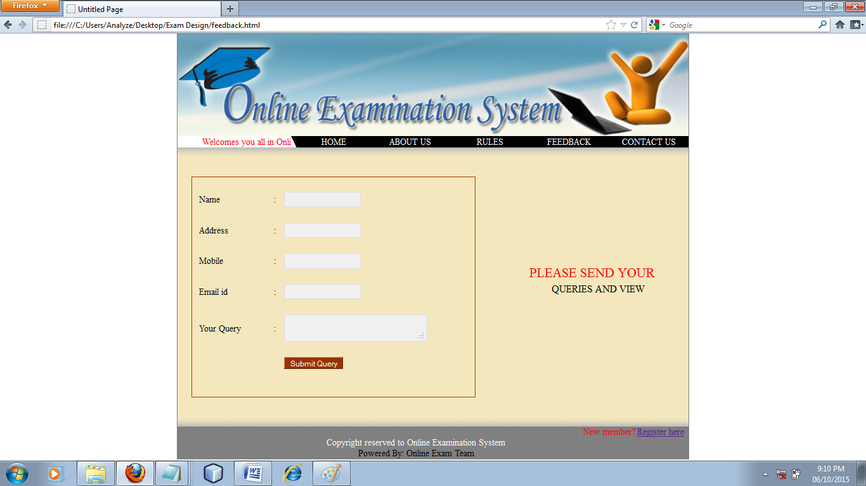

CONTACT US PAGE

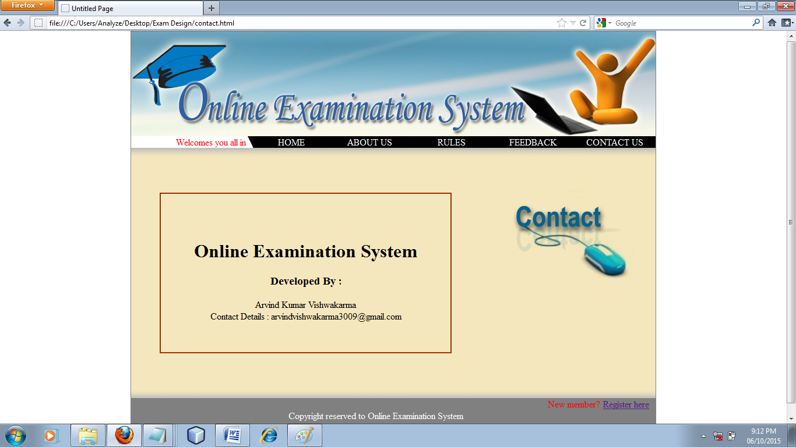

<!DOCTYPE html PUBLIC "-//W3C//DTD XHTML 1.0 Transitional//EN" "http://www.w3.org/TR/xhtml1/DTD/xhtml1-transitional.dtd">

<html xmlns="http://www.w3.org/1999/xhtml">
<head runat="server">
<title>Untitled Page</title>
<link rel="stylesheet" href="style.css">
<style type="text/css">
.link{display:block;color:White;background-color:Black;text-decoration:none;text-align: center;}
.link:hover{color:black;background-color:white;}
.style1{color:red;}

</style>
</head>
<body>

<center>

<div style="width:900px;border:1px solid gray;">

<div style="width:900px;height:180px;">

<img src="images/adminBanner.jpg">

</div>
<div style="width:900px">
<table style="width:900px;" border="0" cellpadding="0" cellspacing="0";>
<tr style="width:900px">
<td style="height:20px;width:200px;"><marquee scrollamount="3" class="style1">Welcomes you all in Online Examination ........</marquee></td>
<td style="height:20px;width:10px">
<img src="images/nav1.png">
</td>
<td style="height:20px;width:130px;background-color:Black;"><a class="link" href="home.html"> HOME </a></td>
<td style="height:20px;width:140px;background-color:Black;"><a class="link" href="about.html"> ABOUT US </a></td>
<td style="height:20px;width:140px;background-color:Black;"><a class="link" href="rules.html"> RULES </a></td>
<td style="height:20px;width:140px;background-color:Black;"><a class="link" href="feedback.html"> FEEDBACK </a></td>
<td style="height:20px;width:140px;background-color:Black;"><a class="link" href="contact.html"> CONTACT US </a></td>
</tr>
</table>
</div>

<div style="width:900px;height:25px;">

<img id="ctl00_Image3" src="Images/home_bor_top.jpg" style="border-width:0px;" />

</div>

<div style="width:900px">

<table style="width:900px" border="0" cellpadding="0" cellspacing="0">
<tr style="width:900px">
<td style="width:900px">

<div style="background-color: #F4E7BD; width: 900px;">
<table style="width: 900px;" border="0" cellpadding="0" cellspacing="0">
<tr>
<td style="width: 600px">
<div style="width: 600px">
<table style="width: 600px;" border="0" cellpadding="0" cellspacing="0">
<tr>
<td style="width: 50px">
&nbsp;</td>
<td style="width: 500px">
&nbsp;</td>
<td style="width: 50px">
&nbsp;</td>
</tr>
<tr>
<td style="width: 50px">
&nbsp;</td>
<td style="border-color: #993300; border-width: 2px; border-style: solid; width: 500px">
<h1>&nbsp;</h1>
<h1 style="text-align:center;">Online Examination System</h1>
<h3 style="text-align:center;">Developed By :</h3>
<p style="text-align:center;"> Arvind Kumar Vishwakarma <br />
Contact Details : arvindvishwakarma3009@gmail.com
</p>
<p> &nbsp;</p>
</td>
<td style="width: 50px">
&nbsp;</td>
</tr>
<tr>
<td style="width: 50px">
&nbsp;</td>
<td style="width: 500px">
&nbsp;</td>
<td style="width: 50px">
&nbsp;</td>
</tr>
</table>
</div>
</td>
<td style="width: 300px">
<div style="width: 300px">
<table style="width: 300px;" border="0" cellpadding="0" cellspacing="0">
<tr>
<td style="width: 25px">
&nbsp;</td>
<td style="width: 250px">
&nbsp;</td>
<td style="width: 25px">
&nbsp;</td>
</tr>
<tr>
<td style="width: 25px">
&nbsp;</td>
<td style="width: 250px">
<img src="Images/contact_us.jpg" style="border-width:0px;" />
</td>
<td style="width: 25px">
&nbsp;</td>
</tr>
<tr>
<td style="width: 25px">
&nbsp;</td>
<td style="width: 250px">
&nbsp;</td>
<td style="width: 25px">
&nbsp;</td>
</tr>
<tr>
<td style="width: 25px">
&nbsp;</td>
<td style="width: 250px">
&nbsp;</td>
<td style="width: 25px">
&nbsp;</td>
</tr>
<tr>
<td style="width: 25px">
&nbsp;</td>
<td style="width: 250px">
&nbsp;</td>
<td style="width: 25px">
&nbsp;</td>
</tr>
<tr>
<td style="width: 25px">
&nbsp;</td>
<td style="width: 250px">
&nbsp;</td>
<td style="width: 25px">
&nbsp;</td>
</tr>
<tr>
<td style="width: 25px">
&nbsp;</td>
<td style="width: 250px">
&nbsp;</td>
<td style="width: 25px">
&nbsp;</td>
</tr>
<tr>
<td style="width: 25px">
&nbsp;</td>
<td style="width: 250px">
&nbsp;</td>
<td style="width: 25px">
&nbsp;</td>
</tr>
<tr>
<td style="width: 25px">
&nbsp;</td>
<td style="width: 250px">
&nbsp;</td>
<td style="width: 25px">
&nbsp;</td>
</tr>
<tr>
<td style="width: 25px">
&nbsp;</td>
<td style="width: 250px">
&nbsp;</td>
<td style="width: 25px">
&nbsp;</td>
</tr>
</table>
</div>
</td>
</tr>
</table>
</div>

</td>
</tr>
</table>

</div>

<div style="width:900px;height:25px;">

<img src="Images/home_bor_bottom.jpg" style="border-width:0px;" />

</div>

<div style="width: 900px;">

<table style="width: 900px; background-color: #808080" cellpadding="0" cellspacing="0" border="0">
<tr>
<td style="width: 250px">
</td>
<td style="width: 340px">
</td>
<td style="width: 60px">

&nbsp;</td>
<td style="width: 65px">

&nbsp;</td>
<td style="width: 95px">
<label style="color:red;">New member?</label>
</td>
<td style="width: 90px">
<a href="reg.html">Register here</a>
</td>
</tr>
<tr>
<td style="width: 250px">
&nbsp;</td>
<td style="width: 340px">
<center>
<label style="color:white;">
Copyright reserved to Online Examination System
</label>
</center>
</td>
<td style="width: 60px">
&nbsp;</td>
<td style="width: 65px">
&nbsp;</td>
<td style="width: 95px">
&nbsp;</td>
<td style="width: 90px">
&nbsp;</td>
</tr>
<tr>
<td style="width: 250px">
&nbsp;</td>
<td style="width: 340px">
<center> Powered By: Online Exam Team </center>
</td>
<td style="width: 60px">
&nbsp;</td>
<td style="width: 65px">
&nbsp;</td>
<td style="width: 95px">
&nbsp;</td>
<td style="width: 90px">
&nbsp;</td>
</tr>
</table>

</div>

</div>

</center>

</body>
</html>

REGISTRATION PAGE

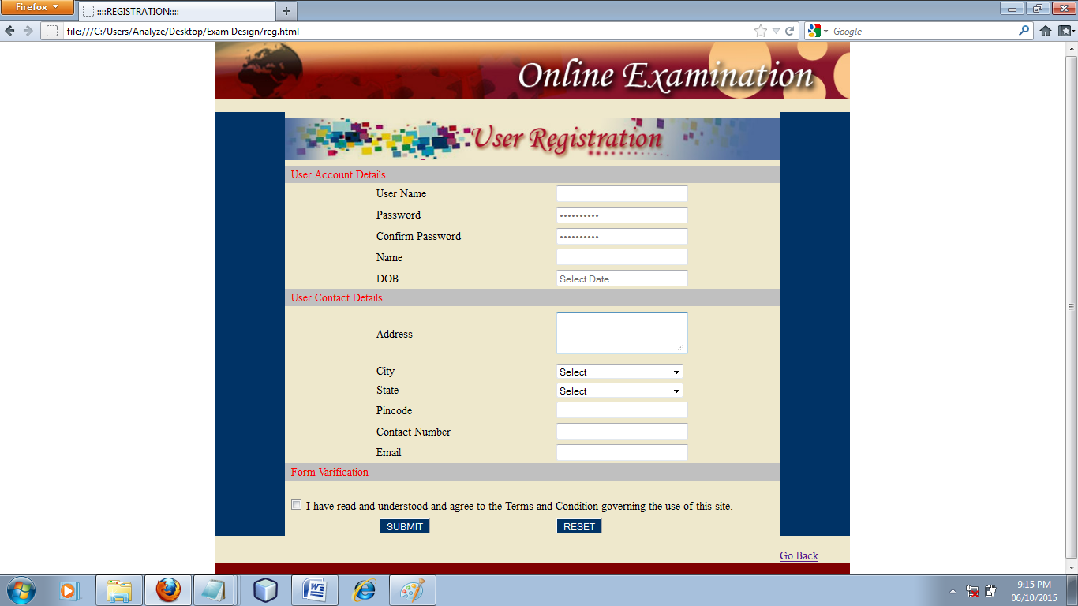

<!DOCTYPE html PUBLIC "-//W3C//DTD XHTML 1.0 Transitional//EN" "http://www.w3.org/TR/xhtml1/DTD/xhtml1-transitional.dtd">

<html xmlns="http://www.w3.org/1999/xhtml">
<head>
<title>
::::REGISTRATION::::
</title>
<link rel="stylesheet" href="style.css">
<script language="javascript" src="js/clndr/scw.js"></script>
</head>
<body>

<div>
<center>
<form action="" method="post">
<div style="width:900px;text-align:left">

<table style="width: 900px;" cellspacing="0" cellpadding="0" border="0">
<tr>
<td style="width: 900px; background-color: #800000;">

<img id="Image2" src="Images/onlinebanner.jpg" style="border-width:0px;" />

</td>
</tr>

<tr>
<td style="width: 900px">
<table style="width: 900px; background-color: #EEE8CC ;" cellspacing="0"
cellpadding="0" border="0">
<tr style="background-color: ">
<td style="width: 100px;">
&nbsp;</td>
<td style="width: 700px">
<br />
</td>
<td style="width: 100px;">
&nbsp;</td>
</tr>
<tr>
<td style="width: 100px; background-color: #003366;">
&nbsp;</td>
<td style="width: 700px">
<table style="width: 700px;height:600px;" cellspacing="0" cellpadding="0" border="0">
<tr>
<td colspan="5">
<img id="Image1" src="Images/register_2.jpg" style="border-width:0px;" />
</td>
</tr>
<tr>
<td style="background-color: #C0C0C0;" colspan="5">
<div style="text-align: left">
&nbsp;&nbsp;<span id="usrAccountDetails" style="color:Red;">User Account Details</span>
</div>
</td>
</tr>

<tr>
<td style="width: 125px">&nbsp;</td>
<td style="width: 200px;text-align:left;">&nbsp;User Name</td>
<td style="width: 50px;text-align:center;">&nbsp;</td>
<td style="width: 200px;text-align:left;">&nbsp;
<input name="t1" type="text" style="width:180px;" />
</td>
<td style="width: 125px">&nbsp;</td>
</tr>

<tr>
<td style="width: 125px">&nbsp;</td>
<td style="width: 200px;text-align:left;">&nbsp;Password</td>
<td style="width: 50px;text-align:center;">&nbsp;</td>
<td style="width: 200px;text-align:left;">&nbsp;
<input name="t2" placeholder="••••••••••" type="password" style="width:180px;" />
</td>
<td style="width: 125px">&nbsp;</td>
</tr>

<tr>
<td style="width: 125px">&nbsp;</td>
<td style="width: 200px;text-align:left;">&nbsp;Confirm Password</td>
<td style="width: 50px;text-align:center;">&nbsp;</td>
<td style="width: 200px;text-align:left;">&nbsp;
<input name="t3" placeholder="••••••••••" type="password" style="width:180px;" />
</td>
<td style="width: 125px">&nbsp;</td>
</tr>

<tr>
<td style="width: 125px">&nbsp;</td>
<td style="width: 200px;text-align:left;">&nbsp;Name</td>
<td style="width: 50px;text-align:center;">&nbsp;</td>
<td style="width: 200px;text-align:left;">&nbsp;
<input name="t4" type="text" style="width:180px;" />
</td>
<td style="width: 125px">&nbsp;</td>
</tr>

<tr>
<td style="width: 125px">&nbsp;</td>
<td style="width: 200px;text-align:left;">&nbsp;DOB</td>
<td style="width: 50px;text-align:center;">&nbsp;</td>
<td style="width: 200px;text-align:left;">&nbsp;
<input name="t5" type="text" placeholder="Select Date" style="width:180px;" onclick="scwShow(this,event)">
</td>
<td style="width: 125px">&nbsp;</td>
</tr>

<tr style="background-color: #FFFFCC">
<td colspan="5" style="background-color: #C0C0C0">
<div style="text-align: left">
&nbsp;&nbsp;<span id="usrContactDetails" style="color:Red;">User Contact Details</span>
</div>
</td>
</tr>

<tr>
<td style="width: 125px">&nbsp;</td>
<td style="width: 200px;text-align:left;">&nbsp;Address</td>
<td style="width: 50px;text-align:center;">&nbsp;</td>
<td style="width: 200px;text-align:left;">&nbsp;
<textarea style="width:180px;" name="t"></textarea>
</td>
<td style="width: 125px">&nbsp;</td>
</tr>

<tr>
<td style="width: 125px">&nbsp;</td>
<td style="width: 200px;text-align:left;">&nbsp;City</td>
<td style="width: 50px;text-align:center;">&nbsp;</td>
<td style="width: 200px;text-align:left;">&nbsp;
<select name="s1" style="width:180px;">
<option selected="selected" value="Select">Select</option>
<option value="Agra">Agra</option>
<option value="Ahmedabad">Ahmedabad</option>
<option value="Ahmednagar">Ahmednagar</option>
<option value="Aligarh">Aligarh</option>
<option value="Allahabad">Allahabad</option>
<option value="Azamgarh">Azamgarh</option>
<option value="Bahraich">Bahraich</option>
<option value="Bangalore">Bangalore</option>
<option value="Bhopal">Bhopal</option>
<option value="Bhubaneswar">Bhubaneswar</option>
<option value="Bhuj">Bhuj</option>
<option value="Chittoor">Chittoor</option>
<option value="Coimbatore">Coimbatore</option>
<option value="Dehradun">Dehradun</option>
<option value="Delhi">Delhi</option>
<option value="Lucknow">Lucknow</option>
<option value="Ludhiana">Ludhiana</option>
<option value="Ujjain">Ujjain</option>
<option value="Ulhasnagar">Ulhasnagar</option>
<option value="Unnao">Unnao</option>
<option value="Vadodara">Vadodara</option>
<option value="Vallabh Vidhyanagar">Vallabh Vidhyanagar</option>
<option value="Valsad">Valsad</option>
<option value="Vandavasi">Vandavasi</option>
<option value="Vapi">Vapi</option>
<option value="Varanasi">Varanasi</option>
<option value="Vasai">Vasai</option>
<option value="Vellore">Vellore</option>
<option value="Wayanad">Wayanad</option>

</select>
</td>
<td style="width: 125px">&nbsp;</td>
</tr>

<tr>
<td style="width: 125px">&nbsp;</td>
<td style="width: 200px;text-align:left;">&nbsp;State</td>
<td style="width: 50px;text-align:center;">&nbsp;</td>
<td style="width: 200px;text-align:left;">&nbsp;
<select name="s2" style="width:180px;">
<option selected="selected" value="Select">Select</option>
<option value="Andhra Pradesh">Andhra Pradesh</option>
<option value="Bihar">Bihar</option>
<option value="Gujrat">Gujrat</option>
<option value="Himanchal Pradesh">Himanchal Pradesh</option>
<option value="Karnatak">Karnatak</option>
<option value="Madhya Pradesh">Madhya Pradesh</option>
<option value="Punjab">Punjab</option>
<option value="Uttarakhand">Uttarakhand</option>
<option value="Uttar Pradesh">Uttar Pradesh</option>

</select>
</td>
<td style="width: 125px">&nbsp;</td>
</tr>

<tr>
<td style="width: 125px">&nbsp;</td>
<td style="width: 200px;text-align:left;">&nbsp;Pincode</td>
<td style="width: 50px;text-align:center;">&nbsp;</td>
<td style="width: 200px;text-align:left;">&nbsp;
<input name="t6" type="text" style="width:180px;" />
</td>
<td style="width: 125px">&nbsp;</td>
</tr>

<tr>
<td style="width: 125px">&nbsp;</td>
<td style="width: 200px;text-align:left;">&nbsp;Contact Number</td>
<td style="width: 50px;text-align:center;">&nbsp;</td>
<td style="width: 200px;text-align:left;">&nbsp;
<input name="t7" type="text" style="width:180px;" />
</td>
<td style="width: 125px">&nbsp;</td>
</tr>

<tr>
<td style="width: 125px">&nbsp;</td>
<td style="width: 200px;text-align:left;">&nbsp;Email</td>
<td style="width: 50px;text-align:center;">&nbsp;</td>
<td style="width: 200px;text-align:left;">&nbsp;
<input name="t8" type="email" style="width:180px;" />
</td>
<td style="width: 125px">&nbsp;</td>
</tr>

<tr>
<td style="background-color: #C0C0C0;" colspan="5">
<div style="text-align: left">
&nbsp;&nbsp;<span id="frmVarification" style="color:Red;">Form Varification</span>
</div>
</td>
</tr>
<tr>
<td colspan="5">
&nbsp;
<br />
&nbsp;<input id="CheckBox1" type="checkbox" name="ch" /><label for="CheckBox1"> I have read and understood and agree to the Terms and Condition governing the use of this site.</label>
<br />
</td>

</tr>

<tr>
<td style="width: 125px">&nbsp;</td>
<td style="width: 200px;text-align:left;">&nbsp;
<input type="submit" name="submit" value="SUBMIT" style="color:White;background-color:#003366;" />
</td>
<td style="width: 50px;text-align:center;">&nbsp;</td>
<td style="width: 200px;text-align:left;">&nbsp;
<input type="reset" name="reset" value="RESET" style="color:White;background-color:#003366;" />
</td>
<td style="width: 125px">&nbsp;</td>
</tr>

</table>
</td>
<td style="width: 100px; background-color: #003366;">
&nbsp;</td>
</tr>
<tr>
<td style="width: 100px;">
&nbsp;</td>
<td style="width: 700px">

</td>
<td style="width: 100px;">
&nbsp;</td>
</tr>
<tr>
<td style="width: 100px;">
&nbsp;</td>
<td style="width: 700px;text-align:left;">
&nbsp;
</td>
<td style="width: 100px;">
<a href="home.html">Go Back</a></td>
</tr>
</table>
</td>
</tr>
<tr>
<td style="width: 900px; background-color: #800000;">
<br />
</td>
</tr>
</table>

</div>
</form>
</center>

</body></html>

C Language Exam

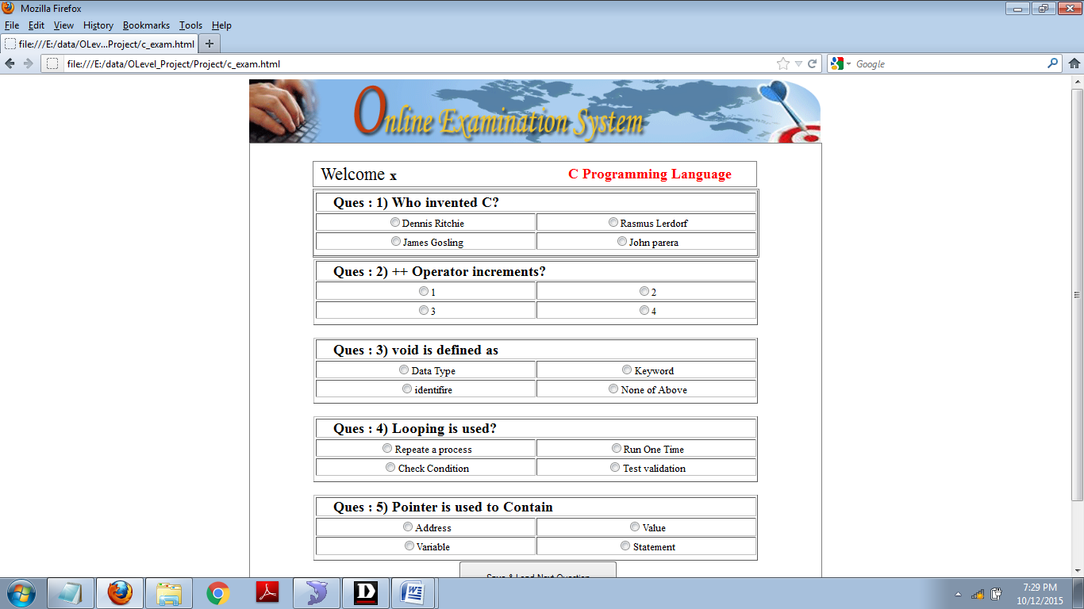

<html>

<head>

<script>
history.go(1);
</script>

</head>

<body>

<center>
<div style="width:900px;">

<div style="width:900px;">
<img src="images/examination_banner.png">
</div>

<div style="width:900px;border:1px solid gray;">

<form action="" method="post">

<table>

<tr>
<td style="width:100px;">&nbsp;</td>
<td style="width:700px;">&nbsp;</td>
<td style="width:100px;">&nbsp;</td>
</tr>
<tr>
<td style="width:100px;">&nbsp;</td>
<td style="width:700px;">

<table style="width:700px;text-align:center;border:1px solid gray;">

<tr>

<td style="width:300px;text-align:left;">&nbsp;
<span style="font-size:28px;"> Welcome </span>
<span style="font-size:22px;font-weight:bold;"> x </span>
</td>
<td style="width:100px;text-align:left;">&nbsp;</td>
<td style="width:300px;text-align:left;">

<span style="font-size:22px;font-weight:bold;color:red;"> C Programming Language </span>

</td>

</tr>

</table>

</td>
<td style="width:100px;">&nbsp;</td>
</tr>
<tr>
<td style="width:100px;">&nbsp;</td>
<td style="width:700px;border:1px solid gray;">

<table border='1' style='width:700px;text-align:center;'><input type='hidden' name='hh' value='Dennis Ritchie'><tr><th colspan='2' style='font-size:22px;text-align:left;'>&nbsp;&nbsp;&nbsp;&nbsp;Ques : 1) Who invented C?</th></tr><tr><td style='width:350px;text-align:center;'> <input type='radio' name='r' value='Dennis Ritchie'>Dennis Ritchie</td><td style='width:350px;text-align:center;'> <input type='radio' name='r' value='Rasmus Lerdorf'>Rasmus Lerdorf</td></tr><tr><td style='width:350px;text-align:center;'> <input type='radio' name='r' value='James Gosling'>James Gosling</td><td style='width:350px;text-align:center;'> <input type='radio' name='r' value='John parera'>John parera</td></tr><tr><th colspan='2'>

</th></tr></table>
</td>
<td style="width:100px;">&nbsp;</td>
</tr>

</table>

<table border='1' style='width:700px;text-align:center;'><input type='hidden' name='hh' value='Dennis Ritchie'><tr><th colspan='2' style='font-size:22px;text-align:left;'>&nbsp;&nbsp;&nbsp;&nbsp;Ques : 2) ++ Operator increments?</th></tr><tr><td style='width:350px;text-align:center;'> <input type='radio' name='r' value='Dennis Ritchie'>1</td><td style='width:350px;text-align:center;'> <input type='radio' name='r' value='Rasmus Lerdorf'>2</td></tr><tr><td style='width:350px;text-align:center;'> <input type='radio' name='r' value='James Gosling'>3</td><td style='width:350px;text-align:center;'> <input type='radio' name='r' value='John parera'>4</td></tr><tr><th colspan='2'>

</th></tr></table>
</td>
<td style="width:100px;">&nbsp;</td>
</tr>

</table>

<table border='1' style='width:700px;text-align:center;'><input type='hidden' name='hh' value='Dennis Ritchie'><tr><th colspan='2' style='font-size:22px;text-align:left;'>&nbsp;&nbsp;&nbsp;&nbsp;Ques : 3) void is defined as</th></tr><tr><td style='width:350px;text-align:center;'> <input type='radio' name='r' value='Dennis Ritchie'>Data Type</td><td style='width:350px;text-align:center;'> <input type='radio' name='r' value='Rasmus Lerdorf'>Keyword</td></tr><tr><td style='width:350px;text-align:center;'> <input type='radio' name='r' value='James Gosling'>identifire</td><td style='width:350px;text-align:center;'> <input type='radio' name='r' value='John parera'>None of Above</td></tr><tr><th colspan='2'>

</th></tr></table>
</td>
<td style="width:100px;">&nbsp;</td>
</tr>

</table>

<table border='1' style='width:700px;text-align:center;'><input type='hidden' name='hh' value='Dennis Ritchie'><tr><th colspan='2' style='font-size:22px;text-align:left;'>&nbsp;&nbsp;&nbsp;&nbsp;Ques : 4) Looping is used?</th></tr><tr><td style='width:350px;text-align:center;'> <input type='radio' name='r' value='Dennis Ritchie'>Repeate a process</td><td style='width:350px;text-align:center;'> <input type='radio' name='r' value='Rasmus Lerdorf'>Run One Time</td></tr><tr><td style='width:350px;text-align:center;'> <input type='radio' name='r' value='James Gosling'>Check Condition</td><td style='width:350px;text-align:center;'> <input type='radio' name='r' value='John parera'>Test validation</td></tr><tr><th colspan='2'>

</th></tr></table>
</td>
<td style="width:100px;">&nbsp;</td>
</tr>

</table>

<table border='1' style='width:700px;text-align:center;'><input type='hidden' name='hh' value='Dennis Ritchie'><tr><th colspan='2' style='font-size:22px;text-align:left;'>&nbsp;&nbsp;&nbsp;&nbsp;Ques : 5) Pointer is used to Contain</th></tr><tr><td style='width:350px;text-align:center;'> <input type='radio' name='r' value='Dennis Ritchie'>Address</td><td style='width:350px;text-align:center;'> <input type='radio' name='r' value='Rasmus Lerdorf'>Value</td></tr><tr><td style='width:350px;text-align:center;'> <input type='radio' name='r' value='James Gosling'>Variable</td><td style='width:350px;text-align:center;'> <input type='radio' name='r' value='John parera'>Statement</td></tr><tr><th colspan='2'>

</th></tr></table>
</td>
<td style="width:100px;">&nbsp;</td>
</tr>

</table>

<input type="submit" value="Save & Load Next Question" name="s" style="width:250px;height:50px;" >

</form>

</div>

</div>
<div style="width: 900px;">

<table style="width: 900px; background-color: #808080" cellpadding="0" cellspacing="0" border="0">
<tr>
<td style="width: 250px">
</td>
<td style="width: 340px">
</td>
<td style="width: 60px">
&nbsp;</td>
<td style="width: 65px">
&nbsp;</td>
<td style="width: 95px">
&nbsp;</td>
<td style="width: 90px">
&nbsp;</td>
</tr>
<tr>
<td style="width: 250px">
&nbsp;</td>
<td style="width: 340px">
<center>
<label style="color:white;">
Copyright reserved to Online Examination System
</label>
</center>
</td>
<td style="width: 60px">
&nbsp;</td>
<td style="width: 65px">
&nbsp;</td>
<td style="width: 95px">
&nbsp;</td>
<td style="width: 90px">
&nbsp;</td>
</tr>
<tr>
<td style="width: 250px">
&nbsp;</td>
<td style="width: 340px">
<center> Powered By: Online Exam Team </center>
</td>
<td style="width: 60px">
&nbsp;</td>
<td style="width: 65px">
&nbsp;</td>
<td style="width: 95px">
&nbsp;</td>
<td style="width: 90px">
&nbsp;</td>
</tr>
</table>

</div>

</div>

</center>

</body>
</html></center>

C++ EXAM

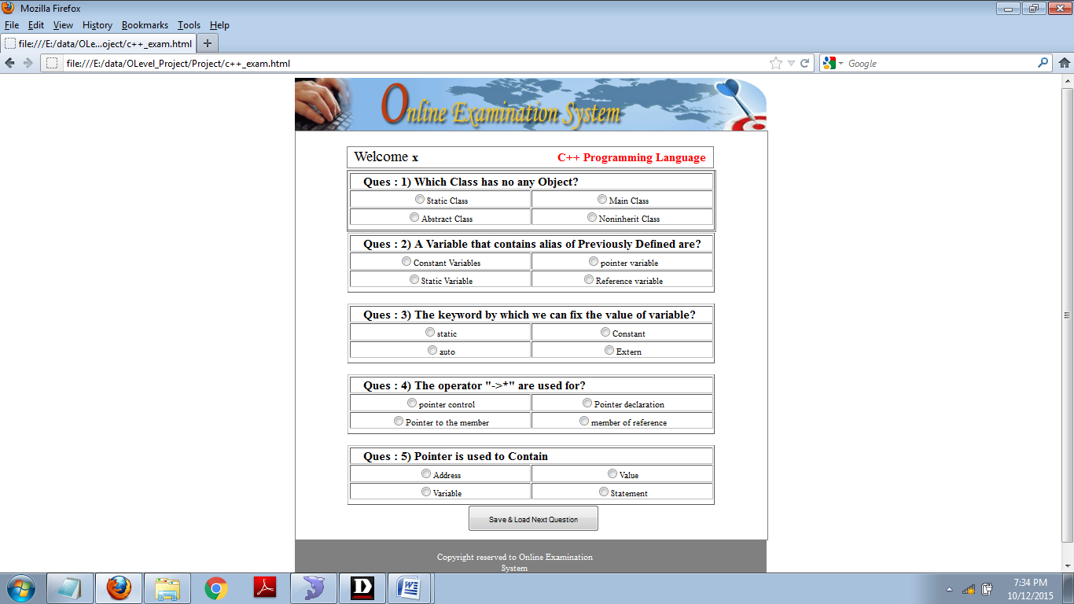

<html>

<head>

<script>
history.go(1);
</script>

</head>

<body>

<center>
<div style="width:900px;">

<div style="width:900px;">
<img src="images/examination_banner.png">
</div>

<div style="width:900px;border:1px solid gray;">

<form action="" method="post">

<table>

<tr>
<td style="width:100px;">&nbsp;</td>
<td style="width:700px;">&nbsp;</td>
<td style="width:100px;">&nbsp;</td>
</tr>
<tr>
<td style="width:100px;">&nbsp;</td>
<td style="width:700px;">

<table style="width:700px;text-align:center;border:1px solid gray;">

<tr>

<td style="width:300px;text-align:left;">&nbsp;
<span style="font-size:28px;"> Welcome </span>
<span style="font-size:22px;font-weight:bold;"> x </span>
</td>
<td style="width:100px;text-align:left;">&nbsp;</td>
<td style="width:300px;text-align:left;">

<span style="font-size:22px;font-weight:bold;color:red;"> C++ Programming Language </span>

</td>

</tr>

</table>

</td>
<td style="width:100px;">&nbsp;</td>
</tr>
<tr>
<td style="width:100px;">&nbsp;</td>
<td style="width:700px;border:1px solid gray;">

<table border='1' style='width:700px;text-align:center;'><input type='hidden' name='hh' value='Dennis Ritchie'><tr><th colspan='2' style='font-size:22px;text-align:left;'>&nbsp;&nbsp;&nbsp;&nbsp;Ques : 1) Which Class has no any Object?</th></tr><tr><td style='width:350px;text-align:center;'> <input type='radio' name='r' value='Dennis Ritchie'>Static Class </td><td style='width:350px;text-align:center;'> <input type='radio' name='r' value='Rasmus Lerdorf'>Main Class</td></tr><tr><td style='width:350px;text-align:center;'> <input type='radio' name='r' value='James Gosling'>Abstract Class</td><td style='width:350px;text-align:center;'> <input type='radio' name='r' value='John parera'>Noninherit Class</td></tr><tr><th colspan='2'>

</th></tr></table>
</td>
<td style="width:100px;">&nbsp;</td>
</tr>

</table>

<table border='1' style='width:700px;text-align:center;'><input type='hidden' name='hh' value='Dennis Ritchie'><tr><th colspan='2' style='font-size:22px;text-align:left;'>&nbsp;&nbsp;&nbsp;&nbsp;Ques : 2) A Variable that contains alias of Previously Defined are?</th></tr><tr><td style='width:350px;text-align:center;'> <input type='radio' name='r' value='Dennis Ritchie'>Constant Variables</td><td style='width:350px;text-align:center;'> <input type='radio' name='r' value='Rasmus Lerdorf'>pointer variable</td></tr><tr><td style='width:350px;text-align:center;'> <input type='radio' name='r' value='James Gosling'>Static Variable</td><td style='width:350px;text-align:center;'> <input type='radio' name='r' value='John parera'>Reference variable</td></tr><tr><th colspan='2'>

</th></tr></table>
</td>
<td style="width:100px;">&nbsp;</td>
</tr>

</table>

<table border='1' style='width:700px;text-align:center;'><input type='hidden' name='hh' value='Dennis Ritchie'><tr><th colspan='2' style='font-size:22px;text-align:left;'>&nbsp;&nbsp;&nbsp;&nbsp;Ques : 3) The keyword by which we can fix the value of variable?</th></tr><tr><td style='width:350px;text-align:center;'> <input type='radio' name='r' value='Dennis Ritchie'>static</td><td style='width:350px;text-align:center;'> <input type='radio' name='r' value='Rasmus Lerdorf'>Constant</td></tr><tr><td style='width:350px;text-align:center;'> <input type='radio' name='r' value='James Gosling'>auto</td><td style='width:350px;text-align:center;'> <input type='radio' name='r' value='John parera'>Extern</td></tr><tr><th colspan='2'>

</th></tr></table>
</td>
<td style="width:100px;">&nbsp;</td>
</tr>

</table>

<table border='1' style='width:700px;text-align:center;'><input type='hidden' name='hh' value='Dennis Ritchie'><tr><th colspan='2' style='font-size:22px;text-align:left;'>&nbsp;&nbsp;&nbsp;&nbsp;Ques : 4) The operator "->*" are used for?</th></tr><tr><td style='width:350px;text-align:center;'> <input type='radio' name='r' value='Dennis Ritchie'>pointer control</td><td style='width:350px;text-align:center;'> <input type='radio' name='r' value='Rasmus Lerdorf'>Pointer declaration</td></tr><tr><td style='width:350px;text-align:center;'> <input type='radio' name='r' value='James Gosling'>Pointer to the member</td><td style='width:350px;text-align:center;'> <input type='radio' name='r' value='John parera'>member of reference</td></tr><tr><th colspan='2'>

</th></tr></table>
</td>
<td style="width:100px;">&nbsp;</td>
</tr>

</table>

<table border='1' style='width:700px;text-align:center;'><input type='hidden' name='hh' value='Dennis Ritchie'><tr><th colspan='2' style='font-size:22px;text-align:left;'>&nbsp;&nbsp;&nbsp;&nbsp;Ques : 5) Pointer is used to Contain</th></tr><tr><td style='width:350px;text-align:center;'> <input type='radio' name='r' value='Dennis Ritchie'>Address</td><td style='width:350px;text-align:center;'> <input type='radio' name='r' value='Rasmus Lerdorf'>Value</td></tr><tr><td style='width:350px;text-align:center;'> <input type='radio' name='r' value='James Gosling'>Variable</td><td style='width:350px;text-align:center;'> <input type='radio' name='r' value='John parera'>Statement</td></tr><tr><th colspan='2'>

</th></tr></table>
</td>
<td style="width:100px;">&nbsp;</td>
</tr>

</table>

<input type="submit" value="Save & Load Next Question" name="s" style="width:250px;height:50px;" >

</form>

</div>

</div>
<div style="width: 900px;">

<table style="width: 900px; background-color: #808080" cellpadding="0" cellspacing="0" border="0">
<tr>
<td style="width: 250px">
</td>
<td style="width: 340px">
</td>
<td style="width: 60px">
&nbsp;</td>
<td style="width: 65px">
&nbsp;</td>
<td style="width: 95px">
&nbsp;</td>
<td style="width: 90px">
&nbsp;</td>
</tr>
<tr>
<td style="width: 250px">
&nbsp;</td>
<td style="width: 340px">
<center>
<label style="color:white;">
Copyright reserved to Online Examination System
</label>
</center>
</td>
<td style="width: 60px">
&nbsp;</td>
<td style="width: 65px">
&nbsp;</td>
<td style="width: 95px">
&nbsp;</td>
<td style="width: 90px">
&nbsp;</td>
</tr>
<tr>
<td style="width: 250px">
&nbsp;</td>
<td style="width: 340px">
<center> Powered By: Online Exam Team </center>
</td>
<td style="width: 60px">
&nbsp;</td>
<td style="width: 65px">
&nbsp;</td>
<td style="width: 95px">
&nbsp;</td>
<td style="width: 90px">
&nbsp;</td>
</tr>
</table>

</div>

</div>

</center>

</body>
</html></center>

Java Exam

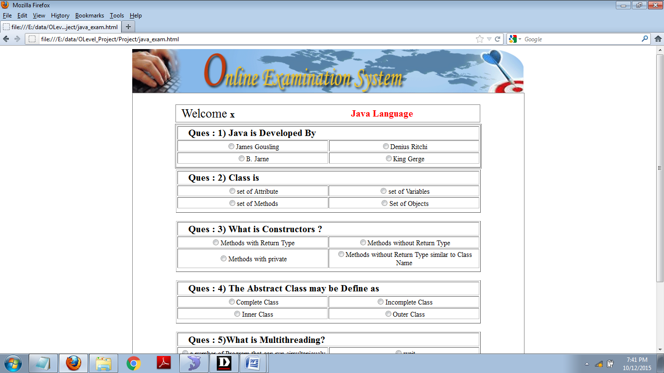

<html>

<head>

<script>
history.go(1);
</script>

</head>

<body>

<center>
<div style="width:900px;">

<div style="width:900px;">
<img src="images/examination_banner.png">
</div>

<div style="width:900px;border:1px solid gray;">

<form action="" method="post">

<table>

<tr>
<td style="width:100px;">&nbsp;</td>
<td style="width:700px;">&nbsp;</td>
<td style="width:100px;">&nbsp;</td>
</tr>
<tr>
<td style="width:100px;">&nbsp;</td>
<td style="width:700px;">

<table style="width:700px;text-align:center;border:1px solid gray;">

<tr>

<td style="width:300px;text-align:left;">&nbsp;
<span style="font-size:28px;"> Welcome </span>
<span style="font-size:22px;font-weight:bold;"> x </span>
</td>
<td style="width:100px;text-align:left;">&nbsp;</td>
<td style="width:300px;text-align:left;">

<span style="font-size:22px;font-weight:bold;color:red;"> Java Language </span>

</td>

</tr>

</table>

</td>
<td style="width:100px;">&nbsp;</td>
</tr>
<tr>
<td style="width:100px;">&nbsp;</td>
<td style="width:700px;border:1px solid gray;">

<table border='1' style='width:700px;text-align:center;'><input type='hidden' name='hh' value='Dennis Ritchie'><tr><th colspan='2' style='font-size:22px;text-align:left;'>&nbsp;&nbsp;&nbsp;&nbsp;Ques : 1) Java is Developed By</th></tr><tr><td style='width:350px;text-align:center;'> <input type='radio' name='r' value='Dennis Ritchie'>James Gousling </td><td style='width:350px;text-align:center;'> <input type='radio' name='r' value='Rasmus Lerdorf'>Denius Ritchi</td></tr><tr><td style='width:350px;text-align:center;'> <input type='radio' name='r' value='James Gosling'>B. Jarne</td><td style='width:350px;text-align:center;'> <input type='radio' name='r' value='John parera'>King Gerge</td></tr><tr><th colspan='2'>

</th></tr></table>
</td>
<td style="width:100px;">&nbsp;</td>
</tr>

</table>

<table border='1' style='width:700px;text-align:center;'><input type='hidden' name='hh' value='Dennis Ritchie'><tr><th colspan='2' style='font-size:22px;text-align:left;'>&nbsp;&nbsp;&nbsp;&nbsp;Ques : 2) Class is</th></tr><tr><td style='width:350px;text-align:center;'> <input type='radio' name='r' value='Dennis Ritchie'>set of Attribute</td><td style='width:350px;text-align:center;'> <input type='radio' name='r' value='Rasmus Lerdorf'>set of Variables</td></tr><tr><td style='width:350px;text-align:center;'> <input type='radio' name='r' value='James Gosling'>set of Methods</td><td style='width:350px;text-align:center;'> <input type='radio' name='r' value='John parera'>Set of Objects</td></tr><tr><th colspan='2'>

</th></tr></table>
</td>
<td style="width:100px;">&nbsp;</td>
</tr>

</table>

<table border='1' style='width:700px;text-align:center;'><input type='hidden' name='hh' value='Dennis Ritchie'><tr><th colspan='2' style='font-size:22px;text-align:left;'>&nbsp;&nbsp;&nbsp;&nbsp;Ques : 3) What is Constructors ?</th></tr><tr><td style='width:350px;text-align:center;'> <input type='radio' name='r' value='Dennis Ritchie'>Methods with Return Type</td><td style='width:350px;text-align:center;'> <input type='radio' name='r' value='Rasmus Lerdorf'>Methods without Return Type</td></tr><tr><td style='width:350px;text-align:center;'> <input type='radio' name='r' value='James Gosling'>Methods with private</td><td style='width:350px;text-align:center;'> <input type='radio' name='r' value='John parera'>Methods without Return Type similar to Class Name</td></tr><tr><th colspan='2'>

</th></tr></table>
</td>
<td style="width:100px;">&nbsp;</td>
</tr>

</table>

<table border='1' style='width:700px;text-align:center;'><input type='hidden' name='hh' value='Dennis Ritchie'><tr><th colspan='2' style='font-size:22px;text-align:left;'>&nbsp;&nbsp;&nbsp;&nbsp;Ques : 4) The Abstract Class may be Define as</th></tr><tr><td style='width:350px;text-align:center;'> <input type='radio' name='r' value='Dennis Ritchie'>Complete Class</td><td style='width:350px;text-align:center;'> <input type='radio' name='r' value='Rasmus Lerdorf'>Incomplete Class</td></tr><tr><td style='width:350px;text-align:center;'> <input type='radio' name='r' value='James Gosling'>Inner Class</td><td style='width:350px;text-align:center;'> <input type='radio' name='r' value='John parera'>Outer Class</td></tr><tr><th colspan='2'>

</th></tr></table>
</td>
<td style="width:100px;">&nbsp;</td>
</tr>

</table>

<table border='1' style='width:700px;text-align:center;'><input type='hidden' name='hh' value='Dennis Ritchie'><tr><th colspan='2' style='font-size:22px;text-align:left;'>&nbsp;&nbsp;&nbsp;&nbsp;Ques : 5)What is Multithreading?</th></tr><tr><td style='width:350px;text-align:center;'> <input type='radio' name='r' value='Dennis Ritchie'>a number of Program that can run simultaniously </td><td style='width:350px;text-align:center;'> <input type='radio' name='r' value='Rasmus Lerdorf'>wait</td></tr><tr><td style='width:350px;text-align:center;'> <input type='radio' name='r' value='James Gosling'>waiting</td><td style='width:350px;text-align:center;'> <input type='radio' name='r' value='John parera'>waits</td></tr><tr><th colspan='2'>

</th></tr></table>
</td>
<td style="width:100px;">&nbsp;</td>
</tr>

</table>

<input type="submit" value="Save & Load Next Question" name="s" style="width:250px;height:50px;" >

</form>

</div>

</div>
<div style="width: 900px;">

<table style="width: 900px; background-color: #808080" cellpadding="0" cellspacing="0" border="0">
<tr>
<td style="width: 250px">
</td>
<td style="width: 340px">
</td>
<td style="width: 60px">
&nbsp;</td>
<td style="width: 65px">
&nbsp;</td>
<td style="width: 95px">
&nbsp;</td>
<td style="width: 90px">
&nbsp;</td>
</tr>
<tr>
<td style="width: 250px">
&nbsp;</td>
<td style="width: 340px">
<center>
<label style="color:white;">
Copyright reserved to Online Examination System
</label>
</center>
</td>
<td style="width: 60px">
&nbsp;</td>
<td style="width: 65px">
&nbsp;</td>
<td style="width: 95px">
&nbsp;</td>
<td style="width: 90px">
&nbsp;</td>
</tr>
<tr>
<td style="width: 250px">
&nbsp;</td>
<td style="width: 340px">
<center> Powered By: Online Exam Team </center>
</td>
<td style="width: 60px">
&nbsp;</td>
<td style="width: 65px">
&nbsp;</td>
<td style="width: 95px">
&nbsp;</td>
<td style="width: 90px">
&nbsp;</td>
</tr>
</table>

</div>

</div>

</center>

</body>
</html></center>

fundamental_exam.html

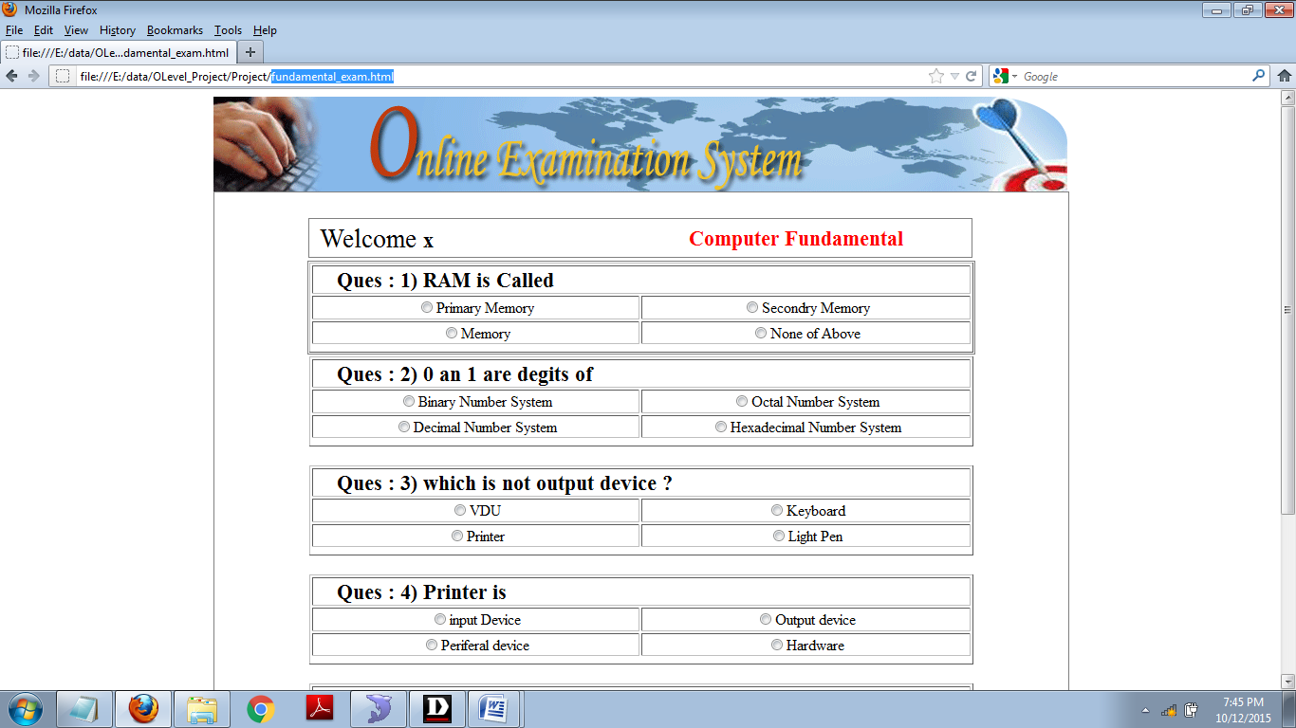

<html>

<head>

<script>
history.go(1);
</script>

</head>

<body>

<center>
<div style="width:900px;">

<div style="width:900px;">
<img src="images/examination_banner.png">
</div>

<div style="width:900px;border:1px solid gray;">

<form action="" method="post">

<table>

<tr>
<td style="width:100px;">&nbsp;</td>
<td style="width:700px;">&nbsp;</td>
<td style="width:100px;">&nbsp;</td>
</tr>
<tr>
<td style="width:100px;">&nbsp;</td>
<td style="width:700px;">

<table style="width:700px;text-align:center;border:1px solid gray;">

<tr>

<td style="width:300px;text-align:left;">&nbsp;
<span style="font-size:28px;"> Welcome </span>
<span style="font-size:22px;font-weight:bold;"> x </span>
</td>
<td style="width:100px;text-align:left;">&nbsp;</td>
<td style="width:300px;text-align:left;">

<span style="font-size:22px;font-weight:bold;color:red;"> Computer Fundamental </span>

</td>

</tr>

</table>

</td>
<td style="width:100px;">&nbsp;</td>
</tr>
<tr>
<td style="width:100px;">&nbsp;</td>
<td style="width:700px;border:1px solid gray;">

<table border='1' style='width:700px;text-align:center;'><input type='hidden' name='hh' value='Dennis Ritchie'><tr><th colspan='2' style='font-size:22px;text-align:left;'>&nbsp;&nbsp;&nbsp;&nbsp;Ques : 1) RAM is Called</th></tr><tr><td style='width:350px;text-align:center;'> <input type='radio' name='r' value='Dennis Ritchie'>Primary Memory </td><td style='width:350px;text-align:center;'> <input type='radio' name='r' value='Rasmus Lerdorf'>Secondry Memory</td></tr><tr><td style='width:350px;text-align:center;'> <input type='radio' name='r' value='James Gosling'>Memory</td><td style='width:350px;text-align:center;'> <input type='radio' name='r' value='John parera'>None of Above</td></tr><tr><th colspan='2'>

</th></tr></table>
</td>
<td style="width:100px;">&nbsp;</td>
</tr>

</table>

<table border='1' style='width:700px;text-align:center;'><input type='hidden' name='hh' value='Dennis Ritchie'><tr><th colspan='2' style='font-size:22px;text-align:left;'>&nbsp;&nbsp;&nbsp;&nbsp;Ques : 2) 0 an 1 are degits of</th></tr><tr><td style='width:350px;text-align:center;'> <input type='radio' name='r' value='Dennis Ritchie'>Binary Number System</td><td style='width:350px;text-align:center;'> <input type='radio' name='r' value='Rasmus Lerdorf'>Octal Number System</td></tr><tr><td style='width:350px;text-align:center;'> <input type='radio' name='r' value='James Gosling'>Decimal Number System</td><td style='width:350px;text-align:center;'> <input type='radio' name='r' value='John parera'>Hexadecimal Number System</td></tr><tr><th colspan='2'>

</th></tr></table>
</td>
<td style="width:100px;">&nbsp;</td>
</tr>

</table>

<table border='1' style='width:700px;text-align:center;'><input type='hidden' name='hh' value='Dennis Ritchie'><tr><th colspan='2' style='font-size:22px;text-align:left;'>&nbsp;&nbsp;&nbsp;&nbsp;Ques : 3) which is not output device ?</th></tr><tr><td style='width:350px;text-align:center;'> <input type='radio' name='r' value='Dennis Ritchie'>VDU</td><td style='width:350px;text-align:center;'> <input type='radio' name='r' value='Rasmus Lerdorf'>Keyboard</td></tr><tr><td style='width:350px;text-align:center;'> <input type='radio' name='r' value='James Gosling'>Printer</td><td style='width:350px;text-align:center;'> <input type='radio' name='r' value='John parera'>Light Pen</td></tr><tr><th colspan='2'>

</th></tr></table>
</td>
<td style="width:100px;">&nbsp;</td>
</tr>

</table>

<table border='1' style='width:700px;text-align:center;'><input type='hidden' name='hh' value='Dennis Ritchie'><tr><th colspan='2' style='font-size:22px;text-align:left;'>&nbsp;&nbsp;&nbsp;&nbsp;Ques : 4) Printer is</th></tr><tr><td style='width:350px;text-align:center;'> <input type='radio' name='r' value='Dennis Ritchie'>input Device</td><td style='width:350px;text-align:center;'> <input type='radio' name='r' value='Rasmus Lerdorf'>Output device</td></tr><tr><td style='width:350px;text-align:center;'> <input type='radio' name='r' value='James Gosling'>Periferal device</td><td style='width:350px;text-align:center;'> <input type='radio' name='r' value='John parera'>Hardware</td></tr><tr><th colspan='2'>

</th></tr></table>
</td>
<td style="width:100px;">&nbsp;</td>
</tr>

</table>

<table border='1' style='width:700px;text-align:center;'><input type='hidden' name='hh' value='Dennis Ritchie'><tr><th colspan='2' style='font-size:22px;text-align:left;'>&nbsp;&nbsp;&nbsp;&nbsp;Ques : 5)Plural of Data is?</th></tr><tr><td style='width:350px;text-align:center;'> <input type='radio' name='r' value='Dennis Ritchie'>Datas </td><td style='width:350px;text-align:center;'> <input type='radio' name='r' value='Rasmus Lerdorf'>Datie</td></tr><tr><td style='width:350px;text-align:center;'> <input type='radio' name='r' value='James Gosling'>Datum</td><td style='width:350px;text-align:center;'> <input type='radio' name='r' value='John parera'>Data</td></tr><tr><th colspan='2'>

</th></tr></table>
</td>
<td style="width:100px;">&nbsp;</td>
</tr>

</table>

<input type="submit" value="Save & Load Next Question" name="s" style="width:250px;height:50px;" >

</form>

</div>

</div>
<div style="width: 900px;">

<table style="width: 900px; background-color: #808080" cellpadding="0" cellspacing="0" border="0">
<tr>
<td style="width: 250px">
</td>
<td style="width: 340px">
</td>
<td style="width: 60px">
&nbsp;</td>
<td style="width: 65px">
&nbsp;</td>
<td style="width: 95px">
&nbsp;</td>
<td style="width: 90px">
&nbsp;</td>
</tr>
<tr>
<td style="width: 250px">
&nbsp;</td>
<td style="width: 340px">
<center>
<label style="color:white;">
Copyright reserved to Online Examination System
</label>
</center>
</td>
<td style="width: 60px">
&nbsp;</td>
<td style="width: 65px">
&nbsp;</td>
<td style="width: 95px">
&nbsp;</td>
<td style="width: 90px">
&nbsp;</td>
</tr>
<tr>
<td style="width: 250px">
&nbsp;</td>
<td style="width: 340px">
<center> Powered By: Online Exam Team </center>
</td>
<td style="width: 60px">
&nbsp;</td>
<td style="width: 65px">
&nbsp;</td>
<td style="width: 95px">
&nbsp;</td>
<td style="width: 90px">
&nbsp;</td>
</tr>
</table>

</div>

</div>

</center>

</body>
</html></center>

english_exam.html

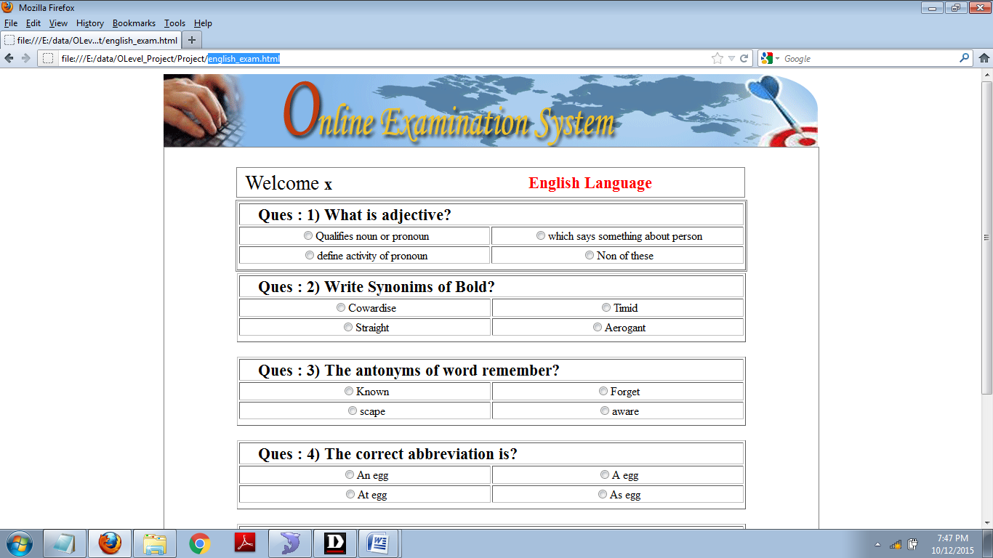

<html>

<head>

<script>
history.go(1);
</script>

</head>

<body>

<center>
<div style="width:900px;">

<div style="width:900px;">
<img src="images/examination_banner.png">
</div>

<div style="width:900px;border:1px solid gray;">

<form action="" method="post">

<table>

<tr>
<td style="width:100px;">&nbsp;</td>
<td style="width:700px;">&nbsp;</td>
<td style="width:100px;">&nbsp;</td>
</tr>
<tr>
<td style="width:100px;">&nbsp;</td>
<td style="width:700px;">

<table style="width:700px;text-align:center;border:1px solid gray;">

<tr>

<td style="width:300px;text-align:left;">&nbsp;
<span style="font-size:28px;"> Welcome </span>
<span style="font-size:22px;font-weight:bold;"> x </span>
</td>
<td style="width:100px;text-align:left;">&nbsp;</td>
<td style="width:300px;text-align:left;">

<span style="font-size:22px;font-weight:bold;color:red;"> English Language </span>

</td>

</tr>

</table>

</td>
<td style="width:100px;">&nbsp;</td>
</tr>
<tr>
<td style="width:100px;">&nbsp;</td>
<td style="width:700px;border:1px solid gray;">

<table border='1' style='width:700px;text-align:center;'><input type='hidden' name='hh' value='Dennis Ritchie'><tr><th colspan='2' style='font-size:22px;text-align:left;'>&nbsp;&nbsp;&nbsp;&nbsp;Ques : 1) What is adjective?</th></tr><tr><td style='width:350px;text-align:center;'> <input type='radio' name='r' value='Dennis Ritchie'>Qualifies noun or pronoun </td><td style='width:350px;text-align:center;'> <input type='radio' name='r' value='Rasmus Lerdorf'>which says something about person</td></tr><tr><td style='width:350px;text-align:center;'> <input type='radio' name='r' value='James Gosling'>define activity of pronoun</td><td style='width:350px;text-align:center;'> <input type='radio' name='r' value='John parera'>Non of these</td></tr><tr><th colspan='2'>

</th></tr></table>
</td>
<td style="width:100px;">&nbsp;</td>
</tr>

</table>

<table border='1' style='width:700px;text-align:center;'><input type='hidden' name='hh' value='Dennis Ritchie'><tr><th colspan='2' style='font-size:22px;text-align:left;'>&nbsp;&nbsp;&nbsp;&nbsp;Ques : 2) Write Synonims of Bold?</th></tr><tr><td style='width:350px;text-align:center;'> <input type='radio' name='r' value='Dennis Ritchie'>Cowardise</td><td style='width:350px;text-align:center;'> <input type='radio' name='r' value='Rasmus Lerdorf'>Timid</td></tr><tr><td style='width:350px;text-align:center;'> <input type='radio' name='r' value='James Gosling'>Straight</td><td style='width:350px;text-align:center;'> <input type='radio' name='r' value='John parera'>Aerogant</td></tr><tr><th colspan='2'>

</th></tr></table>
</td>
<td style="width:100px;">&nbsp;</td>
</tr>

</table>

<table border='1' style='width:700px;text-align:center;'><input type='hidden' name='hh' value='Dennis Ritchie'><tr><th colspan='2' style='font-size:22px;text-align:left;'>&nbsp;&nbsp;&nbsp;&nbsp;Ques : 3) The antonyms of word remember?</th></tr><tr><td style='width:350px;text-align:center;'> <input type='radio' name='r' value='Dennis Ritchie'>Known</td><td style='width:350px;text-align:center;'> <input type='radio' name='r' value='Rasmus Lerdorf'>Forget</td></tr><tr><td style='width:350px;text-align:center;'> <input type='radio' name='r' value='James Gosling'>scape</td><td style='width:350px;text-align:center;'> <input type='radio' name='r' value='John parera'>aware</td></tr><tr><th colspan='2'>

</th></tr></table>
</td>
<td style="width:100px;">&nbsp;</td>
</tr>

</table>

<table border='1' style='width:700px;text-align:center;'><input type='hidden' name='hh' value='Dennis Ritchie'><tr><th colspan='2' style='font-size:22px;text-align:left;'>&nbsp;&nbsp;&nbsp;&nbsp;Ques : 4) The correct abbreviation is?</th></tr><tr><td style='width:350px;text-align:center;'> <input type='radio' name='r' value='Dennis Ritchie'>An egg</td><td style='width:350px;text-align:center;'> <input type='radio' name='r' value='Rasmus Lerdorf'>A egg</td></tr><tr><td style='width:350px;text-align:center;'> <input type='radio' name='r' value='James Gosling'>At egg</td><td style='width:350px;text-align:center;'> <input type='radio' name='r' value='John parera'>As egg</td></tr><tr><th colspan='2'>

</th></tr></table>
</td>
<td style="width:100px;">&nbsp;</td>
</tr>

</table>

<table border='1' style='width:700px;text-align:center;'><input type='hidden' name='hh' value='Dennis Ritchie'><tr><th colspan='2' style='font-size:22px;text-align:left;'>&nbsp;&nbsp;&nbsp;&nbsp;Ques : 5) I have been ______ since last week?</th></tr><tr><td style='width:350px;text-align:center;'> <input type='radio' name='r' value='Dennis Ritchie'>waited</td><td style='width:350px;text-align:center;'> <input type='radio' name='r' value='Rasmus Lerdorf'>wait</td></tr><tr><td style='width:350px;text-align:center;'> <input type='radio' name='r' value='James Gosling'>waiting</td><td style='width:350px;text-align:center;'> <input type='radio' name='r' value='John parera'>waits</td></tr><tr><th colspan='2'>

</th></tr></table>
</td>
<td style="width:100px;">&nbsp;</td>
</tr>

</table>

<input type="submit" value="Save & Load Next Question" name="s" style="width:250px;height:50px;" >

</form>

</div>

</div>
<div style="width: 900px;">

<table style="width: 900px; background-color: #808080" cellpadding="0" cellspacing="0" border="0">
<tr>
<td style="width: 250px">
</td>
<td style="width: 340px">
</td>
<td style="width: 60px">
&nbsp;</td>
<td style="width: 65px">
&nbsp;</td>
<td style="width: 95px">
&nbsp;</td>
<td style="width: 90px">
&nbsp;</td>
</tr>
<tr>
<td style="width: 250px">
&nbsp;</td>
<td style="width: 340px">
<center>
<label style="color:white;">
Copyright reserved to Online Examination System
</label>
</center>
</td>
<td style="width: 60px">
&nbsp;</td>
<td style="width: 65px">
&nbsp;</td>
<td style="width: 95px">
&nbsp;</td>
<td style="width: 90px">
&nbsp;</td>
</tr>
<tr>
<td style="width: 250px">
&nbsp;</td>
<td style="width: 340px">
<center> Powered By: Online Exam Team </center>
</td>
<td style="width: 60px">
&nbsp;</td>
<td style="width: 65px">
&nbsp;</td>
<td style="width: 95px">
&nbsp;</td>
<td style="width: 90px">
&nbsp;</td>
</tr>
</table>

</div>

</div>

</center>

</body>
</html></center>

Bibliography

- Kritzinger, A.A.C and Fourie, C.M.W 1996 Basic Principles of Financial Management, Cape Tow Juta

- Smith, R.J. Comparative themes in higher education, in “Trends in High Education” edited by J.N. Green. London: Benton

- www pages: e.g. Unknown (1995) Sentient micorfilaments: A tempest in a tubule (online). Available:http://somecomputer.printer.edu/pub/harnard/bixley
Date accessed:

- http://rmit.libuides.com/content.php?pid=220068&sid=1827557

- http://www2.lib.uct.ac.za/infolit/bibharvard.htm

