mysql> create database lab1;

Query OK, 1 row affected (0.23 sec)

mysql> use rvce;

Database changed

**Table Creation**

mysql> create table MUSICIAN(ssn varchar(10) primary key,name varchar (10) NOT NULL,contact bigint(10),address varchar(10));

Query OK, 0 rows affected, 1 warning (1.34 sec)

mysql> desc MUSICIAN;

+---------+-------------+------+-----+---------+-------+

| Field | Type | Null | Key | Default | Extra |

+---------+-------------+------+-----+---------+-------+

| ssn | varchar(10) | NO | PRI | NULL | |

| name | varchar(10) | NO | | NULL | |

| contact | bigint | YES | | NULL | |

| address | varchar(10) | YES | | NULL | |

+---------+-------------+------+-----+---------+-------+

4 rows in set (0.05 sec)

mysql> create table INSTRUMENT(instID varchar(10)primary key,name varchar(10),musickey varchar(5));

mysql> create table ALBUM(albumid varchar(10)primary key,title varchar(10),copyrightdate date,ssn varchar(10),foreign key(ssn) references MUSICIAN(ssn));

mysql> create table PLAY(ssn varchar(10),inst_ID varchar(10),foreign key(ssn) references MUSICIAN(ssn),foreign key(inst_ID) references INSTRUMENT(instID),primary key(ssn,inst_ID));

mysql> create table SONG(id varchar(10)primary key,title varchar(10) NOT NULL,author varchar(10),albumid varchar(10),foreign key(albumid) references ALBUM(albumid));

mysql> create table PERFORM(ssn varchar(10),id varchar(10),foreign key(ssn) references MUSICIAN(ssn), foreign key(id) references SONG(id),primary key(ssn,id));

**Insert Data into a Musician Table:-**

Sql>insert into musician(ssn,name,contact,address) values(“M1”,”Durgesh”,7564533456,”BGP”);

**Check the Description of a table:-**





**Show Data of all Table:-**

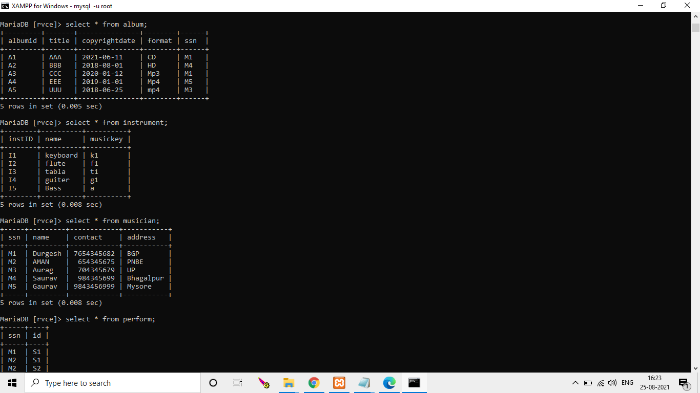

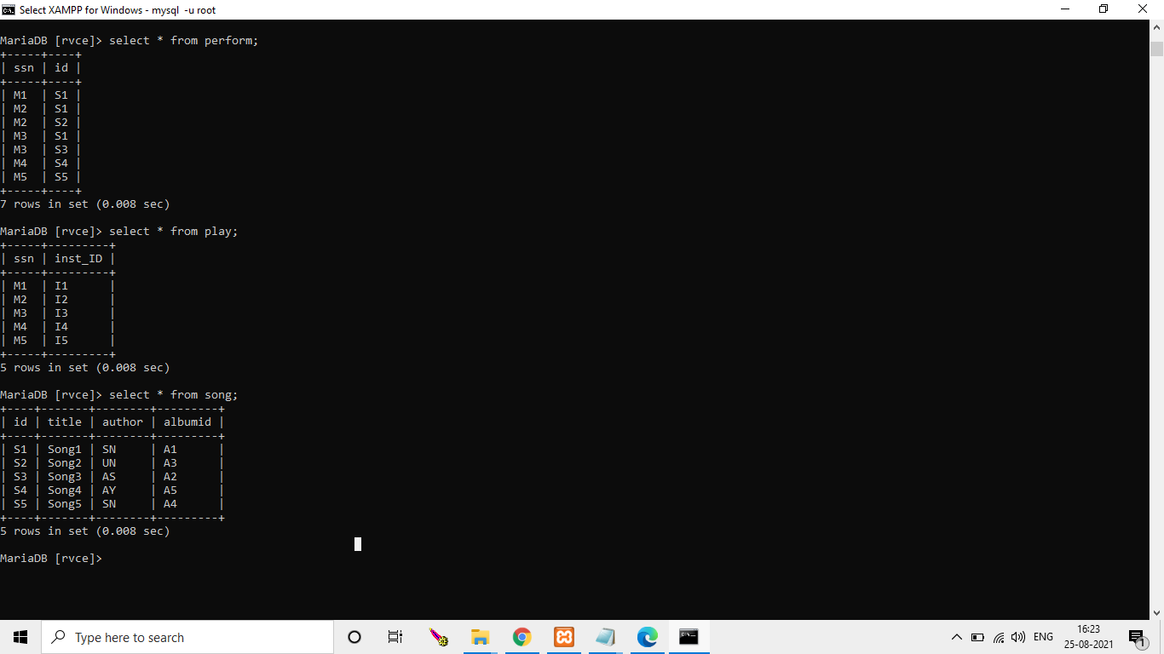

**Class Work:-**

1.a:- List musician name, title of the song which he has played, the album in which song has occulted.

Answer:-select m.name,s.title,a.albumid from musician m,perform p,song s,album a where m.ssn=p.ssn and p.id=s.id and s.albumid=a.albumid;

or

select m.name,s.title,a.title from musician m,perform p,song s,album a where m.ssn=p.ssn and p.id=s.id and s.albumid=a.albumid;

2.b:-List the musicians who have not produced any album.

Answer:-select m.ssn,m.name from musician m where m.ssn not in(select m.ssn from musician m,album a where m.ssn=a.ssn);

3.c:-List the details of songs which are performed bymore than 3 musicians.

Answer:-select s.id,s.title from song s,perform p where s.id=p.id group by p.id having count(p.id)>=3;

4.d:-List the different instruments played by the musicians and the average number of musicians who play the instrument.

Answer:-select count(p.inst_id), i.name,count(p.Inst_ID)/(select count(*) from musician) as 'Musician name' from play p ,instrument i where i.instID=p.inst_id group by p.inst_id ;

5:-Retrieve album title produced by the producer who plays guitar as well as flute and has produced no of songs greater than the average songsproduced by all producers.

Answer:-select m.*from musician m,play p,instrument i where m.ssn=p.ssn group by p.ssn having count(distinct p.inst_ID)=count(distinct i.instid);

6.f:-List the details of musicians who can play all the instruments present.

Answer:-select distinct(a.title) from album a, instrument i, play p where p.inst_ID=i.instID and a.ssn=p.ssn and p.ssn in (select ssn from album where noofsongs >(select avg(noofsongs) from album)) and i.name in ('flute','guitar') ;

**Screenshot of class Work:-**

