mysql>create database lab3;

mysql>use lab3;

**Tables Creation:-**

mysql> CREATE TABLE solar_panel (PV VARCHAR(25),capacity INT,price INT,warranty INT);

Query OK, 0 rows affected (1.37 sec)

**Data Insertion:-**

mysql> insert into solar_panel values("pv_5",5,4000,7,"polycystalline");

Query OK, 1 row affected (0.06 sec)

**Question Answer:-**

1)list the vendors with most installation in domestic places

sql>select d.d_name,count(d.d_TIN) from distributor d,installation i where i.d_TIN=d.d_TIN and i.ins_type="non-commercial" group by d.d_TIN;

2)list the place name with highest capacity panel installed

sql> select u.u_area from users u,solar_panel p,installation i where u.u_buildno=i.u_buildno and p.pv=i.pv and p.capacity=(select max(capacity) from solar_panel);

3)display the area where monocrystalline pannelsa are installed

sql> select distinct u.u_area,u.u_buildno from users u,solar_panel p,installation i where u.u_buildno=i.u_buildno and p.pv=i.pv and p.type="monocystalline";

4)List the place where both type of panels are installed and calculate the installation charges.

sql>select u.u_buildno,u.u_area,s.type from users u,installation i,solar_panel s where s.PV=i.PV and u.u_buildno=i.u_buildno and s.type="monocystalline";

5)list the details of vendor and panel that is the oldest installation

sql> select d.*,s.*,i.ins_date from distributor d, solar_panel s, installation i where d.d_tin=i.d_tin and s.pv=i.pv and i.ins_date in(select min(ins_date) from installation);

6)find the average sales of both type of panels in only commercial places

sql> select d.type,avg(d.ins_charge) from ( select a.*,b.capacity,c.u_area,b.type from installation a inner join solar_panel b on a.pv=b.pv inner join users c on c.u_buildno=a.u_buildno where a.ins_type="commercial")as d GROUP by d.type;

**Screenshot of Question Answer:-**

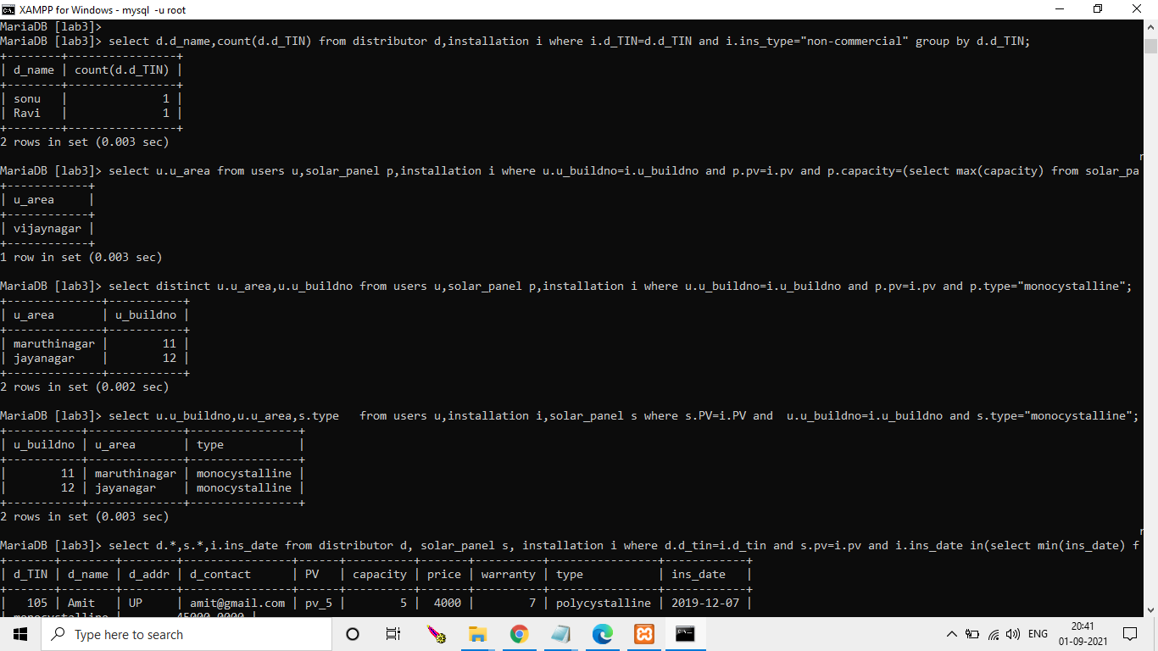

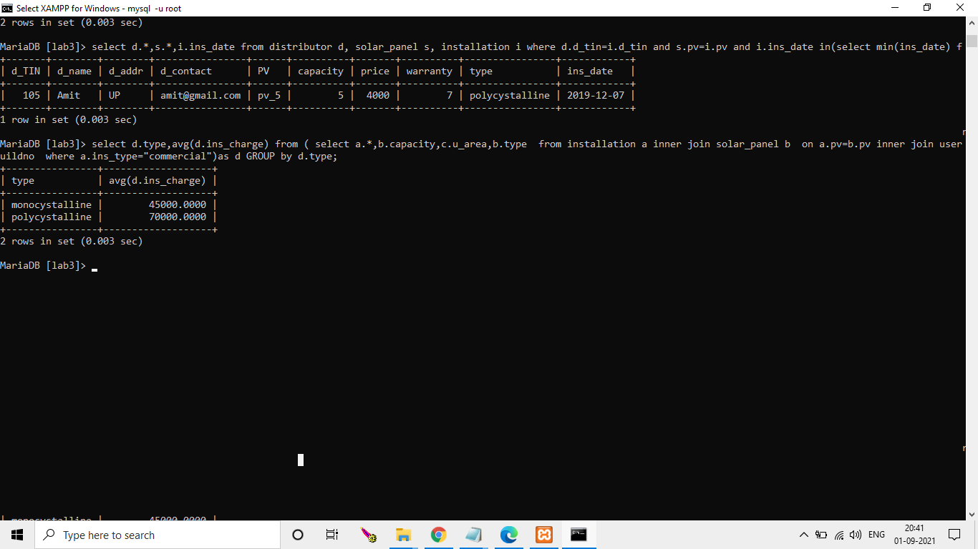

**Describe of a table:-**



