// create db

use rvce;

// to check db

show dbs;

db.dropDatabase()

1) Insert minimum 5 employee records.

-----------------------------------------

// insert records for emp table

db.emp.insert({_eid : "E1001" , ename:"Durgesh" , socialno : "S1001" ,addr1 : "knp" , esal : 90000 , gender : "M" , emp_exp : 10})

db.emp.insert({_eid : "E1006" , ename:"Adity" , socialno : "S1006" ,addr1 : "Mum" , esal :750000 , gender : "M" , emp_exp : 12 })

db.emp.insert({_eid : "E1007" , ename:"Anurag" , socialno : "S1007" ,addr1 : "Knp" , esal :95000 , gender : "M" , emp_exp : 14})

db.emp.find().forEach(printjson)

// insert records for dept table

db.dept.insert({_dno : "D101" , dname:"IT" , mgid : db.emp.find()[0]._eid , mg_start_date : 2005})

db.dept.insert({_dno : "D106" , dname:"finance" , mgid : db.emp.find()[5]._eid , mg_start_date : 2019})

db.dept.insert({_dno : "D107" , dname:"finance" , mgid : db.emp.find()[6]._eid , mg_start_date : 2020})

db.dept.find().forEach(printjson)

// insert records for project table

db.proj.insert({_pid : "P101" , pname:"retail" , ploc : "Blr" , dno : db.dept.find()[0]._dno})

db.proj.insert({_pid : "P106" , pname:"private" , ploc : "Hyd" , dno : db.dept.find()[5]._dno})

db.proj.insert({_pid : "P107" , pname:"retail" , ploc : "Hyd" , dno : db.dept.find()[6]._dno})

db.dept.find().forEach(printjson)

// insert records for workson table

db.workson.insert({eid : db.emp.find()[0]._eid , pid : db.proj.find()[0]._pid })

db.workson.insert({eid : db.emp.find()[1]._eid , pid : db.proj.find()[1]._pid })

db.workson.insert({eid : db.emp.find()[6]._eid , pid : db.proj.find()[6]._pid })

db.workson.find().forEach(printjson)

1.// display record

db.emp.find().pretty()

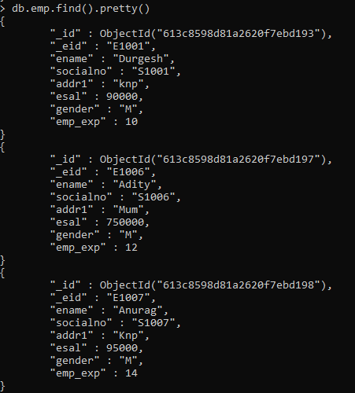

2) Sort the employee list by SSN

-------------------------------------

// ascending order

db.emp.find().sort({socialno:-1})

// descending order

db.emp.find().sort({socialno:-1})

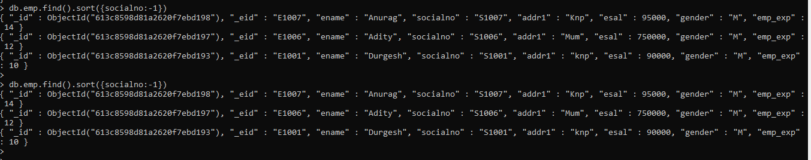

3) List the employees who are working in the finance department

-------------------------------------------------------------------

>db.employee.find({department:"finance"}).forEach(printjson);

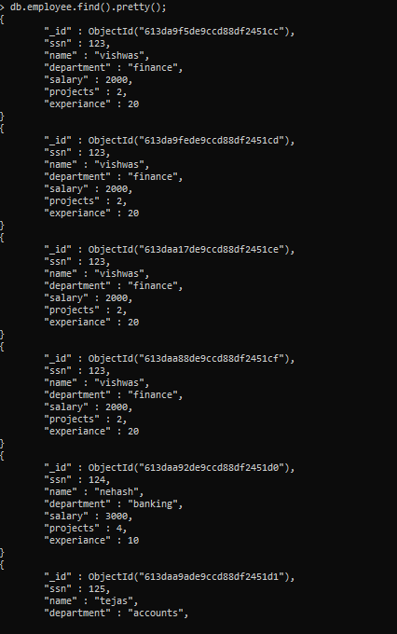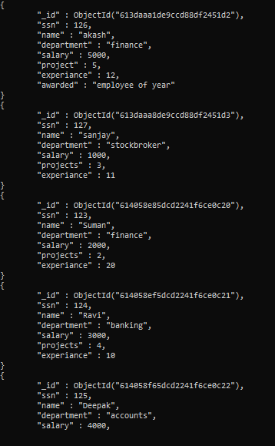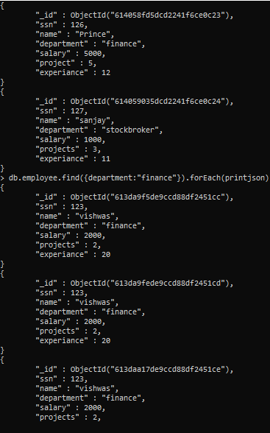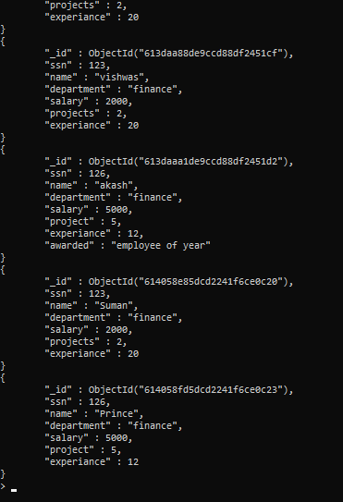

4) Find the employee who draws the maximum salary.

------------------------------------------------------

// to get highest salary

db.emp.find({}).sort({"esal":-1}).limit(1)

// second highest salary

db.emp.find({}).sort({"esal":-1}).skip(1).limit(1)



5) Update the record of the employee who has worked on maximum projects as “employee of the year”

-----------------------------------------------------------------------------------------------------

> db.employee.update({project:5},{$set:{awarded:"employee of year"}})

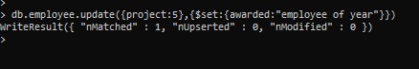

6) Delete employee records who have minimum experience

----------------------------------------------------------

db.emp.remove({emp_exp: db.emp.find().sort({emp_exp:1})[0].emp_exp})



