PROJECT DOCUMENTATION REPORT
ERASM
Enterprise Resource Allocation and Skill Management System
Prepared By
[ Student / Author Name ]
Institution
[ Institution / Organization Name ]
Document Date
July 6, 2026
Java | Spring Boot | Spring Security (JWT + Role-Based Access) | Spring Data JPA | MySQL

Table of Contents

1. Project Overview 3
2. Problem Statement 4
3. Database Design 4
3.1 Schema Overview 4
3.2 Table Structures 5
3.3 Entity Relationships 7
4. ER Diagram 8
5. API List 8
6. Screenshots 12
7. Test Cases 26

1 Project Overview
ERASM (Enterprise Resource Allocation and Skill Management System) is a Java Spring Boot backend application built to help an organization track employee skills and certifications, manage client projects, and allocate employees onto those projects through a structured, secured process. The system exposes its functionality as a REST API, protected with JWT-based authentication and role-based method authorization, and is backed by a MySQL relational database accessed through Spring Data JPA.
The implementation covers all ten functional modules called for in the project requirements: User Management, Skill Management, Employee Skill Profile, Project Management, Resource Request Management, Approval Workflow, Resource Allocation, Utilization Dashboard (delivered here as a Reports module), Audit Management, and Certification Management, together with a Role module underpinning the Employee-to-Role relationship.
Technology stack: Java, Spring Boot, Spring Web REST controllers, Spring Data JPA with Hibernate, Spring Security with a custom JWT filter and method-level @PreAuthorize checks (ADMIN, DELIVERY_MANAGER, RESOURCE_MANAGER, EMPLOYEE, AUDITOR roles), BCrypt password hashing, and MySQL as the relational datastore. The project also includes a JUnit / Mockito unit test suite, described in Section 7.

Module Summary
Module | Key Capabilities
User Management | Registration, login, and full account CRUD
Role Management | Maintain the set of roles used for access control
Skill Management | Maintain the master catalog of organizational skills
Employee Management | Maintain employee profiles linked to a user account and role
Employee Skill Profile | Assign skills to an employee with skill level and years of experience
Certification Management | Record certifications an employee holds, with issue and expiry dates
Project Management | Maintain client project records, technology stack, and budget
Resource Request Management | Raise a staffing request against a project for a required skill and count
Approval Workflow | Track a resource request through DRAFT, SUBMITTED, REVIEW, APPROVED, ALLOCATED, and COMPLETED states
Resource Allocation | Allocate an employee to a project at a given percentage, enforcing a 100% total cap across all of an employee's active allocations
Reports / Utilization | Skill inventory, allocation, and utilization reporting endpoints
Audit Management | Record of key actions performed across the system, with who performed them and when

2 Problem Statement
Organizations that run multiple concurrent client engagements need a reliable way to answer three recurring questions: which employees hold which skills and at what level, which employees are available versus already committed to a project, and whether a given staffing decision has gone through a consistent, traceable approval process. Where these questions are answered informally, through spreadsheets, verbal confirmation, or scattered communication, organizations run into predictable problems.
Skill and certification records fall out of date because there is no single system of record for them. Staffing decisions are made without a reliable view of an employee's existing workload, risking over-commitment beyond what is actually available. Requests for staff on a new project move between stakeholders without a formal, auditable approval trail. There is no straightforward way to see organization-wide utilization, or to confirm that an allocation decision was checked against an employee's existing commitments before it was made.
ERASM addresses each of these problems directly: a centralized Employee Skill Profile keeps skill and certification data in one place; the Resource Allocation module enforces a hard 100% cap on an employee's combined allocation percentage across all active assignments; a defined Approval Workflow status model (DRAFT through SUBMITTED, REVIEW, APPROVED, ALLOCATED, and COMPLETED) gives every staffing decision a consistent lifecycle; role-based access control ensures only the appropriate role can create, approve, or delete sensitive records; and the Audit Management module keeps a durable record of key actions for traceability.
The remainder of this report documents the data model built to support these goals (Section 3), the ER diagram for that model (Section 4), the REST API implemented against it (Section 5), verification screenshots (Section 6), and the automated unit test suite covering the service layer (Section 7).

3 Database Design
The schema below matches both the ER diagram in Section 4 and the JPA entity classes in the codebase, ten tables in total, satisfying the database requirements in the project specification.

3.1 Schema Overview
Table | Purpose
roles | Master list of roles used for role-based access control
users | Login accounts: name, email, password hash, and active status
employees | Employee profile linked to a user account and a role
skills | Master catalog of skills the organization tracks
employee_skills | Many-to-many association between employees and skills, carrying skill level and years of experience
certifications | Certifications an employee holds, with issuing organization and dates
projects | Client projects the organization is delivering
resource_requests | Staffing requests raised against a project for a required skill and count
allocations | Actual assignment of an employee to a project at a given allocation percentage
audit_logs | Audit trail of key actions performed across the system

3.2 Table Structures
roles
Column | Type | Key / Constraint
roleId | BIGINT | Primary Key
roleName | VARCHAR(255) | Not Null, Unique
users
Column | Type | Key / Constraint
userId | BIGINT | Primary Key
firstName / lastName | VARCHAR(255) | Not Null
email | VARCHAR(255) | Not Null, Unique
password | VARCHAR(255) | Not Null (BCrypt hash)
active | BOOLEAN | Not Null
employees
Column | Type | Key / Constraint
employeeId | BIGINT | Primary Key
employeeCode | VARCHAR(255) | Not Null, Unique
department | VARCHAR(255) | Not Null
designation | VARCHAR(255) | Not Null
experience | INT | Not Null
availability | BOOLEAN | Not Null
user | BIGINT (FK) | One-to-One to users
role | BIGINT (FK) | Many-to-One to roles
skills
Column | Type | Key / Constraint
skillId | BIGINT | Primary Key
skillName | VARCHAR(255) | Not Null, Unique
description | VARCHAR(255) | —
employee_skills
Column | Type | Key / Constraint
employeeSkillId | BIGINT | Primary Key
employee | BIGINT (FK) | Many-to-One to employees
skill | BIGINT (FK) | Many-to-One to skills
skillLevel | VARCHAR(255) | Not Null
experienceYears | INT | Not Null
certifications
Column | Type | Key / Constraint
certificationId | BIGINT | Primary Key
certificationName | VARCHAR(255) | Not Null
issuingOrganization | VARCHAR(255) | Not Null
issueDate | VARCHAR(255) | Not Null
expiryDate | VARCHAR(255) | —
employee | BIGINT (FK) | Many-to-One to employees
projects
Column | Type | Key / Constraint
projectId | BIGINT | Primary Key
projectName | VARCHAR(255) | Not Null
clientName | VARCHAR(255) | Not Null
startDate / endDate | VARCHAR(255) | Not Null
technologyStack | VARCHAR(255) | Not Null
budget | DOUBLE | Not Null
resource_requests
Column | Type | Key / Constraint
requestId | BIGINT | Primary Key
project | BIGINT (FK) | Many-to-One to projects
requiredSkill | VARCHAR(255) | Not Null
requiredCount | INT | Not Null
status | VARCHAR(255) | DRAFT / SUBMITTED / REVIEW / APPROVED / ALLOCATED / COMPLETED
allocations
Column | Type | Key / Constraint
allocationId | BIGINT | Primary Key
employee | BIGINT (FK) | Many-to-One to employees
project | BIGINT (FK) | Many-to-One to projects
allocationPercentage | DOUBLE | Not Null, 1–100 (validated against the employee's existing total)
allocationDate | VARCHAR(255) | Not Null
releaseDate | VARCHAR(255) | —
status | VARCHAR(255) | Not Null
audit_logs
Column | Type | Key / Constraint
auditId | BIGINT | Primary Key
action | VARCHAR(255) | Not Null
createdBy / modifiedBy | VARCHAR(255) | Not Null
createdDate / modifiedDate | VARCHAR(255) | Not Null

3.3 Entity Relationships
The relationships below satisfy the JPA relationship types called for in the project requirements.
Relationship Type | Entities | Description
One-to-One | User ↔ Employee | Each employee profile belongs to exactly one user account
Many-to-One | Employee → Role | Each employee has exactly one assigned role
One-to-Many | Project → Resource Request | A project can have many resource requests raised against it
Many-to-Many | Employee ↔ Skill | Implemented via employee_skills, which also carries skill level and years of experience
Many-to-One | Certification → Employee | Each certification belongs to one employee
Many-to-One | Allocation → Employee, Allocation → Project | Each allocation assigns one employee to one project
One-to-Many | Project → Allocation | A project can have many employees allocated to it

4 ER Diagram
The entity relationship diagram below was supplied for this project and is included as provided.
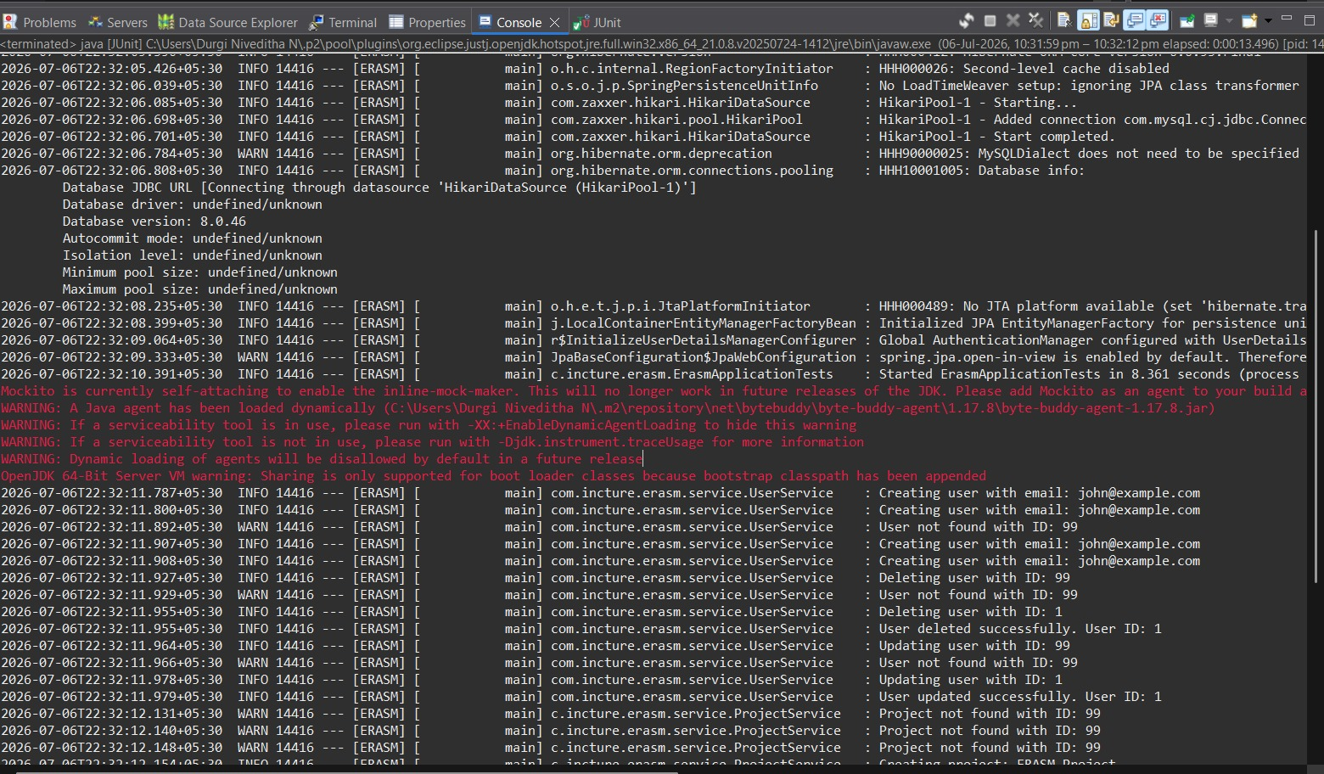
Figure 4.1 — ERASM Entity Relationship Diagram

5 API List
Base URL: http://localhost:8081. Most endpoints are namespaced under /api; the Authentication endpoints are the one exception, living directly under /auth. “ADMIN”, “EMPLOYEE”, and so on in the Access column mean the endpoint is restricted with @PreAuthorize to that role.

Authentication
Method | Endpoint | Description | Access
POST | /auth/login | Authenticate with email and password; returns a JWT | Public
POST | /auth/register | Register a new user account | Public

User Management
Method | Endpoint | Description | Access
POST | /api/users | Create a user | ADMIN
GET | /api/users | List all users | ADMIN
GET | /api/users/{id} | Get a user by ID | ADMIN
PUT | /api/users/{id} | Update a user | ADMIN
DELETE | /api/users/{id} | Delete a user | ADMIN

Role Management
Method | Endpoint | Description | Access
POST | /api/roles | Create a role | ADMIN
GET | /api/roles | List all roles | ADMIN
GET | /api/roles/{id} | Get a role by ID | ADMIN
PUT | /api/roles/{id} | Update a role | ADMIN
DELETE | /api/roles/{id} | Delete a role | ADMIN

Skill Management
Method | Endpoint | Description | Access
POST | /api/skills | Create a skill | ADMIN
GET | /api/skills | List all skills | ADMIN
GET | /api/skills/{id} | Get a skill by ID | ADMIN
PUT | /api/skills/{id} | Update a skill | ADMIN
DELETE | /api/skills/{id} | Delete a skill | ADMIN

Employee Management
Method | Endpoint | Description | Access
POST | /api/employees | Create an employee profile | ADMIN / EMPLOYEE
GET | /api/employees | List all employees | ADMIN / EMPLOYEE
GET | /api/employees/{id} | Get an employee by ID | ADMIN / EMPLOYEE
PUT | /api/employees/{id} | Update an employee | ADMIN / EMPLOYEE
DELETE | /api/employees/{id} | Delete an employee | ADMIN / EMPLOYEE

Employee Skill Profile
Method | Endpoint | Description | Access
POST | /api/employee-skills | Assign a skill to an employee, with level and experience | Authenticated
GET | /api/employee-skills | List all employee skill records | Authenticated
GET | /api/employee-skills/{id} | Get an employee skill record by ID | Authenticated
PUT | /api/employee-skills/{id} | Update an employee skill record | Authenticated
DELETE | /api/employee-skills/{id} | Remove a skill from an employee's profile | Authenticated

Certification Management
Method | Endpoint | Description | Access
POST | /api/certifications | Add a certification for an employee | Authenticated
GET | /api/certifications | List all certifications | Authenticated
GET | /api/certifications/{id} | Get a certification by ID | Authenticated
PUT | /api/certifications/{id} | Update a certification | Authenticated
DELETE | /api/certifications/{id} | Delete a certification | Authenticated

Project Management
Method | Endpoint | Description | Access
POST | /api/projects | Create a project | ADMIN / DELIVERY_MANAGER
GET | /api/projects | List all projects | ADMIN / DELIVERY_MANAGER
GET | /api/projects/{id} | Get a project by ID | ADMIN / DELIVERY_MANAGER
PUT | /api/projects/{id} | Update a project | ADMIN / DELIVERY_MANAGER
DELETE | /api/projects/{id} | Delete a project | ADMIN / DELIVERY_MANAGER

Resource Request Management and Approval Workflow
Method | Endpoint | Description | Access
POST | /api/resource-requests | Create a resource request (status validated against the allowed workflow states) | ADMIN / DELIVERY_MANAGER
GET | /api/resource-requests | List all resource requests | ADMIN / DELIVERY_MANAGER
GET | /api/resource-requests/{id} | Get a resource request by ID | ADMIN / DELIVERY_MANAGER
PUT | /api/resource-requests/{id} | Update a resource request, including its workflow status | ADMIN / DELIVERY_MANAGER
DELETE | /api/resource-requests/{id} | Delete a resource request | ADMIN / DELIVERY_MANAGER
The workflow status (DRAFT, SUBMITTED, REVIEW, APPROVED, ALLOCATED, COMPLETED) is validated against the allowed set of values on create and update, rather than through dedicated /submit, /approve, and /reject endpoints; the update endpoint is the single place a request's status is moved forward.

Resource Allocation
Method | Endpoint | Description | Access
POST | /api/allocations | Allocate an employee to a project (rejects a total over 100% across all of the employee's allocations) | ADMIN / RESOURCE_MANAGER
GET | /api/allocations | List all allocations | ADMIN / RESOURCE_MANAGER
GET | /api/allocations/{id} | Get an allocation by ID | ADMIN / RESOURCE_MANAGER
PUT | /api/allocations/{id} | Update an allocation | ADMIN / RESOURCE_MANAGER
DELETE | /api/allocations/{id} | Delete an allocation | ADMIN / RESOURCE_MANAGER

Reports
Method | Endpoint | Description | Access
GET | /api/reports/skills | Skill inventory report | ADMIN / RESOURCE_MANAGER / DELIVERY_MANAGER
GET | /api/reports/allocations | Allocation report | ADMIN / RESOURCE_MANAGER / DELIVERY_MANAGER
GET | /api/reports/utilization | Utilization report | ADMIN / RESOURCE_MANAGER / DELIVERY_MANAGER

Audit Management
Method | Endpoint | Description | Access
POST | /api/audit-logs | Manually record an audit entry | ADMIN / AUDITOR
GET | /api/audit-logs | List all audit log entries | ADMIN / AUDITOR
GET | /api/audit-logs/{id} | Get an audit log entry by ID | ADMIN / AUDITOR
PUT | /api/audit-logs/{id} | Update an audit log entry | ADMIN / AUDITOR
DELETE | /api/audit-logs/{id} | Delete an audit log entry | ADMIN / AUDITOR

6 Screenshots
About this section
These screenshots were supplied as a set of image files without individual endpoint labels. They are included below in the order provided as general verification evidence of the API being exercised in Postman; if specific captions are wanted for particular endpoints, let me know which image corresponds to which request and I will relabel them precisely.
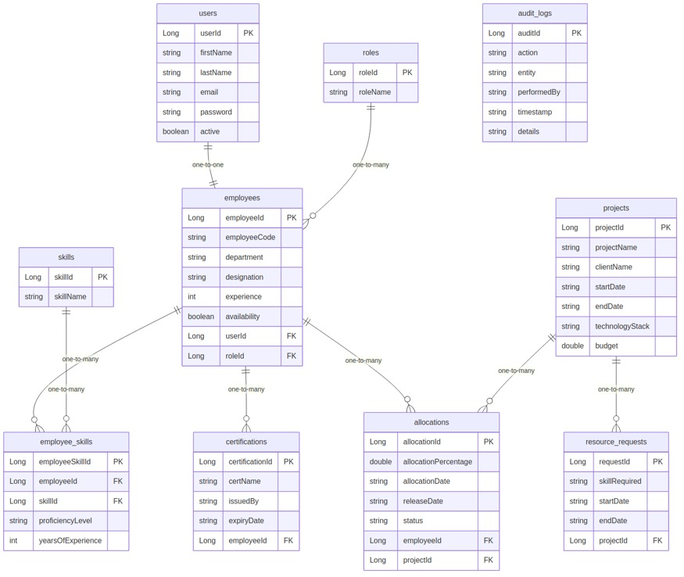
Screenshot 1 — API verification
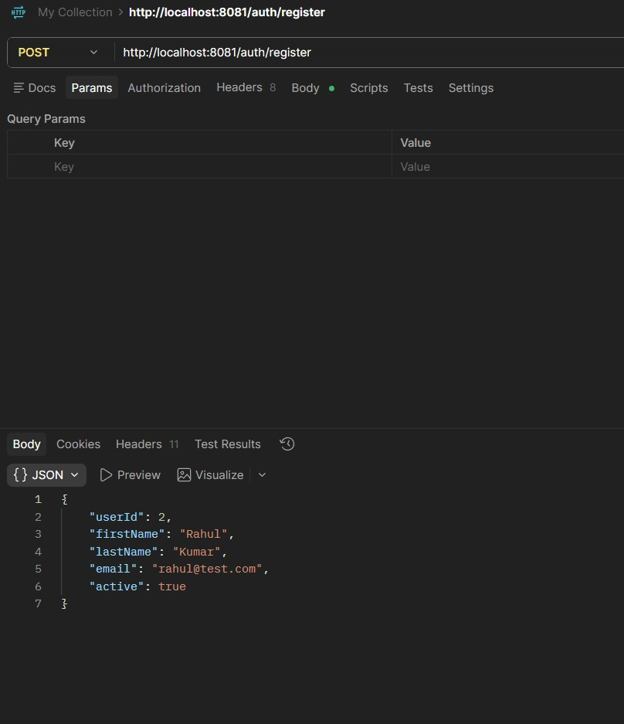
Screenshot 2 — API verification
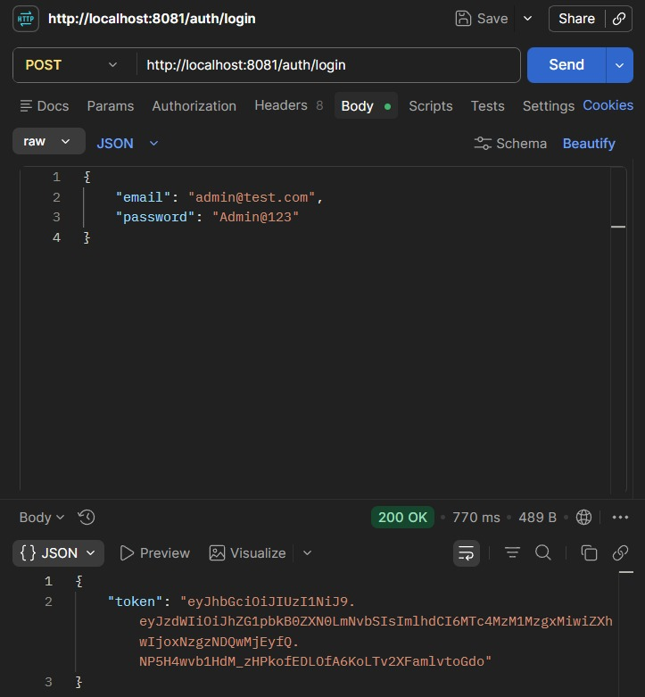
Screenshot 3 — API verification
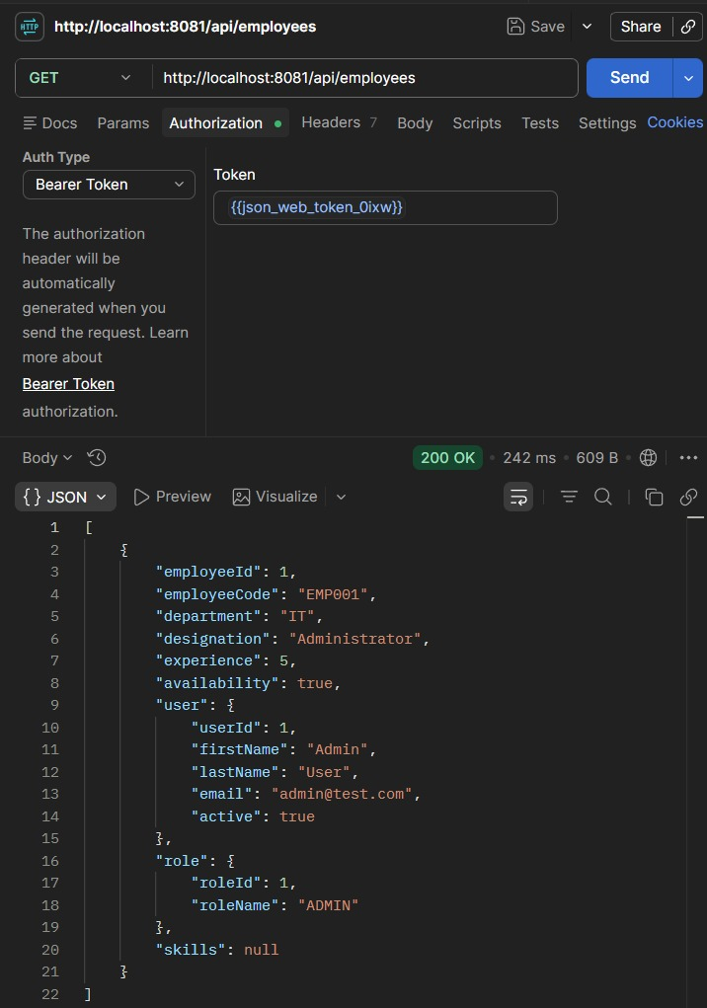
Screenshot 4 — API verification
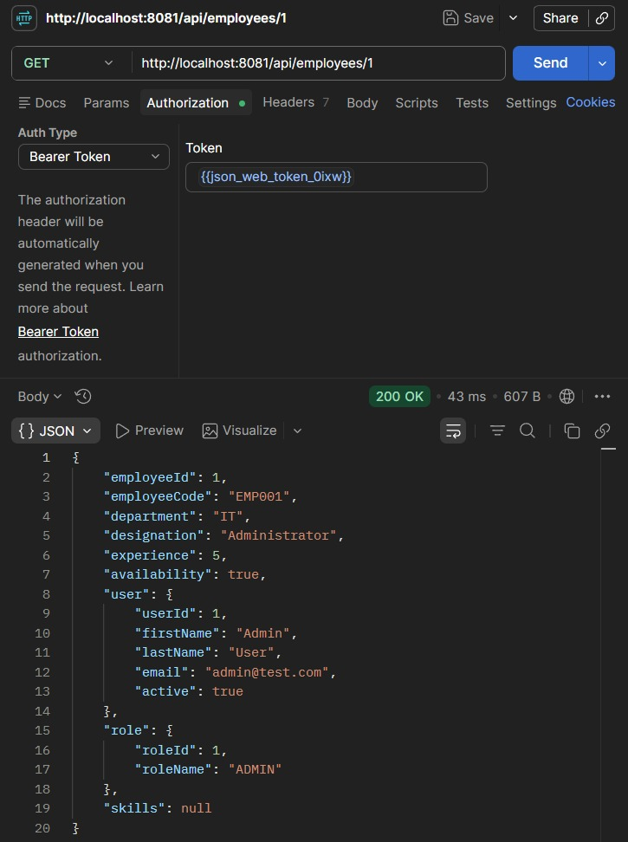
Screenshot 5 — API verification
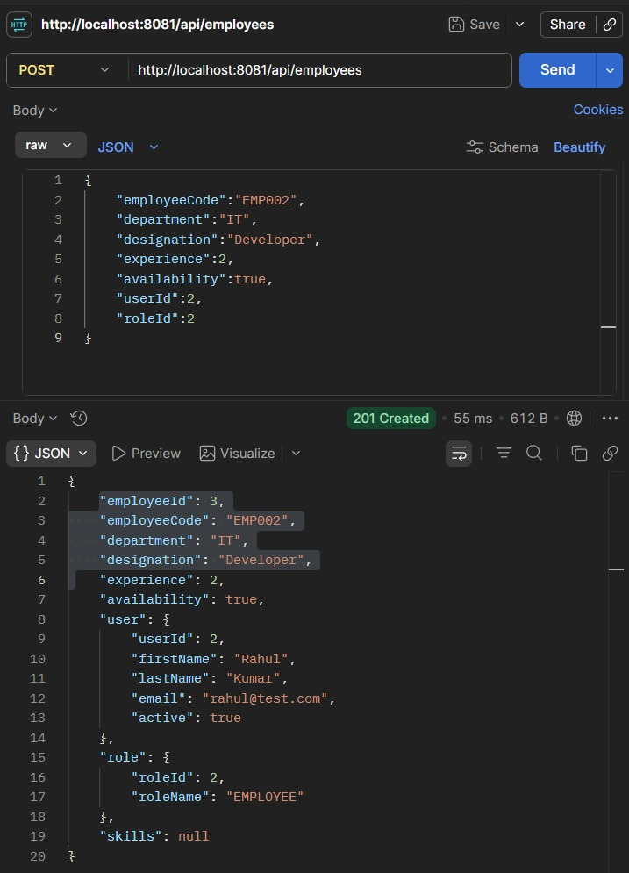
Screenshot 6 — API verification
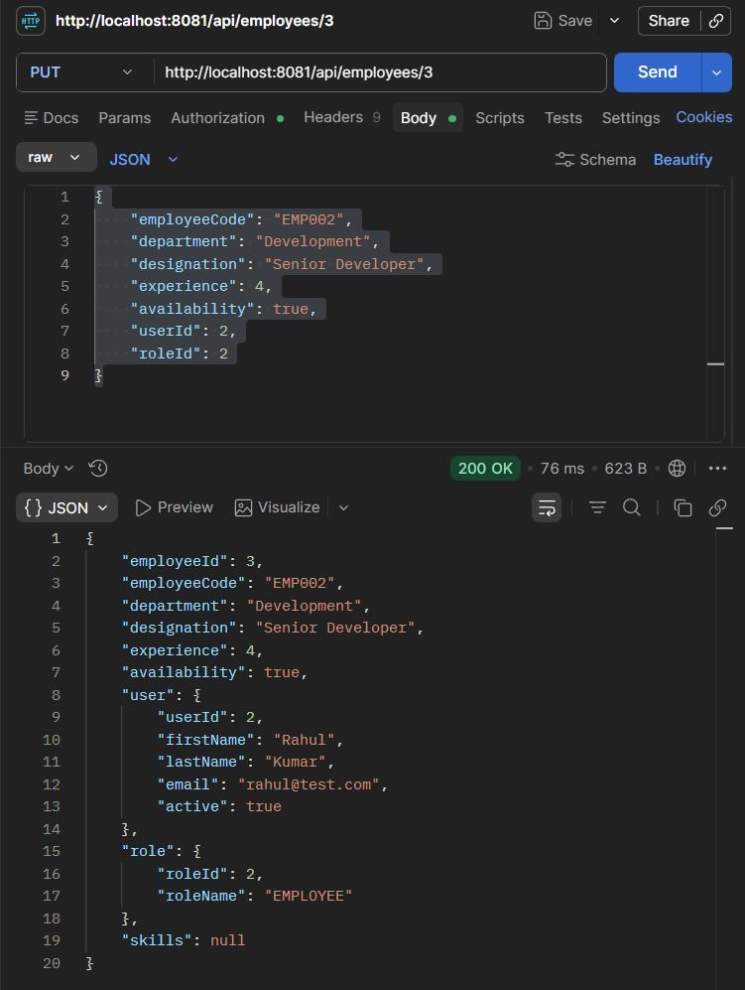
Screenshot 7 — API verification
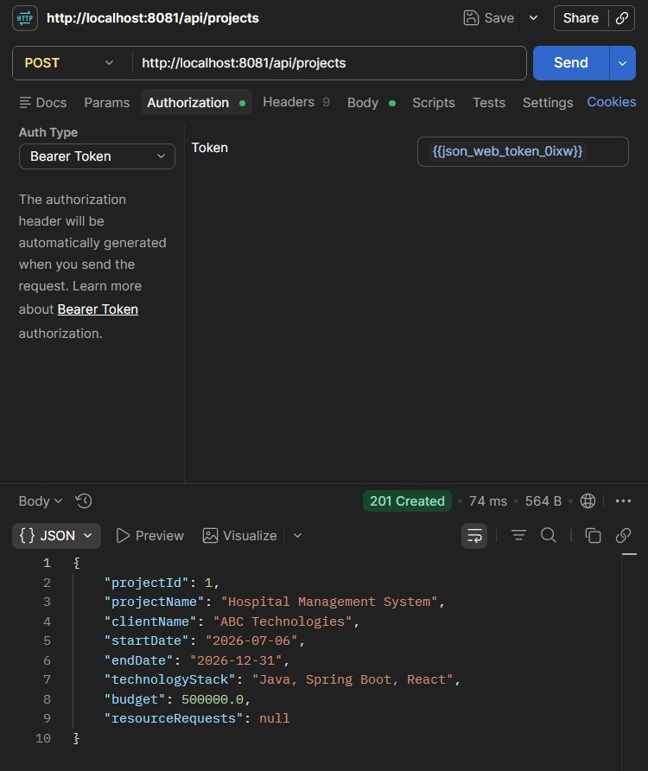
Screenshot 8 — API verification
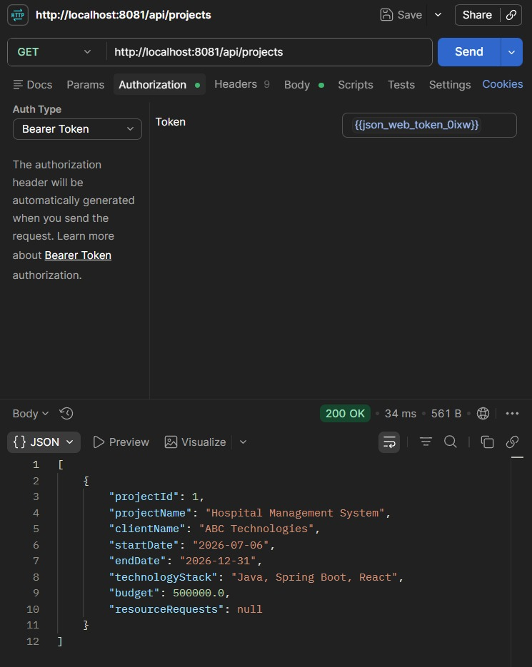
Screenshot 9 — API verification
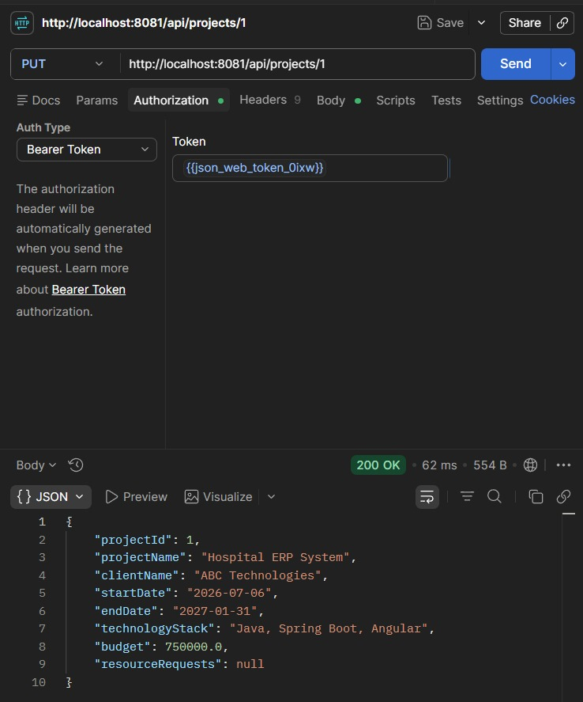
Screenshot 10 — API verification
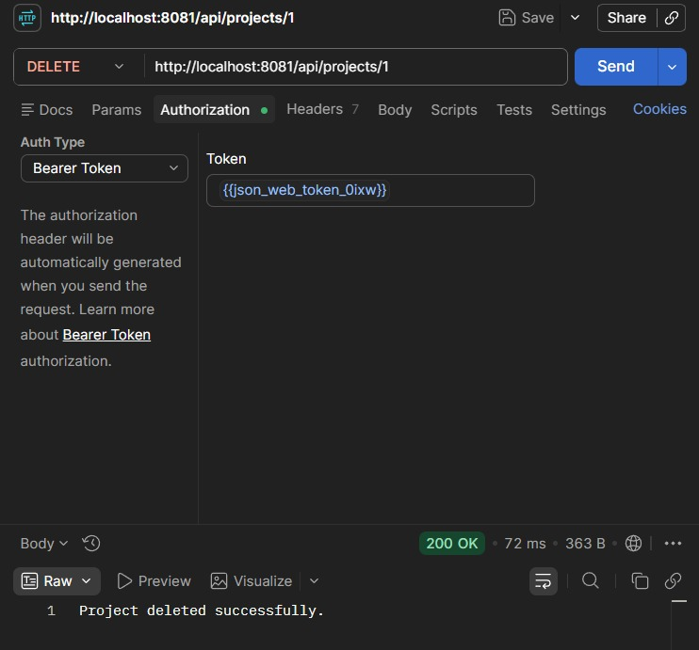
Screenshot 11 — API verification
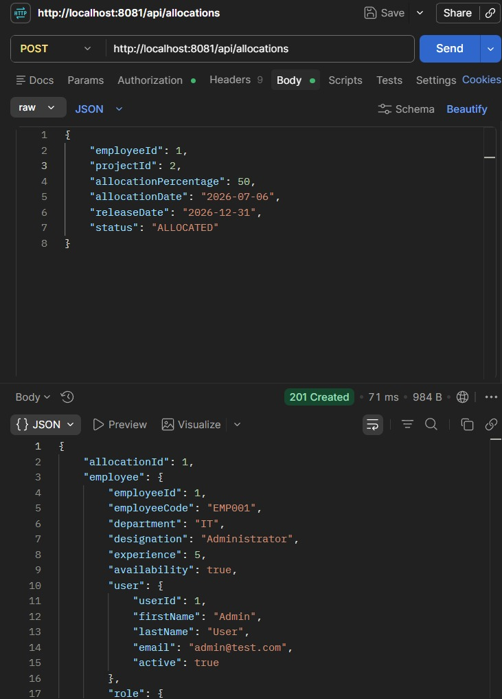
Screenshot 12 — API verification
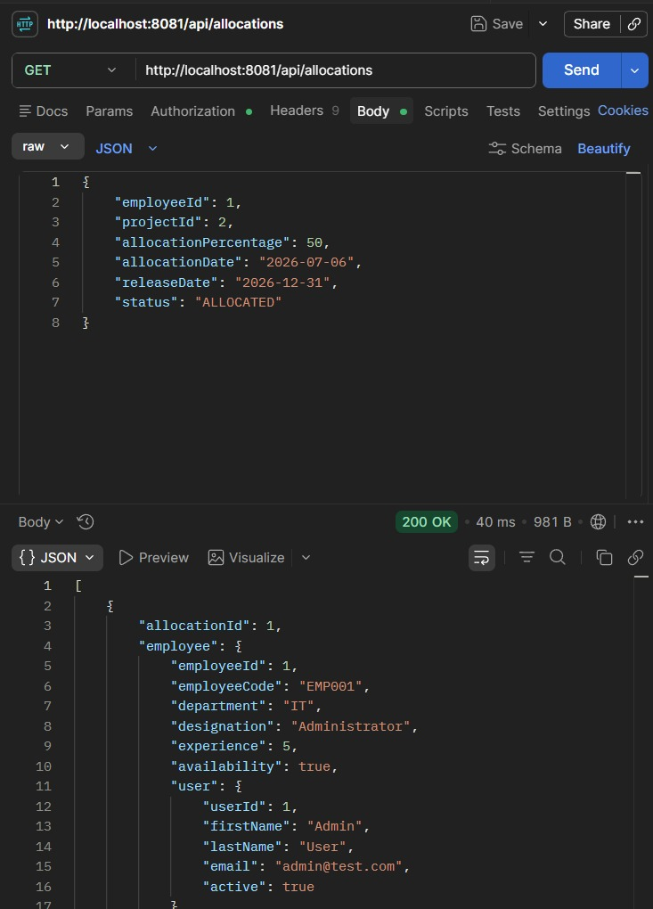
Screenshot 13 — API verification
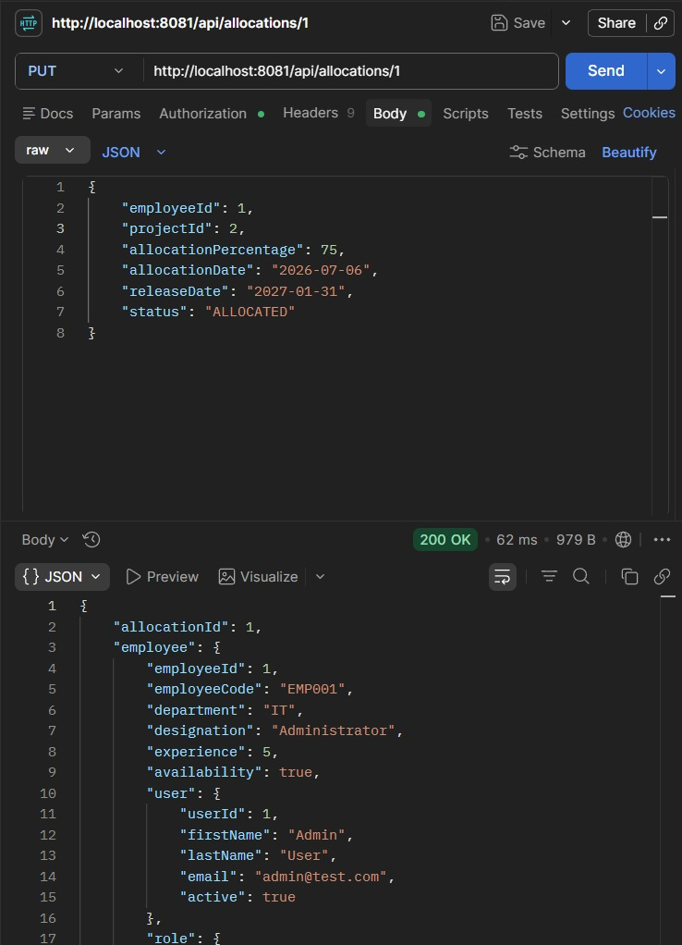
Screenshot 14 — API verification
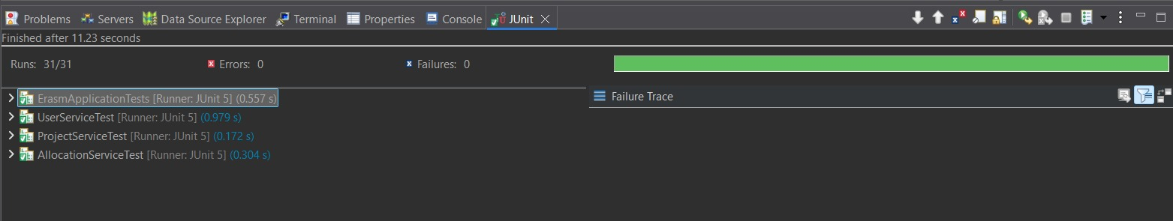
Screenshot 15 — API verification

7 Test Cases
The project includes an automated unit test suite written with JUnit 5 and Mockito, covering the Allocation, Project, and User services in depth, plus the default Spring Boot context-load test. Repositories are mocked so each test verifies business logic in isolation.
Test Class | Test Method | Verifies
AllocationServiceTest | createAllocation_Success | A valid allocation is created and saved
AllocationServiceTest | createAllocation_ExceedsHundredPercent_ThrowsException | An allocation pushing the employee's total over 100% is rejected
AllocationServiceTest | createAllocation_ExactlyHundredPercent_Success | An allocation that brings the total to exactly 100% is accepted
AllocationServiceTest | createAllocation_EmployeeNotFound_ThrowsException | Allocating a non-existent employee is rejected
AllocationServiceTest | createAllocation_ProjectNotFound_ThrowsException | Allocating to a non-existent project is rejected
AllocationServiceTest | getAllocationById_Success | An existing allocation is retrieved correctly
AllocationServiceTest | getAllocationById_NotFound_ThrowsException | Requesting a non-existent allocation ID fails correctly
AllocationServiceTest | getAllAllocations_ReturnsAllAllocations | All allocations are retrieved correctly
AllocationServiceTest | deleteAllocation_Success | An allocation is deleted correctly
AllocationServiceTest | deleteAllocation_NotFound_ThrowsException | Deleting a non-existent allocation fails correctly
ProjectServiceTest | createProject_Success | A new project is created and saved
ProjectServiceTest | createProject_SaveCalledOnce | The repository's save method is invoked exactly once per creation
ProjectServiceTest | getProjectById_Success | An existing project is retrieved correctly
ProjectServiceTest | getProjectById_NotFound_ThrowsException | Requesting a non-existent project ID fails correctly
ProjectServiceTest | getAllProjects_ReturnsAllProjects | All projects are retrieved correctly
ProjectServiceTest | getAllProjects_EmptyList_ReturnsEmptyList | An empty project list is handled without error
ProjectServiceTest | updateProject_Success | An existing project's fields are updated correctly
ProjectServiceTest | updateProject_NotFound_ThrowsException | Updating a non-existent project fails correctly
ProjectServiceTest | deleteProject_Success | A project is deleted correctly
ProjectServiceTest | deleteProject_NotFound_ThrowsException | Deleting a non-existent project fails correctly
UserServiceTest | createUser_Success | A new user is created and saved
UserServiceTest | createUser_PasswordIsEncoded | The user's password is stored BCrypt-encoded, not in plain text
UserServiceTest | getUserById_Success | An existing user is retrieved correctly
UserServiceTest | getUserById_UserNotFound_ThrowsException | Requesting a non-existent user ID fails correctly
UserServiceTest | getAllUsers_ReturnsAllUsers | All users are retrieved correctly
UserServiceTest | getAllUsers_EmptyList_ReturnsEmptyList | An empty user list is handled without error
UserServiceTest | updateUser_Success | An existing user's fields are updated correctly
UserServiceTest | updateUser_UserNotFound_ThrowsException | Updating a non-existent user fails correctly
UserServiceTest | deleteUser_Success | A user is deleted correctly
UserServiceTest | deleteUser_UserNotFound_ThrowsException | Deleting a non-existent user fails correctly
Test coverage is currently strongest for Resource Allocation, Project Management, and User Management, each with a full suite of success, not-found, and edge-case tests (including the exact-100% boundary case for allocation). Extending the same pattern to Skill, Employee, Employee Skill, Certification, Resource Request, Role, Report, and Audit Log services would be a natural next step and is a straightforward extension of the existing test style rather than a new approach.

