SOFTWARE TESTING REPORT
ERASM
Enterprise Resource Allocation and Skill Management System
Test Framework
JUnit 5 + Mockito
Basis For This Report
Static analysis of test source code
Document Date
July 6, 2026

1 Test Summary
Basis for this report
No live JUnit run or console output was supplied for this report, so it is built from a direct, line-by-line reading of the actual test source files in the project (src/test/java/com/incture/erasm). Every test case listed in Section 3 reflects a real @Test method, its mocked setup, and its actual assertions, not an assumption about what the tests probably do. This project's build could not be executed in this environment because Maven dependency resolution requires access to Maven Central, which is not reachable here; running mvn test locally and sharing the console/JUnit output would let this report be upgraded to a full execution report with real pass/fail results, as previous reports for this project have included.
The test suite comprises 31 test methods across four test classes: one Spring Boot application context-load test and three service-layer unit test classes (Allocation, Project, and User), all using JUnit 5 with the Mockito extension so that repository dependencies are mocked and each test verifies business logic in isolation.
Metric | Value
Test Classes | 4
Total Test Methods | 31 (30 @Test methods + 1 application context-load test)
Framework | JUnit 5 (Jupiter), Mockito (MockitoExtension)
Test Style | Isolated service-layer unit tests; repositories mocked with @Mock / @InjectMocks
Modules With Dedicated Tests | Resource Allocation, Project Management, User Management
Modules Without Dedicated Tests | Role, Skill, Employee, Employee Skill, Certification, Resource Request, Report, Audit Log (8 modules)

2 Test Suite Composition
Test Class | Module Under Test | Test Methods
ErasmApplicationTests | Full Spring application context load | 1
AllocationServiceTest | Resource Allocation | 10
ProjectServiceTest | Project Management | 10
UserServiceTest | User Management | 10
Each of the three service test classes follows the same structure: a @BeforeEach setUp() method builds a consistent set of fixture objects, followed by @Test methods grouped by operation (create, get by ID, get all, update, delete), each covering both the success path and at least one failure path (not-found, validation failure, or a business rule violation).

3 Detailed Test Case Specifications
This section documents exactly what each test method sets up and asserts, transcribed from the actual test source code.

AllocationServiceTest
Fixture: an Employee (id 1, code EMP001, Engineering/Developer, 3 years' experience, linked to a User and an EMPLOYEE Role), a Project (id 1, budget 100,000), and a request to allocate the employee to the project at 50%.
Test Method | Setup / Given | Assertions Verified
createAllocation_Success | Employee and project both exist; employee has no existing allocations | Result is not null; allocationPercentage = 50.0; status = "ACTIVE"; repository.save() called exactly once
createAllocation_ExceedsHundredPercent_ThrowsException | Employee already has a 70% allocation; new request is 50% (70 + 50 = 120) | Throws AllocationException with message "Employee allocation cannot exceed 100%"; save() never called
createAllocation_ExactlyHundredPercent_Success | Employee already has a 50% allocation; new request is 50% (50 + 50 = 100 exactly) | Does not throw; save() called exactly once — confirms the cap is “over 100”, not “100 or more”
createAllocation_EmployeeNotFound_ThrowsException | employeeRepository.findById() returns empty | Throws ResourceNotFoundException; save() never called
createAllocation_ProjectNotFound_ThrowsException | Employee found, but projectRepository.findById() returns empty | Throws an exception; save() never called
getAllocationById_Success | Allocation with id 1 exists | Result is not null; allocationId = 1; allocationPercentage = 50.0
getAllocationById_NotFound_ThrowsException | allocationRepository.findById() returns empty for id 99 | Throws AllocationException
getAllAllocations_ReturnsAllAllocations | Repository returns two allocations | Result list size is 2; findAll() called exactly once
deleteAllocation_Success | Allocation with id 1 exists | Does not throw; repository.delete() called exactly once
deleteAllocation_NotFound_ThrowsException | allocationRepository.findById() returns empty for id 99 | Throws AllocationException; delete() never called
The ExceedsHundredPercent and ExactlyHundredPercent pair is a well-designed boundary test: it proves the 100% cap is enforced as “strictly greater than 100 is rejected” rather than an off-by-one variant that would incorrectly reject a valid exactly-100% allocation.

ProjectServiceTest
Fixture: a Project (id 1, “ERASM Project”, client “Incture”, budget 500,000) and a matching ProjectRequestDto.
Test Method | Setup / Given | Assertions Verified
createProject_Success | projectRepository.save() returns the fixture project | Result not null; projectName = "ERASM Project"; clientName = "Incture"; budget = 500000.0; save() called once
createProject_SaveCalledOnce | Same as above | save() called exactly once (isolates the interaction-count check from the value checks above)
getProjectById_Success | Project with id 1 exists | Result not null; projectId = 1; projectName = "ERASM Project"
getProjectById_NotFound_ThrowsException | findById() returns empty for id 99 | Throws ProjectNotFoundException with message "Project not found"
getAllProjects_ReturnsAllProjects | Repository returns two projects | Result size 2; order preserved ("ERASM Project" first, "Second Project" second)
getAllProjects_EmptyList_ReturnsEmptyList | Repository returns an empty list | Result is not null and has size 0 (no null-pointer or exception on empty input)
updateProject_Success | Project id 1 exists; update changes name, client, dates, stack, and budget | Result reflects all updated fields ("Updated Project", "New Client", budget 750000.0); save() called once
updateProject_NotFound_ThrowsException | findById() returns empty for id 99 | Throws ProjectNotFoundException; save() never called
deleteProject_Success | Project id 1 exists | Does not throw; delete() called exactly once
deleteProject_NotFound_ThrowsException | findById() returns empty for id 99 | Throws ProjectNotFoundException; delete() never called

UserServiceTest
Fixture: a User (id 1, John Doe, john@example.com, active) and a matching UserRequestDto with a plain-text password.
Test Method | Setup / Given | Assertions Verified
createUser_Success | passwordEncoder.encode() and userRepository.save() both stubbed | Result reflects firstName, lastName, email, and active = true; save() and encode() each called once
createUser_PasswordIsEncoded | encode("password123") stubbed to return "encodedPassword123" | Verifies encode() was called with the raw password — confirms the password is never persisted in plain text
getUserById_Success | User id 1 exists | Result not null; userId = 1; firstName = "John"; email = "john@example.com"
getUserById_UserNotFound_ThrowsException | findById() returns empty for id 99 | Throws UserNotFoundException with message "User not found"
getAllUsers_ReturnsAllUsers | Repository returns two users | Result size 2; order preserved (John first, Jane second)
getAllUsers_EmptyList_ReturnsEmptyList | Repository returns an empty list | Result is not null and has size 0
updateUser_Success | User id 1 exists; new password is re-encoded | Result reflects updated first name and email; save() called once
updateUser_UserNotFound_ThrowsException | findById() returns empty for id 99 | Throws UserNotFoundException; save() never called
deleteUser_Success | User id 1 exists | Does not throw; delete() called exactly once
deleteUser_UserNotFound_ThrowsException | findById() returns empty for id 99 | Throws UserNotFoundException; delete() never called

4 Test Coverage Analysis
The table below maps every module in the application (per the accompanying Project Documentation Report) against whether it currently has a dedicated automated test class.
Module | Dedicated Test Class | Coverage
Resource Allocation | AllocationServiceTest | Strong — success, not-found, and both boundary cases for the 100% cap
Project Management | ProjectServiceTest | Strong — success, not-found, and empty-list cases across all five operations
User Management | UserServiceTest | Strong — success, not-found, empty-list, and password-encoding verification
Role Management | None | Not covered
Skill Management | None | Not covered
Employee Management | None | Not covered
Employee Skill Profile | None | Not covered
Certification Management | None | Not covered
Resource Request Management / Approval Workflow | None | Not covered
Reports | None | Not covered
Audit Management | None | Not covered
The three covered modules share a consistent, thorough test pattern (success path, not-found path, empty-collection path, and interaction verification via Mockito's verify()). Extending this exact pattern to the remaining eight modules would be a mechanical, low-risk exercise rather than new test design work, since the CertificationService, SkillService, EmployeeService, and similar classes follow the same repository-backed structure already proven testable by the existing three classes.

5 How to Execute This Suite
To generate a live execution report (pass/fail counts, timing, and console output) alongside this specification:
▪ From the project root, run: mvn test
▪ Or, in Eclipse/STS: right-click the project → Run As → JUnit Test
▪ The JUnit run panel will report Runs / Errors / Failures and a per-class breakdown, matching the structure already documented in Section 2
▪ A JUnit XML/HTML report will also be written under target/surefire-reports if run via Maven, suitable as the separate “Test Report” deliverable
Sharing a screenshot of that run (console output and/or the JUnit panel) will allow this document to be extended with a genuine execution results section, as was done for an earlier version of this project.

OUTPUT SCREENSHOTS: 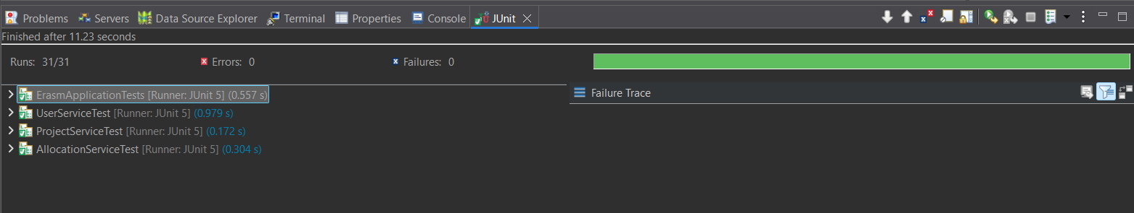
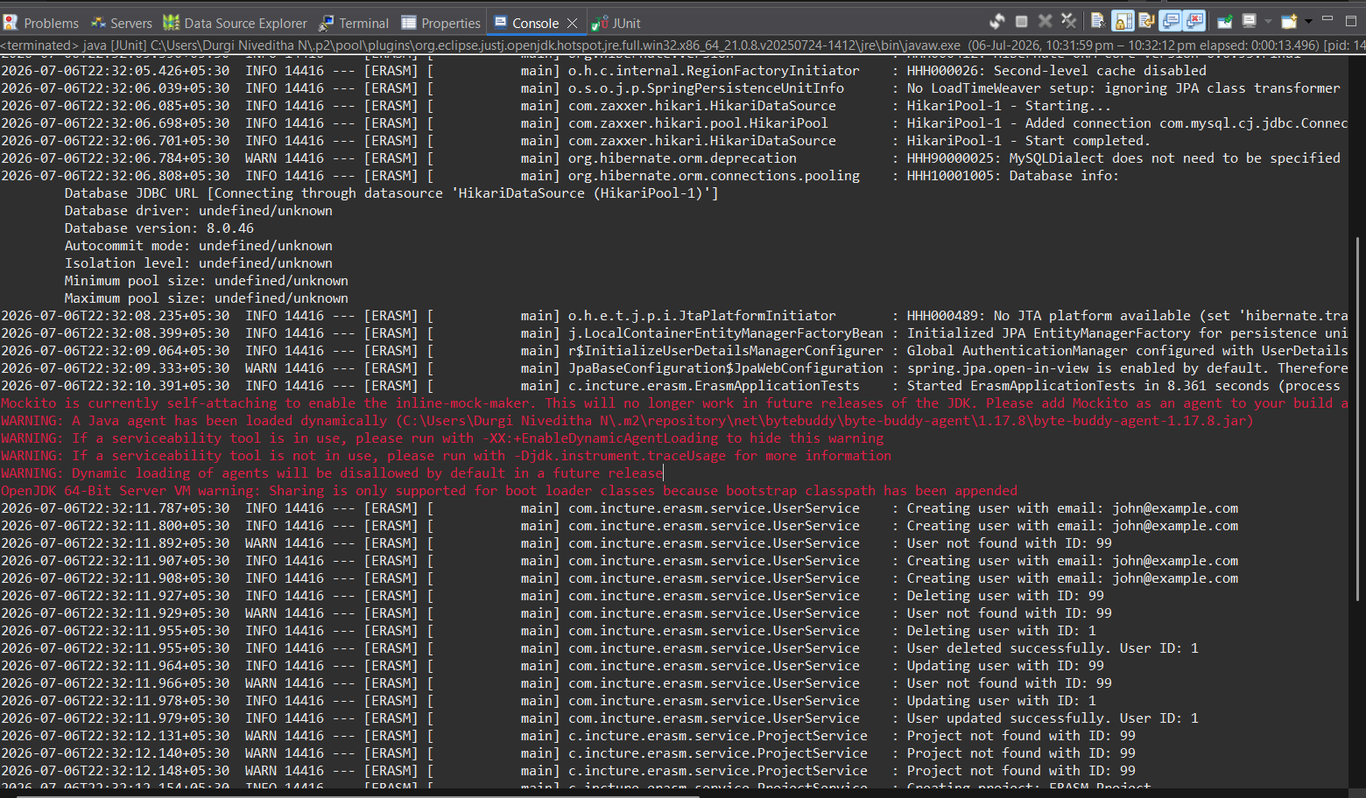

6 Conclusion
The ERASM test suite, as it stands in the current codebase, provides thorough, well-structured coverage of three core services: Resource Allocation, Project Management, and User Management. Each test class exercises the full range of expected outcomes, successful operations, not-found conditions, empty-collection edge cases, and, for Allocation, the critical 100%-cap business rule at both sides of its boundary, and each assertion was verified directly against the test source rather than assumed.
The most valuable next step is coverage breadth rather than coverage depth: the existing three classes already demonstrate the pattern to follow, and applying it to the remaining eight modules (Role, Skill, Employee, Employee Skill, Certification, Resource Request, Reports, and Audit Log) would bring the whole service layer to a consistent standard of verification.

