Project Reflection
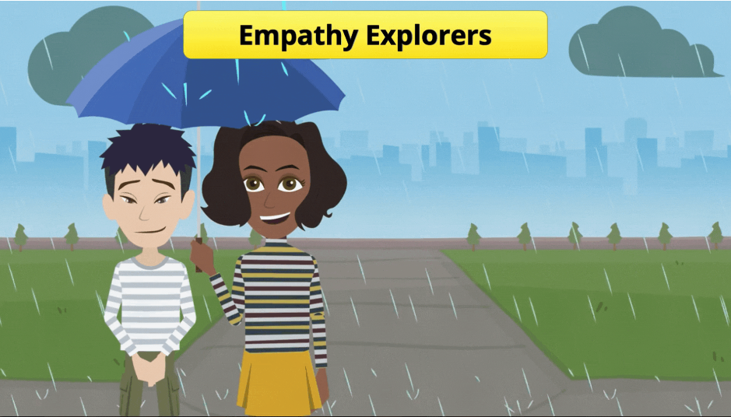
Overview
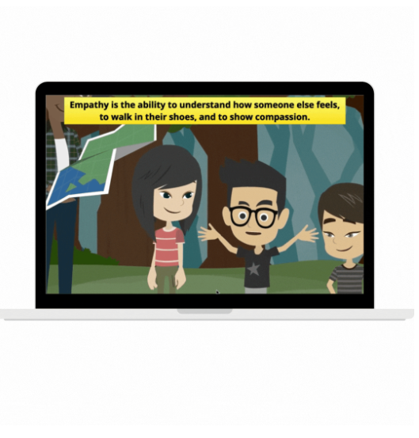 | My Role: | Content Creator  Instructional Designer
 | Tools: | Storyline 360
 | Description: | Asanas and Anatomy is a seminar for adults gaining their yoga teaching licensure. It focuses on examining research about the health benefits of yoga.

Develop
Because the learners were children, I focused even more heavily on lowering the cognitive load. The main content comes from the videos while the words that pop up on the screen throughout the course are meant to reinforce the most important ideas. I also chose colors that are more vibrant for the text and buttons. Each video has closed captions for accessibility.
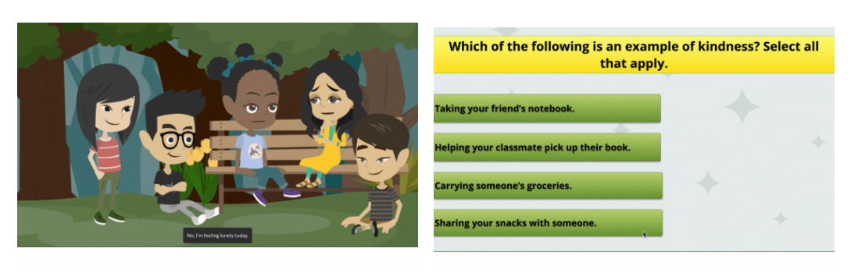
What I Learned
This course was challenging because it involved many elements on each slide - video, audio, text, and buttons. I ensured the timing was appropriate so that the audio, video, and text all lined up. I also created the quiz from scratch rather than using a Storyline template. I learned how to use triggers and layers appropriately to provide feedback and ensure students could not skip forward until they chose the correct answers.

