Project Reflection
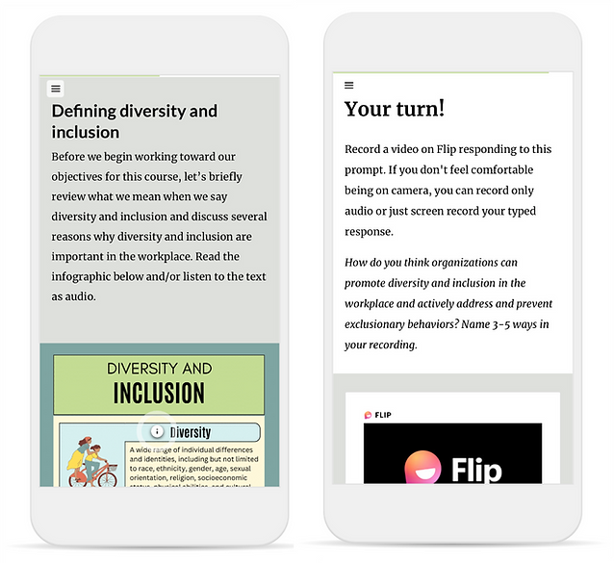
Overview
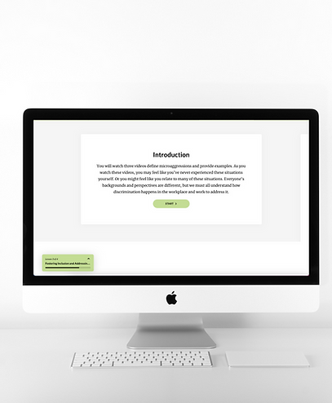 | My Role: | Content Creator  Instructional Designer
 | Tools: | Rise 360  Canva
 | Description: | Fostering Equity is a corporate training that supports learners in defining their own cultural perspectives, building empathy for others, and addressing microaggressions.
Analysis
During the analysis stage, I learned about what my participants needed with these questions:
1. What are the goals of this training?
2. How will the students benefit from this course?
3. How will the organization benefit from this course?
4. Who should receive this training?
5. What should students know and be able to do after this training?
6. Who are the SMEs for this project?
7. How would you define the biggest issues that you want this training to address?

Then, I created a learner persona:

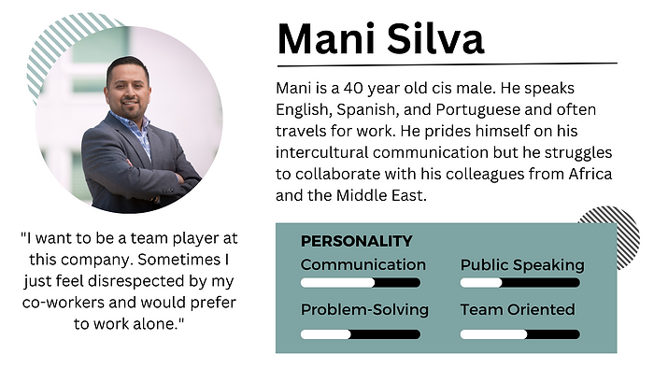
Analysis
The most important goals of this project were to make the elearning module as efficient and engaging as possible. More advanced participants can "test out" of the course, making sure they use their time efficiently. Moreover, healthcare professionals go through many training sessions during their careers, so this training needed to be interesting and fun to hold their attention. As such, the first slide asks "Why is this diet important?" to give learners a sense of purpose about why they are learning this material. I also incorporated many vivid visuals to add a vibrant feel and several types of interactions to present information in a more engaging way.
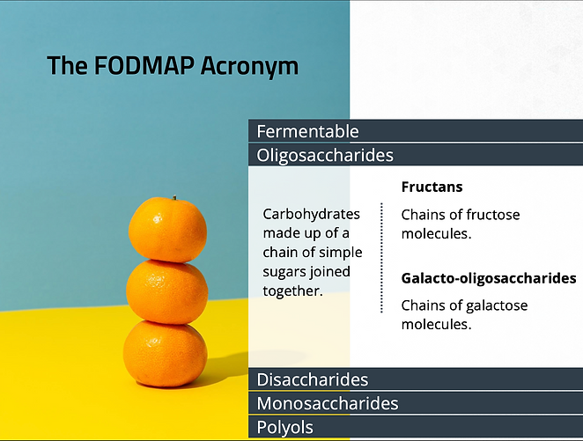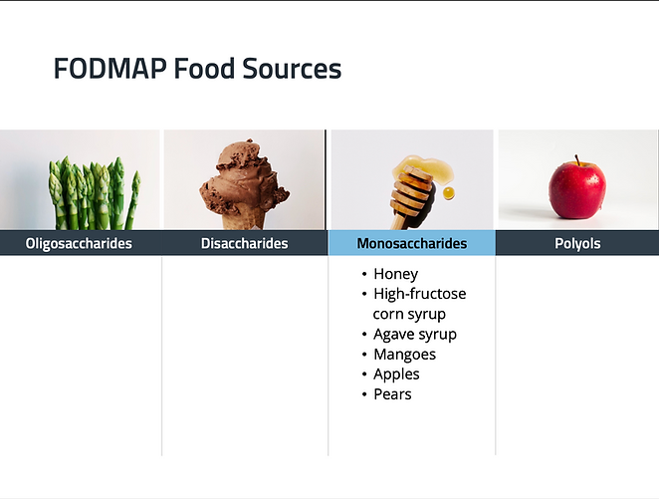
Implement
This training is meant to be completed virtually so that participants can complete it on their own time.
What I Learned
Through working on this project, I learned how to collaborate with my elearning design colleagues to build the module more efficiently. I used several templates and ideas from the Articulate community to make the design process faster. Even so, I customized not only the content, but also the color palette, fonts, and layouts of each slide to ensure my product was original. However, the templates provided me with functions, like pre-set triggers, that sped up the process.

