Project Reflection
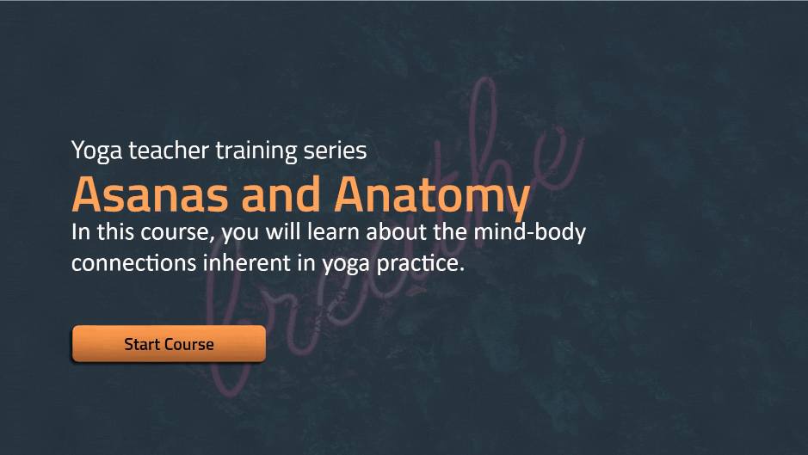
Overview
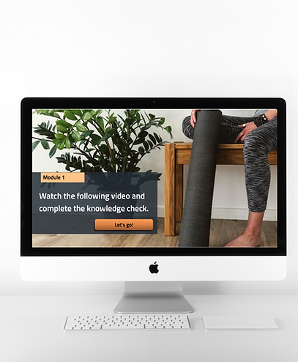 | My Role: | Content Creator  Instructional Designer
 | Tools: | Storyline 360
 | Description: | Asanas and Anatomy is a seminar for adults gaining their yoga teaching licensure. It focuses on examining research about the health benefits of yoga.
Develop
I used Knowle's Principles of Adult Learning when designing this elearning experience. Considering adults' self-concept, or the fact that adults learn better when they work autonomously though self-directed content, I provided multiple forms of choice where students could click on any of the content they found most interesting.
I also drew on students' prior knowledge about basic yoga poses and added another level of complexity - the knowledge of human anatomy. I also created a sleek, interactive experiences and ensure that diverse participants would be represented. I accomplished this with visually appealing photography and a modern color palette of nudes.
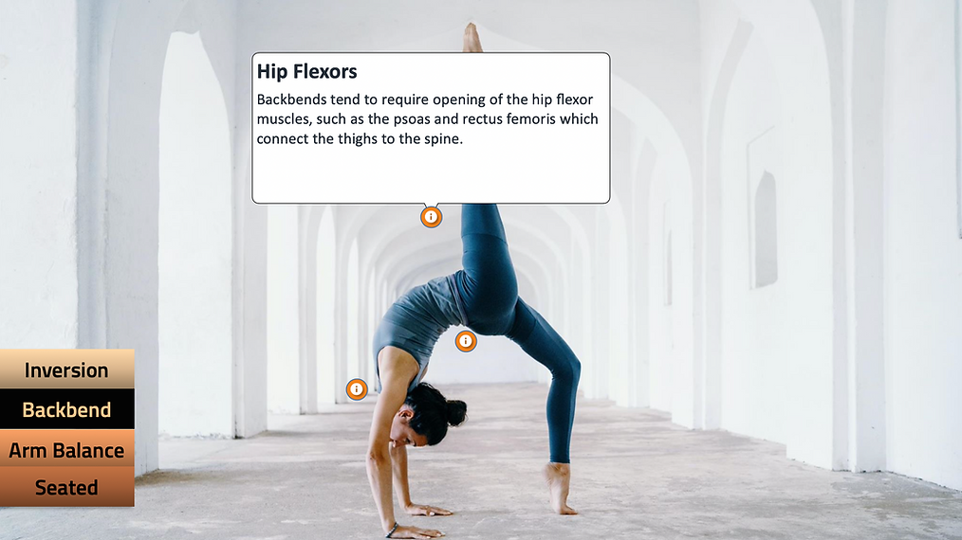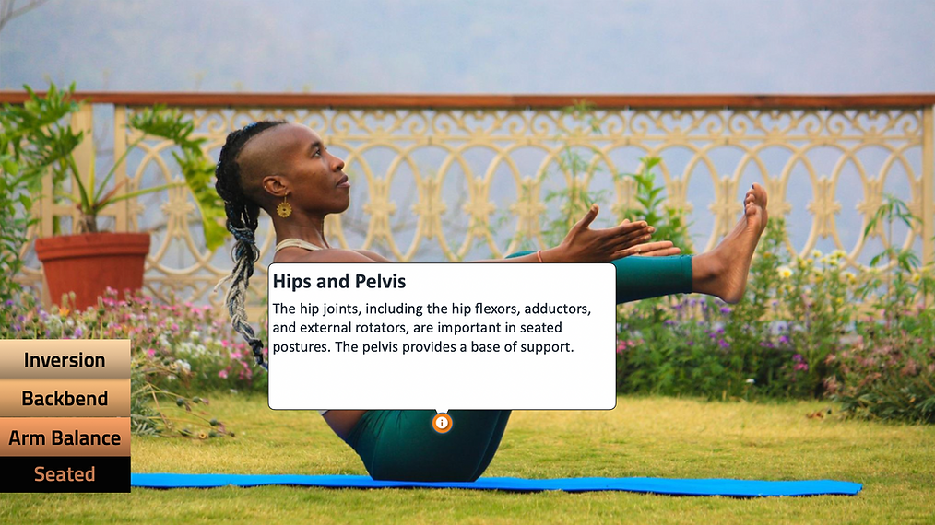
Implement
This training is meant to be completed virtually so that participants can complete it on their own time.
Evaluate
I tested the site using Levels 1-2 of the Kirkpatrick Model. I watched users use the site and asked them questions along the way. Users enjoyed using the elearning module. They found it visually appealing and interesting. Users were generally successful on the knowledge checks and quizzes, showing that they were gaining knowledge.
Areas of improvement for the future: I learned that the buttons are not obvious to users. As such, users skipped some of the instructional materials. In future iterations, I would include more instructions along the way to guide students toward the content they should access. I would also work with users in the long term to examine Levels 3-4, or how their behaviors change after the training and the results of this intervention. I would gauge this by analyzing how well the teachers incorporated aspects of anatomy into their yoga classes.
What I Learned
Working on this project helped me reflect on how to give students voice and choice in their learning experience. I created a lot of freedom into the website, like allowing students to go back and forth between pages and click on the topics that sounded most interesting to them. The only parts of the learning modules that prohibit this freedom of movement are the knowledge checks and quizzes.
I also reflected on how to make the content feel relevant to students. I included photography of people doing yoga poses rather than clip art depictions, and I used modern, sleek colors to give the site a calm, welcoming, and hip vibe.

