To clone, please use: https://github.com/durimdead/DaveTestBlazor.git

Once cloned, please run the following in the indicated order on a local database:

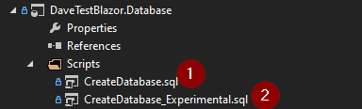

The first one will create the user used for both, the second one will simply re-use and link the user to the second database. We do not require the second database, but we will use it.

Once done with both of those, please compile and start the project.

You will notice 4 users:

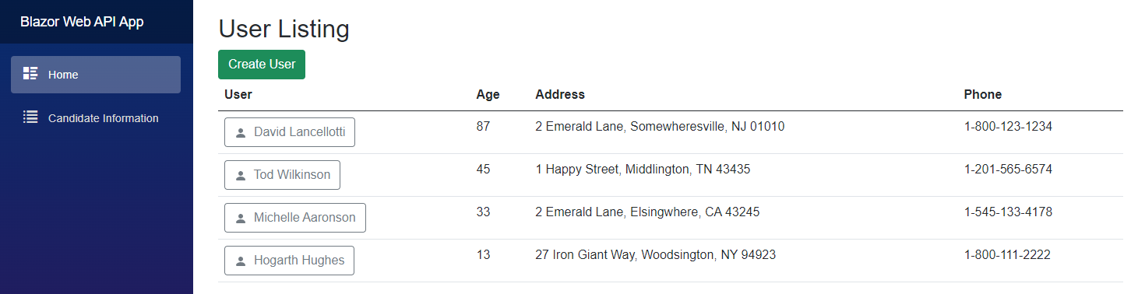

Clicking on any of the user names will bring up the following screen:

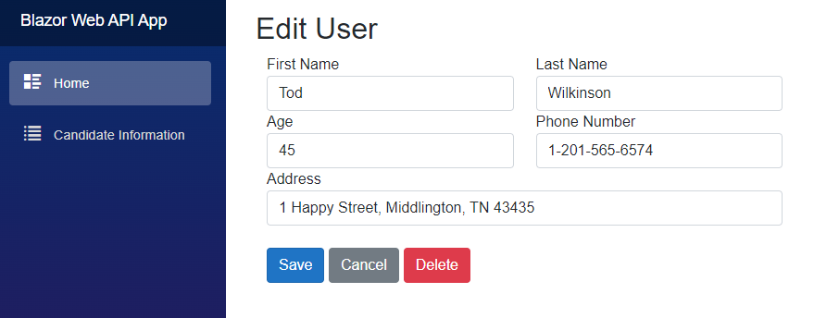All 3 buttons will bring you back to the user listing after clicking them:

* Save will update the user in the database
* Cancel will do nothing to the record
* Delete will remove the record from the database

Clicking on “Create User” button will bring you here:

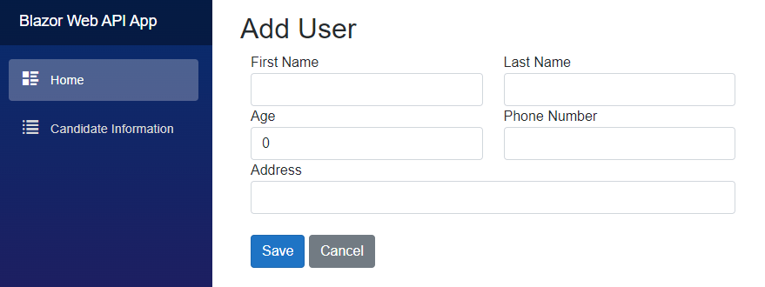Similar to the “Edit screen” both buttons will do the following before returning you to the listing screen:

* Save will Add a new user with the entered information (caveat – form validation was foregone on this demo).
* Cancel will do nothing

Once you have decided that you are good with the current configuration, the json config can be updated to point to the other database: Initial Catalog=DaveTest_Complex

Upon updating this, you will notice that you can restart the application and have everything work the same. The difference is the guts of the database. This is simply to show an argument for utilizing views and stored procedures due to the ability of keeping layers completely separate. The way I look at it is that they act almost like a “database API”.

Lastly, I put a page with a small bit of information (Candidate Information):

