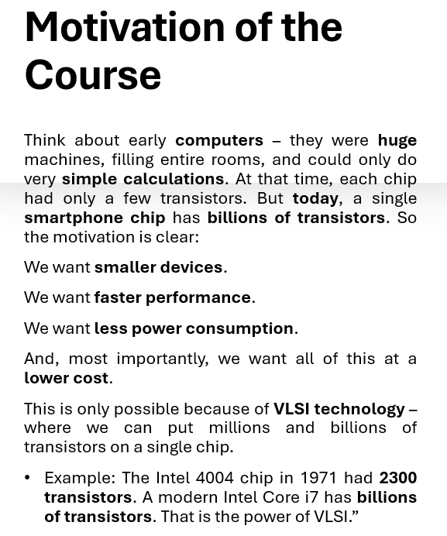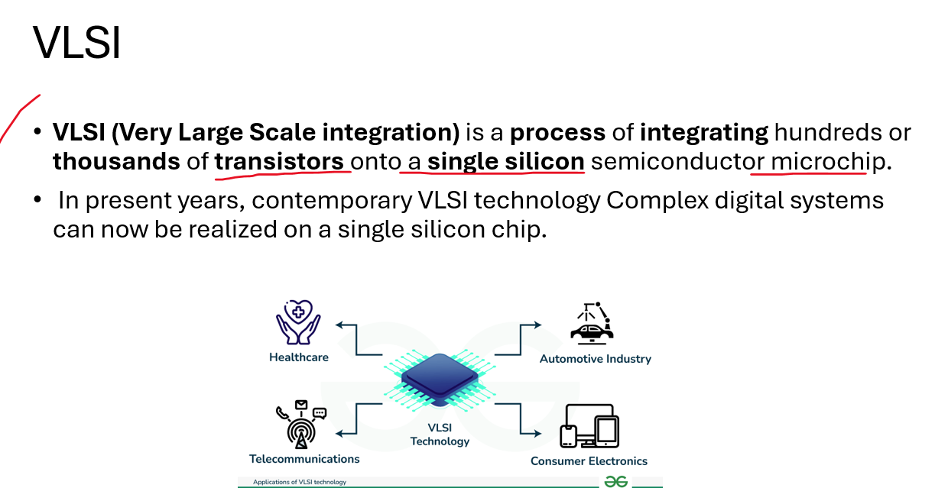
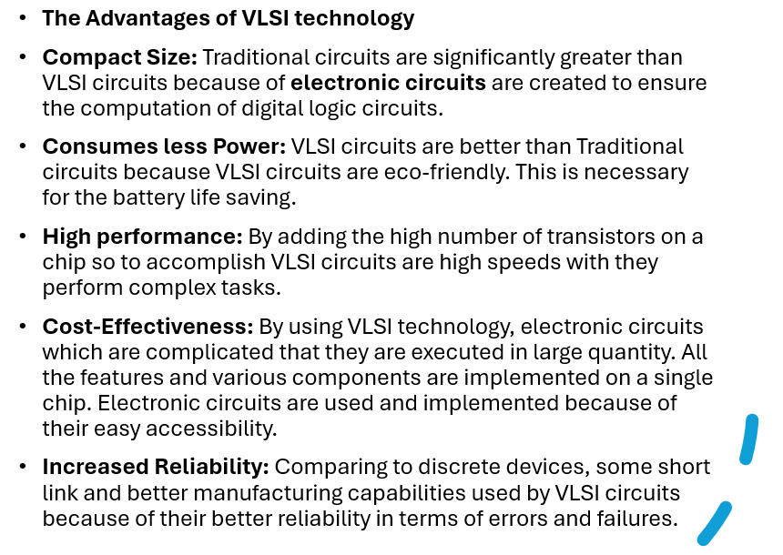
- High speed
- Low power consumption
- Less heat generation
- High storage
- Lower Cost
- Increase reliability
- Compact size
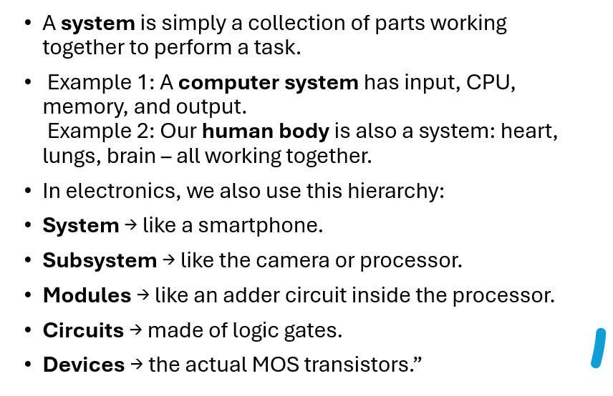
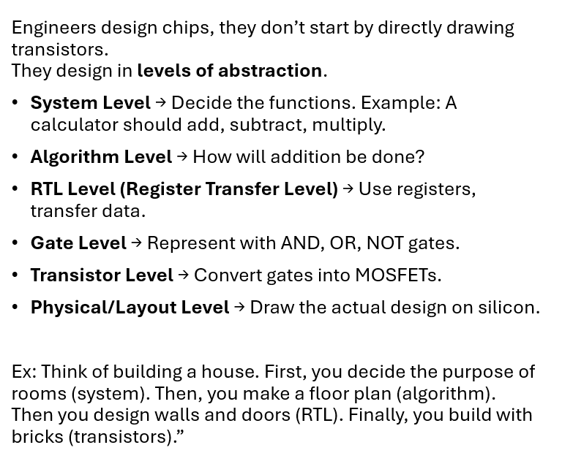
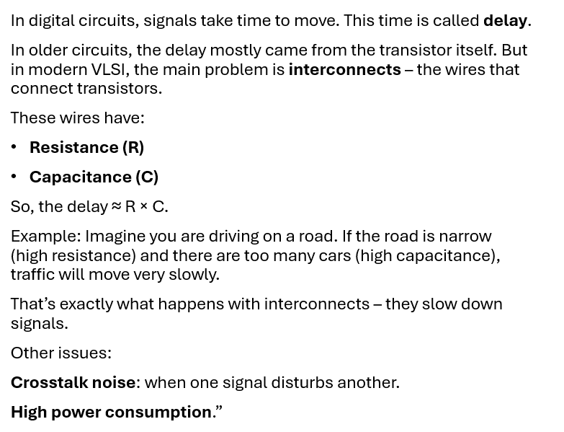
What is MOS?
MOS is a structure used to make the MOSFET (Metal-Oxide-Semiconductor Field Effect Transistor), the most important device in VLSI design.
It is the building block of modern digital circuits.
All processors, memory chips, and logic circuits are made from MOSFETs.
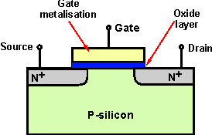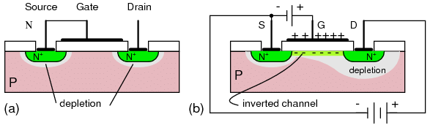
Parts of a MOS transistor (simple explanation)
1. Gate (Metal)
- This is the control terminal.
- You apply voltage here to turn the transistor ON or OFF.
Example:
Like a switch button that you press to allow current to flow.

2. Oxide Layer (Silicon Dioxide – SiO₂)
- A very thin insulation layer between the gate and the silicon.
- Prevents direct current flow from gate into the channel.
Example:
Like a plastic cover that separates your finger from touching live wire.

3. Semiconductor (Substrate / Body)
- The base material, usually silicon.
- It contains the region where current will flow.
Example:
Like the road where cars (electrons) will travel.

4. Source
- The terminal from which charge carriers enter.
Example:
Like the start of a water pipe.

5. Drain
- The terminal where charge carriers leave.
Example:
Like the end of the water pipe.

6. Channel
- Forms between source and drain when gate voltage is applied.
- This is the path for current flow.
Example:
Like opening a road between two cities by pressing a button.

How MOSFET works (simple steps)
OFF state
- No voltage at gate → no channel → no current flows
ON state
- Voltage applied to gate → channel formed → current flows from source to drain
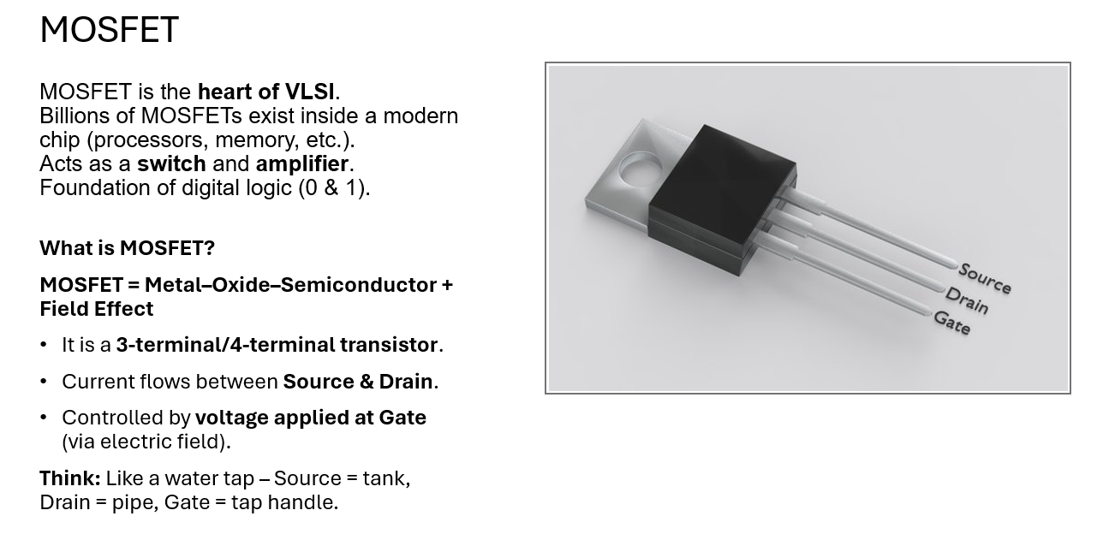
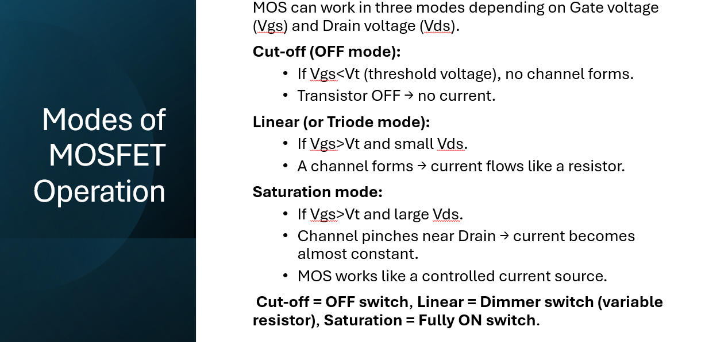
Operating Modes of MOSFET (simple explanation)
MOSFET works in three modes based on Gate–Source voltage (VGS) and Drain–Source voltage (VDS).
1. Cut-off Region (OFF Mode)
Condition:
- VGS < VT (threshold voltage)
What happens:
- No channel is formed
- No current flows → transistor is OFF
Simple example:
➡️ Like an open switch (current can’t flow)

2. Linear / Triode Region
Condition:
- VGS > VT
- VDS is small
What happens:
- Channel is formed
- Current flows freely
- Acts like a variable resistor
Simple example:
➡️ Like a dimmer switch controlling brightness of a light

3. Saturation Region
Condition:
- VGS > VT
- VDS is large
What happens:
- Channel is pinched near the drain
- Current becomes almost constant
- Works as a controlled current source
Simple example:
➡️ Like a fully ON switch in amplifier circuits

One-line memory trick
Cut-off → OFF
Linear → Resistor
Saturation → Current source
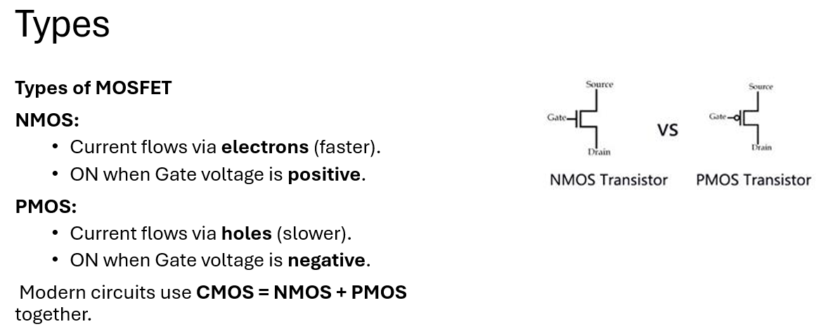
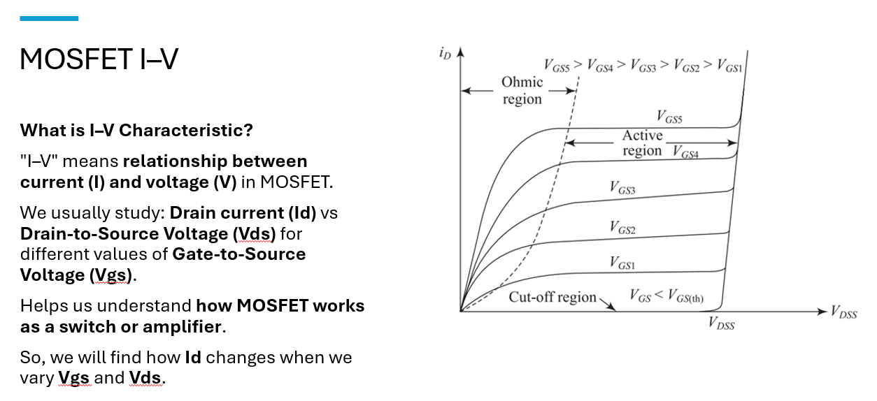
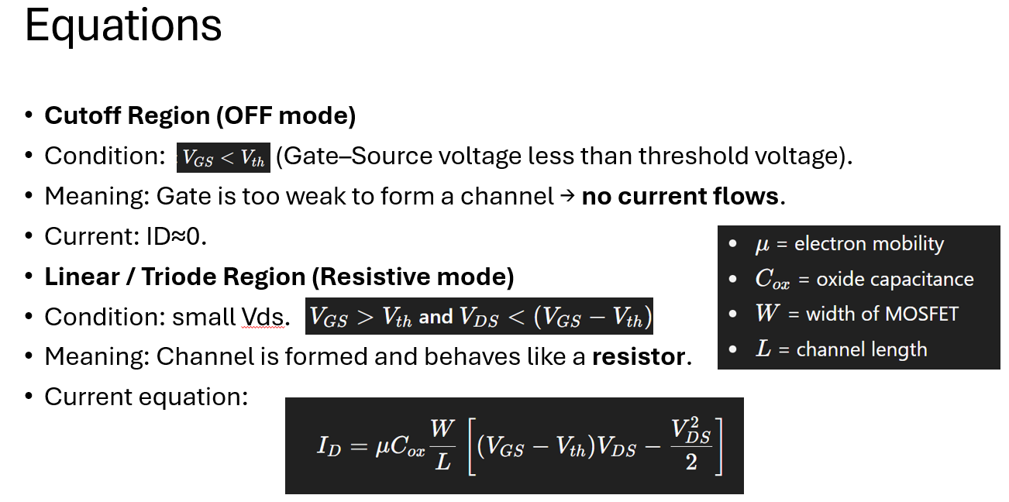
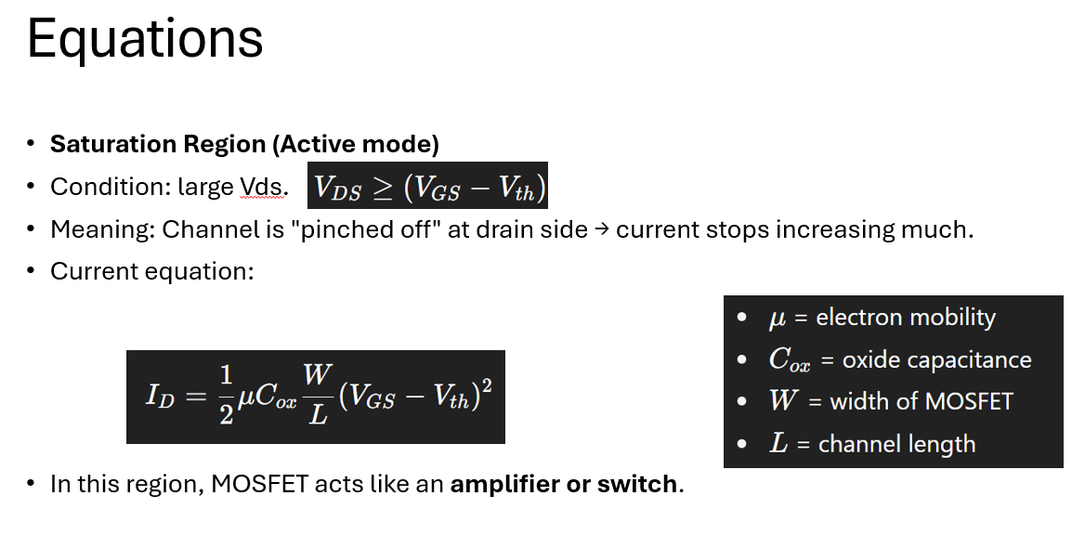

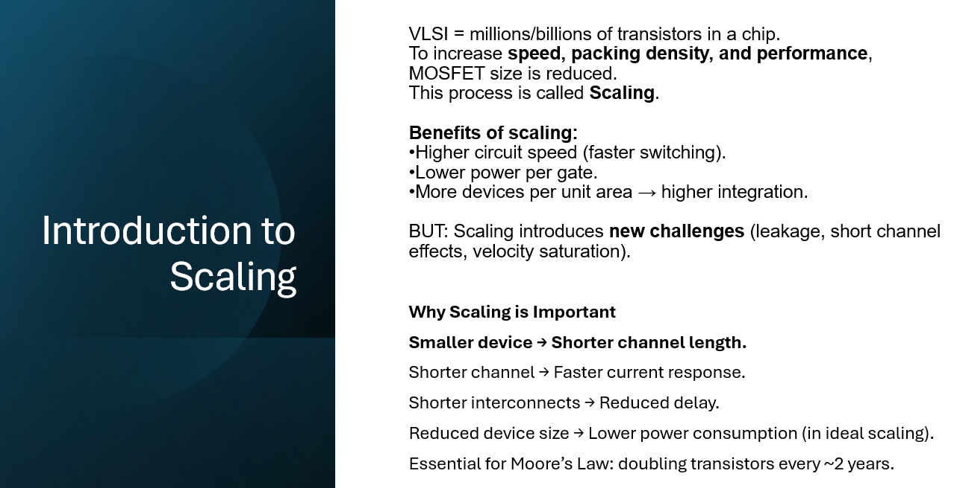
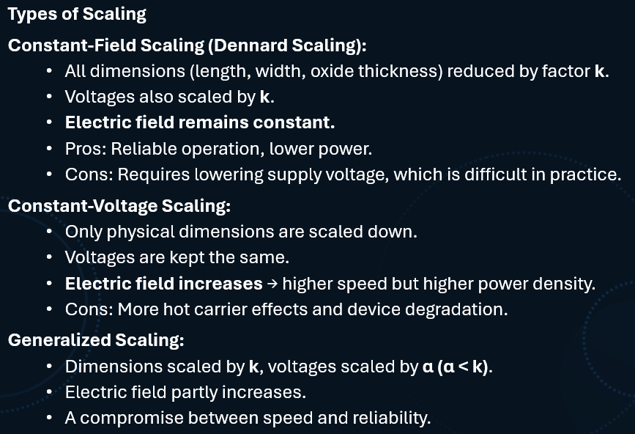
1. Constant Field Scaling (Full Scaling)
Idea:
All dimensions and voltages are scaled down by the same factor so the electric field remains constant.
What is scaled by factor k (k > 1):
- Device dimensions (L, W, tox) → ÷ k
- Supply voltage (Vdd) → ÷ k
- Threshold voltage (Vt) → ÷ k
Result:
- Circuits become faster
- Power per gate decreases
- Power density remains roughly constant
✅ Example:
If technology scales from 180 nm → 90 nm (k = 2):
- Length becomes half
- Voltage reduces: 1.8 V → 0.9 V
- Faster operation and lower power

2. Constant Voltage Scaling
Idea:
Device dimensions are reduced, but supply voltage is kept constant.
What happens:
- Dimensions → ÷ k
- Vdd → unchanged
- Electric field increases
Result:
- Higher speed
- But more power dissipation and reliability issues
✅ Example:
From 180 nm → 90 nm:
- Channel length halves
- Supply voltage stays at 1.8 V
- Leads to higher electric fields and heating

3. General (Combined) Scaling
Idea:
A practical mix between constant field and constant voltage scaling.
What happens:
- Dimensions → ÷ k
- Voltage → ÷ α (α < k)
Result:
- Trade-off between speed and power
- Most realistic approach used in modern chips
✅ Example:
From 65 nm → 45 nm:
- Dimensions scale by ~1.4
- Voltage reduces slightly (e.g., 1.2 V → 1.0 V)

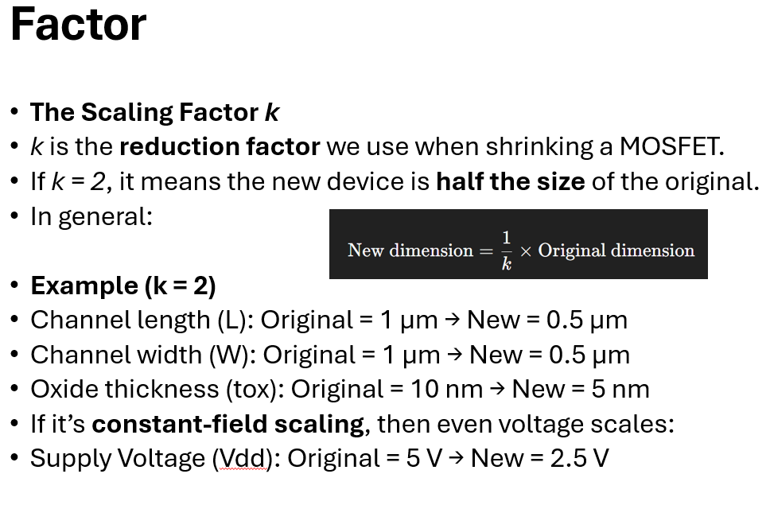
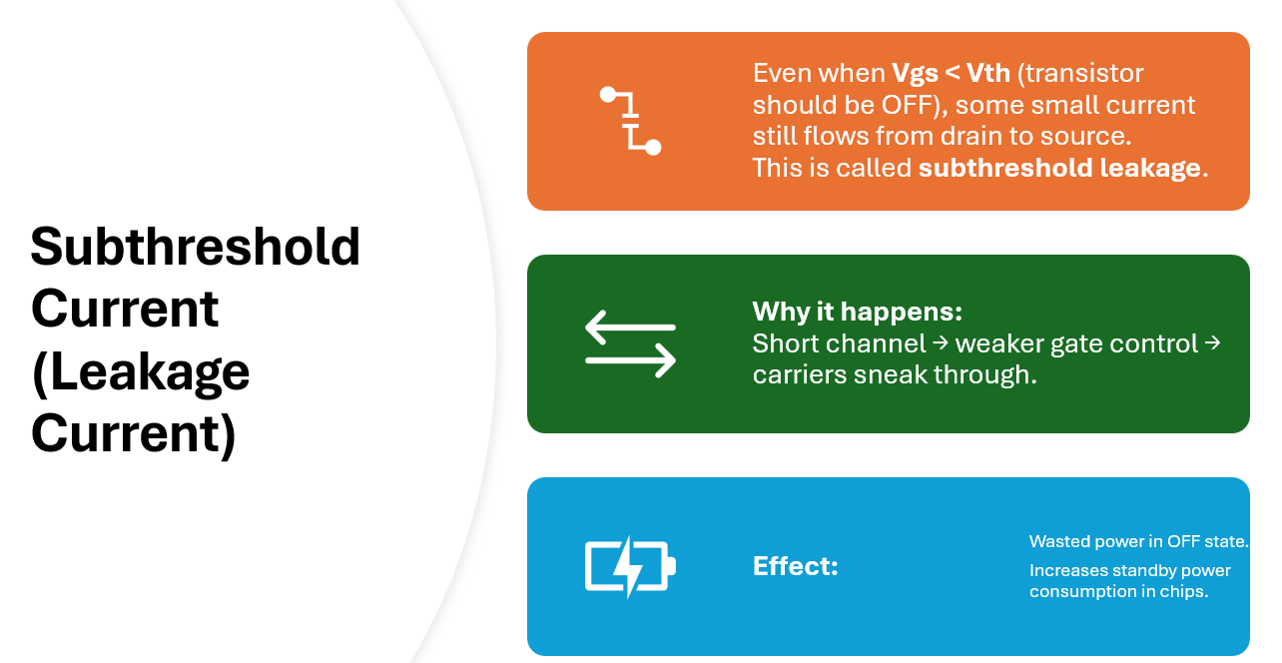
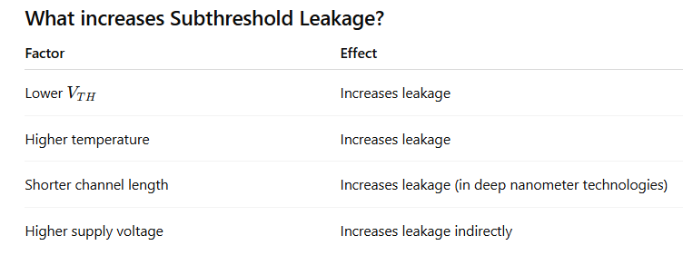
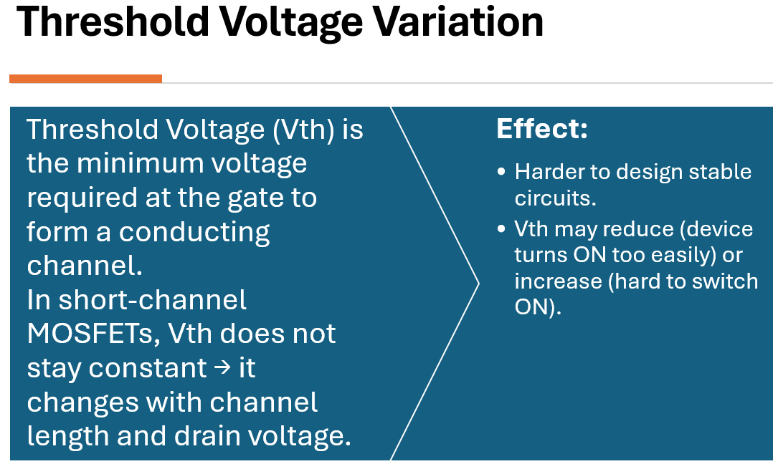
Threshold Voltage Variation (Vth Variation)
What it is:
Threshold voltage is the minimum gate voltage needed to turn a MOSFET ON.
In small (short channel) transistors, Vth changes instead of staying constant.
Why it changes:
- Short channel length
- High drain voltage
- Temperature changes
Effect:
- If Vth decreases → transistor turns ON too easily (more leakage)
- If Vth increases → harder to turn ON (slower circuit)
Example:
A MOSFET designed for Vth = 0.5V
But in real chip it becomes 0.4V → device turns ON too easily
Or becomes 0.6V → device becomes slow
One-line exam answer:
Threshold voltage variation is the change in Vth due to short channel effects, drain voltage, and temperature, affecting circuit stability and performance.

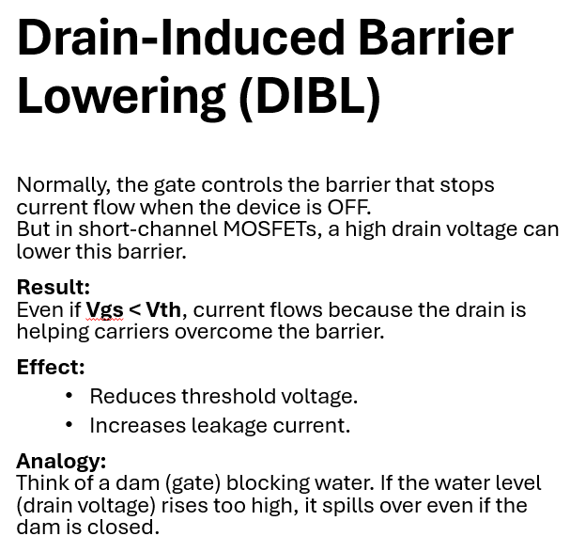
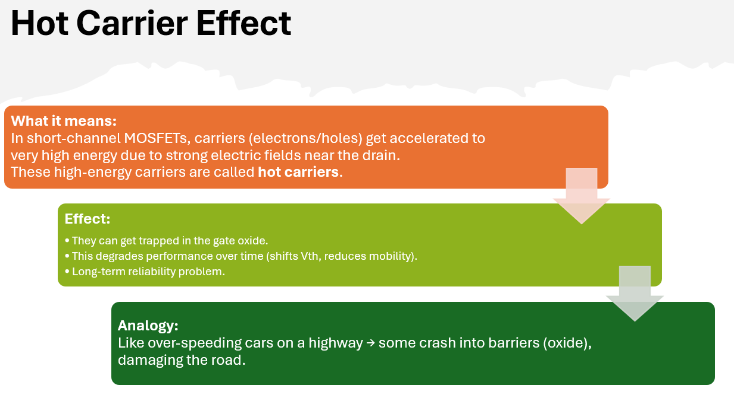
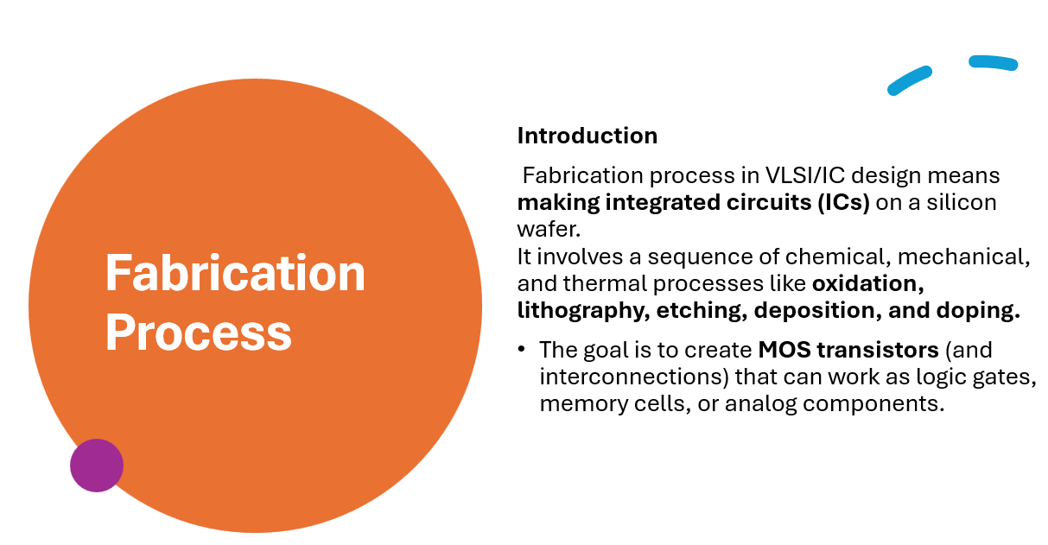
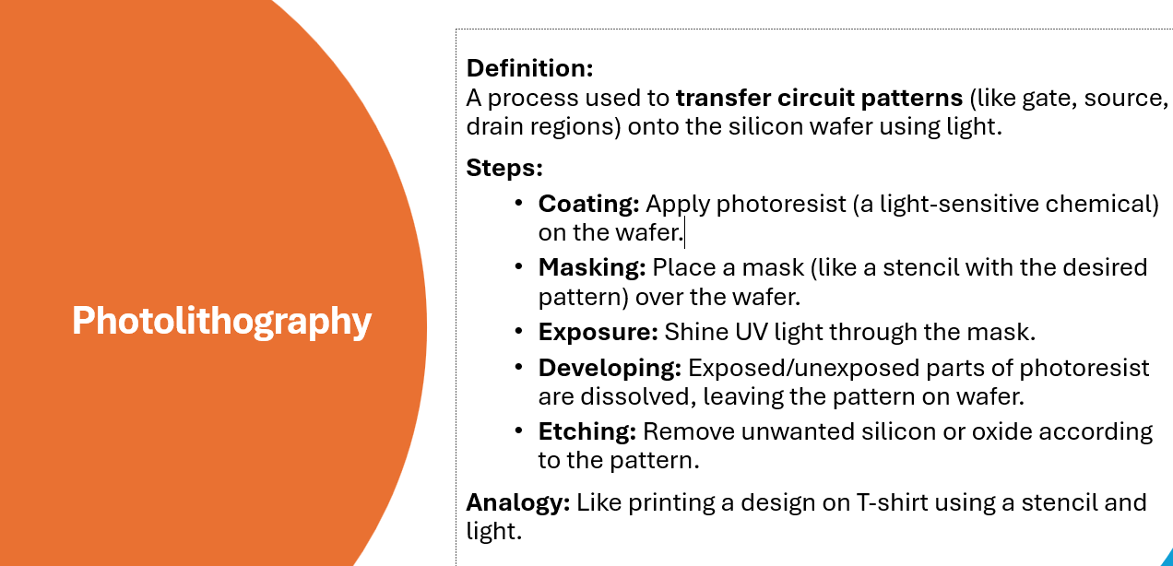
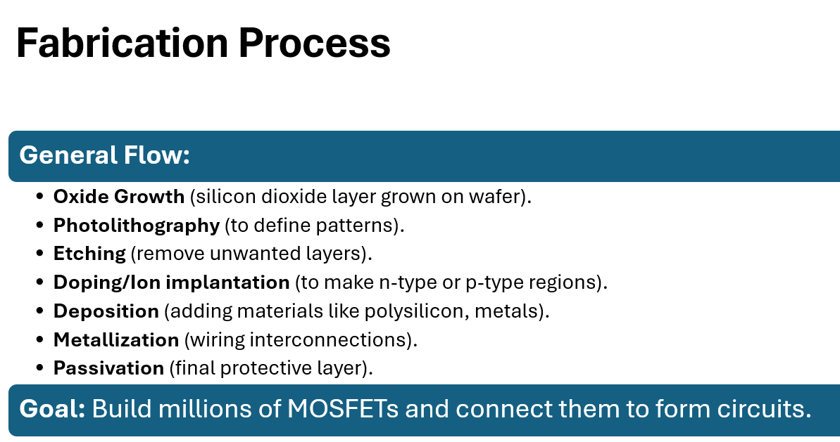

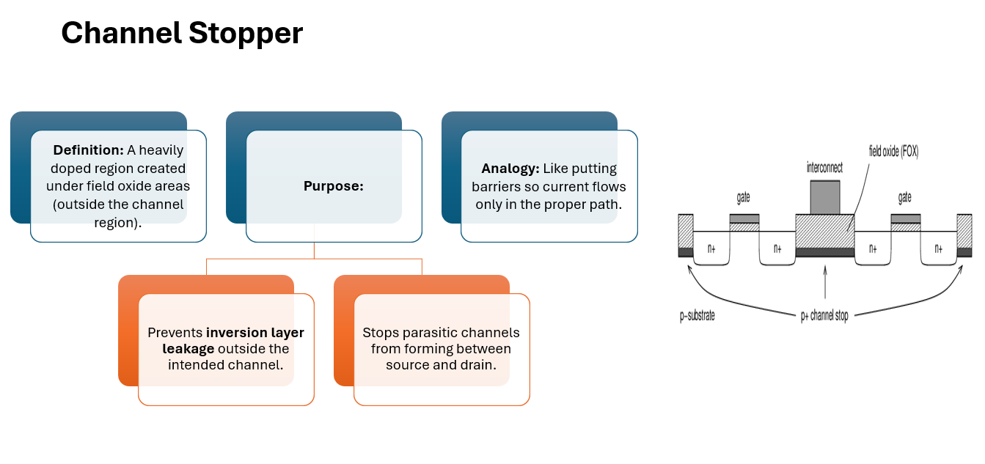
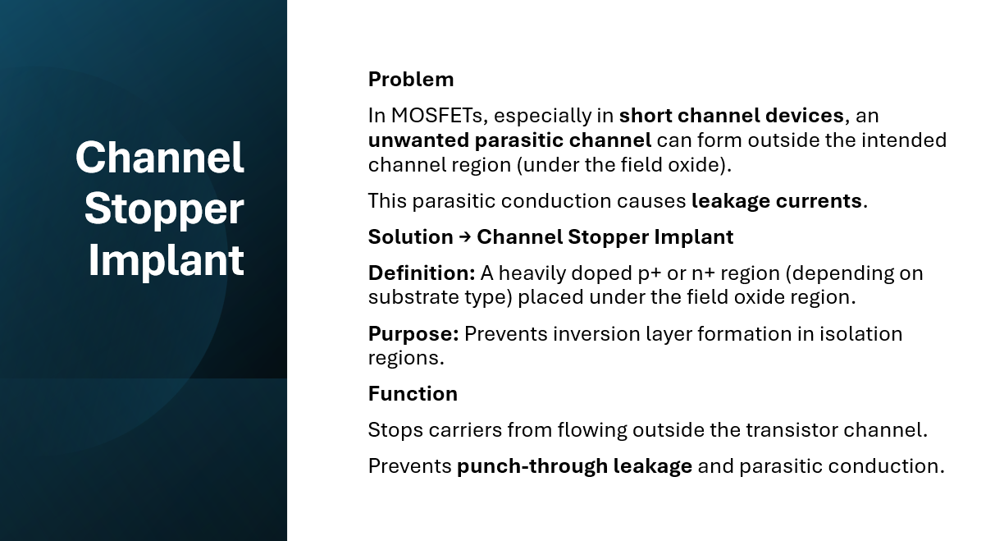
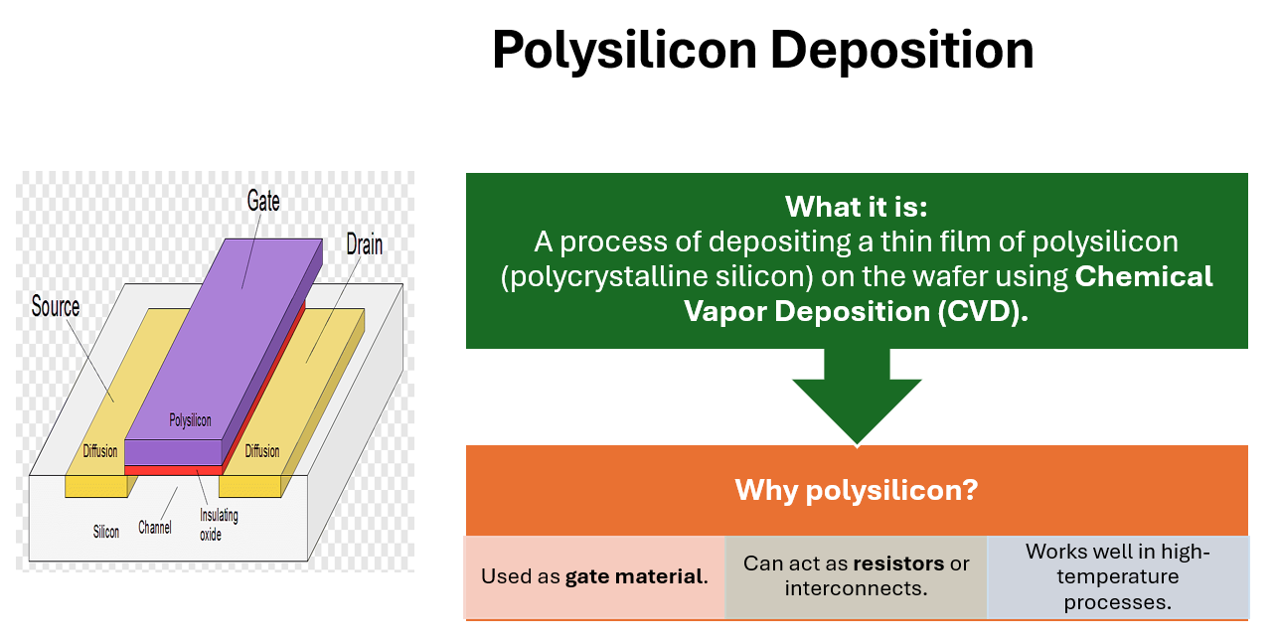
1. Geometrical Rules
These rules define the physical dimensions of layout objects.
They control:
- Minimum width
- Minimum spacing
- Minimum overlap
✅ Example:
- Metal width ≥ 2λ
- Spacing between metal lines ≥ 2λ
If lines are thinner/closer → fabrication errors may occur.

2. Connectivity Rules
These rules define how layers can be electrically connected.
They specify:
- Which layers can connect
- Where contacts or vias must be placed
✅ Example:
- Metal-1 connects to Poly only through a contact
- Metal-1 connects to Metal-2 only through a via

3. Stick Diagram
A stick diagram is a simple symbolic representation of a circuit layout.
It shows:
- Rough positions of layers
- Connections
- Not actual sizes (not to scale)
✅ Example:
Think of it like a hand-drawn map before making the real layout.
4. Lambda (λ) Based Layout Design Rules
This method uses λ (lambda) as a scalable unit instead of fixed micrometer values.
So designs work for different technology sizes.
✅ Example:
If λ = 0.1 µm, then:
- Minimum width = 2λ = 0.2 µm
- Minimum spacing = 2λ = 0.2 µm
This makes the design technology independent.
