Slide-1
• Early computers: Huge, room-sized machines with very few transistors, performing simple calculations.
• Modern goal: Smaller devices, faster performance, lower power consumption, and reduced cost.
• VLSI (Very Large Scale Integration) enables millions/billions of transistors on a single chip—making this progress possible.
• Example:
- Intel 4004 (1971) – 2,300 transistors
- Modern Intel Core i7 – billions of transistors
→ VLSI is the key to modern high-performance, compact, and efficient electronics.

Slide-2
- Definition: Process of integrating hundreds, thousands, or even billions of transistors onto a single silicon microchip.
- Modern VLSI: Enables realization of complex digital systems (like processors and memory) on a single chip.
- Result: Higher performance, smaller size, lower power consumption, and reduced cost.
Slide-3
Advantages of VLSI Technology
- Compact Size – Much smaller than traditional circuits; many components integrated on a single chip.
- Low Power Consumption – Eco-friendly and extends battery life.
- High Performance – Can perform complex tasks at high speed due to billions of transistors on a chip.
- Cost-Effective – Complex circuits implemented in large quantities on one chip, reducing production cost.
- Increased Reliability – Fewer errors and failures compared to discrete devices; better manufacturing precision.
Slide-4:
System: Collection of parts working together to perform a task.
- Example: Computer → input, CPU, memory, output; Human body → heart, lungs, brain.
Electronics Hierarchy:
- System: Smartphone
- Subsystem: Camera, Processor
- Module: Adder circuit inside processor
- Circuit: Made of logic gates
- Device: MOS transistors
Basic Flow:
Input → Processing → Output

Slide -5:
Chip Design: Levels of Abstraction
- Engineers don’t start with transistors; they design in steps.
- System Level: Decide functions.
  - Example: Calculator → add, subtract, multiply.
- Algorithm Level: Decide how to perform functions.
  - Example: How addition is done.
- RTL (Register Transfer Level): Use registers, transfer data.
- Gate Level: Represent using AND, OR, NOT gates.
- Transistor Level: Convert gates to MOSFETs.
- Physical/Layout Level: Draw actual design on silicon.
Analogy: Building a house → purpose of rooms (system) → floor plan (algorithm) → walls/doors (RTL) → bricks (transistors)
Slide -6:
Digital Circuit Delay
- Signals take time to move → called delay.
- Old circuits: delay mainly from transistors.
- Modern VLSI: delay mainly from interconnects (wires).
Interconnect Characteristics:
- Resistance (R) and Capacitance (C)
- Delay ≈ R × C
- Analogy: Narrow road (high R) + heavy traffic (high C) → slow movement
Other Issues:
- Crosstalk noise: one signal disturbs another
- High power consumption
Slide-7:
MOS (Metal-Oxide-Semiconductor):
- Structure used to make MOSFETs, the key device in VLSI.
- Building block of modern digital circuits: processors, memory, logic circuits.
Slide-8:
MOS Structure: 3 Main Parts
- Metal (Gate): Thin metal or polysilicon layer → acts as the switch handle
- Oxide: Very thin insulator layer (SiO₂)
- Semiconductor (Substrate): Base material, usually silico

Slide-9:
MOSFET (Metal–Oxide–Semiconductor FET):
- Heart of VLSI: billions in modern chips (processors, memory, etc.)
- Functions: Switch & amplifier → foundation of digital logic (0 & 1)
- Structure: 3 or 4 terminals → Source, Drain, Gate (and Body)
- Operation: Current flows Source to Drain, controlled by Gate voltage (electric field)
- Analogy: Like a water tap → Source = tank, Drain = pipe, Gate = tap handle
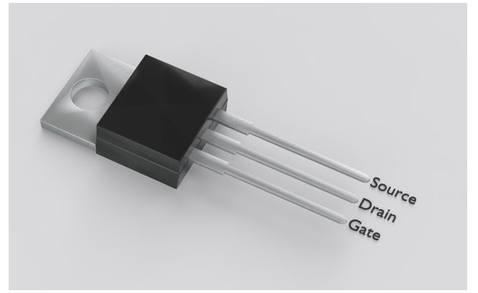
Slide-10:
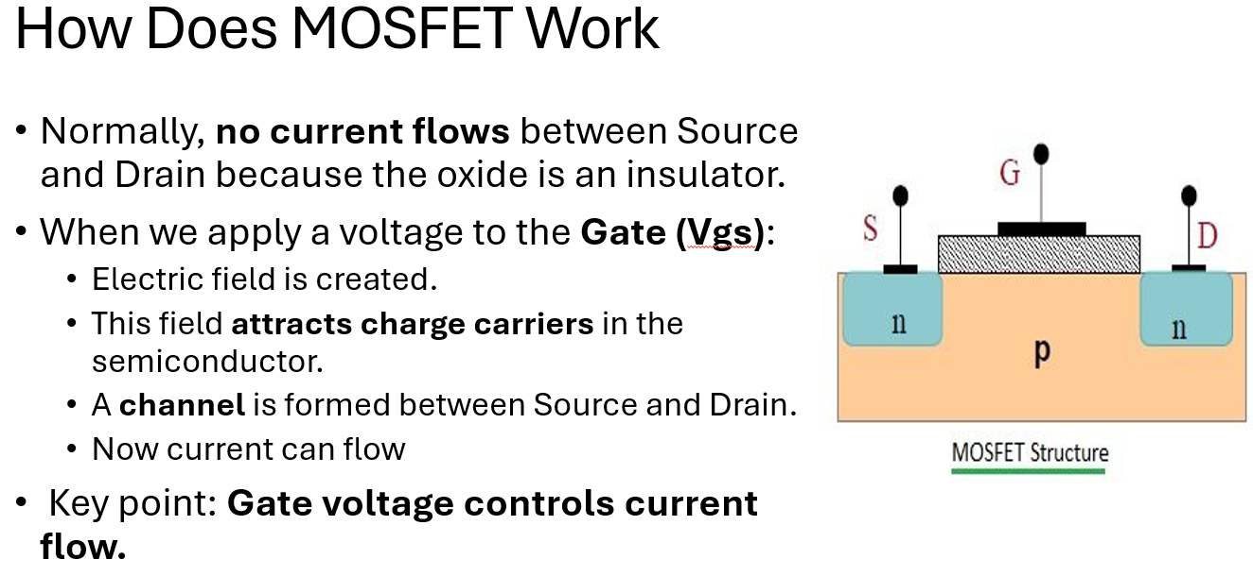
Slide- 11:

Lecture- 2
LECTURE-2: VLSI – Full Explanation With Examples

1. CMOS Inverter Fabrication Process
What is CMOS?
CMOS = Complementary Metal Oxide Semiconductor
It uses:
- nMOS transistor (made from n-type silicon → electrons)
- pMOS transistor (made from p-type silicon → holes)
They work oppositely:
- When nMOS is ON, pMOS is OFF
- When pMOS is ON, nMOS is OFF
Why CMOS is used everywhere?
✔ Very low power consumption
✔ Used in CPUs, RAM, logic gates, smartphones

2. CMOS Inverter Basics
A CMOS inverter contains:
VDD (+)
|
PMOS
|
------ → Output
|
NMOS
|
GND
How it works?
- Input = 0 → PMOS ON, NMOS OFF → Output = 1
- Input = 1 → PMOS OFF, NMOS ON → Output = 0
This is why it’s called an inverter.

3. Propagation Delay (tp)
When input changes, output does not change instantly.
This delay occurs due to the output capacitor CL that must charge or discharge.
Charging
- PMOS charges the capacitor → Output goes 0 → 1
Discharging
- NMOS discharges the capacitor → Output goes 1 → 0

✔ Simple Example:
Suppose:
- CL = 1 pF
- Current provided by transistor = 1 mA
Time = Q / I
= (C × V) / I
= (1 pF × 1 V) / 1 mA
= 1 ns
So delay ≈ 1 ns

4. Silicon on Insulator (SOI)
SOI = A thin silicon layer placed on top of insulator (SiO₂) instead of bulk silicon.
Advantages
✔ Lower parasitic capacitance → high speed
✔ Low power
✔ No latch-up
Disadvantages
✘ Expensive

✔ Example:
Apple’s A-series chips use SOI for lower power consumption.

5. Layout Design Rules
Used for drawing IC layout so fabrication is possible.
Rules include:
- Minimum spacing
- Minimum width
- Overlap rules
Layers
- Diffusion → Green
- Poly → Red
- Metal → Blue
These colors help designers check connections.

✔ Example:
If minimum poly width = 0.2 µm,
you cannot draw poly smaller than that.

6. Logical Effort
A method to calculate delay of logic gates and compare them.
It helps designers:
- Choose fastest gate
- Optimize transistor sizing
- Reduce delay in critical paths

✔ Example:
A NAND gate is slower than an inverter due to more transistors.
Logical effort helps quantify how much slower.

7. Semiconductor Memory Overview
Semiconductor memory stores 0s and 1s using transistors & capacitors.
Two major types:
- RAM (volatile)
- ROM (non-volatile)

8. RAM (Random Access Memory)
✔ Data can be accessed in any order
✔ Volatile → loses data without power
✔ Used for running apps, open files, browsers
Types of RAM
- SRAM
- DRAM

9. DRAM
Data stored using a capacitor.
But capacitor leaks → must be refreshed periodically.
✔ Example:
A DRAM cell has:
- 1 transistor
- 1 capacitor
Stores:
- Charged capacitor → 1
- Discharged capacitor → 0

10. SRAM
SRAM stores data using a flip-flop made of 6 transistors.
✔ Does not need refreshing
✔ Very fast
✘ Expensive
✘ Larger cell size

✔ Example:
CPU caches (L1, L2, L3) are made of SRAM because speed is critical.

11. ROM (Read Only Memory)
✔ Permanent memory
✔ Cannot be changed during normal operation
✔ Used for firmware, BIOS, device drivers

✔ Example:
Microcontroller ROM stores:
- Bootloader
- Program code
Even when power is off, the data stays.

12. Working of Semiconductor Memory
DRAM Working
- Data stored as charge in capacitor
- Charge leaks → must refresh every few ms:
  - Read value
  - Boost it
  - Write back
SRAM Working
- Stores value using two cross-coupled inverters
- No capacitor → No refresh needed
Flash Memory Working
Uses floating gate transistors.
Electrons trapped = 0
Electrons removed = 1

13. Advantages of Semiconductor Memory
✔ High speed
✔ Low power
✔ High density
✔ Scalable
✔ Non-volatile (Flash, ROM)

✔ Example:
Your smartphone uses:
- LPDDR RAM → low power
- Flash storage → non-volatile

14. Disadvantages
✘ RAM is volatile
✘ Flash has limited write cycles
✘ Expensive for large capacity
✘ Vulnerable to hacking
✘ Manufacturing has environmental impact

15. Applications
Used in:
- Smartphones
- Computers
- GPUs
- USB pen drives
- SSD
- Cameras
- MP3 Players

✔ COMPLETE SUMMARY (1-Minute)
Topic | Summary
CMOS inverter | Uses PMOS + NMOS
Delay | Caused by capacitor charging/discharging
SOI | Fast, low power chips
Layout rules | Needed for fabrication
Logical effort | Compare gate speeds
RAM | Volatile, fast
DRAM | Needs refresh
SRAM | No refresh, expensive
ROM | Permanent storage
Flash | Used in SSDs, USBs

