EXPERIMENT NO: 1
Comparative Study of Low-Code Development versus Traditional Application Development Approaches

1. Aim
To study and analyze the concept of Low-Code Application Development and Traditional Application Development, and to carry out a comparative analysis between the two approaches based on parameters such as development speed, cost, flexibility, scalability, and suitability, in order to understand their respective advantages, limitations, and appropriate use cases.

2. Introduction to Traditional Approach
Traditional application development refers to the conventional method of building software applications by writing source code manually, line by line, using programming languages such as Java, C++, Python, or .NET, along with associated frameworks and integrated development environments (IDEs). This approach follows a structured Software Development Life Cycle (SDLC), which typically includes phases such as requirement analysis, system design, implementation (coding), testing, deployment, and maintenance.
In the traditional approach, developers have complete control over the application's architecture, logic, and behavior, which allows for a high degree of customization and flexibility. However, this method requires skilled programmers, significant development time, and rigorous testing, making it more time-consuming and costly compared to modern alternatives. It is best suited for building complex, large-scale, and mission-critical enterprise applications that demand high performance, security, and scalability.
Key characteristics of the traditional approach include:
- Requires strong programming knowledge and technical expertise.
- Follows a well-defined, sequential Software Development Life Cycle (SDLC).
- Offers complete control over application logic, architecture, and performance.
- Involves longer development and testing cycles.
- Suitable for complex, custom, and large-scale enterprise applications.

3. Introduction to Low-Code Development
Low-code development is a modern software development approach that enables developers, and even non-technical users known as citizen developers, to design and build applications using visual interfaces, drag-and-drop components, and pre-built templates, with minimal manual coding. Low-code platforms such as Microsoft Power Apps, OutSystems, Mendix, and Appian provide a graphical development environment where application logic, workflows, and user interfaces can be configured visually rather than coded from scratch.
This approach significantly accelerates the application development process by reducing the amount of hand-written code required, allowing rapid prototyping and faster deployment. Low-code platforms typically provide built-in modules for database integration, workflow automation, and user interface design, along with reusable components and pre-built connectors to third-party systems. While low-code development offers speed and ease of use, it may have limitations in terms of deep customization and scalability for highly complex applications.
Key characteristics of low-code development include:
- Uses visual, drag-and-drop tools instead of traditional hand-coding.
- Enables rapid application development (RAD) and faster time to market.
- Can be used by both professional developers and citizen developers.
- Provides pre-built templates, reusable components, and connectors.
- Best suited for simple to moderately complex applications and internal business tools.

4. Diagram: Stages in Traditional Application Development Approach
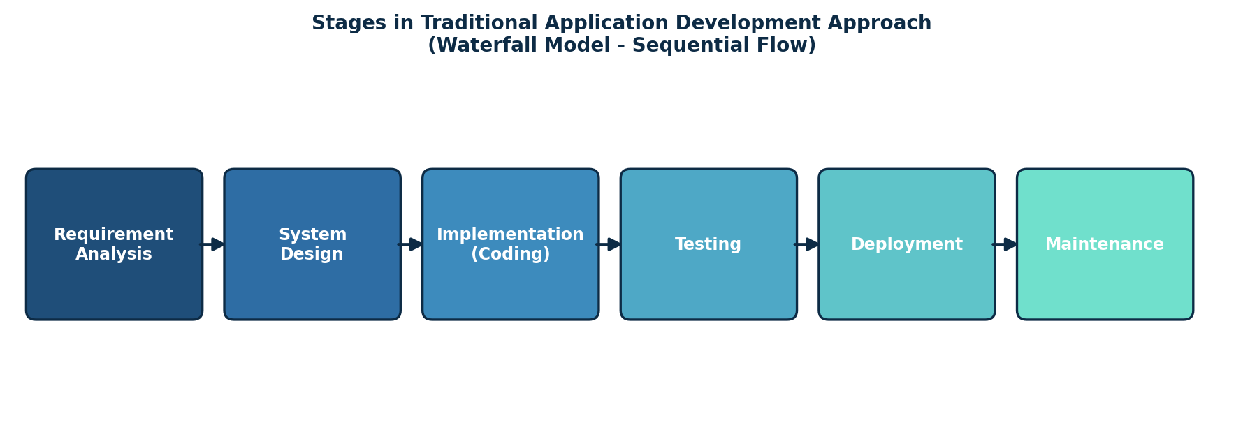
Fig 1.1 – Sequential stages of the Traditional (Waterfall-based) Development Approach

5. Diagram: Steps in Low-Code Application Development
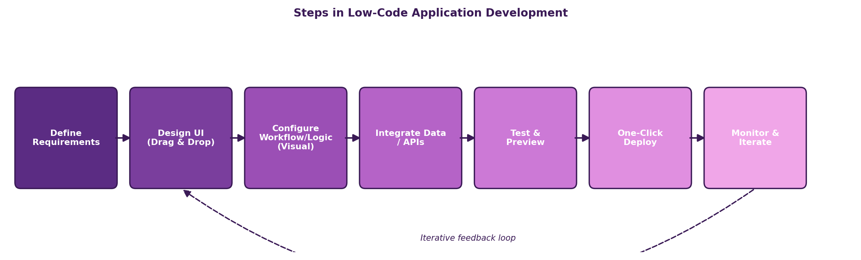
Fig 1.2 – Steps involved in Low-Code Application Development

6. Comparative Analysis: Traditional vs Low-Code Development
Parameter | Traditional Development | Low-Code Development
Development Approach | Manual, hand-written source code using programming languages | Visual/drag-and-drop interface with model-driven configuration
Development Speed | Slow; takes weeks to months depending on complexity | Fast; applications can be built in days or weeks
Coding Skill Required | High – requires experienced programmers/developers | Low to moderate – can be used by citizen developers
Cost | Higher, due to longer development time and skilled resources | Lower, due to reduced development time and reusable components
Flexibility & Customization | Very high; any custom logic or UI can be implemented | Limited by platform capabilities; complex customization may need plugins/code
Scalability | Fully scalable and controllable by developers | Depends on the platform's architecture and vendor limitations
Maintenance | Requires dedicated developers for bug fixes and updates | Easier maintenance through visual editors and platform updates
Learning Curve | Steep; requires knowledge of programming languages and frameworks | Gentle; minimal coding knowledge needed
Integration Capability | Custom integrations possible with any system via code | Pre-built connectors; may be restricted to supported integrations
Team Size Required | Larger teams (developers, testers, architects) | Smaller teams; even a single citizen developer can build apps
Deployment Time | Longer, involves multiple testing and release cycles | Shorter, often supports one-click deployment
Best Suited For | Complex, large-scale, mission-critical enterprise applications | Simple to moderately complex apps, prototypes, internal business tools
Examples of Tools | Java, .NET, Python with IDEs like Eclipse, Visual Studio | OutSystems, Mendix, Microsoft Power Apps, Appian

7. Result
Thus, a comparative study of Low-Code Development and Traditional Application Development approaches was carried out successfully. It was observed that the traditional approach offers greater flexibility, control, and scalability, making it ideal for complex and large-scale enterprise applications, whereas the low-code approach offers faster development, lower cost, and ease of use, making it ideal for rapid prototyping, small to medium business applications, and projects with limited development resources. The choice between the two approaches ultimately depends on the complexity, scalability requirements, budget, and timeline of the project.

